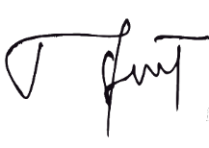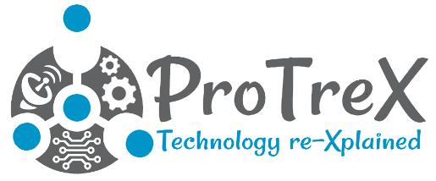

*For outstanding contribution as a participant in 2 Days Workshop on “Artificial Intelligence using Python” from 18th March to 19th  March 2023 at UCEK(A), JNTU Kakinada organized by ProTreX LLP in association with E-Cell IIT Bombay*

**VEGESNA GNANA SAI VARMA**

This certificate is proudly presented to

**Nishant Singh**

*Director*

Certificate of Achievement