**ASSINGMENT 2**

**Name: varna nemulla**

**Id: 700744920**

1. **Write a program that takes two strings from the user: first_name, last_name. Pass these variables to fullname function that should return the (full name). o For example: ▪ First_name = “your first name”, last_name = “your last name” ▪ Full_name = “your full name” o Write function named “string_alternative” that returns every other char in the full_name string. Str = “Good evening” Output: Go vnn**

**Note: You need to create a function named “string_alternative” for this program and call it from main function.**

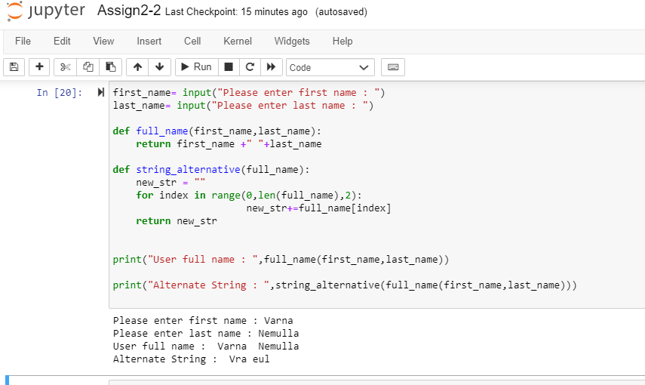

**Description:** In the above program in order to generate full name I used first_name, last_name variables and fullname as a function which will return full name. Also using string_alteranative function, I developed second part of the program. As we can see in the attachment my full name has been changed to vra eul by removing every other char.

1. **Write a python program to find the wordcount in a file (input.txt) for each line and then print the output. o Finally store the output in output.txt file.**

**Example:**

**Input: a file includes two lines: Python Course Deep Learning Course**

**Output: Python Course Deep Learning Course Word_Count: Python: 1 Course: 2 Deep: 1 Learning: 1**

**Description:** In order tocomplete this second program, I used two variables input_file, output_file and if else statement. It will take the content from input.txt to output.txt and print the count of number of words are there in the input file.as we can see in the diagram after completing the output generation the program will save and close the output file and also close the inputfile.

**3. Write a program, which reads heights (inches.) customers into a list and convert these heights to centimeters in a separate list using:**

**1) Nested Interactive loop. 2) List comprehensions**

**Description:** In this question the main concept of the question is to convert the customers heights into centimeters in a separate list using nested interactive loop For this I have used heights, lst_in_cm variables for operation and data variable for the input by using formula ‘heights *2.54 ‘ this program will convert the heights into centimeter.

**Google drive:** **https://drive.google.com/file/d/1F3aPhJh-guIEKdfE1Fs04uqkbse8ADtk/view?usp=sharing**