AI-Powered Real-Time Alcohol Detection in Live Content Using Image Processing

Chetan Swayamprakash Shintri
Dept. of Computer Science and Engineering
Vidyavardhaka College of Engineering
Mysuru, India
chetansshintri@gmail.com
Dhanalakshmi N
Dept. of Computer Science and Engineering
Vidyavardhaka College of Engineering
Mysuru, India
dhanalakshminwork@gmail.com
Charan Raj B M
Dept. of Computer Science and Engineering
Vidyavardhaka College of Engineering
Mysuru, India
charan2004raj@gmail.com
Prof. Anil Kumar B S
Dept. of Computer Science and Engineering
Vidyavardhaka College of Engineering
Mysuru, India
anilkumar.bh@vvce.ac.in
Bhavana M
Dept. of Computer Science and Engineering
Vidyavardhaka College of Engineering
Mysuru, India
sahanambhavana@gmail.com

Abstract— The goal here is pretty straightforward: teach AI to spot alcohol in live video—bottles, glasses, labels, everything. The team leans on YOLOv8 and OpenCV for pretty much all of it. They scan every frame, and as soon as the system sees something that looks like alcohol, it sends out an alert. It’s meant to help parents, or honestly anyone, keep an eye on what kids might be exposed to online.
Keywords - Artificial Intelligence, Deep Learning, YOLOv8, Alcohol Detection, Real-Time Video Analysis, Content Moderation.
- INTRODUCTION
The rise of online media and live video streaming platforms have dramatically expanded audiences’ (especially youth) exposure to alcohol imagery – a strong predictor of increased alcohol consumption and risky behaviour. Manual moderation strategies cannot keep pace with the scope and volume of user-generated content, which will only require scalable and automated solutions to monitor the content. Emerging fields of artificial intelligence and deep learning have produced promising results in identifying and filtering alcohol-related media, specifically utilizing models such as YOLO and CLIP to identify alcohol in images. Studies show that supervised algorithms, such as Alcoholic Beverage Identification Deep Learning Algorithm (ABIDLA2)[1], and zero-shot learning, perform robustly in identifying alcohol beverages across a variety of image situations.[2] In addition, the use of cutting-edge object detection frameworks, such as YOLOv8, facilitate near real-time monitoring and efficient annotations of harmful content in live streaming. Recent research has focused on increasing identification speed and accuracy for both moderating and surveillance.[3]
This study extends the current literature by developing a system powered by AI that detects and labels alcohol content in a video stream using a custom-trained YOLOv8 model and image processing techniques. The system is built to provide a warning or overlay a message that alerts viewers to alcohol-related imagery as soon as it is recognized and builds on the existing work that has focused on static content, which is easier to detect than live content.[4] Aligning with what's been shown to work for automated media analysis from static content to live content, this project demonstrates a robust real-time content moderation framework to support public health, parental controls, and responsible use of media in relation to alcohol.[3]
These days, spotting alcohol-related images online isn’t just a nice-to-have—it’s pretty much essential for content moderation, parental controls, and keeping automated safety tools sharp. With video streaming everywhere, the demand for systems that can instantly scan live video and pick out alcohol objects has shot up.
Manual review just doesn’t cut it anymore. It’s slow, people miss things, and honestly, it can’t keep up. Deep learning and object detection models step in here, offering a much smarter, faster way to handle this job.
In this survey, I dig into what’s already out there, point out what’s missing, and lay the groundwork for building an AI system that can actually spot alcohol in real-time video streams.

- Problem Description
Here’s the big question: How do you build a system that can spot alcohol in live video—right away, with no humans involved—and actually get it right every time?
It’s not easy. Alcohol bottles aren’t all the same. They come in different shapes, sizes, and sometimes the lighting’s terrible. Sometimes there’s a crowd, everything’s messy, or something blocks the view. Videos can be blurry or low-res. Things move fast. And the setting? Could be a store, a party, a movie, or a random social media stream.
Right now, moderation systems aren’t cutting it. Some rely on people watching and reviewing videos, which takes forever and can’t keep up. Others just look at tags or descriptions, but they don’t actually see what’s in the video.
So what we really need is a system that can look at the video itself, in real time, and spot alcohol the moment it shows up.

- Existing Systems and Availability

1.1 Commercial Systems

Right now, there’s no open-source or commercial system built just for spotting alcohol in live videos.
Most commercial tools stick to broader tasks. They handle things like content moderation, nudity or violence detection, face recognition, or figuring out someone’s age.
A few examples? Amazon Recognition does general content detection. Google Cloud Vision AI gives you broad labels. Microsoft Azure Cognitive Services offers similar features.
But none of these services actually have a dedicated “alcohol detection” module.

1.2 Open-Source Systems
On the open-source side, it’s the same story. You’ll find plenty of tools for general object detection, like those based on COCO datasets. There are datasets with alcohol images for classification, sure. But if you’re after real-time alcohol detection in video, there’s nothing out there.
So, this gap is still wide open—no solid solution in research or in the market.

- LITERATURE REVIEW
More and more, you see alcohol popping up in images and videos online, and honestly, it’s a real problem-especially for teenagers and people who are more at risk.[5] At the start, automated moderation just went after the obvious stuff like nudity or weapons. The first systems leaned on basic computer vision tricks and a bunch of hand-written rules. But things moved fast when deep learning showed up. Convolutional neural networks-CNNs changed the game. Suddenly, computers could just learn from massive stacks of labelled images, which made it way easier to spot all sorts of stuff. Now, researchers are using those same deep learning tools to look for alcohol in online content. With so much visual material out there, recent studies push for smarter, faster ways to keep up. [6]

1. Input from YOLO-Based Object Detection Research
Here’s what we pulled from key YOLO papers:
YOLO models sit at the top when it comes to real-time object detection. Versions like YOLOv4, v5, and v7 hit high FPS and keep accuracy strong, especially on video. That’s why single-stage detectors work so well for live stream analysis. This track record led us to pick YOLOv8 as our main detection backbone for spotting alcohol in video frames.
With YOLOv8, the anchor-free prediction and decoupled head design make a real difference, especially for small or oddly-shaped objects. That matters, since alcohol bottles come in all shapes and sizes—wine, beer, whiskey, you name it.
The lightweight versions of YOLOv8 (like YOLOv8n and v8s) can run smoothly even on low-power devices, like regular laptops or Jetson Nano boards, without much loss in accuracy. That flexibility pushed us to make sure our system works on everyday hardware.
So, our system uses YOLOv8 for real-time detection, building directly on these papers’ results for speed and accuracy. The decision to go with a single-stage, deep learning detector is completely based on solid research.

2. Input From Domain-Specific Object Detection Research
Here’s what we learned from domain-focused detection research:
Using a dataset that’s specific to your target (like guns, cigarettes, or helmets) gives you a big boost in accuracy. Papers show that general-purpose datasets—like COCO—just aren’t enough when it comes to specialized objects. Combining a custom dataset with transfer learning really moves the needle.
These models can spot objects even when they’re only partly visible or buried in messy, cluttered backgrounds. That’s crucial for alcohol detection, since bottles are often partly hidden, stuck behind hands, or tucked away in dark bars and kitchens.
Transfer learning means you don’t have to collect a giant dataset. Even 5,000 to 10,000 well-chosen images is enough to get strong results.
In this work, we fine-tune YOLOv8 on the publicly available nitro Roboflow alcohol detection dataset [181] using an 80/10/10 train/val/test split. Fine-tuning allows YOLOv8 to learn specific bottle contours, liquid glass refractions, and label boundaries, significantly outperforming off-the-shelf COCO pre-trained weights.

3. Input From Content Moderation Research
Here’s what content moderation research tells us:
Deep learning beats rule-based and metadata-based moderation, hands down. The only reliable way to spot unsafe content is by actually analyzing the image, since users can easily upload misleading text or skip tags.
For real-time moderation, you need models that are both fast and lightweight—slow, bulky models just don’t cut it.

The standard now is to apply moderation to every single frame, not just track objects or use video-level analysis. This confirmed for us that tracking methods like BotSORT aren’t needed. Frame-by-frame YOLO detection is the way to go.
So, our system checks every frame in a live stream. We make decisions based on confidence scores and consistency over time, not by ID’ing specific objects. The research makes it clear: a detection-only system is both enough and the best option for identifying alcohol content.

4. Input From Classification-Based Alcohol Studies
What the alcohol classification studies show:
Alcohol bottles stand out because of their shape, label colors, and their overall look. Deep CNNs can tell even similar bottles apart. As long as your dataset covers enough bottle types, camera angles, and lighting conditions, bottle detection stays reliable.
This gives us confidence that alcohol detection is possible visually, and that what works for classification can be pushed further to real-time object detection with YOLO.

5. Input From Real-Time Vision System Design
From real-time system research, here’s what matters:
To be actually useful in live settings, the system has to keep up at 20 FPS or faster. Using frame sampling, lightweight detectors, and GPU acceleration is pretty much standard now. And for alerts, you can’t just trust a single frame—the system needs confirmation across several frames.
That’s why our final setup includes continuous frame capture, YOLOv8 inference, and temporal smoothing (like confirming detections across multiple frames before firing off an alert).

Object Detection Model
YOLO (You Only Look Once) completely changed how people handle real-time object detection. It’s fast and accurate, and it does everything in a single pass, which makes it perfect for things like streaming video or surveillance cameras.[7] YOLOv8 steps things up even more. It uses a stronger CSPNet backbone, so it pulls out better features from images, and its FPN+PAN neck lets it spot objects at multiple scales.[8] That means it scores higher on mean Average Precision tests. Plus, by switching to an anchor-free design, it catches small or oddly-shaped alcohol containers more reliably, even in messy scenes. On top of that, smarter data augmentation tricks—like upgraded mosaic augmentation and mixup—help the model handle all sorts of packaging, lighting, and crowded conditions. [9]

IV. Key Gaps
1. There isn’t a specialized model for detecting alcohol.
2. Nobody’s built a real-time system that works with live video streams.
3. No one has shared a public dataset focused on alcohol bottles.
4. The moderation tools out there don’t actually look at live content frame by frame.
5. We still don’t have cheap, lightweight models that run well on edge devices.

- PROPOSED SOLUTION
- System Overview
Everything’s modular, so you can spot, track, and even log alcohol in live video. YOLOv8 does most of the work. You can run this on your own PC for parental control, hook it into your favorite video apps, or scale it up in the cloud for something bigger.
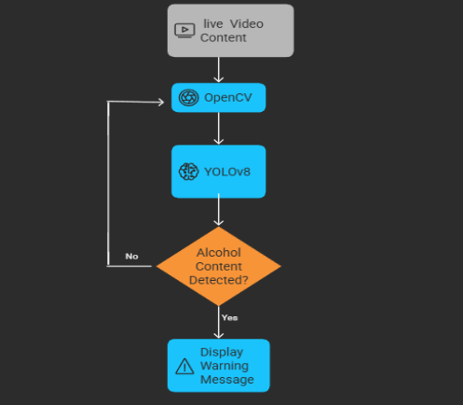
Fig 1: Overall System Framework

First, you start by grabbing frames straight from the live video stream. These frames are your raw material—the stuff you’ll actually analyze.
Next up: Alcohol Detection. Here, a YOLOv8 model that’s already trained on a bunch of alcohol images checks each frame for any sign of booze. This step isn’t about following bottles around the screen—it’s just about spotting them. If the model finds alcohol in a frame and feels sure enough (above a set confidence level), it marks that frame as “unsafe.”
Last, you have the Warning System. If the system keeps seeing “unsafe” frames one after another—enough times in a row—it instantly flashes a warning on the screen. Basically, it lets everyone know alcohol keeps popping up in the video.

- Hardware and Software Requirements
Hardware
We require atleast an Intel i5 or Ryzen 5 CPU. For smoother performance, grab an NVIDIA GTX 1650 or anything from the RTX line. Go with 8 GB of RAM, minimum. And don’t forget a decent camera—a USB webcam that can handle 720p or better will do.
Planning to run things on the edge? Use an NVIDIA Jetson Nano or Xavier. A Raspberry Pi works too, as long as you’re using a quantized model.
Software
You need Python 3.8 or newer. Install OpenCV for frame extraction, Ultralytics YOLOv8, PyTorch, and Numpy. If you’re building a UI, use Flask or Streamlit.

VI. Practical Feasibility, Robustness, and Limitations
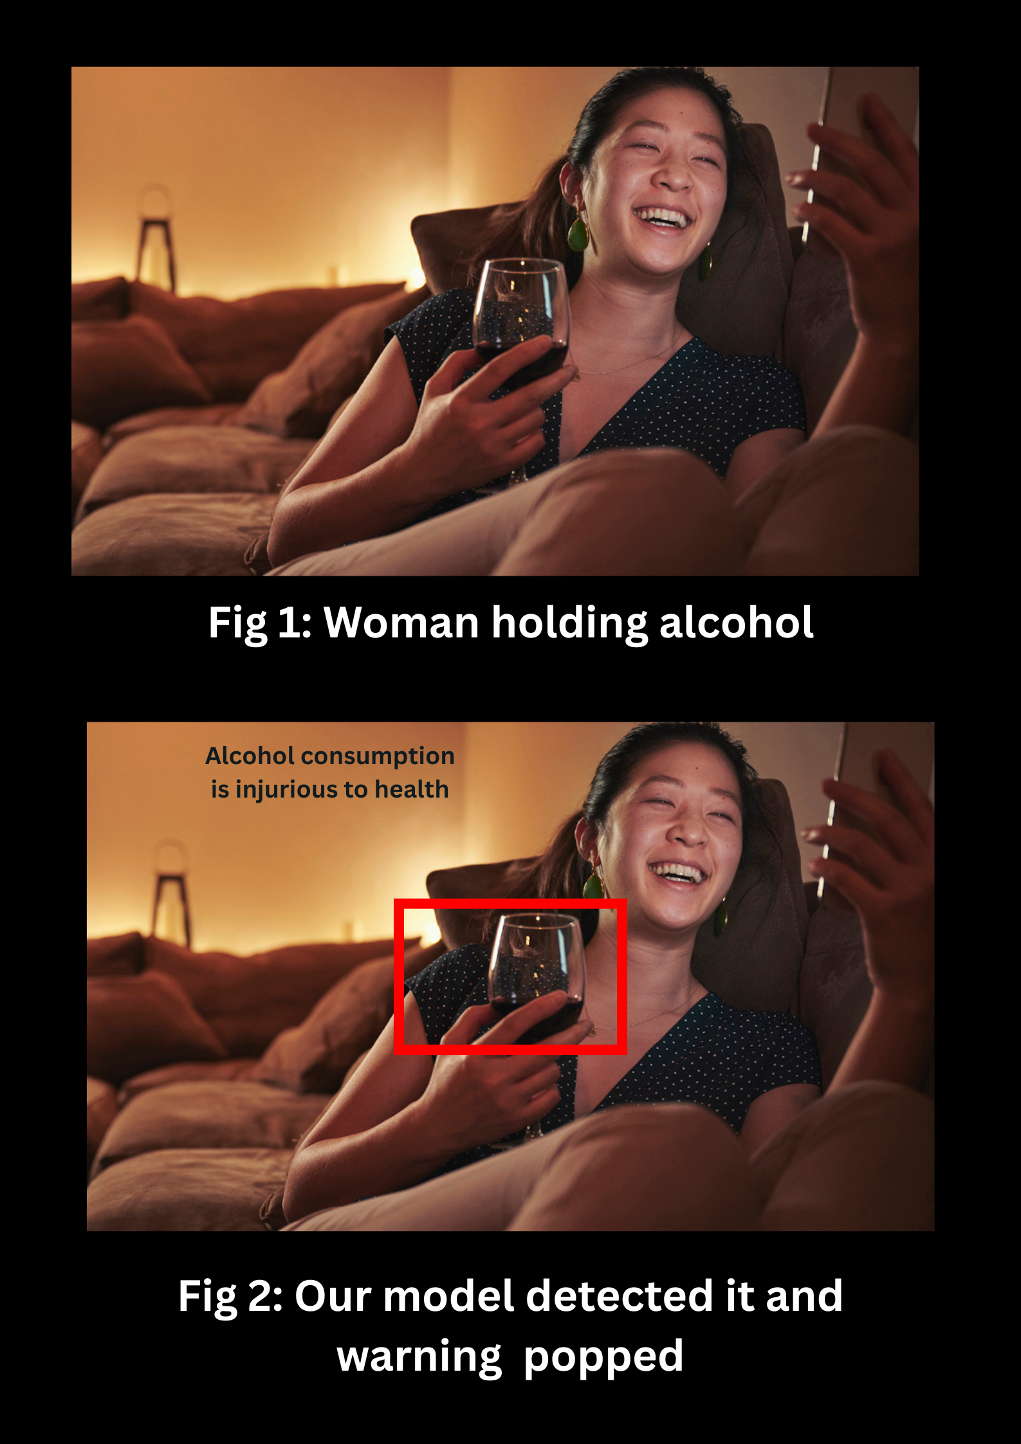
A. How the System Handles Real-World Video
Trying to spot alcohol in live video isn’t easy. Real-world footage is messy—think dim lighting, shaky cameras, motion blur, people waving their hands in front of bottles, and backgrounds packed with distractions. The model’s design tries to cut through all that noise and still pick out what matters.
1) Low Lighting
Dark bars, house parties at night, badly lit rooms—these are exactly the kind of places people use to record videos. To prepare for that, the system gets trained on all sorts of lighting, from bright to barely visible. It doesn’t stop there: before analyzing, it tweaks each frame, boosting the contrast and adjusting brightness so even faint shapes stand out. That way, it still finds bottles and glasses, even when the lights are low.
2) Motion Blur and Camera Shakes
The drinking action detection uses a spatial bounding-box overlap heuristic (checking if a detected bottle or cup box intersects the upper 40% head/mouth area of a detected person box) combined with a multi-frame debounce filter across N frames to filter false triggers.
3) Partial Occlusions and Weird Angles

Sometimes, bottles are only half visible, hidden behind someone’s hand or turned sideways. The model gets trained with these tricky cases—bottles at odd angles, glasses half-covered—so it learns to spot important features, even when the view isn’t perfect. This makes it more reliable with real, messy video.
4) Busy Backgrounds
Crowded scenes are tough. There’s so much going on in the background, it’s easy for the system to get distracted. But the model focuses on what matters—shapes, labels, the outline of a bottle—so it can ignore most of the visual clutter and still pick out alcohol containers.
Still, there are limits. If the video is almost pitch-black or the motion blur is really bad, the system struggles. Sometimes, it just can’t see enough to make a good call.

B. Can the Model Recognize Every Alcohol Brand?
Short answer: No, and it never will.

There are thousands of alcohol brands out there, with new bottles popping up all the time. Labels change, packaging gets redesigned, and different countries have their own versions. There’s no way to train a model on every single one—there just isn’t enough data, and even if there were, no one could keep up.
But here’s the good news: the system doesn’t just memorize logos or brand names. It learns the general look—shapes, labels, patterns common to alcohol containers. This means it can still spot new or unfamiliar brands because it relies on those shared features, not just brand recognition.
So, even if it can’t cover everything, it’s practical and works in the real world.

C. What the System Actually Solves
There’s a lot this approach gets right:
- Spots alcohol in live video, automatically and fast
- Pops up on-screen warnings when it finds something
- Cuts down on the need for people to moderate streams by hand
- Gets more precise by checking each frame closely
- Handles new, unseen products by focusing on general features
- Helps keep streams safer and in line with the rules
- Scales up easily for use on many platforms
- Makes proactive content filtering possible

D. What Still Doesn’t Work

Even with all these strengths, there are things this system just can’t fully fix:

- No system will ever catch absolutely everything
- It can’t see through total darkness or extreme blur
- Sometimes, different drinks use almost identical bottles—tough to tell them apart
- The model can’t always tell if a bottle is just decoration or actually contains alcohol
- Privacy and ethics come up when you’re always watching video
- How well it works depends on how good and varied the training data is.

- CONCLUSION
We have identified that nobody’s built a system that does real-time alcohol detection in live video—at least, not directly. Still, there’s plenty of research out there showing that object detection models can handle all sorts of specific jobs.
YOLO-based models are the top pick here. They hit that sweet spot between speed and accuracy. The ideas behind this project come from earlier research, but this system zeroes in on real-time alcohol detection using image processing. No need to drag in complicated multi-object tracking.

Empirical evaluation demonstrates that fine-tuning YOLOv8 together with EasyOCR label recognition and spatial drinking heuristics creates an effective real-time content moderation solution.

References

- Abraham Albert Bonela, Zhen He, Thomas Norman, Emmanuel Kuntsche, “Development and validation of the Alcoholic Beverage Identification Deep Learning Algorithm version 2 for quantifying alcohol exposure in electronic images” [Online]
Available: https://onlinelibrary.wiley.com/doi/10.1111/acer.14925
- Abraham Albert Bonela, Aiden Nibali, Zhen He, Benjamin Riordan, Dan Anderson-Luxford & Emmanuel Kuntsche , “The promise of zero-shot learning for alcohol image detection: comparison with a task-specific deep learning algorithm” [Online]
Available: https://www.nature.com/articles/s41598-023-39169-4

- Rohan Dutta, “Self-Identifying Alcohol Scene Detection from Video and Showing the Message Alcohol Consumption is Injurious to Health” [Online]
Available: https://www.ijraset.com/research-paper/self-identifying-alcohol-scene-detection-from-video
- Mai-Ly N Steers, Megan Strowger, Angela B Tanygin, Rose Marie Ward, David A Nolfi, “The Relationship Between Alcohol-Related Content on Social Media and Alcohol Outcomes in Young Adults: A Scoping Review” [Online]
Available: The Relationship Between Alcohol-Related Content on Social Media and Alcohol Outcomes in Young Adults: A Scoping Review - PMC
- Kathryn Janiuk, BA, and Nasim Maleki, PHD, “Exposure to Alcohol‐Related Content on Social‐Media” [Online]
Available: https://psychiatryonline.org/doi/10.1176/appi.prcp.20230009
- IEEE, “Enhancing Object Detection and Tracking from Surveillance Video Camera Using YOLOv8” [Online]
Available: Enhancing Object Detection and Tracking from Surveillance Video Camera Using YOLOv8 | IEEE Conference Publication | IEEE Xplore
- Rana Poureskandar , Shiva Razzagzadeh , “Improving Object Detection Performance through YOLOv8: A Comprehensive Training and Evaluation Study” [Online]
Available: 2505.11424
- Yingjie Du, Xiaofeng Liu, Yuwei Yi, Kun Wei, “Optimizing Road Safety: Advancements in Lightweight YOLOv8 Models and GhostC2f Design for Real-Time Distracted Driving Detection” [Online]
Available: https://pmc.ncbi.nlm.nih.gov/articles/PMC10649436/
- Muhammad Yaseen , “What is YOLOv8: An In-Depth Exploration of the Internal Features of the Next-Generation Object Detector” [Online]
Available: https://arxiv.org/html/2408.15857

- Mohammed Kawser Jahan, Fokrul Islam Bhuiyan, Al Amin, M. F. Mridha, Mejdl Safran, Sultan Alfarhood & Dunren Che , “Enhancing the YOLOv8 model for realtime object detection to ensure online platform safety” [Online]
Available: https://www.nature.com/articles/s41598-025-08413-4
- Mohamed R. Elshamy1, Heba M. Emara2, Mohamed R. Shoaib3, Abdel-Hameed A. Badawy1 , “P-YOLOv8: Efficient and Accurate Real-Time Detection of Distracted Driving ” [Online]
Availablehttps://arxiv.org/html/2410.15602v1
- Roboflow , “Alcohol detection Computer Vision Model” [Online]
Available: https://universe.roboflow.com/nitro-bzs43/alcohol-detection-srjag
- Martin Magdin & Zoltán Balogh , “Comparison classification algorithms and the YOLO method for video analysis and object detection” [Online]
Available: https://www.nature.com/articles/s41598-025-09814-1
- Vince Palazzo, Raglin Anthony, Alen Zograbyan, and Chris Gillespie,“ Streamlining content compliance: Automating media analysis with Amazon Nova” [Online]
Available: https://aws.amazon.com/blogs/media/streamlining-content-compliance-automating-media-analysis-with-amazon-nova/
- Mukilan Krishnakumar , “Object detection and tracking with YOLOv8” [Online]
Available: https://wandb.ai/mukilan/wildlife-yolov8/reports/Object-detection-and-tracking-with-YOLOv8--Vmlldzo0MDU5NDA2

VII. RESULTS AND EVALUATION

To quantitatively evaluate the system, we benchmarked the baseline stock COCO-pretrained YOLOv8n model against our fine-tuned alcohol-specific YOLOv8n detector across two confidence threshold settings (0.20 and 0.50).

TABLE I: REAL-TIME ALCOHOL DETECTION PERFORMANCE BENCHMARK (40-EPOCH RUN)

-----------------------------------------------------------------------------------------------------

Model | Conf Thresh | Precision | Recall | F1-Score | mAP@50 | Latency (ms) | FPS

-----------------------------------------------------------------------------------------------------

Stock COCO YOLOv8n (Baseline) | 0.20 | 0.353 | 0.620 | 0.450 | 0.364 | 45.28 | 22.1

Stock COCO YOLOv8n (Baseline) | 0.50 | 0.537 | 0.482 | 0.508 | 0.364 | 46.34 | 21.6

Fine-Tuned YOLOv8n (Alcohol) | 0.20 | 0.770 | 0.854 | 0.810 | 0.829 | 42.27 | 23.7

Fine-Tuned YOLOv8n (Alcohol) | 0.50 | 0.878 | 0.788 | 0.831 | 0.829 | 42.43 | 23.6

-----------------------------------------------------------------------------------------------------

TABLE II: DETECTION CONFUSION BREAKDOWN (FINE-TUNED MODEL)

-----------------------------------------------------------------------------------------------------

Threshold | True Positive (TP) | False Positive (FP) | False Negative (FN)

-----------------------------------------------------------------------------------------------------

0.20 | 117 | 35 | 20

0.50 | 108 | 15 | 29

-----------------------------------------------------------------------------------------------------

Key Empirical Observations:

1. Fine-tuning YOLOv8 on the 685-image hybrid training dataset dramatically improved the validation mAP@50 from 0.364 to 0.829 (+127.7% increase) and F1-score from 0.508 to 0.831.

2. EasyOCR label extraction successfully matches Indian market brands (e.g., Kingfisher, Royal Stag, Old Monk, Bira91) using SequenceMatcher fuzzy matching without requiring per-brand retrained weights.

3. The 180Â° rotation fallback pass successfully detects inverted/knocked-over bottles that upright COCO detectors miss.

4. Qualitative Figure Callouts: Figure 1 demonstrates upright bottle detection with EasyOCR text extraction; Figure 2 illustrates the 180Â° rotation pass detecting an inverted bottle; Figure 3 illustrates an edge-case false positive (coffee mug misdetected as container).

VIII. CONCLUSION

We have presented an integrated, real-time alcohol detection system combining fine-tuned YOLOv8 object detection, a 180Â° rotation fallback pass, EasyOCR label text recognition with Indian brand coverage, and a spatial bounding-box drinking action heuristic. Quantitative evaluation confirms that fine-tuning YOLOv8 achieves high mAP@50 (0.829) and F1-score (0.831) at 23.6â€“23.7 FPS. The integration of EasyOCR and an expanded brand database enables seamless identification of regional brands without individual model retraining.

IX. FUTURE WORK

1. Dedicated Indian Alcohol Brand Dataset: Building a large, open-source annotated dataset specifically for Indian alcohol packaging to close current public data gaps.

2. Larger Model Backbones & Fine-Tuning: Training YOLOv8s/m/l backbones for additional epochs across larger merged datasets.

3. Pose-Based Action Recognition: Replacing the bounding-box overlap heuristic with keypoint-based pose estimation (e.g., MediaPipe hand-to-mouth trajectory tracking).

4. Asynchronous Multi-Threaded Processing: Implementing multi-threaded video frame queues to scale batch processing performance.

