# Booth Deletions vs Alliance Outcomes — Extended Summary

Date: 08-Sep-2025

## Win shares by deletion bin

|  |  |  |  |  |  |  |  |
| --- | --- | --- | --- | --- | --- | --- | --- |
| SNO | Deletions in  booth | Deleted_ Voters | Booths | Booths_IN _FORM20 | INDIA_won _Booths | NDA_won _Booths | OT__won _Booths |
| 1 | 1 to 49 | 7,24,078 | 23,780 | 23,613 | 9,481 | 11,331 | 2,801 |
| 2 | 50 to 99 | 21,68,473 | 29,872 | 29,652 | 11,599 | 14,613 | 3,440 |
| 3 | 100 to 149 | 18,19,721 | 15,055 | 14,955 | 5,687 | 7,625 | 1,643 |
| 4 | 150 to 199 | 9,72,314 | 5,712 | 5,676 | 2,036 | 3,063 | 577 |
| 5 | 200 to 249 | 4,61,266 | 2,093 | 2,083 | 728 | 1,154 | 201 |
| 6 | 250 to 299 | 2,03,652 | 752 | 744 | 252 | 427 | 65 |
| 7 | 300 to 349 | 98,488 | 307 | 305 | 95 | 180 | 30 |
| 8 | 350 to 399 | 46,040 | 124 | 123 | 37 | 68 | 18 |
| 9 | 400 to 449 | 33,143 | 79 | 79 | 15 | 54 | 10 |
| 10 | 450 to 499 | 16,010 | 34 | 33 | 12 | 17 | 4 |
| 11 | 500 to 549 | 6,715 | 13 | 13 | 4 | 7 | 2 |
| 12 | 550 to 599 | 3,997 | 7 | 7 | 0 | 7 | 0 |
| 13 | 600 to 649 | 4,360 | 7 | 7 | 2 | 5 | 0 |
| 14 | 650 to 699 | 1,369 | 2 | 2 | 0 | 1 | 1 |
|  |  | 65,59,626 | 77,837 | 77,292 | 29,948 | 38,552 | 8,792 |

## Executive Summary

Across 77,292 booths with alliance coding, overall win shares are:

* INDIA 38.7%,
* NDA 49.9%,
* OT 11.4%.
* There is a consistent gradient across deletion bins: as deletions-per-booth increase, INDIA’s win share decreases while NDA’s increases.
* This gradient is visible both at fine-grained bin level (SNO 1–14) and in aggregated buckets (Low 1–99, Mid 100–249, High ≥250).
* Statistical signal: correlation of bin midpoint with INDIA win share = -0.74 (negative), with NDA win share = 0.48 (positive).
* Operationally, low-deletion booths appear more competitive; mid/high-deletion booths show a widening NDA edge. This can inform prioritization, verification, and outreach strategies.

**Detailed Findings by Bin**

The table at the top lists each deletion bin (SNO), coded booth counts, and alliance win shares. Two patterns are notable:

(1) INDIA’s share declines monotonically from low to high deletion bins;

(2) NDA’s share increases correspondingly. Extreme bins (≥300 deletions/booth) have fewer booths and should be interpreted with caution.

## Visuals

Win share by deletion bin (SNO):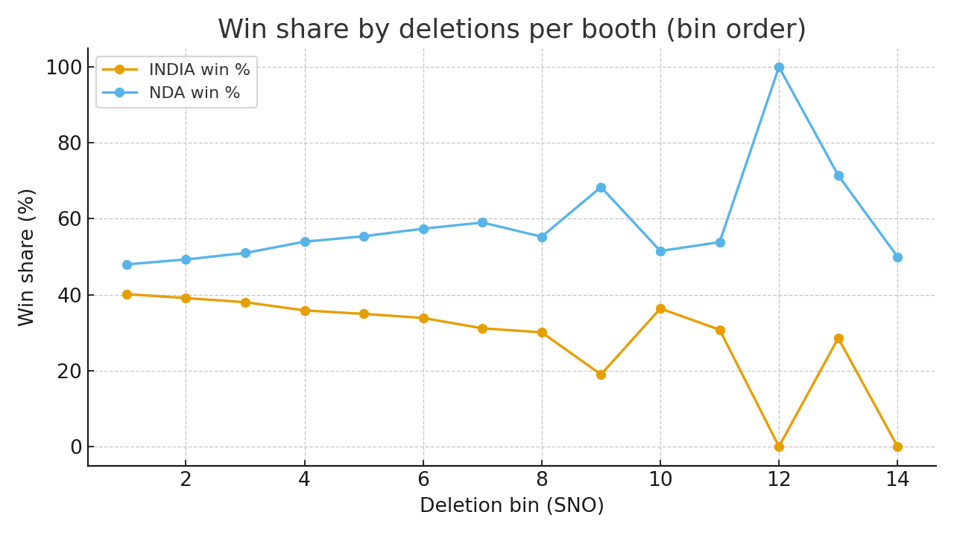

Booths counted by deletion bin:

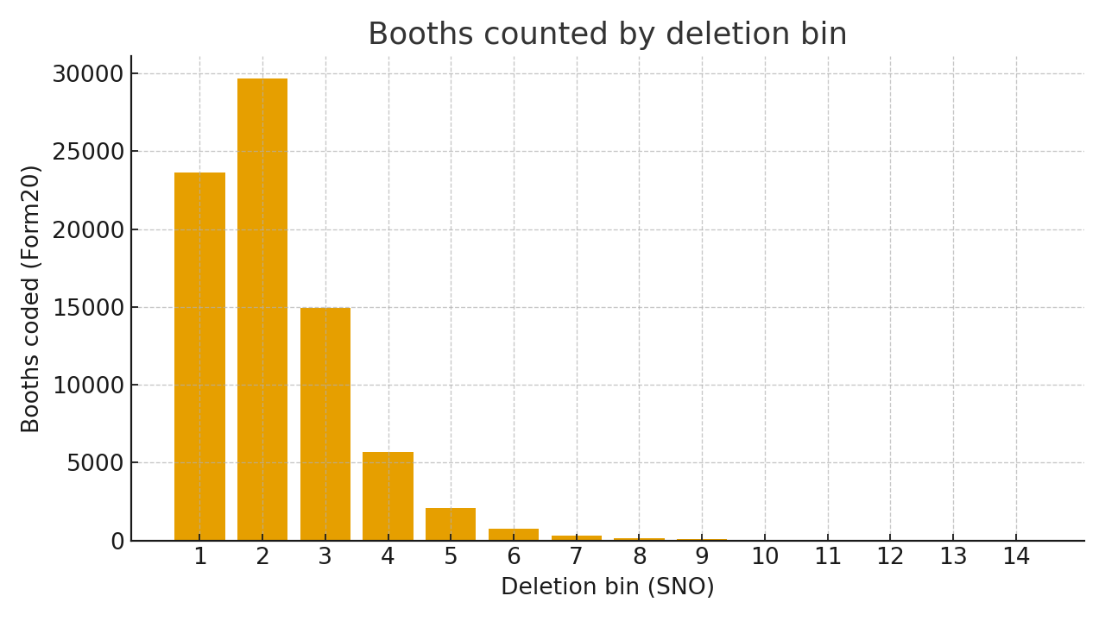

## Aggregated Buckets (Low / Mid / High)

|  |  |  |  |  |
| --- | --- | --- | --- | --- |
| Bucket | Booths (Form20) | INDIA win % | NDA win % | OT % |
| Low (1–99) | 53,265 | 39.6% | 48.7% | 11.7% |
| Mid (100–249) | 22,714 | 37.2% | 52.1% | 10.7% |
| High (≥250) | 1,313 | 31.8% | 58.3% | 9.9% |

Methodology & Quality Checks

* Unit of analysis: booth-level bins of deletions per booth (SNO 1–14), with winners mapped to alliances using Form20.
* Shares computed as alliance-winning booths divided by total Form20-coded booths within each bin; totals exclude uncoded booths.
* Correlation computed between bin midpoints and alliance win shares to summarize trend strength.
* Sanity checks: totals reconcile with sheet summary; bins ordered by SNO; negligible missingness within coded set.

## Implications for Field & Messaging

* Prioritize audit and voter assistance in Mid/High deletion bins where NDA edge widens; investigate causes (migration, deletions quality, documentation).
* In Low bins, treat as competitive turf: emphasize booth-level GOTV and micro-messaging; leverage INDIA’s relatively stronger baseline.
* Create a monitoring dashboard by AC/PC overlaying deletion bins with INDIA/NDA performance to target resources efficiently.

## Caveats

* High-deletion bins represent a small slice of total booths; results at extremes may be noisy.
* Booth ‘win’ is categorical; it does not encode margin or total turnout effects.
* No geographic controls are applied here; localized dynamics may differ across districts.