# Muslim Deletions % vs NDA Wins — Summary (Lok Sabha)

Date: 09-Sep-2025 • Source: DELETIONS-WINNER-LS-VS-AC-SUMMARY.xlsx

## Executive Summary

* Overall deletion composition across ACs: H ~74.4%, M ~15.2%, UK ~8.9%.
* Correlation — Muslim deletion % vs NDA win (binary): r = -0.07.
* Correlation — Muslim deletion % vs NDA vote share: r = -0.11.
* Across deciles/tertiles of Muslim deletion %, NDA win rates vary; charts below visualise the pattern.
* These are associations; they do not prove causation. Geography and historical voting patterns likely confound.

## Charts

Muslim deletion % vs NDA vote share (scatter):

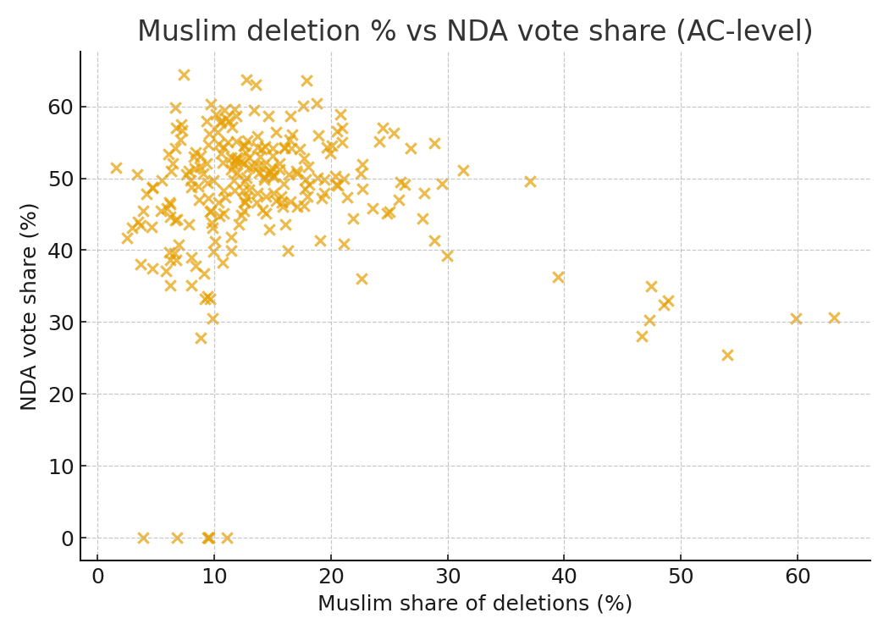

NDA win rate by decile of Muslim deletion %:

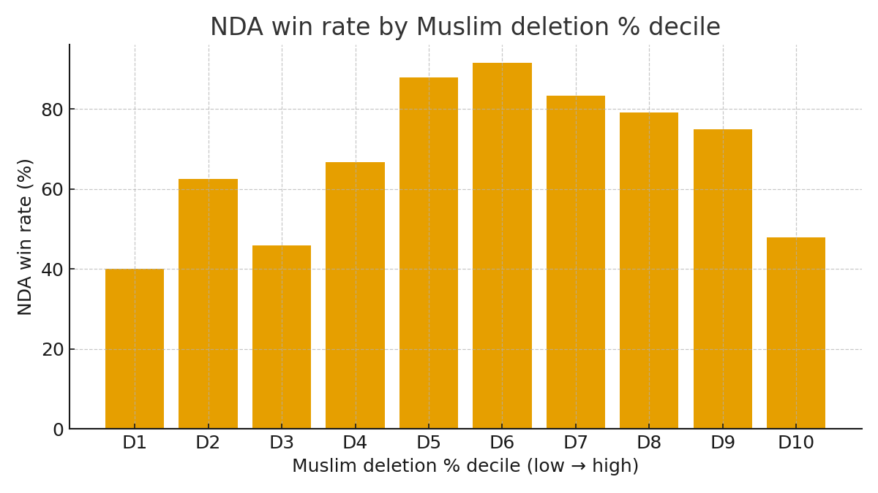

NDA win rate by tertile (Low/Mid/High) of Muslim deletion %:

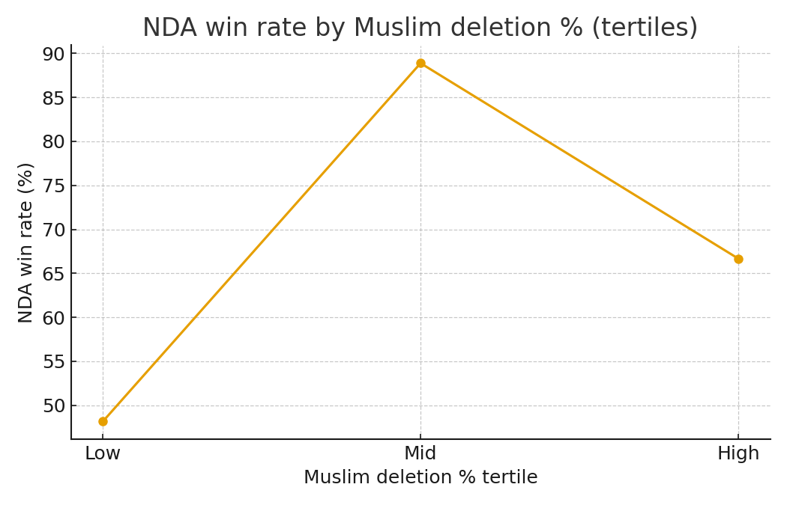

Overall deletion composition (H/M/UK):

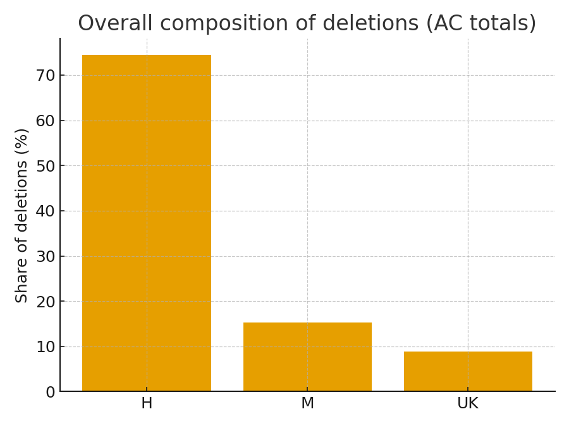

## Notes & Caveats

AC-level aggregates; no controls for district effects, urban/rural mix, turnout, or baseline party strength.