Date: 09-Sep-2025

## Executive Summary



* Overall booth outcomes (Form20-coded):
* INDIA 38.7%,
* NDA 49.9%,
* OT 11.4%
* (n=77,292).
* Overall deletion composition:
* Hindus 74.4%,
* Muslims 15.2%,
* Unknown 8.9%.
* Muslim share of deletions vs NDA win share (bin-level): r≈-0.52.
* **Trend by deletions-per-booth:** as we move from **Low (1–99)** → **Mid (100–249)** → **High (≥250)** bins:
* **Muslim share of deletions** rises modestly.
* **Hindu share of deletions** declines slightly.
* **Unknown** share tapers.
* **Per-booth levels:** Hindu and Muslim **deletions per booth** both increase with the higher deletion bins (by definition of the bins), but the **composition** shift (Muslim share up, Hindu share down) is the key pattern.

## Key Charts

Win share by deletion bin:

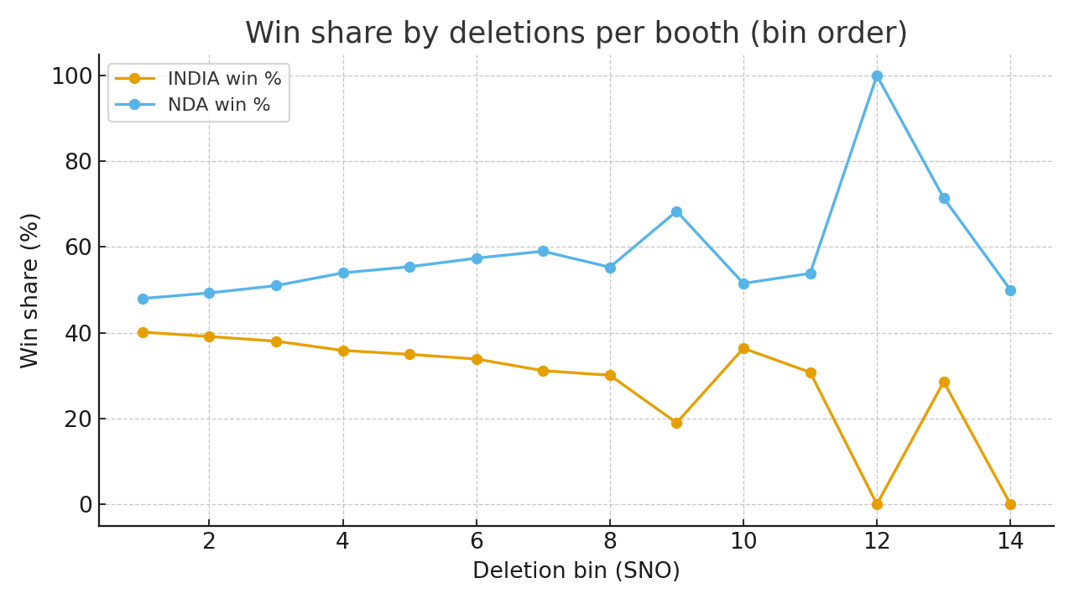

Religion composition of deletions by bin:

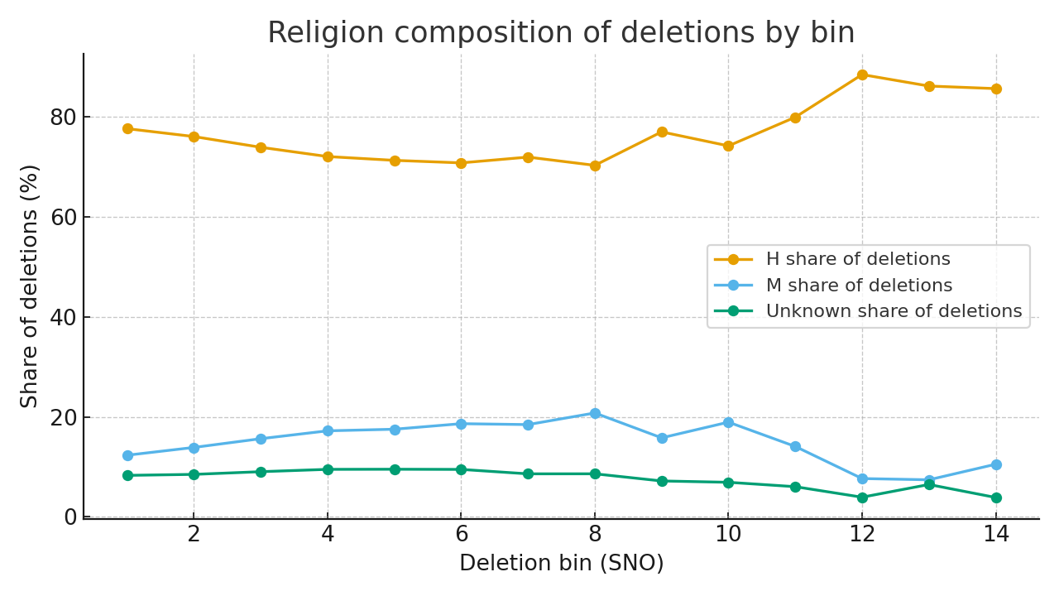

Muslim-deletion share vs NDA win share (scatter):

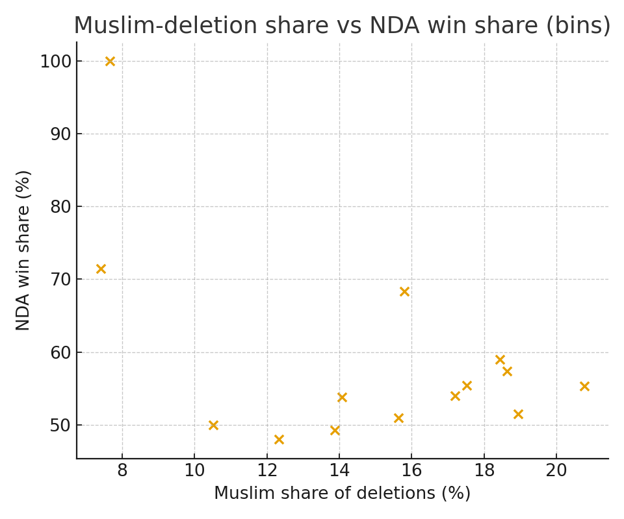

Booths counted by deletion bin (Form20):

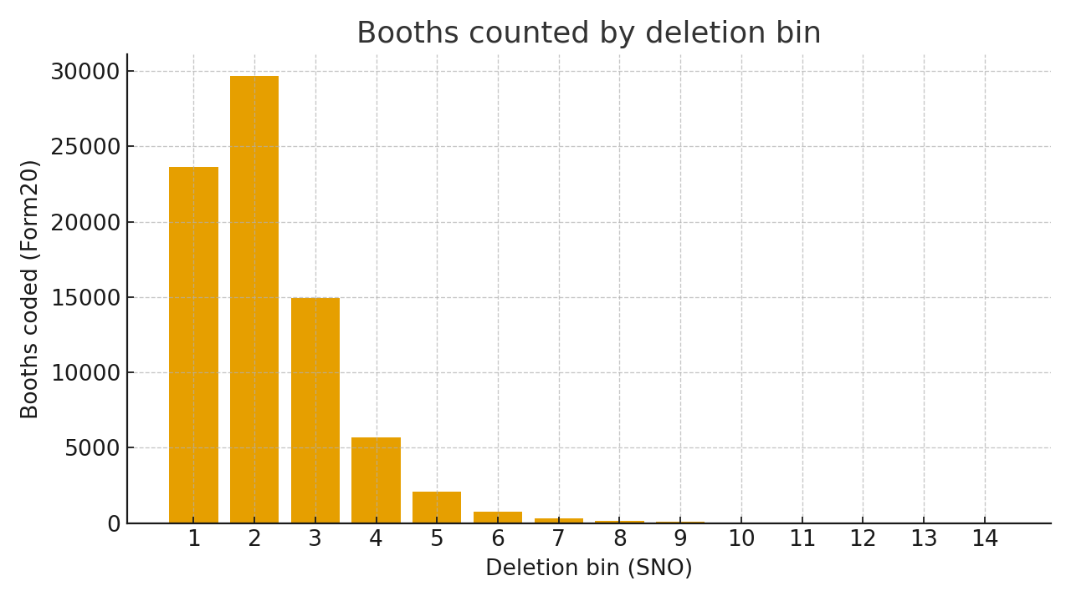

## Bucket Summary (Low/Mid/High)

|  |  |  |  |  |  |  |  |
| --- | --- | --- | --- | --- | --- | --- | --- |
| Bucket | Booths (Form20) | INDIA win % | NDA win % | Del/Booth | H % of del | M % of del | UK % of del |
| Low (1–99) | 53,265 | 39.6% | 48.7% | 53.9 | 76.4% | 13.5% | 8.4% |
| Mid (100–249) | 22,714 | 37.2% | 52.1% | 142.3 | 73.0% | 16.4% | 9.2% |
| High (≥250) | 1,313 | 31.8% | 58.3% | 312.3 | 72.1% | 18.3% | 8.7% |

Notes: Extreme deletion bins comprise few booths; interpret with caution. Religion figures reflect deletion composition, not population shares.