SPECIAL INTENSIVE REVISION 2025
Bihar: 69 lakh names struck off
Removals from the electoral roll, booth by booth, set against the margins and the votes that decided each seat

69,10,559 names removed across both phases
13.9% of the votes polled in the November 2025 election
174 of 243 seats where more names were removed than the seat was won by
55.5% of the removed are women

Varna Sri Raman · 29 September 2026

Contents
Right-click and choose Update Field to show the contents.

Part I: Bihar as a whole

At a glance
69,10,559  names removed, both phases | 13.9%  of all votes polled in 2025 | 174 of 243  seats: removals exceed the margin | 55.5%  of the removed are women

The Special Intensive Revision removed 69,10,559 names from Bihar's electoral roll in 2025: 65,59,409 before the draft roll of 1 August and 3,51,150 more before the final roll. That is 9.25 names for every 100 electors on the final roll, across 77,837 polling booths in 243 constituencies. In the Assembly election that followed in November, 4,96,35,462 votes were polled. The names removed equal 13.9% of them, one for every 7.2 votes cast.
Set against the results, the removals are larger than the margin of victory in 174 of 243 constituencies. They exceed the combined winning margin of all 243 seats, 51.4 lakh, by a factor of 1.34, and they exceed the combined winning margin of the NDA across the 202 seats it won, 46.7 lakh. In 66 of the 87 seats the NDA took from INDIA, more names were removed than the NDA won by.
Women are 55.5% of those removed, against 47.86% of Bihar's population in the 2011 census, and their share of the removed is higher than their share of the population in 38 of 38 districts. Sex is recorded on the roll, so this figure rests on no estimate.

Deletions and coverage
The booth lists account for every one of Bihar's 77,837 polling booths. The table gives each district's removals, removals per 100 electors on the 2025 roll, and its share of the state total.
District | Seats | Names removed | Per 100 electors | Per booth | Share of state
Gopalganj | 6 | 3,14,853 | 17.31 | 154.2 | 4.6%
Purnia | 7 | 2,99,452 | 14.30 | 123.8 | 4.3%
Kishanganj | 4 | 1,56,727 | 13.90 | 123.5 | 2.3%
Madhubani | 10 | 3,61,114 | 11.55 | 104.8 | 5.2%
Bhagalpur | 7 | 2,53,818 | 11.35 | 108.0 | 3.7%
Saharsa | 4 | 1,39,670 | 10.76 | 94.7 | 2.0%
Sitamarhi | 8 | 2,52,512 | 10.25 | 95.9 | 3.7%
Samastipur | 10 | 2,93,199 | 9.96 | 92.0 | 4.2%
Katihar | 7 | 2,06,621 | 9.93 | 85.8 | 3.0%
Saran | 10 | 2,88,515 | 9.88 | 89.9 | 4.2%
Sheohar | 1 | 28,685 | 9.41 | 88.8 | 0.4%
East Champaran | 12 | 3,23,982 | 9.40 | 90.1 | 4.7%
Bhojpur | 7 | 1,97,931 | 9.35 | 84.8 | 2.9%
Siwan | 8 | 2,28,135 | 9.28 | 87.3 | 3.3%
Vaishali | 8 | 2,35,676 | 9.27 | 87.1 | 3.4%
Supaul | 5 | 1,37,607 | 8.93 | 80.4 | 2.0%
Begusarai | 7 | 1,90,817 | 8.91 | 80.1 | 2.8%
Aurangabad | 6 | 1,63,211 | 8.89 | 79.6 | 2.4%
Muzaffarpur | 11 | 2,94,340 | 8.89 | 81.2 | 4.3%
Araria | 6 | 1,75,087 | 8.84 | 77.9 | 2.5%
Patna | 14 | 4,15,580 | 8.58 | 80.7 | 6.0%
Gaya | 10 | 2,53,055 | 8.44 | 75.3 | 3.7%
Banka | 5 | 1,21,034 | 8.31 | 75.0 | 1.8%
West Champaran | 9 | 2,17,300 | 8.26 | 70.2 | 3.1%
Munger | 3 | 82,185 | 8.19 | 72.4 | 1.2%
Jamui | 4 | 1,00,975 | 7.92 | 69.0 | 1.5%
Madhepura | 4 | 1,04,304 | 7.65 | 72.5 | 1.5%
Nawada | 5 | 1,30,263 | 7.55 | 70.3 | 1.9%
Khagaria | 4 | 85,658 | 7.32 | 66.6 | 1.2%
Darbhanga | 10 | 2,10,711 | 7.26 | 69.0 | 3.0%
Buxar | 4 | 93,120 | 7.19 | 65.9 | 1.3%
Jehanabad | 3 | 57,619 | 7.09 | 59.1 | 0.8%
Rohtas | 7 | 1,57,939 | 7.06 | 66.1 | 2.3%
Lakhisarai | 2 | 51,608 | 6.88 | 64.7 | 0.7%
Kaimur | 4 | 78,779 | 6.71 | 58.7 | 1.1%
Nalanda | 7 | 1,48,457 | 6.60 | 57.9 | 2.1%
Arwal | 2 | 32,872 | 6.23 | 53.6 | 0.5%
Sheikhpura | 2 | 27,148 | 5.47 | 49.2 | 0.4%

Removals range from 5.5 per 100 electors in Sheikhpura to 17.3 in Gopalganj. Among constituencies the range is wider, from 4.4 in Darbhanga to 23.6 in Purnia.

Deletions against the margins and the votes polled
Each constituency's removals are set against two yardsticks from the November 2025 election: the margin by which the seat was won, and the votes polled. The comparison is not a claim that these electors would have voted, or how. It measures the size of the revision beside the vote that decided each seat.
174 of 243  seats: removals exceed the margin | 30  seats: removals five times the margin or more | 68  seats: removals over 15% of votes polled | 27  smallest margin (Sandesh)

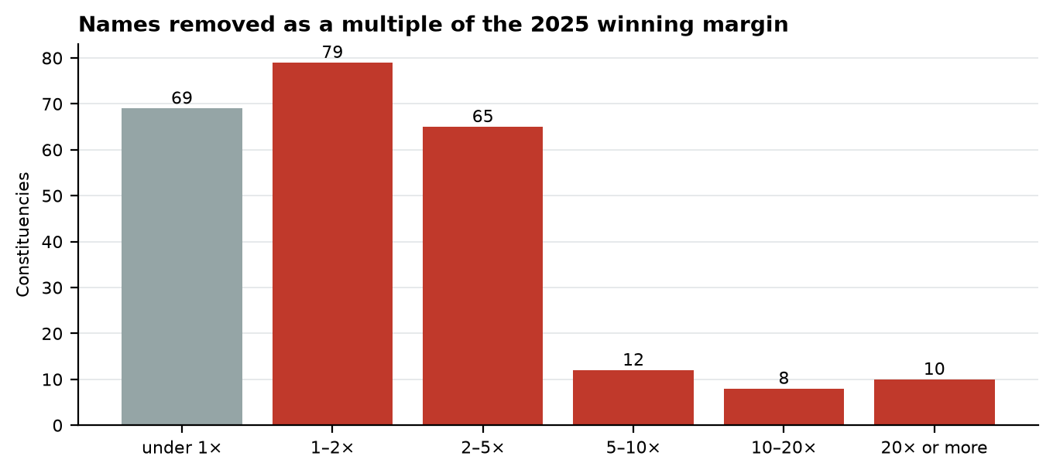
Figure 1. Constituencies by names removed ÷ 2025 winning margin. Grey: removals below the margin.
Constituency | District | Won by | Margin | Names removed | Removed − margin | × margin | % of votes polled
192 Sandesh | Bhojpur | JD(U) (NDA) | 27 | 25,665 | +25,638 | 950.6× | 14.1%
203 Ramgarh | Kaimur | BSP (Other) | 30 | 19,225 | +19,195 | 640.8× | 9.9%
195 Agiaon | Bhojpur | BJP (NDA) | 95 | 21,862 | +21,767 | 230.1× | 14.4%
221 Nabinagar | Aurangabad | JD(U) (NDA) | 112 | 24,857 | +24,745 | 221.9× | 13.2%
48 Forbesganj | Araria | INC (INDIA) | 221 | 27,262 | +27,041 | 123.4× | 10.9%
21 Dhaka | East Champaran | RJD (INDIA) | 178 | 18,163 | +17,985 | 102.0× | 7.4%
65 Balrampur | Katihar | LJP(RV) (NDA) | 389 | 30,850 | +30,461 | 79.3× | 11.2%
216 Jehanabad | Jehanabad | RJD (INDIA) | 793 | 22,793 | +22,000 | 28.7× | 12.0%
116 Taraiya | Saran | BJP (NDA) | 1,329 | 33,676 | +32,347 | 25.3× | 17.5%
7 Chanpatia | West Champaran | INC (INDIA) | 602 | 14,829 | +14,227 | 24.6× | 6.8%
229 Bodh Gaya | Gaya | RJD (INDIA) | 881 | 17,168 | +16,287 | 19.5× | 7.5%
1 Valmiki Nagar | West Champaran | INC (INDIA) | 1,675 | 31,543 | +29,868 | 18.8× | 13.8%
180 Bakhtiarpur | Patna | LJP(RV) (NDA) | 981 | 17,924 | +16,943 | 18.3× | 9.3%
12 Narkatiya | East Champaran | JD(U) (NDA) | 1,443 | 23,783 | +22,340 | 16.5× | 10.9%
231 Tikari | Gaya | RJD (INDIA) | 2,058 | 33,447 | +31,389 | 16.3× | 15.8%
75 Saharsa | Saharsa | IIP (INDIA) | 2,038 | 28,198 | +26,160 | 13.8× | 10.9%
201 Dumraon | Buxar | JD(U) (NDA) | 2,105 | 22,651 | +20,546 | 10.8× | 11.6%
77 Mahishi | Saharsa | RJD (INDIA) | 3,740 | 39,143 | +35,403 | 10.5× | 19.8%
120 Amnour | Saran | BJP (NDA) | 3,808 | 37,843 | +34,035 | 9.9× | 22.7%
232 Belaganj | Gaya | JD(U) (NDA) | 2,882 | 27,917 | +25,035 | 9.7× | 13.6%
27 Bajpatti | Sitamarhi | RLM (NDA) | 3,395 | 31,190 | +27,795 | 9.2× | 14.2%
213 Karakat | Rohtas | CPI(ML)L (INDIA) | 2,836 | 25,162 | +22,326 | 8.9× | 12.9%
218 Makhdumpur | Jehanabad | RJD (INDIA) | 1,830 | 14,829 | +12,999 | 8.1× | 9.0%
199 Brahampur | Buxar | RJD (INDIA) | 3,220 | 24,989 | +21,769 | 7.8× | 12.1%
72 Singheshwar | Madhepura | JD(U) (NDA) | 2,982 | 22,947 | +19,965 | 7.7× | 10.2%

The 25 constituencies where the removals were largest against the margin. Sandesh was won by 27 votes and lost 25,665 names.
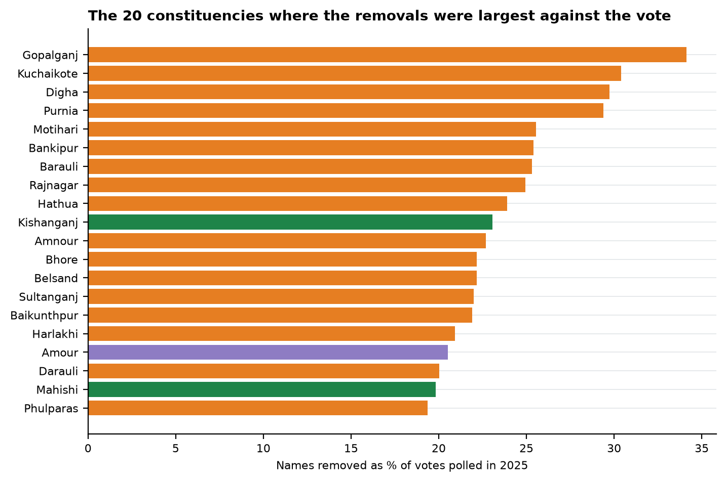
Figure 2. Colour marks the alliance that won the seat in 2025: orange NDA, green INDIA, purple neither.
Across Bihar the removals equal 13.9% of the votes polled. In 68 constituencies they equal more than 15%, in 18 more than a fifth, and in Gopalganj they reach 34.1%. In Digha the names removed exceed the runner-up's entire vote. In no constituency do they exceed the total votes polled: Bihar removed about nine names per hundred electors, where the Old City of Hyderabad removed forty.
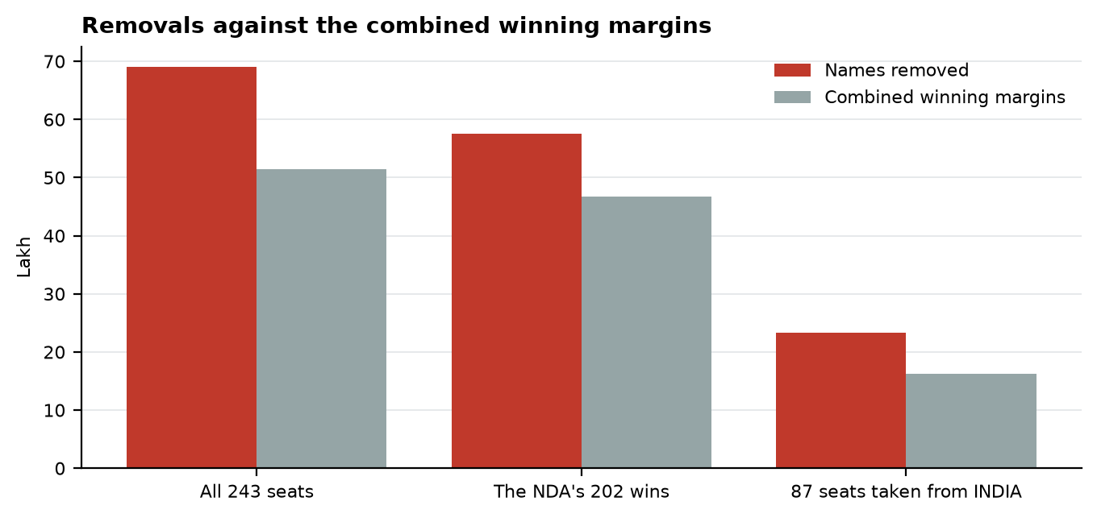
Figure 3. In lakh. The combined margin of a group of seats is the sum of each seat's margin of victory.

Women and the deletions
The roll records each elector's sex, so women's share of the removed needs no estimate. Women are 55.5% of all removals: 38,33,870 women and 30,76,689 men, 7,57,181 more women than men. Their share of the removed exceeds their share of the population in 38 of 38 districts, by up to 13.7 points in Kaimur.
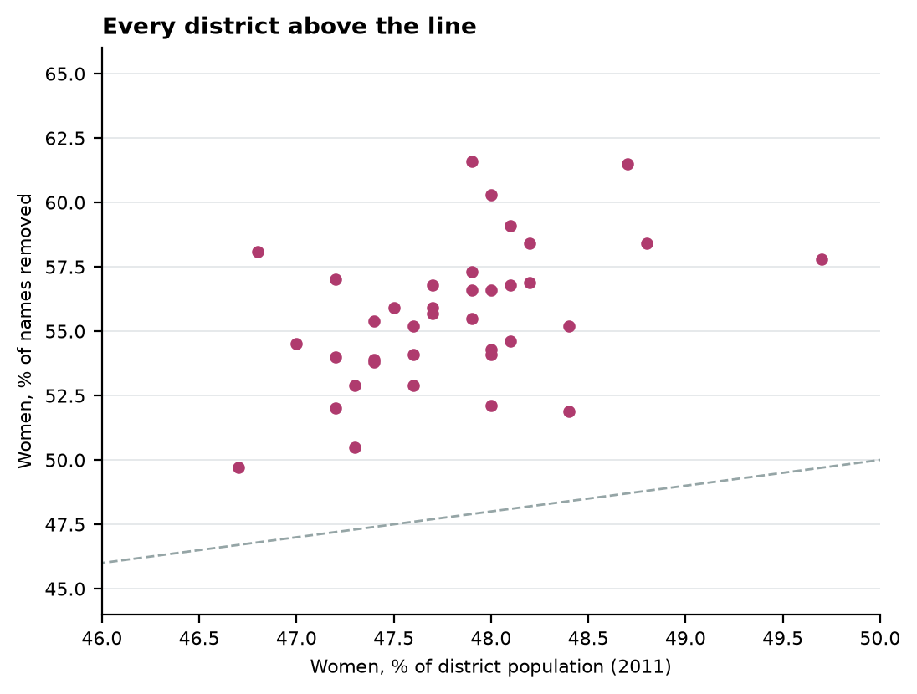
Figure 4. Each dot is a district. Above the dashed line, women's share of the removed exceeds their share of the population.
Women who move on marriage and are marked "shifted" at their parents' address are likely to be a large part of this. The lists do not show whether any of them were enrolled again where they now live. If they were not, they have lost the vote.

Religion
The roll records no religion. The booth lists classify removed names as Hindu or Muslim where the name allows it, and leave 9.0% of names unclassified. The Muslim share of removals is therefore a range: 15.4% counting only names classified Muslim, and 24.4% if every unclassified name were Muslim. Bihar's Muslim population was 16.87% in the 2011 census and 17.70% in the 2023 caste survey. The census share lies inside the range in 18 of 38 districts. In 8 districts the classified Muslim share alone runs more than a point above the census share: Aurangabad, Gaya, Jehanabad, Lakhisarai, Nalanda, Nawada, Patna and Sheikhpura.
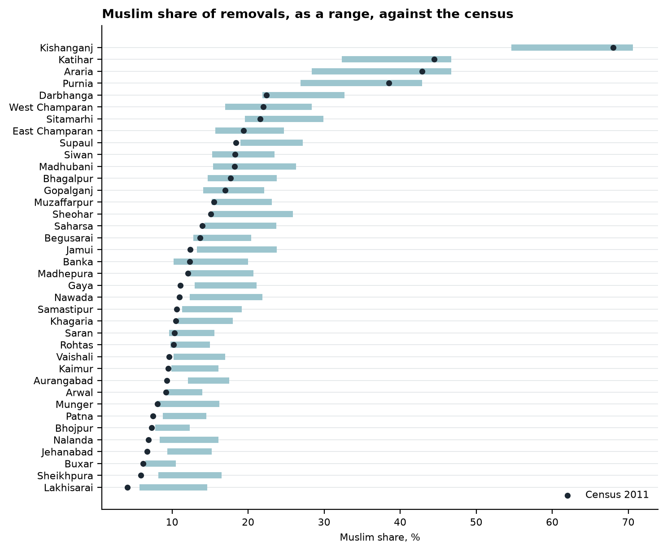
Figure 5. The bar runs from names classified Muslim to all names that could be Muslim; the dot is the 2011 census share.

Caste
Caste is not recorded either. It can be read, in part, from the surname of the father or husband listed with each removed elector, and two classifications are used because surnames cross caste lines. Classification A places 70.9% of removals in a group; the stricter classification B, which sets aside surnames carried by more than one group, places 35.2%. Only what holds under both is reported here.
Group | Survey share 2023 | Share under A | Ratio A | Share under B | Ratio B
General | 10.72% | 34.4% | 3.21 | 14.6% | 1.36
BC | 25.03% | 14.8% | 0.59 | 17.0% | 0.68
EBC | 25.72% | 17.5% | 0.68 | 8.1% | 0.31
SC | 19.65% | 19.8% | 1.01 | 30.0% | 1.52
ST | 1.68% | 1.3% | 0.75 | 1.5% | 0.91
Muslim | 17.70% | 12.2% | 0.69 | 28.9% | 1.63

A ratio above 1 means the group's share of the removed exceeds its share of the population. Under both classifications, General and SC families are removed at or above their population share and BC, EBC and ST families below it. The two disagree on Muslim families.

Booths
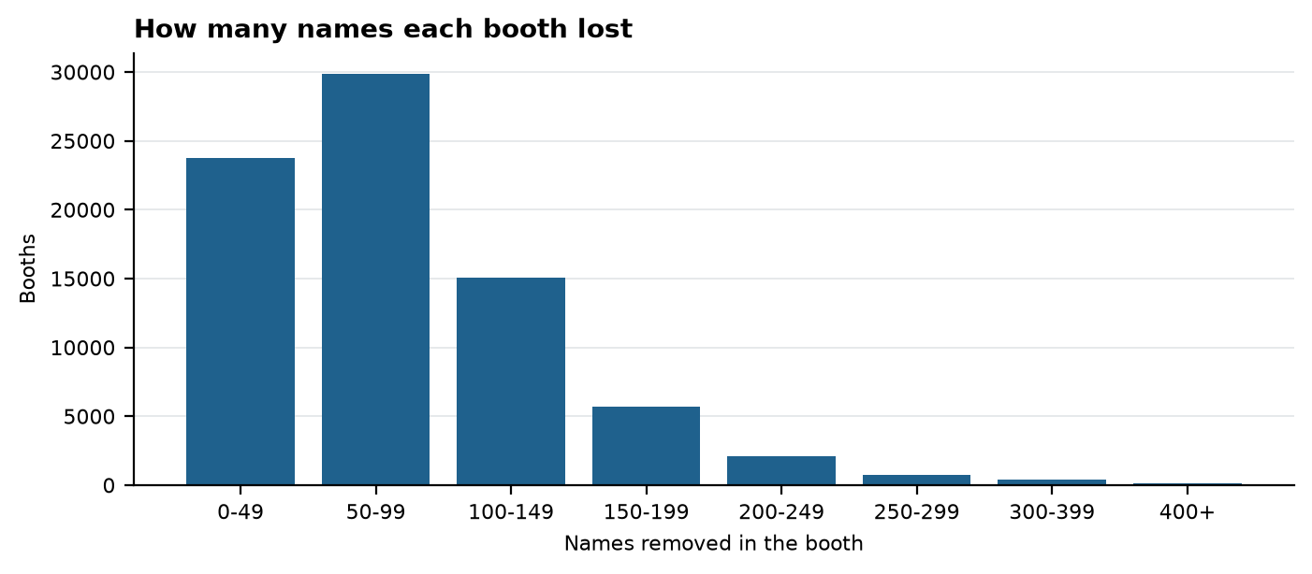
Figure 6. Booths by the number of names removed.
The median booth lost 71 names. 3,418 booths lost 200 or more each, and 142 lost 400 or more. A booth serves on average about 960 electors, so 200 removals is a fifth of a booth's roll.

Border districts
District neighbours | Seats | Names removed | Per 100 electors | Women %
West Bengal | 7 | 2,99,452 | 14.30 | 55.5%
Nepal + West Bengal | 4 | 1,56,727 | 13.90 | 61.5%
Uttar Pradesh | 35 | 11,22,554 | 10.58 | 58.3%
Nepal | 41 | 12,50,302 | 9.96 | 54.8%
Jharkhand + West Bengal | 7 | 2,06,621 | 9.93 | 56.6%
Jharkhand | 36 | 9,97,932 | 8.90 | 55.5%
Interior | 93 | 24,22,953 | 8.36 | 53.8%
Nepal + Uttar Pradesh | 9 | 2,17,300 | 8.26 | 54.1%
Jharkhand + Uttar Pradesh | 11 | 2,36,718 | 6.94 | 58.8%

A constituency counts as a border seat when its district touches Nepal, West Bengal, Jharkhand or Uttar Pradesh. Border seats lost 9.81 names per 100 electors, the interior 8.36.

The alliances
Seats the NDA held lost 9.58 names per 100 electors, and INDIA seats 8.79 (2020 winners); the order is the same under 2024 and 2025 labels. Within the same constituency, booths the NDA led in 2024 lost 2.4 more names each than booths INDIA led. A booth's leader says how most of its voters voted in 2024, not how the removed electors voted; every booth holds voters of both sides. Names were not removed at a higher rate in the seats INDIA lost in 2025 than in the seats it kept. What the lists establish is the scale of the removals against the margins, set out above.

Key insights
- 69,10,559 names removed, 9.25 per 100 electors on the final roll, across 77,837 booths.
- Equal to 13.9% of the votes polled in the November 2025 election: one name for every 7.2 votes cast.
- Larger than the margin in 174 of 243 seats, five times the margin or more in 30, ten times or more in 18.
- Larger than the NDA's combined winning margin in its 202 wins (69.1 lakh against 46.7 lakh).
- 66 of the 87 seats the NDA took from INDIA lost more names than the NDA won by.
- Women are 55.5% of the removed, over-represented in 38 of 38 districts.
- Muslim names are 15.4% to 24.4% of removals, against 16.87% of the population; above the census share by more than a point in 8 districts.
- 3,418 booths lost 200 names or more each.

What this shows and what it does not
The lists show how many names were removed, where, and who the removed were by sex and by name, and they allow the removals to be set against the margins and votes that decided each seat. They do not show why an individual name was removed, whether the removal was right, or how the elector voted. Religion and caste are read from names and are estimates, given as ranges or under two classifications. Votes polled are the turnout on the 2025 roll, within about 1% of a second calculation from each winner's vote and share.

Part II: District chapters
One chapter for each of Bihar's 38 districts, in order of removals per 100 electors. Each gives the district's totals and every constituency in it, with the 2025 result.

Gopalganj
3,14,853  names removed | 17.31  per 100 electors (#1 of 38) | 26.2%  of votes polled in 2025 | 6 of 6  seats: removals exceed margin

Gopalganj lost 3,14,853 names across 6 constituencies, 17.31 for every 100 electors. Women are 60.0% of those removed, against 50.5% of the district's population in 2011. Names classified Muslim are 14.1% to 22.1% of removals, against a census share of 17.0%. The heaviest constituency is Gopalganj, at 22.72 per 100 electors; the largest multiple of the margin is in Barauli, where 48,477 names were removed against a margin of 12,374. In 2025 the NDA won 6 of the district's seats and INDIA 0.
Constituency | Removed | Per 100 | Women % | Won by (2025) | Margin | × margin | % polled
99 Baikunthpur | 46,412 | 15.05 | 59.8% | BJP (NDA) | 16,953 | 2.7× | 21.9%
100 Barauli | 48,477 | 17.06 | 60.0% | JD(U) (NDA) | 12,374 | 3.9× | 25.3%
101 Gopalganj | 67,501 | 22.72 | 59.4% | BJP (NDA) | 28,972 | 2.3× | 34.1%
102 Kuchaikote | 60,230 | 20.07 | 59.9% | JD(U) (NDA) | 24,491 | 2.5× | 30.4%
103 Bhore | 45,792 | 13.57 | 60.2% | JD(U) (NDA) | 16,163 | 2.8× | 22.2%
104 Hathua | 46,441 | 15.95 | 60.9% | JD(U) (NDA) | 12,348 | 3.8× | 23.9%

Purnia
2,99,452  names removed | 14.30  per 100 electors (#2 of 38) | 18.8%  of votes polled in 2025 | 3 of 7  seats: removals exceed margin

Purnia lost 2,99,452 names across 7 constituencies, 14.30 for every 100 electors. Women are 55.5% of those removed, against 47.9% of the district's population in 2011. Names classified Muslim are 26.9% to 42.9% of removals, against a census share of 38.5%. The heaviest constituency is Purnia, at 23.64 per 100 electors; the largest multiple of the margin is in Kasba, where 36,240 names were removed against a margin of 12,875. In 2025 the NDA won 5 of the district's seats and INDIA 0, and 2 went to neither alliance.
Constituency | Removed | Per 100 | Women % | Won by (2025) | Margin | × margin | % polled
56 Amour | 47,373 | 15.14 | 61.1% | AIMIM (Other) | 38,928 | 1.2× | 20.5%
57 Baisi | 27,113 | 9.45 | 60.2% | AIMIM (Other) | 27,251 | 1.0× | 12.2%
58 Kasba | 36,240 | 12.59 | 55.4% | LJP(RV) (NDA) | 12,875 | 2.8× | 15.5%
59 Banmankhi | 37,097 | 12.28 | 55.6% | BJP (NDA) | 45,296 | 0.8× | 17.5%
60 Rupauli | 39,248 | 13.14 | 55.7% | JD(U) (NDA) | 73,572 | 0.5× | 17.8%
61 Dhamdaha | 43,626 | 13.85 | 54.0% | JD(U) (NDA) | 55,159 | 0.8× | 18.4%
62 Purnia | 68,755 | 23.64 | 50.6% | BJP (NDA) | 33,222 | 2.1× | 29.4%

Kishanganj
1,56,727  names removed | 13.90  per 100 electors (#3 of 38) | 17.7%  of votes polled in 2025 | 4 of 4  seats: removals exceed margin

Kishanganj lost 1,56,727 names across 4 constituencies, 13.90 for every 100 electors. Women are 61.5% of those removed, against 48.7% of the district's population in 2011. Names classified Muslim are 54.6% to 70.6% of removals, against a census share of 68.0%. The heaviest constituency is Kishanganj, at 18.57 per 100 electors; the largest multiple of the margin is in Kishanganj, where 52,574 names were removed against a margin of 12,794. In 2025 the NDA won 1 of the district's seats and INDIA 1, and 2 went to neither alliance.
Constituency | Removed | Per 100 | Women % | Won by (2025) | Margin | × margin | % polled
52 Bahadurganj | 39,475 | 13.51 | 61.2% | AIMIM (Other) | 28,726 | 1.4× | 18.2%
53 Thakurganj | 31,708 | 10.53 | 63.2% | JD(U) (NDA) | 8,822 | 3.6× | 12.9%
54 Kishanganj | 52,574 | 18.57 | 60.4% | INC (INDIA) | 12,794 | 4.1× | 23.1%
55 Kochadhaman | 32,970 | 13.15 | 62.1% | AIMIM (Other) | 23,021 | 1.4× | 17.1%

Madhubani
3,61,114  names removed | 11.55  per 100 electors (#4 of 38) | 18.2%  of votes polled in 2025 | 9 of 10  seats: removals exceed margin

Madhubani lost 3,61,114 names across 10 constituencies, 11.55 for every 100 electors. Women are 54.6% of those removed, against 48.1% of the district's population in 2011. Names classified Muslim are 15.4% to 26.3% of removals, against a census share of 18.2%. The heaviest constituency is Rajnagar, at 15.04 per 100 electors; the largest multiple of the margin is in Bisfi, where 30,343 names were removed against a margin of 8,107. In 2025 the NDA won 9 of the district's seats and INDIA 1.
Constituency | Removed | Per 100 | Women % | Won by (2025) | Margin | × margin | % polled
31 Harlakhi | 37,156 | 13.45 | 53.9% | JD(U) (NDA) | 36,236 | 1.0× | 20.9%
32 Benipatti | 32,853 | 11.32 | 54.2% | BJP (NDA) | 23,932 | 1.4× | 18.8%
33 Khajauli | 36,590 | 12.46 | 56.1% | BJP (NDA) | 13,126 | 2.8× | 18.1%
34 Babubarhi | 35,139 | 11.41 | 54.3% | JD(U) (NDA) | 17,568 | 2.0× | 17.4%
35 Bisfi | 30,343 | 9.23 | 56.3% | RJD (INDIA) | 8,107 | 3.7× | 14.7%
36 Madhubani | 38,316 | 11.29 | 52.8% | RLM (NDA) | 20,552 | 1.9× | 18.3%
37 Rajnagar | 47,111 | 15.04 | 53.4% | BJP (NDA) | 42,185 | 1.1× | 24.9%
38 Jhanjharpur | 26,588 | 8.31 | 55.1% | BJP (NDA) | 54,849 | 0.5× | 13.9%
39 Phulparas | 39,139 | 12.21 | 55.2% | JD(U) (NDA) | 14,099 | 2.8× | 19.4%
40 Laukaha | 37,879 | 11.24 | 55.5% | JD(U) (NDA) | 25,511 | 1.5× | 16.8%

Bhagalpur
2,53,818  names removed | 11.35  per 100 electors (#5 of 38) | 16.9%  of votes polled in 2025 | 3 of 7  seats: removals exceed margin

Bhagalpur lost 2,53,818 names across 7 constituencies, 11.35 for every 100 electors. Women are 58.1% of those removed, against 46.8% of the district's population in 2011. Names classified Muslim are 14.7% to 23.8% of removals, against a census share of 17.7%. The heaviest constituency is Sultanganj, at 14.32 per 100 electors; the largest multiple of the margin is in Bhagalpur, where 33,936 names were removed against a margin of 13,474. In 2025 the NDA won 7 of the district's seats and INDIA 0.
Constituency | Removed | Per 100 | Women % | Won by (2025) | Margin | × margin | % polled
152 Bihpur | 25,870 | 9.71 | 59.6% | BJP (NDA) | 30,025 | 0.9× | 14.9%
153 Gopalpur | 21,669 | 7.82 | 60.2% | JD(U) (NDA) | 58,135 | 0.4× | 11.5%
154 Pirpainti | 46,910 | 13.57 | 57.8% | BJP (NDA) | 53,107 | 0.9× | 18.9%
155 Kahalgaon | 40,790 | 11.83 | 58.9% | JD(U) (NDA) | 50,112 | 0.8× | 16.3%
156 Bhagalpur | 33,936 | 9.85 | 53.6% | BJP (NDA) | 13,474 | 2.5× | 17.4%
157 Sultanganj | 45,838 | 14.32 | 59.2% | JD(U) (NDA) | 31,136 | 1.5× | 22.0%
158 Nathnagar | 38,805 | 11.48 | 58.0% | LJP(RV) (NDA) | 25,424 | 1.5× | 16.3%

Saharsa
1,39,670  names removed | 10.76  per 100 electors (#6 of 38) | 15.8%  of votes polled in 2025 | 4 of 4  seats: removals exceed margin

Saharsa lost 1,39,670 names across 4 constituencies, 10.76 for every 100 electors. Women are 55.9% of those removed, against 47.5% of the district's population in 2011. Names classified Muslim are 14.3% to 23.7% of removals, against a census share of 14.0%. The heaviest constituency is Mahishi, at 13.59 per 100 electors; the largest multiple of the margin is in Saharsa, where 28,198 names were removed against a margin of 2,038. In 2025 the NDA won 2 of the district's seats and INDIA 2.
Constituency | Removed | Per 100 | Women % | Won by (2025) | Margin | × margin | % polled
74 Sonbarsha | 37,595 | 12.45 | 55.9% | JD(U) (NDA) | 13,454 | 2.8× | 18.6%
75 Saharsa | 28,198 | 7.61 | 53.1% | IIP (INDIA) | 2,038 | 13.8× | 10.9%
76 Simri Bakhtiarpur | 34,734 | 10.31 | 56.1% | LJP(RV) (NDA) | 7,930 | 4.4× | 15.2%
77 Mahishi | 39,143 | 13.59 | 57.7% | RJD (INDIA) | 3,740 | 10.5× | 19.8%

Sitamarhi
2,52,512  names removed | 10.25  per 100 electors (#7 of 38) | 15.3%  of votes polled in 2025 | 6 of 8  seats: removals exceed margin

Sitamarhi lost 2,52,512 names across 8 constituencies, 10.25 for every 100 electors. Women are 52.9% of those removed, against 47.3% of the district's population in 2011. Names classified Muslim are 19.6% to 29.9% of removals, against a census share of 21.6%. The heaviest constituency is Belsand, at 15.07 per 100 electors; the largest multiple of the margin is in Bajpatti, where 31,190 names were removed against a margin of 3,395. In 2025 the NDA won 8 of the district's seats and INDIA 0.
Constituency | Removed | Per 100 | Women % | Won by (2025) | Margin | × margin | % polled
23 Riga | 30,770 | 9.70 | 52.4% | BJP (NDA) | 33,125 | 0.9× | 14.3%
24 Bathnaha | 29,961 | 9.42 | 54.8% | BJP (NDA) | 51,769 | 0.6× | 14.1%
25 Parihar | 30,176 | 9.29 | 52.5% | BJP (NDA) | 17,189 | 1.8× | 14.4%
26 Sursand | 32,241 | 10.20 | 53.5% | JD(U) (NDA) | 23,667 | 1.4× | 15.6%
27 Bajpatti | 31,190 | 9.37 | 54.2% | RLM (NDA) | 3,395 | 9.2× | 14.2%
28 Sitamarhi | 29,816 | 9.75 | 50.0% | BJP (NDA) | 5,562 | 5.4× | 13.8%
29 Runnisaidpur | 28,913 | 10.06 | 52.3% | JD(U) (NDA) | 19,737 | 1.5× | 15.2%
30 Belsand | 39,445 | 15.07 | 53.2% | LJP(RV) (NDA) | 22,685 | 1.7× | 22.2%

Samastipur
2,93,199  names removed | 9.96  per 100 electors (#8 of 38) | 14.1%  of votes polled in 2025 | 8 of 10  seats: removals exceed margin

Samastipur lost 2,93,199 names across 10 constituencies, 9.96 for every 100 electors. Women are 55.7% of those removed, against 47.7% of the district's population in 2011. Names classified Muslim are 11.3% to 19.2% of removals, against a census share of 10.6%. The heaviest constituency is Morwa, at 13.32 per 100 electors; the largest multiple of the margin is in Morwa, where 35,848 names were removed against a margin of 8,671. In 2025 the NDA won 7 of the district's seats and INDIA 3.
Constituency | Removed | Per 100 | Women % | Won by (2025) | Margin | × margin | % polled
131 Kalyanpur | 33,315 | 10.25 | 57.3% | JD(U) (NDA) | 38,586 | 0.9× | 14.3%
132 Warisnagar | 34,723 | 10.69 | 56.9% | JD(U) (NDA) | 34,436 | 1.0× | 15.1%
133 Samastipur | 28,343 | 10.30 | 53.0% | JD(U) (NDA) | 13,875 | 2.0× | 14.5%
134 Ujiarpur | 25,695 | 8.28 | 55.8% | RJD (INDIA) | 16,283 | 1.6× | 11.2%
135 Morwa | 35,848 | 13.32 | 54.8% | RJD (INDIA) | 8,671 | 4.1× | 18.5%
136 Sarairanjan | 21,465 | 7.58 | 56.4% | JD(U) (NDA) | 20,798 | 1.0× | 10.5%
137 Mohiuddinnagar | 28,262 | 10.85 | 57.4% | BJP (NDA) | 11,682 | 2.4× | 15.5%
138 Bibhutipur | 22,976 | 8.35 | 54.3% | CPI(M) (INDIA) | 10,281 | 2.2× | 11.9%
139 Rosera | 31,633 | 9.54 | 54.4% | BJP (NDA) | 50,533 | 0.6× | 14.3%
140 Hasanpur | 30,939 | 10.68 | 56.7% | JD(U) (NDA) | 7,914 | 3.9× | 15.3%

Katihar
2,06,621  names removed | 9.93  per 100 electors (#9 of 38) | 12.6%  of votes polled in 2025 | 7 of 7  seats: removals exceed margin

Katihar lost 2,06,621 names across 7 constituencies, 9.93 for every 100 electors. Women are 56.6% of those removed, against 47.9% of the district's population in 2011. Names classified Muslim are 32.3% to 46.7% of removals, against a census share of 44.5%. The heaviest constituency is Katihar, at 13.74 per 100 electors; the largest multiple of the margin is in Balrampur, where 30,850 names were removed against a margin of 389. In 2025 the NDA won 6 of the district's seats and INDIA 1.
Constituency | Removed | Per 100 | Women % | Won by (2025) | Margin | × margin | % polled
63 Katihar | 35,988 | 13.74 | 53.1% | BJP (NDA) | 22,154 | 1.6× | 18.2%
64 Kadwa | 31,716 | 11.30 | 58.5% | JD(U) (NDA) | 18,368 | 1.7× | 15.1%
65 Balrampur | 30,850 | 8.85 | 60.1% | LJP(RV) (NDA) | 389 | 79.3× | 11.2%
66 Pranpur | 28,825 | 9.19 | 58.7% | BJP (NDA) | 7,752 | 3.7× | 11.4%
67 Manihari | 28,542 | 9.59 | 54.6% | INC (INDIA) | 15,168 | 1.9× | 12.0%
68 Barari | 24,495 | 8.76 | 56.9% | JD(U) (NDA) | 10,984 | 2.2× | 10.8%
69 Korha | 26,205 | 8.77 | 54.9% | BJP (NDA) | 22,257 | 1.2× | 11.1%

Saran
2,88,515  names removed | 9.88  per 100 electors (#10 of 38) | 15.7%  of votes polled in 2025 | 9 of 10  seats: removals exceed margin

Saran lost 2,88,515 names across 10 constituencies, 9.88 for every 100 electors. Women are 58.4% of those removed, against 48.8% of the district's population in 2011. Names classified Muslim are 9.6% to 15.6% of removals, against a census share of 10.3%. The heaviest constituency is Amnour, at 15.09 per 100 electors; the largest multiple of the margin is in Taraiya, where 33,676 names were removed against a margin of 1,329. In 2025 the NDA won 7 of the district's seats and INDIA 3.
Constituency | Removed | Per 100 | Women % | Won by (2025) | Margin | × margin | % polled
113 Ekma | 30,110 | 10.32 | 59.7% | JD(U) (NDA) | 22,708 | 1.3× | 18.1%
114 Manjhi | 30,533 | 10.36 | 59.9% | JD(U) (NDA) | 9,787 | 3.1× | 17.6%
115 Baniapur | 29,266 | 9.22 | 62.4% | BJP (NDA) | 15,436 | 1.9× | 14.8%
116 Taraiya | 33,676 | 11.28 | 58.0% | BJP (NDA) | 1,329 | 25.3× | 17.5%
117 Marhaura | 29,210 | 10.76 | 58.6% | RJD (INDIA) | 27,928 | 1.0× | 16.6%
118 Chapra | 27,250 | 8.38 | 54.7% | BJP (NDA) | 7,600 | 3.6× | 14.5%
119 Garkha | 23,450 | 7.54 | 59.6% | RJD (INDIA) | 12,804 | 1.8× | 11.6%
120 Amnour | 37,843 | 15.09 | 56.9% | BJP (NDA) | 3,808 | 9.9× | 22.7%
121 Parsa | 24,640 | 9.11 | 57.0% | RJD (INDIA) | 25,772 | 1.0× | 13.9%
122 Sonpur | 22,537 | 7.77 | 56.6% | BJP (NDA) | 4,767 | 4.7× | 11.4%

Sheohar
28,685  names removed | 9.41  per 100 electors (#11 of 38) | 13.8%  of votes polled in 2025 | 0 of 1  seats: removals exceed margin

Sheohar lost 28,685 names across 1 constituencies, 9.41 for every 100 electors. Women are 57.0% of those removed, against 47.2% of the district's population in 2011. Names classified Muslim are 15.3% to 25.9% of removals, against a census share of 15.1%. The heaviest constituency is Sheohar, at 9.41 per 100 electors; the largest multiple of the margin is in Sheohar, where 28,685 names were removed against a margin of 31,398. In 2025 the NDA won 1 of the district's seats and INDIA 0.
Constituency | Removed | Per 100 | Women % | Won by (2025) | Margin | × margin | % polled
22 Sheohar | 28,685 | 9.41 | 57.0% | JD(U) (NDA) | 31,398 | 0.9× | 13.8%

East Champaran
3,23,982  names removed | 9.40  per 100 electors (#12 of 38) | 13.2%  of votes polled in 2025 | 9 of 12  seats: removals exceed margin

East Champaran lost 3,23,982 names across 12 constituencies, 9.40 for every 100 electors. Women are 55.4% of those removed, against 47.4% of the district's population in 2011. Names classified Muslim are 15.7% to 24.7% of removals, against a census share of 19.4%. The heaviest constituency is Motihari, at 18.65 per 100 electors; the largest multiple of the margin is in Dhaka, where 18,163 names were removed against a margin of 178. In 2025 the NDA won 11 of the district's seats and INDIA 1.
Constituency | Removed | Per 100 | Women % | Won by (2025) | Margin | × margin | % polled
10 Raxaul | 21,816 | 7.62 | 54.5% | BJP (NDA) | 17,878 | 1.2× | 10.2%
11 Sugauli | 21,398 | 7.54 | 57.3% | LJP(RV) (NDA) | 58,191 | 0.4× | 11.0%
12 Narkatiya | 23,783 | 7.90 | 53.7% | JD(U) (NDA) | 1,443 | 16.5× | 10.9%
13 Harsidhi | 18,006 | 6.56 | 60.3% | BJP (NDA) | 7,095 | 2.5× | 9.0%
14 Govindganj | 28,822 | 10.89 | 58.6% | LJP(RV) (NDA) | 32,683 | 0.9× | 15.9%
15 Kesaria | 25,556 | 9.81 | 56.6% | JD(U) (NDA) | 16,340 | 1.6× | 14.7%
16 Kalyanpur | 22,721 | 8.86 | 56.7% | BJP (NDA) | 15,568 | 1.5× | 12.4%
17 Pipra | 35,852 | 10.66 | 56.7% | BJP (NDA) | 10,745 | 3.3× | 14.8%
18 Madhuban | 23,890 | 9.00 | 55.2% | BJP (NDA) | 5,492 | 4.3× | 13.1%
19 Motihari | 54,575 | 18.65 | 50.8% | BJP (NDA) | 13,563 | 4.0× | 25.5%
20 Chiraia | 29,400 | 10.16 | 54.5% | BJP (NDA) | 39,360 | 0.7× | 14.9%
21 Dhaka | 18,163 | 5.41 | 55.6% | RJD (INDIA) | 178 | 102.0× | 7.4%

Bhojpur
1,97,931  names removed | 9.35  per 100 electors (#13 of 38) | 15.7%  of votes polled in 2025 | 7 of 7  seats: removals exceed margin

Bhojpur lost 1,97,931 names across 7 constituencies, 9.35 for every 100 electors. Women are 55.2% of those removed, against 47.6% of the district's population in 2011. Names classified Muslim are 7.8% to 12.3% of removals, against a census share of 7.3%. The heaviest constituency is Tarari, at 10.66 per 100 electors; the largest multiple of the margin is in Sandesh, where 25,665 names were removed against a margin of 27. In 2025 the NDA won 7 of the district's seats and INDIA 0.
Constituency | Removed | Per 100 | Women % | Won by (2025) | Margin | × margin | % polled
192 Sandesh | 25,665 | 8.79 | 56.9% | JD(U) (NDA) | 27 | 950.6× | 14.1%
193 Barhara | 26,916 | 8.62 | 56.6% | BJP (NDA) | 14,403 | 1.9× | 14.7%
194 Arrah | 29,475 | 9.00 | 50.0% | BJP (NDA) | 19,581 | 1.5× | 16.1%
195 Agiaon | 21,862 | 8.29 | 55.3% | BJP (NDA) | 95 | 230.1× | 14.4%
196 Tarari | 32,411 | 10.66 | 57.6% | BJP (NDA) | 11,464 | 2.8× | 16.6%
197 Jagdishpur | 28,930 | 9.38 | 56.6% | JD(U) (NDA) | 18,193 | 1.6× | 15.4%
198 Shahpur | 32,672 | 10.60 | 53.8% | BJP (NDA) | 15,225 | 2.1× | 18.2%

Siwan
2,28,135  names removed | 9.28  per 100 electors (#14 of 38) | 15.6%  of votes polled in 2025 | 8 of 8  seats: removals exceed margin

Siwan lost 2,28,135 names across 8 constituencies, 9.28 for every 100 electors. Women are 57.8% of those removed, against 49.7% of the district's population in 2011. Names classified Muslim are 15.3% to 23.5% of removals, against a census share of 18.3%. The heaviest constituency is Darauli, at 11.18 per 100 electors; the largest multiple of the margin is in Ziradei, where 19,626 names were removed against a margin of 2,626. In 2025 the NDA won 7 of the district's seats and INDIA 1.
Constituency | Removed | Per 100 | Women % | Won by (2025) | Margin | × margin | % polled
105 Siwan | 24,594 | 7.71 | 54.1% | BJP (NDA) | 9,370 | 2.6× | 13.0%
106 Ziradei | 19,626 | 7.10 | 57.9% | JD(U) (NDA) | 2,626 | 7.5× | 12.7%
107 Darauli | 34,441 | 11.18 | 58.5% | LJP(RV) (NDA) | 9,572 | 3.6× | 20.0%
108 Raghunathpur | 30,839 | 10.46 | 60.1% | RJD (INDIA) | 9,248 | 3.3× | 17.3%
109 Daraunda | 30,322 | 9.60 | 59.8% | BJP (NDA) | 18,367 | 1.7× | 16.8%
110 Barharia | 28,225 | 9.10 | 56.5% | JD(U) (NDA) | 12,136 | 2.3× | 14.6%
111 Goriakothi | 31,297 | 9.45 | 57.4% | BJP (NDA) | 12,385 | 2.5× | 14.9%
112 Maharajganj | 28,791 | 9.52 | 57.0% | JD(U) (NDA) | 21,099 | 1.4× | 15.5%

Vaishali
2,35,676  names removed | 9.27  per 100 electors (#15 of 38) | 13.6%  of votes polled in 2025 | 4 of 8  seats: removals exceed margin

Vaishali lost 2,35,676 names across 8 constituencies, 9.27 for every 100 electors. Women are 52.0% of those removed, against 47.2% of the district's population in 2011. Names classified Muslim are 10.2% to 17.0% of removals, against a census share of 9.6%. The heaviest constituency is Hajipur, at 12.06 per 100 electors; the largest multiple of the margin is in Raghopur, where 35,382 names were removed against a margin of 14,532. In 2025 the NDA won 7 of the district's seats and INDIA 1.
Constituency | Removed | Per 100 | Women % | Won by (2025) | Margin | × margin | % polled
123 Hajipur | 40,511 | 12.06 | 49.9% | BJP (NDA) | 18,509 | 2.2× | 18.1%
124 Lalganj | 34,715 | 10.09 | 52.8% | BJP (NDA) | 32,167 | 1.1× | 14.5%
125 Vaishali | 28,348 | 8.40 | 54.8% | JD(U) (NDA) | 32,590 | 0.9× | 12.1%
126 Mahua | 20,079 | 6.79 | 52.8% | LJP(RV) (NDA) | 44,997 | 0.4× | 9.6%
127 Raja Pakar | 20,127 | 7.15 | 50.2% | JD(U) (NDA) | 48,189 | 0.4× | 11.0%
128 Raghopur | 35,382 | 10.24 | 51.3% | RJD (INDIA) | 14,532 | 2.4× | 15.0%
129 Mahnar | 29,475 | 9.78 | 53.1% | JD(U) (NDA) | 38,558 | 0.8× | 14.6%
130 Patepur | 27,039 | 8.98 | 52.1% | BJP (NDA) | 22,380 | 1.2× | 13.0%

Supaul
1,37,607  names removed | 8.93  per 100 electors (#16 of 38) | 12.5%  of votes polled in 2025 | 3 of 5  seats: removals exceed margin

Supaul lost 1,37,607 names across 5 constituencies, 8.93 for every 100 electors. Women are 58.4% of those removed, against 48.2% of the district's population in 2011. Names classified Muslim are 19.0% to 27.2% of removals, against a census share of 18.4%. The heaviest constituency is Supaul, at 11.29 per 100 electors; the largest multiple of the margin is in Triveniganj, where 23,705 names were removed against a margin of 5,683. In 2025 the NDA won 5 of the district's seats and INDIA 0.
Constituency | Removed | Per 100 | Women % | Won by (2025) | Margin | × margin | % polled
41 Nirmali | 25,417 | 8.36 | 61.6% | JD(U) (NDA) | 37,310 | 0.7× | 11.7%
42 Pipra | 22,972 | 7.53 | 57.5% | JD(U) (NDA) | 37,776 | 0.6× | 10.8%
43 Supaul | 33,150 | 11.29 | 57.9% | JD(U) (NDA) | 30,803 | 1.1× | 16.2%
44 Triveniganj | 23,705 | 7.79 | 57.4% | JD(U) (NDA) | 5,683 | 4.2× | 10.9%
45 Chhatapur | 32,363 | 9.70 | 57.7% | BJP (NDA) | 16,178 | 2.0× | 13.2%

Begusarai
1,90,817  names removed | 8.91  per 100 electors (#17 of 38) | 12.9%  of votes polled in 2025 | 6 of 7  seats: removals exceed margin

Begusarai lost 1,90,817 names across 7 constituencies, 8.91 for every 100 electors. Women are 54.0% of those removed, against 47.2% of the district's population in 2011. Names classified Muslim are 12.8% to 20.4% of removals, against a census share of 13.7%. The heaviest constituency is Begusarai, at 12.58 per 100 electors; the largest multiple of the margin is in Matihani, where 33,902 names were removed against a margin of 5,290. In 2025 the NDA won 5 of the district's seats and INDIA 2.
Constituency | Removed | Per 100 | Women % | Won by (2025) | Margin | × margin | % polled
141 Cheria-Bariarpur | 17,413 | 6.40 | 56.9% | JD(U) (NDA) | 4,119 | 4.2× | 9.3%
142 Bachhwara | 23,501 | 7.53 | 55.7% | BJP (NDA) | 15,841 | 1.5× | 10.6%
143 Teghra | 28,755 | 9.50 | 53.2% | BJP (NDA) | 35,364 | 0.8× | 13.5%
144 Matihani | 33,902 | 9.57 | 53.7% | RJD (INDIA) | 5,290 | 6.4× | 13.9%
145 Sahebpur Kamal | 23,003 | 8.74 | 56.2% | RJD (INDIA) | 15,721 | 1.5× | 12.2%
146 Begusarai | 43,059 | 12.58 | 51.3% | BJP (NDA) | 30,632 | 1.4× | 19.1%
147 Bakhri | 21,184 | 7.19 | 54.0% | LJP(RV) (NDA) | 17,318 | 1.2× | 10.4%

Aurangabad
1,63,211  names removed | 8.89  per 100 electors (#18 of 38) | 13.7%  of votes polled in 2025 | 6 of 6  seats: removals exceed margin

Aurangabad lost 1,63,211 names across 6 constituencies, 8.89 for every 100 electors. Women are 56.8% of those removed, against 48.1% of the district's population in 2011. Names classified Muslim are 12.1% to 17.5% of removals, against a census share of 9.3%. The heaviest constituency is Aurangabad, at 9.83 per 100 electors; the largest multiple of the margin is in Nabinagar, where 24,857 names were removed against a margin of 112. In 2025 the NDA won 5 of the district's seats and INDIA 1.
Constituency | Removed | Per 100 | Women % | Won by (2025) | Margin | × margin | % polled
219 Goh | 24,424 | 7.79 | 58.8% | RJD (INDIA) | 4,041 | 6.0× | 11.7%
220 Obra | 29,926 | 9.35 | 55.9% | LJP(RV) (NDA) | 12,013 | 2.5× | 14.6%
221 Nabinagar | 24,857 | 8.76 | 57.6% | JD(U) (NDA) | 112 | 221.9× | 13.2%
222 Kutumba | 24,551 | 9.00 | 57.1% | HAM(S) (NDA) | 21,525 | 1.1× | 14.3%
223 Aurangabad | 30,760 | 9.83 | 55.8% | BJP (NDA) | 6,794 | 4.5× | 15.5%
224 Rafiganj | 28,693 | 8.59 | 56.3% | JD(U) (NDA) | 11,956 | 2.4× | 13.0%

Muzaffarpur
2,94,340  names removed | 8.89  per 100 electors (#19 of 38) | 12.5%  of votes polled in 2025 | 8 of 11  seats: removals exceed margin

Muzaffarpur lost 2,94,340 names across 11 constituencies, 8.89 for every 100 electors. Women are 53.9% of those removed, against 47.4% of the district's population in 2011. Names classified Muslim are 15.2% to 23.1% of removals, against a census share of 15.5%. The heaviest constituency is Muzaffarpur, at 11.07 per 100 electors; the largest multiple of the margin is in Kurhani, where 24,567 names were removed against a margin of 9,718. In 2025 the NDA won 10 of the district's seats and INDIA 1.
Constituency | Removed | Per 100 | Women % | Won by (2025) | Margin | × margin | % polled
88 Gaighat | 28,978 | 8.99 | 53.5% | JD(U) (NDA) | 23,417 | 1.2× | 13.1%
89 Aurai | 31,322 | 10.05 | 54.6% | BJP (NDA) | 57,206 | 0.5× | 15.2%
90 Minapur | 20,823 | 7.36 | 54.5% | JD(U) (NDA) | 34,238 | 0.6× | 9.8%
91 Bochahan | 23,660 | 8.27 | 53.1% | LJP(RV) (NDA) | 20,316 | 1.2× | 10.9%
92 Sakra | 18,264 | 6.68 | 55.5% | JD(U) (NDA) | 15,050 | 1.2× | 9.0%
93 Kurhani | 24,567 | 8.02 | 56.4% | BJP (NDA) | 9,718 | 2.5× | 10.6%
94 Muzaffarpur | 35,084 | 11.07 | 48.5% | BJP (NDA) | 32,657 | 1.1× | 18.6%
95 Kanti | 29,383 | 9.20 | 53.3% | JD(U) (NDA) | 25,795 | 1.1× | 13.0%
96 Baruraj | 24,311 | 8.73 | 55.8% | BJP (NDA) | 29,052 | 0.8× | 12.0%
97 Paroo | 29,537 | 9.43 | 56.6% | RJD (INDIA) | 28,827 | 1.0× | 13.0%
98 Sahebganj | 28,411 | 9.42 | 54.1% | BJP (NDA) | 13,522 | 2.1× | 13.1%

Araria
1,75,087  names removed | 8.84  per 100 electors (#20 of 38) | 12.6%  of votes polled in 2025 | 5 of 6  seats: removals exceed margin

Araria lost 1,75,087 names across 6 constituencies, 8.84 for every 100 electors. Women are 54.3% of those removed, against 48.0% of the district's population in 2011. Names classified Muslim are 28.4% to 46.7% of removals, against a census share of 42.9%. The heaviest constituency is Raniganj, at 10.53 per 100 electors; the largest multiple of the margin is in Forbesganj, where 27,262 names were removed against a margin of 221. In 2025 the NDA won 2 of the district's seats and INDIA 3, and 1 went to neither alliance.
Constituency | Removed | Per 100 | Women % | Won by (2025) | Margin | × margin | % polled
46 Narpatganj | 32,356 | 9.61 | 54.1% | BJP (NDA) | 25,353 | 1.3× | 13.5%
47 Raniganj | 36,077 | 10.53 | 52.3% | RJD (INDIA) | 8,530 | 4.2× | 15.9%
48 Forbesganj | 27,262 | 7.57 | 51.4% | INC (INDIA) | 221 | 123.4× | 10.9%
49 Araria | 31,376 | 9.38 | 55.5% | INC (INDIA) | 12,741 | 2.5× | 13.0%
50 Jokihat | 26,264 | 8.64 | 57.7% | AIMIM (Other) | 28,803 | 0.9× | 12.2%
51 Sikti | 21,752 | 7.18 | 55.5% | BJP (NDA) | 19,322 | 1.1× | 9.9%

Patna
4,15,580  names removed | 8.58  per 100 electors (#21 of 38) | 14.7%  of votes polled in 2025 | 8 of 14  seats: removals exceed margin

Patna lost 4,15,580 names across 14 constituencies, 8.58 for every 100 electors. Women are 50.5% of those removed, against 47.3% of the district's population in 2011. Names classified Muslim are 8.8% to 14.5% of removals, against a census share of 7.5%. The heaviest constituency is Digha, at 12.58 per 100 electors; the largest multiple of the margin is in Bakhtiarpur, where 17,924 names were removed against a margin of 981. In 2025 the NDA won 11 of the district's seats and INDIA 3.
Constituency | Removed | Per 100 | Women % | Won by (2025) | Margin | × margin | % polled
178 Mokama | 19,274 | 6.74 | 56.0% | JD(U) (NDA) | 28,206 | 0.7× | 10.6%
179 Barh | 16,651 | 5.68 | 51.9% | BJP (NDA) | 24,813 | 0.7× | 8.9%
180 Bakhtiarpur | 17,924 | 6.01 | 51.0% | LJP(RV) (NDA) | 981 | 18.3× | 9.3%
181 Digha | 57,646 | 12.58 | 48.6% | BJP (NDA) | 59,079 | 1.0× | 29.7%
182 Bankipur | 39,606 | 10.44 | 47.5% | BJP (NDA) | 51,936 | 0.8× | 25.4%
183 Kumhrar | 29,831 | 6.92 | 47.5% | BJP (NDA) | 47,524 | 0.6× | 17.2%
184 Patna Sahib | 32,565 | 8.35 | 49.9% | BJP (NDA) | 38,900 | 0.8× | 13.9%
185 Fatuha | 19,691 | 6.88 | 52.1% | RJD (INDIA) | 7,992 | 2.5× | 10.1%
186 Danapur | 29,253 | 7.76 | 47.1% | BJP (NDA) | 29,133 | 1.0× | 13.4%
187 Maner | 31,025 | 9.28 | 50.1% | RJD (INDIA) | 20,034 | 1.5× | 13.9%
188 Phulwari | 36,247 | 9.38 | 49.5% | JD(U) (NDA) | 32,657 | 1.1× | 14.3%
189 Masaurhi | 38,072 | 11.65 | 53.2% | JD(U) (NDA) | 7,643 | 5.0× | 17.2%
190 Paliganj | 22,838 | 7.99 | 55.0% | CPI(ML)L (INDIA) | 6,655 | 3.4× | 12.6%
191 Bikram | 24,957 | 8.05 | 55.5% | BJP (NDA) | 5,601 | 4.5× | 11.7%

Gaya
2,53,055  names removed | 8.44  per 100 electors (#22 of 38) | 12.4%  of votes polled in 2025 | 7 of 10  seats: removals exceed margin

Gaya lost 2,53,055 names across 10 constituencies, 8.44 for every 100 electors. Women are 55.2% of those removed, against 48.4% of the district's population in 2011. Names classified Muslim are 13.0% to 21.1% of removals, against a census share of 11.1%. The heaviest constituency is Tikari, at 11.04 per 100 electors; the largest multiple of the margin is in Bodh Gaya, where 17,168 names were removed against a margin of 881. In 2025 the NDA won 8 of the district's seats and INDIA 2.
Constituency | Removed | Per 100 | Women % | Won by (2025) | Margin | × margin | % polled
225 Gurua | 24,037 | 8.41 | 57.3% | BJP (NDA) | 24,194 | 1.0× | 12.0%
226 Sherghati | 20,758 | 7.43 | 55.7% | LJP(RV) (NDA) | 13,524 | 1.5× | 10.5%
227 Imamganj | 28,534 | 9.37 | 55.7% | HAM(S) (NDA) | 25,856 | 1.1× | 13.9%
228 Barachatti | 26,862 | 8.64 | 55.3% | HAM(S) (NDA) | 8,893 | 3.0× | 11.9%
229 Bodh Gaya | 17,168 | 5.21 | 53.9% | RJD (INDIA) | 881 | 19.5× | 7.5%
230 Gaya Town | 24,242 | 8.65 | 50.7% | BJP (NDA) | 26,423 | 0.9× | 14.5%
231 Tikari | 33,447 | 11.04 | 56.8% | RJD (INDIA) | 2,058 | 16.3× | 15.8%
232 Belaganj | 27,917 | 9.98 | 55.1% | JD(U) (NDA) | 2,882 | 9.7× | 13.6%
233 Atri | 22,029 | 7.14 | 55.1% | HAM(S) (NDA) | 25,777 | 0.9× | 11.3%
234 Wazirganj | 28,061 | 8.89 | 54.9% | BJP (NDA) | 12,733 | 2.2× | 13.5%

Banka
1,21,034  names removed | 8.31  per 100 electors (#23 of 38) | 11.9%  of votes polled in 2025 | 3 of 5  seats: removals exceed margin

Banka lost 1,21,034 names across 5 constituencies, 8.31 for every 100 electors. Women are 52.9% of those removed, against 47.6% of the district's population in 2011. Names classified Muslim are 10.2% to 20.0% of removals, against a census share of 12.3%. The heaviest constituency is Banka, at 9.70 per 100 electors; the largest multiple of the margin is in Katoria, where 20,155 names were removed against a margin of 10,986. In 2025 the NDA won 5 of the district's seats and INDIA 0.
Constituency | Removed | Per 100 | Women % | Won by (2025) | Margin | × margin | % polled
159 Amarpur | 25,550 | 8.55 | 52.5% | JD(U) (NDA) | 33,221 | 0.8× | 13.5%
160 Dhoraiya | 23,137 | 7.53 | 53.9% | JD(U) (NDA) | 22,426 | 1.0× | 10.6%
161 Banka | 25,245 | 9.70 | 54.6% | BJP (NDA) | 23,764 | 1.1× | 13.1%
162 Katoria | 20,155 | 7.46 | 49.9% | BJP (NDA) | 10,986 | 1.8× | 10.5%
163 Belhar | 26,947 | 8.43 | 53.2% | JD(U) (NDA) | 37,206 | 0.7× | 12.1%

West Champaran
2,17,300  names removed | 8.26  per 100 electors (#24 of 38) | 11.6%  of votes polled in 2025 | 4 of 9  seats: removals exceed margin

West Champaran lost 2,17,300 names across 9 constituencies, 8.26 for every 100 electors. Women are 54.1% of those removed, against 47.6% of the district's population in 2011. Names classified Muslim are 17.0% to 28.4% of removals, against a census share of 22.0%. The heaviest constituency is Lauriya, at 10.79 per 100 electors; the largest multiple of the margin is in Chanpatia, where 14,829 names were removed against a margin of 602. In 2025 the NDA won 7 of the district's seats and INDIA 2.
Constituency | Removed | Per 100 | Women % | Won by (2025) | Margin | × margin | % polled
1 Valmiki Nagar | 31,543 | 9.52 | 53.2% | INC (INDIA) | 1,675 | 18.8× | 13.8%
2 Ramnagar | 28,496 | 9.51 | 53.3% | BJP (NDA) | 35,680 | 0.8× | 13.4%
3 Narkatiaganj | 19,595 | 7.06 | 55.3% | BJP (NDA) | 26,458 | 0.7× | 10.0%
4 Bagaha | 29,428 | 9.25 | 53.5% | BJP (NDA) | 6,313 | 4.7× | 13.2%
5 Lauriya | 27,220 | 10.79 | 57.0% | BJP (NDA) | 26,966 | 1.0× | 14.3%
6 Nautan | 18,753 | 6.54 | 52.3% | BJP (NDA) | 22,072 | 0.8× | 9.0%
7 Chanpatia | 14,829 | 5.03 | 55.1% | INC (INDIA) | 602 | 24.6× | 6.8%
8 Bettiah | 17,782 | 6.09 | 50.1% | BJP (NDA) | 22,373 | 0.8× | 9.1%
9 Sikta | 29,654 | 10.66 | 56.4% | JD(U) (NDA) | 47,144 | 0.6× | 14.3%

Munger
82,185  names removed | 8.19  per 100 electors (#25 of 38) | 13.1%  of votes polled in 2025 | 1 of 3  seats: removals exceed margin

Munger lost 82,185 names across 3 constituencies, 8.19 for every 100 electors. Women are 49.7% of those removed, against 46.7% of the district's population in 2011. Names classified Muslim are 8.0% to 16.2% of removals, against a census share of 8.1%. The heaviest constituency is Tarapur, at 8.34 per 100 electors; the largest multiple of the margin is in Munger, where 27,022 names were removed against a margin of 18,750. In 2025 the NDA won 3 of the district's seats and INDIA 0.
Constituency | Removed | Per 100 | Women % | Won by (2025) | Margin | × margin | % polled
164 Tarapur | 27,633 | 8.34 | 50.1% | BJP (NDA) | 45,843 | 0.6× | 12.9%
165 Munger | 27,022 | 7.90 | 48.9% | BJP (NDA) | 18,750 | 1.4× | 12.9%
166 Jamalpur | 27,530 | 8.33 | 50.1% | JD(U) (NDA) | 36,228 | 0.8× | 13.7%

Jamui
1,00,975  names removed | 7.92  per 100 electors (#26 of 38) | 11.5%  of votes polled in 2025 | 3 of 4  seats: removals exceed margin

Jamui lost 1,00,975 names across 4 constituencies, 7.92 for every 100 electors. Women are 56.6% of those removed, against 48.0% of the district's population in 2011. Names classified Muslim are 13.3% to 23.8% of removals, against a census share of 12.4%. The heaviest constituency is Jamui, at 9.54 per 100 electors; the largest multiple of the margin is in Jhajha, where 20,808 names were removed against a margin of 4,262. In 2025 the NDA won 3 of the district's seats and INDIA 1.
Constituency | Removed | Per 100 | Women % | Won by (2025) | Margin | × margin | % polled
240 Sikandra | 25,713 | 8.53 | 57.3% | HAM(S) (NDA) | 23,907 | 1.1× | 13.4%
241 Jamui | 29,876 | 9.54 | 56.9% | BJP (NDA) | 54,498 | 0.5× | 13.8%
242 Jhajha | 20,808 | 6.12 | 57.4% | JD(U) (NDA) | 4,262 | 4.9× | 8.7%
243 Chakai | 24,578 | 7.68 | 54.7% | RJD (INDIA) | 12,972 | 1.9× | 10.7%

Madhepura
1,04,304  names removed | 7.65  per 100 electors (#27 of 38) | 11.3%  of votes polled in 2025 | 2 of 4  seats: removals exceed margin

Madhepura lost 1,04,304 names across 4 constituencies, 7.65 for every 100 electors. Women are 55.9% of those removed, against 47.7% of the district's population in 2011. Names classified Muslim are 12.3% to 20.7% of removals, against a census share of 12.1%. The heaviest constituency is Alamnagar, at 9.37 per 100 electors; the largest multiple of the margin is in Singheshwar, where 22,947 names were removed against a margin of 2,982. In 2025 the NDA won 3 of the district's seats and INDIA 1.
Constituency | Removed | Per 100 | Women % | Won by (2025) | Margin | × margin | % polled
70 Alamnagar | 33,760 | 9.37 | 56.0% | JD(U) (NDA) | 55,465 | 0.6× | 13.6%
71 Bihariganj | 22,541 | 6.88 | 55.9% | JD(U) (NDA) | 31,622 | 0.7× | 10.3%
72 Singheshwar | 22,947 | 6.96 | 56.7% | JD(U) (NDA) | 2,982 | 7.7× | 10.2%
73 Madhepura | 25,056 | 7.25 | 54.9% | RJD (INDIA) | 7,809 | 3.2× | 10.7%

Nawada
1,30,263  names removed | 7.55  per 100 electors (#28 of 38) | 13.2%  of votes polled in 2025 | 4 of 5  seats: removals exceed margin

Nawada lost 1,30,263 names across 5 constituencies, 7.55 for every 100 electors. Women are 51.9% of those removed, against 48.4% of the district's population in 2011. Names classified Muslim are 12.3% to 21.9% of removals, against a census share of 11.0%. The heaviest constituency is Hisua, at 10.28 per 100 electors; the largest multiple of the margin is in Rajauli, where 20,850 names were removed against a margin of 3,953. In 2025 the NDA won 4 of the district's seats and INDIA 1.
Constituency | Removed | Per 100 | Women % | Won by (2025) | Margin | × margin | % polled
235 Rajauli | 20,850 | 6.29 | 52.2% | LJP(RV) (NDA) | 3,953 | 5.3× | 10.6%
236 Hisua | 37,869 | 10.28 | 51.8% | BJP (NDA) | 27,849 | 1.4× | 17.8%
237 Nawada | 19,925 | 5.46 | 50.1% | JD(U) (NDA) | 27,594 | 0.7× | 10.0%
238 Gobindpur | 25,413 | 8.06 | 53.0% | LJP(RV) (NDA) | 22,906 | 1.1× | 14.3%
239 Warsaliganj | 26,206 | 7.58 | 52.2% | RJD (INDIA) | 7,543 | 3.5× | 13.3%

Khagaria
85,658  names removed | 7.32  per 100 electors (#29 of 38) | 11.0%  of votes polled in 2025 | 1 of 4  seats: removals exceed margin

Khagaria lost 85,658 names across 4 constituencies, 7.32 for every 100 electors. Women are 54.5% of those removed, against 47.0% of the district's population in 2011. Names classified Muslim are 10.8% to 18.0% of removals, against a census share of 10.5%. The heaviest constituency is Khagaria, at 8.99 per 100 electors; the largest multiple of the margin is in Khagaria, where 23,509 names were removed against a margin of 23,415. In 2025 the NDA won 4 of the district's seats and INDIA 0.
Constituency | Removed | Per 100 | Women % | Won by (2025) | Margin | × margin | % polled
148 Alauli | 16,592 | 6.22 | 54.0% | JD(U) (NDA) | 35,732 | 0.5× | 9.4%
149 Khagaria | 23,509 | 8.99 | 54.4% | JD(U) (NDA) | 23,415 | 1.0× | 13.0%
150 Beldaur | 20,135 | 6.22 | 54.3% | JD(U) (NDA) | 35,175 | 0.6× | 9.6%
151 Parbatta | 25,422 | 8.00 | 55.2% | LJP(RV) (NDA) | 34,039 | 0.7× | 12.0%

Darbhanga
2,10,711  names removed | 7.26  per 100 electors (#30 of 38) | 11.5%  of votes polled in 2025 | 8 of 10  seats: removals exceed margin

Darbhanga lost 2,10,711 names across 10 constituencies, 7.26 for every 100 electors. Women are 56.8% of those removed, against 47.7% of the district's population in 2011. Names classified Muslim are 21.9% to 32.7% of removals, against a census share of 22.4%. The heaviest constituency is Bahadurpur, at 9.91 per 100 electors; the largest multiple of the margin is in Gaura Bauram, where 20,236 names were removed against a margin of 5,669. In 2025 the NDA won 10 of the district's seats and INDIA 0.
Constituency | Removed | Per 100 | Women % | Won by (2025) | Margin | × margin | % polled
78 Kusheshwar Asthan | 20,496 | 7.89 | 58.2% | JD(U) (NDA) | 36,441 | 0.6× | 13.0%
79 Gaura Bauram | 20,236 | 7.73 | 58.8% | BJP (NDA) | 5,669 | 3.6× | 12.3%
80 Benipur | 18,655 | 6.21 | 59.2% | JD(U) (NDA) | 13,603 | 1.4× | 10.0%
81 Alinagar | 14,869 | 5.20 | 57.9% | BJP (NDA) | 11,730 | 1.3× | 8.8%
82 Darbhanga Rural | 26,818 | 9.24 | 56.0% | JD(U) (NDA) | 18,392 | 1.5× | 14.9%
83 Darbhanga | 14,325 | 4.40 | 50.6% | BJP (NDA) | 24,593 | 0.6× | 7.3%
84 Hayaghat | 13,708 | 5.41 | 58.0% | BJP (NDA) | 11,839 | 1.2× | 8.2%
85 Bahadurpur | 30,805 | 9.91 | 55.0% | JD(U) (NDA) | 12,011 | 2.6× | 14.1%
86 Keoti | 23,361 | 7.81 | 58.8% | BJP (NDA) | 7,305 | 3.2× | 12.2%
87 Jale | 27,438 | 8.72 | 55.8% | BJP (NDA) | 21,862 | 1.3× | 13.8%

Buxar
93,120  names removed | 7.19  per 100 electors (#31 of 38) | 11.6%  of votes polled in 2025 | 3 of 4  seats: removals exceed margin

Buxar lost 93,120 names across 4 constituencies, 7.19 for every 100 electors. Women are 60.3% of those removed, against 48.0% of the district's population in 2011. Names classified Muslim are 6.5% to 10.5% of removals, against a census share of 6.2%. The heaviest constituency is Buxar, at 9.83 per 100 electors; the largest multiple of the margin is in Dumraon, where 22,651 names were removed against a margin of 2,105. In 2025 the NDA won 3 of the district's seats and INDIA 1.
Constituency | Removed | Per 100 | Women % | Won by (2025) | Margin | × margin | % polled
199 Brahampur | 24,989 | 7.22 | 59.9% | RJD (INDIA) | 3,220 | 7.8× | 12.1%
200 Buxar | 28,333 | 9.83 | 59.3% | BJP (NDA) | 28,353 | 1.0× | 15.0%
201 Dumraon | 22,651 | 6.98 | 59.6% | JD(U) (NDA) | 2,105 | 10.8× | 11.6%
202 Rajpur | 17,147 | 5.09 | 63.6% | JD(U) (NDA) | 9,136 | 1.9× | 8.2%

Jehanabad
57,619  names removed | 7.09  per 100 electors (#32 of 38) | 11.0%  of votes polled in 2025 | 3 of 3  seats: removals exceed margin

Jehanabad lost 57,619 names across 3 constituencies, 7.09 for every 100 electors. Women are 54.1% of those removed, against 48.0% of the district's population in 2011. Names classified Muslim are 9.4% to 15.2% of removals, against a census share of 6.7%. The heaviest constituency is Ghosi, at 7.66 per 100 electors; the largest multiple of the margin is in Jehanabad, where 22,793 names were removed against a margin of 793. In 2025 the NDA won 1 of the district's seats and INDIA 2.
Constituency | Removed | Per 100 | Women % | Won by (2025) | Margin | × margin | % polled
216 Jehanabad | 22,793 | 7.53 | 54.6% | RJD (INDIA) | 793 | 28.7× | 12.0%
217 Ghosi | 19,997 | 7.66 | 53.8% | JD(U) (NDA) | 11,929 | 1.7× | 11.8%
218 Makhdumpur | 14,829 | 5.96 | 54.0% | RJD (INDIA) | 1,830 | 8.1× | 9.0%

Rohtas
1,57,939  names removed | 7.06  per 100 electors (#33 of 38) | 11.3%  of votes polled in 2025 | 4 of 7  seats: removals exceed margin

Rohtas lost 1,57,939 names across 7 constituencies, 7.06 for every 100 electors. Women are 57.3% of those removed, against 47.9% of the district's population in 2011. Names classified Muslim are 9.8% to 15.0% of removals, against a census share of 10.2%. The heaviest constituency is Chenari, at 8.22 per 100 electors; the largest multiple of the margin is in Karakat, where 25,162 names were removed against a margin of 2,836. In 2025 the NDA won 6 of the district's seats and INDIA 1.
Constituency | Removed | Per 100 | Women % | Won by (2025) | Margin | × margin | % polled
207 Chenari | 25,671 | 8.22 | 58.4% | LJP(RV) (NDA) | 21,988 | 1.2× | 12.4%
208 Sasaram | 27,211 | 7.66 | 53.8% | RLM (NDA) | 25,443 | 1.1× | 12.3%
209 Kargahar | 26,089 | 7.86 | 59.7% | JD(U) (NDA) | 35,676 | 0.7× | 11.9%
210 Dinara | 18,111 | 5.88 | 57.5% | RLM (NDA) | 10,834 | 1.7× | 9.7%
211 Nokha | 18,118 | 6.08 | 59.7% | JD(U) (NDA) | 24,054 | 0.8× | 10.0%
212 Dehri | 17,577 | 5.86 | 56.0% | LJP(RV) (NDA) | 35,968 | 0.5× | 9.2%
213 Karakat | 25,162 | 7.55 | 56.9% | CPI(ML)L (INDIA) | 2,836 | 8.9× | 12.9%

Lakhisarai
51,608  names removed | 6.88  per 100 electors (#34 of 38) | 10.7%  of votes polled in 2025 | 2 of 2  seats: removals exceed margin

Lakhisarai lost 51,608 names across 2 constituencies, 6.88 for every 100 electors. Women are 53.8% of those removed, against 47.4% of the district's population in 2011. Names classified Muslim are 5.7% to 14.6% of removals, against a census share of 4.1%. The heaviest constituency is Suryagarha, at 6.92 per 100 electors; the largest multiple of the margin is in Lakhisarai, where 26,844 names were removed against a margin of 24,940. In 2025 the NDA won 2 of the district's seats and INDIA 0.
Constituency | Removed | Per 100 | Women % | Won by (2025) | Margin | × margin | % polled
167 Suryagarha | 24,764 | 6.92 | 54.2% | JD(U) (NDA) | 23,861 | 1.0× | 10.5%
168 Lakhisarai | 26,844 | 6.85 | 53.4% | BJP (NDA) | 24,940 | 1.1× | 11.0%

Kaimur
78,779  names removed | 6.71  per 100 electors (#35 of 38) | 9.8%  of votes polled in 2025 | 3 of 4  seats: removals exceed margin

Kaimur lost 78,779 names across 4 constituencies, 6.71 for every 100 electors. Women are 61.6% of those removed, against 47.9% of the district's population in 2011. Names classified Muslim are 9.9% to 16.1% of removals, against a census share of 9.5%. The heaviest constituency is Mohania, at 7.20 per 100 electors; the largest multiple of the margin is in Ramgarh, where 19,225 names were removed against a margin of 30. In 2025 the NDA won 3 of the district's seats and INDIA 0, and 1 went to neither alliance.
Constituency | Removed | Per 100 | Women % | Won by (2025) | Margin | × margin | % polled
203 Ramgarh | 19,225 | 6.70 | 62.7% | BSP (Other) | 30 | 640.8× | 9.9%
204 Mohania | 20,014 | 7.20 | 63.5% | BJP (NDA) | 18,752 | 1.1× | 10.6%
205 Bhabua | 17,974 | 6.41 | 61.4% | BJP (NDA) | 24,415 | 0.7× | 9.4%
206 Chainpur | 21,566 | 6.55 | 59.0% | JD(U) (NDA) | 8,362 | 2.6× | 9.4%

Nalanda
1,48,457  names removed | 6.60  per 100 electors (#36 of 38) | 11.2%  of votes polled in 2025 | 1 of 7  seats: removals exceed margin

Nalanda lost 1,48,457 names across 7 constituencies, 6.60 for every 100 electors. Women are 52.1% of those removed, against 48.0% of the district's population in 2011. Names classified Muslim are 8.4% to 16.1% of removals, against a census share of 6.9%. The heaviest constituency is Islampur, at 9.01 per 100 electors; the largest multiple of the margin is in Hilsa, where 24,545 names were removed against a margin of 16,012. In 2025 the NDA won 7 of the district's seats and INDIA 0.
Constituency | Removed | Per 100 | Women % | Won by (2025) | Margin | × margin | % polled
171 Asthawan | 15,632 | 5.13 | 51.8% | JD(U) (NDA) | 40,708 | 0.4× | 9.3%
172 Biharsharif | 21,994 | 5.64 | 49.8% | BJP (NDA) | 29,168 | 0.8× | 10.4%
173 Rajgir | 25,641 | 8.55 | 53.9% | JD(U) (NDA) | 55,428 | 0.5× | 14.2%
174 Islampur | 27,325 | 9.01 | 52.6% | JD(U) (NDA) | 32,239 | 0.8× | 14.8%
175 Hilsa | 24,545 | 8.05 | 53.3% | JD(U) (NDA) | 16,012 | 1.5× | 12.9%
176 Nalanda | 15,774 | 4.84 | 50.1% | JD(U) (NDA) | 33,008 | 0.5× | 8.0%
177 Harnaut | 17,546 | 5.49 | 51.9% | JD(U) (NDA) | 48,335 | 0.4× | 9.3%

Arwal
32,872  names removed | 6.23  per 100 electors (#37 of 38) | 9.8%  of votes polled in 2025 | 2 of 2  seats: removals exceed margin

Arwal lost 32,872 names across 2 constituencies, 6.23 for every 100 electors. Women are 59.1% of those removed, against 48.1% of the district's population in 2011. Names classified Muslim are 9.3% to 14.0% of removals, against a census share of 9.2%. The heaviest constituency is Arwal, at 6.26 per 100 electors; the largest multiple of the margin is in Kurtha, where 16,073 names were removed against a margin of 5,481. In 2025 the NDA won 2 of the district's seats and INDIA 0.
Constituency | Removed | Per 100 | Women % | Won by (2025) | Margin | × margin | % polled
214 Arwal | 16,799 | 6.26 | 59.7% | BJP (NDA) | 14,093 | 1.2× | 9.8%
215 Kurtha | 16,073 | 6.20 | 58.5% | JD(U) (NDA) | 5,481 | 2.9× | 9.7%

Sheikhpura
27,148  names removed | 5.47  per 100 electors (#38 of 38) | 9.0%  of votes polled in 2025 | 0 of 2  seats: removals exceed margin

Sheikhpura lost 27,148 names across 2 constituencies, 5.47 for every 100 electors. Women are 56.9% of those removed, against 48.2% of the district's population in 2011. Names classified Muslim are 8.2% to 16.5% of removals, against a census share of 5.9%. The heaviest constituency is Barbigha, at 5.84 per 100 electors; the largest multiple of the margin is in Sheikhpura, where 13,577 names were removed against a margin of 22,547. In 2025 the NDA won 2 of the district's seats and INDIA 0.
Constituency | Removed | Per 100 | Women % | Won by (2025) | Margin | × margin | % polled
169 Sheikhpura | 13,577 | 5.15 | 56.1% | JD(U) (NDA) | 22,547 | 0.6× | 8.4%
170 Barbigha | 13,571 | 5.84 | 57.7% | JD(U) (NDA) | 25,493 | 0.5× | 9.8%

Conclusion and what an audit needs
The revision removed 69,10,559 names from Bihar's roll in the months before an Assembly election. The names removed exceed the margin in 174 of 243 seats and equal 13.9% of all votes polled. Whatever the reason entered against each name, a change to the roll of that size is larger than the decision at the ballot box in most of the state.
Women carried a larger share of the removals than their share of the population in every district, and the lists cannot show whether those women were enrolled again where they now live. The reasons officers entered, dead, shifted, absent or enrolled twice, are entries after a visit or its absence, not findings, and the lists used here do not carry them against each name.
What would settle the questions the lists leave open:
- A name-by-name verification of the removals in every constituency where they exceed the margin, starting with the 30 where they exceed it five times or more.
- Publication, booth by booth, of every claim and objection filed after the draft roll, with its outcome, so that restorations can be counted against removals.
- The reason entered against each removed name, published with the booth lists, and the evidence for each "shifted" and "absent" entry.
- A check of women removed as "shifted" against new enrolments in the constituencies they moved to.
- An independent review of the revision's method before it is repeated in other states.

Method and sources
- Removals by polling booth: the phase 1 deletion lists the Chief Electoral Officer, Bihar published against the draft roll of 1 August 2025, for all 77,837 booths.
- Removals by constituency, phase and sex: Chief Electoral Officer, Bihar.
- Religion and surnames of the removed: counts from the same lists, by booth; no individual records.
- 2025 Assembly results: winner, runner-up and turnout for each constituency, cross-checked between two independent tables; where they disagreed, the figure matching the reported result was used.
- 2024 Lok Sabha result by booth: Form 20. Census of India 2011; Bihar caste-based survey, 2 October 2023; Bihar Economic Survey.
Each booth is counted once. Every headline figure is recomputed from the lists by a second, independent program before publication. Votes polled are the turnout applied to the 2025 roll. No name, EPIC number or address is published.

