**Loops**

In programming, sometimes there is a need to perform some operation**more than once** or (say) **n number**of times. Loops come into use when we need to repeatedly execute a block of statements.

**For example**: Suppose we want to print “Hello World” 10 times. This can be done in two ways as shown below:

**Manual Method (Iterative Method)**

Manually we have to write ***cout***for the C++ statement 10 times. Let’s say you have to write it 20 times (it would surely take more time to write 20 statements) now imagine you have to write it 100 times, it would be really hectic to re-write the same statement again and again. So, *here loops have their role.*

C++

// C++ program to Demonstrate the need of loops

#include <iostream>

using namespace std;

int main()

{

cout << "Hello World\n";

cout << "Hello World\n";

cout << "Hello World\n";

cout << "Hello World\n";

cout << "Hello World\n";

return 0;

}

**Output**

Hello World

Hello World

Hello World

Hello World

Hello World

**Using Loops**

In Loop, the statement needs to be written only once and the loop will be executed 10 times as shown below.  In computer programming, a loop is a sequence of instructions that is repeated until a certain condition is reached.

* An operation is done, such as getting an item of data and changing it, and then some condition is checked such as whether a counter has reached a prescribed number.
* **Counter not Reached:**If the counter has not reached the desired number, the next instruction in the sequence returns to the first instruction in the sequence and repeats it.
* **Counter reached:** If the condition has been reached, the next instruction “falls through” to the next sequential instruction or branches outside the loop.  
  **There are mainly two types of loops:**

1. **Entry Controlled loops**: In this type of loop, the test condition is tested before entering the loop body. **For Loop** and **While Loop** is entry-controlled loops.
2. **Exit Controlled Loops**: In this type of loop the test condition is tested or evaluated at the end of the loop body. Therefore, the loop body will execute at least once, irrespective of whether the test condition is true or false. the do-while**loop** is exit controlled loop.

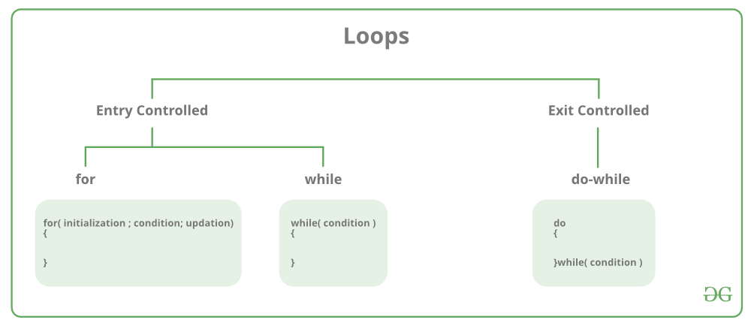

| **S.No.** | **Loop Type and Description** |
| --- | --- |
| 1. | **while loop** – First checks the condition, then executes the body. |
| 2. | **for loop**– firstly initializes, then, condition check, execute body, update. |
| 3. | **do-while** **loop**– firstly, execute the body then condition check |