WMATA Performance Analytics Report
By
MetroMind
Data Processing, Strategic Insights, and Operational Recommendations
Team: Jacob Andew Lourie
Kunal Roy Chowdhury
Varnika Bethireddy
Vishesh Khare

Data Processing
We wanted to focus on bus routes, so we identified the Metrobus annual line performance report for each year from 2019 - 2024. These reports were in pdf format so we extracted the data to csvs via a pdf scraper in python. For one of the statistics, Annual Ridership, the data was not in an easily extractable format so we had to use a computer vision-to-text OCR to scrape that as well.
We got current bus stops for current routes from an API call to WMATAs API. Note that because routes changed drastically between 2024 and 2025 in terms of numbering and naming, we could only include a subset of routes that were easily mappable between the new routes and the old routes, so specific stop information is not included in our report.

References

Metrobus FY2024 Annual Line Performance Report
Metrobus FY2023 Annual Line Performance Report
Metrobus FY2020 Annual Line Performance Report
Metrobus FY2021 Annual Line Performance Report
Metrobus FY2020 Annual Line Performance Report
Metrobus FY2019 Annual Line Performance Report
WMATA API

Business Transaction 1: Post-Covid Ridership Recovery
Question: Which route riderships were affected most by Covid and how did they recover?
Visual Reference: 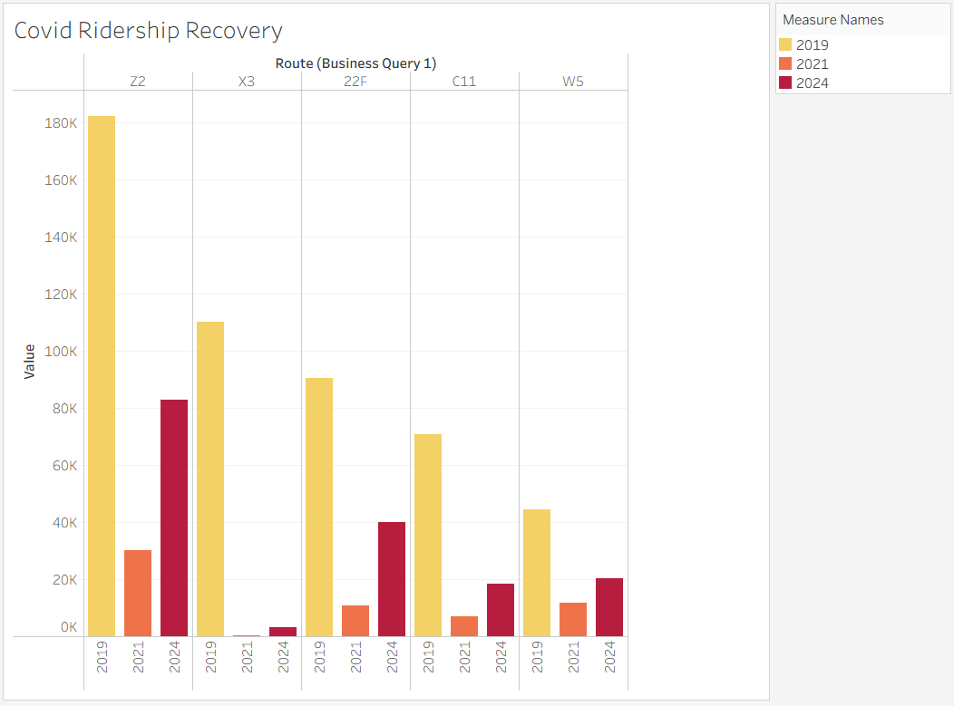
Findings & Insights:
- Drastic Decline: The data compares ridership across 2019 (Pre-Covid), 2021, and 2024. Route X3 shows the most catastrophic decline, dropping from over 100k riders in 2019 to near-zero levels in 2021, with negligible recovery by 2024.
- Stagnant Recovery: Route Z2 was the highest volume route in 2019 (~180k) but has only recovered to approximately 80k by 2024, remaining well below 50% of its pre-pandemic capacity.
- Moderate Struggles: Routes 22F and C11 show a similar pattern of sharp decline with only minor improvements in the 2024 fiscal year.
Recommendations:
- Discontinuation Analysis: Route X3 appears to have lost its user base entirely. Unless there is a specific external cause (e.g., long-term construction), we recommend this route be slated for discontinuation to save operational resources.
- Strategic Audit: Route Z2 requires a "Deep Dive" audit. Since it was formerly a high-volume line, the demand likely still exists but may have shifted to other modes of transport or remote work. We suggest surveying former riders to understand barriers to return.

Business Transaction 2: Cost Efficiency Analysis
Question: Which routes, weighted by total operating cost, still have low rates of cost recovery?
Visual Reference: 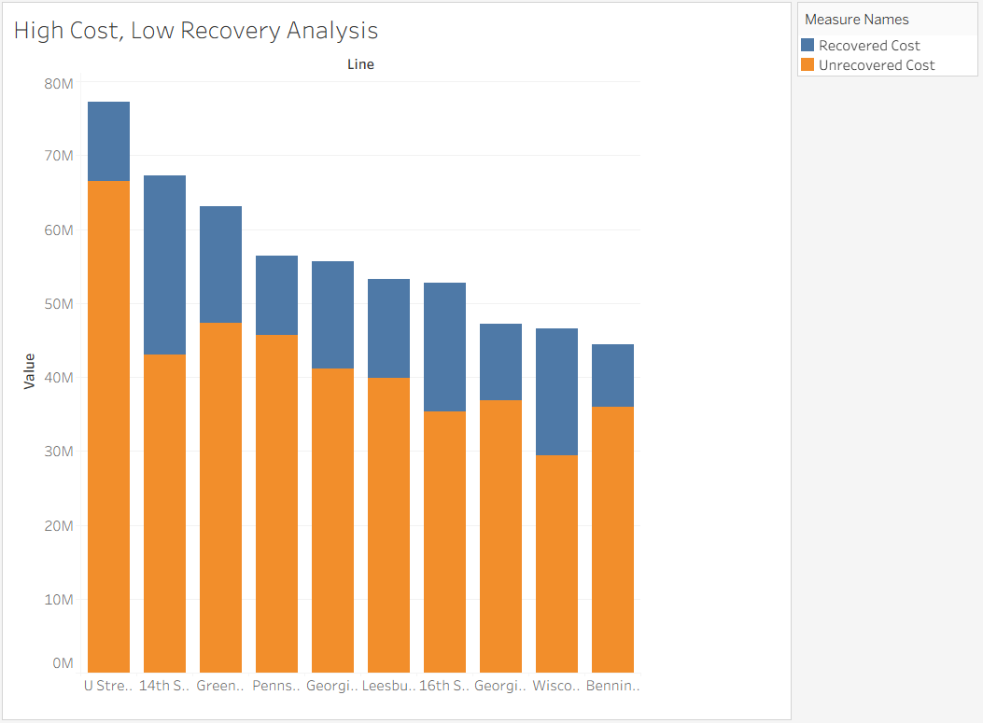
Findings & Insights:
- Major Financial Drain: The U Street-Garfield line stands out as having the highest Total Operating Cost (combined blue and orange bar) while simultaneously having the largest proportion of "Unrecovered Cost" (orange bar).
- Recovery Variance: While the 14th Street line also has high operating costs, its "Recovered Cost" (blue bar) is noticeably larger than U Street-Garfield, indicating it is generating better revenue despite the expense.
- Inefficient Lines: The Wisconsin Avenue and Benning Road lines show a high ratio of unrecovered costs relative to their total volume.
Recommendations:
- Revenue Enforcement: For the U Street-Garfield line, we recommend a study on fare evasion or pricing structures. The high operating cost suggests frequent service, but the low recovery suggests passengers are not paying, or the route is running empty buses too frequently.
- Service Optimization: For lines like Wisconsin Avenue, consider reducing frequency during off-peak hours to lower the "Unrecovered Cost" portion without abandoning the route entirely.
Business Transaction 3: Weekend Service Shifts
Question: Which routes experience large vs. small shifts in ridership and/or crowding from weekday to weekend?
Visual Reference:
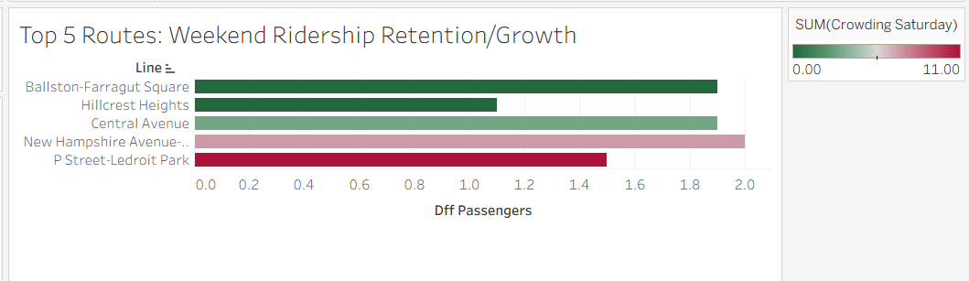
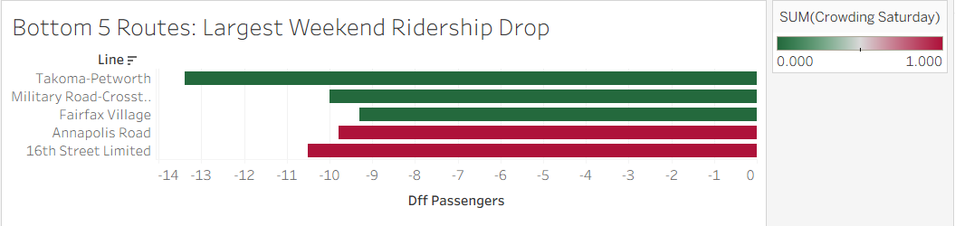
Findings & Insights:
- Growth Leaders: The New Hampshire Avenue and Ballston-Farragut Square lines are showing the highest positive difference in weekend passengers. Notably, New Hampshire Avenue is also showing higher "Crowding Saturday" levels (indicated by the pinkish hue).
- Significant Drop-offs: The Takoma-Petworth and Military Road-Crosstown lines are experiencing the largest weekend ridership drops (negative values on the "Bottom 5" chart), suggesting these are primarily commuter routes that are underutilized on weekends.
Recommendations:
- Resource Reallocation: WMATA should shift buses and drivers from the Takoma-Petworth line (where weekend buses are running empty) to the New Hampshire Avenue line.
- Capacity Expansion: The high crowding index on New Hampshire Avenue suggests that current weekend service levels are insufficient for the demand. Adding frequency here will improve customer satisfaction and capture more revenue.

Business Transaction 4: Equity and Performance
Question: Which transit lines show weak on-time performance or high crowding in areas with higher percentages of low-income riders?
Visual Reference: 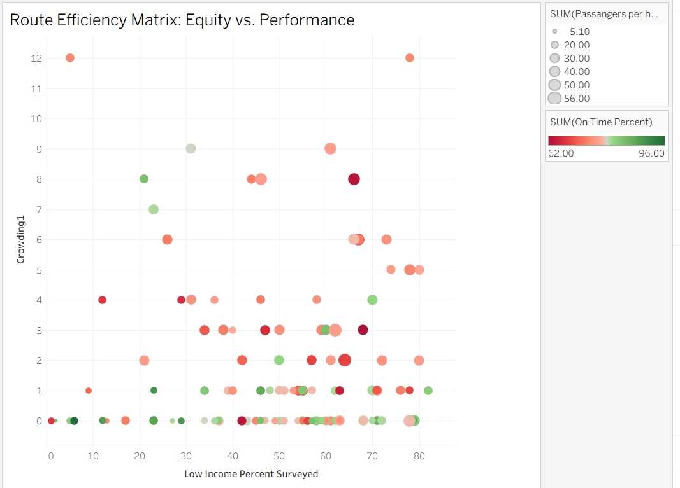
Findings & Insights:
- Equity Gaps: The scatter plot analyzes "Low Income Percent Surveyed" (X-axis) against crowding and reliability. We observed several data points on the far right (60-80% low income) that are colored red, indicating poor "On Time Percent" (around 62-70%).
- Reliability Issues: High-income areas (left side of the chart) generally show more green (higher on-time percentages) compared to the dispersed reliability in lower-income areas.
- Crowding Correlation: There are specific routes serving high low-income populations (approx. 60%) that also experience moderate to high crowding (Y-axis values of 3-6).
Recommendations:
- Targeted Reliability Investments: Prioritize infrastructure and scheduling improvements for the specific "Red Dot" routes in the 60-80% low-income range. Poor reliability in these areas disproportionately affects riders who likely have fewer transportation alternatives.
- Capacity Review: For the routes in high low-income areas showing high crowding, immediate relief vehicles should be deployed to ensure equitable access to comfortable transit.

