Name- Varnika Singh
Batch-3
SapID-500120368

TITLE: Basic Java Programming

- Write a program to calculate the final grade of a student based on the marks entered in three subjects. Use the following grading scale:
Average >= 90: Grade A
Average >= 75: Grade B
Average >= 50: Grade C
Otherwise: Grade F

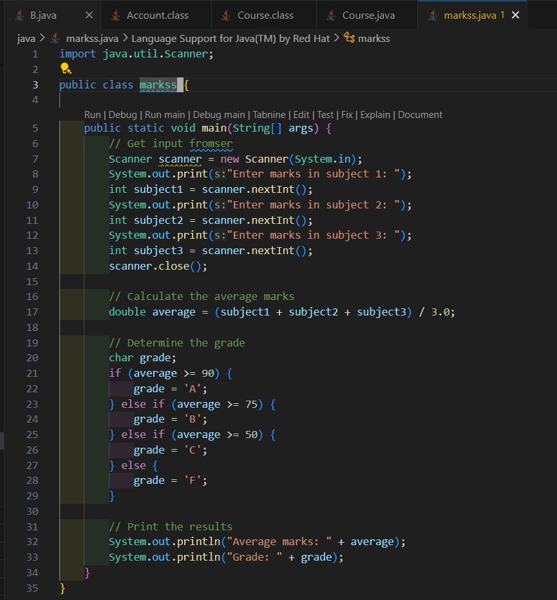
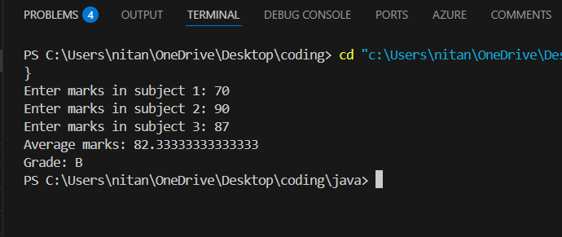

- Print this Pattern:
1 2 3 4 5
1 2 3 4
1 2 3
1 2
1

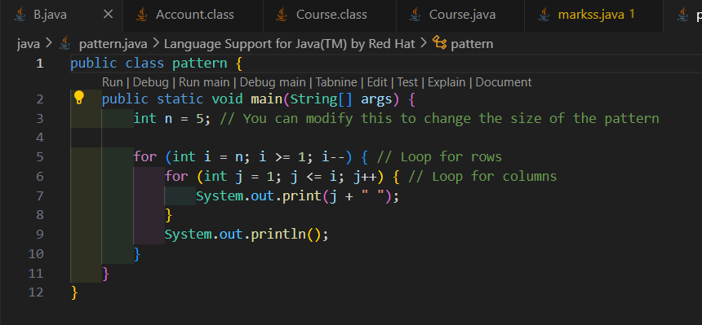
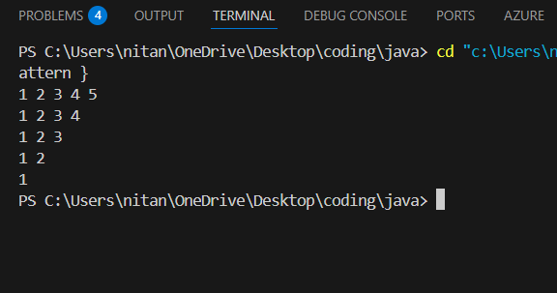

- Create a program that accepts a number (1–7) and displays the corresponding day of the week using a switch statement.
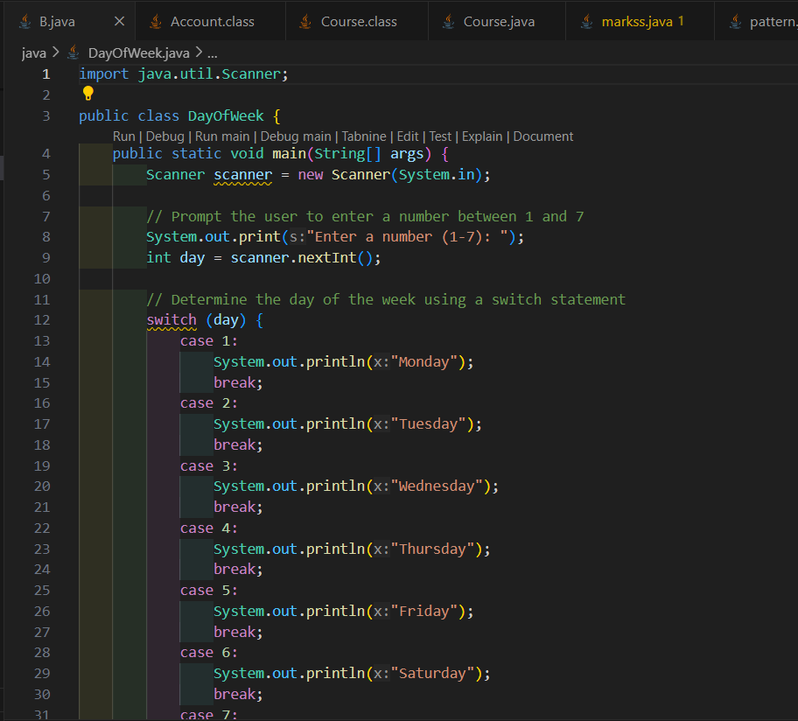
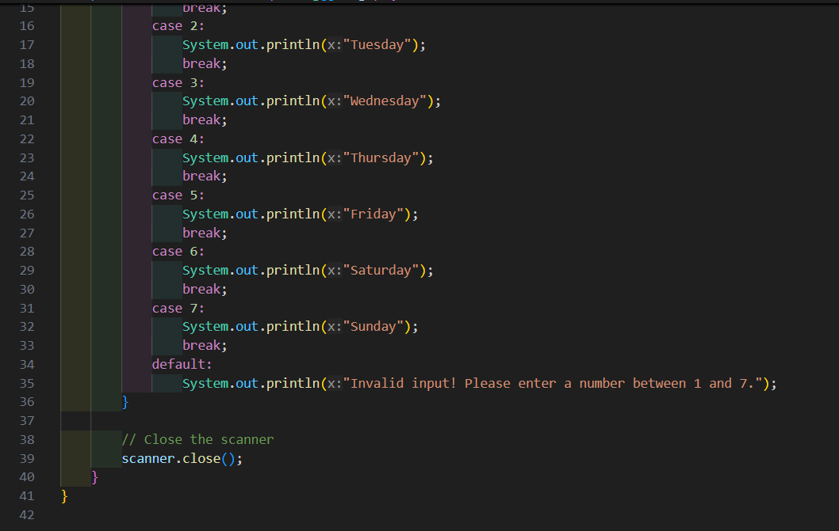
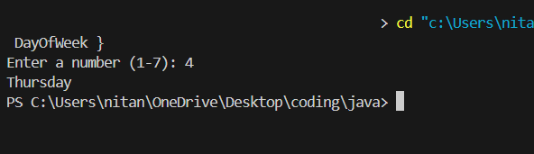

- Write a program to find the area of a shape (Rectangle, Square, Circle, Triangle) using method overloading.

