
Web Application Penetration Testing Report
12th December 2025
Level 1 Report
1.1 Copyright
The copyright in this work is vested in Cybertryzub Infosec Pvt. Ltd., and the document is issued in confidence for the purpose for which it is supplied. It must not be reproduced in whole or in part or used for tendering or manufacturing purposes except under agreement or with the consent in writing of Cybertryzub Infosec Pvt. Ltd. and then only on condition that this notice is included in any such reproduction. No information as to the contents or subject matter of this document or any part thereof arising directly or indirectly there from shall be given orally or in writing or communicated in any manner whatsoever to any third party being an individual firm or company or any employee thereof without the prior consent in writing of Cybertryzub Infosec Pvt. Ltd.
© Cybertryzub Infosec Pvt. Ltd.
1.2 Contact Information

Mrs. Jyoti Singh
CISA, CIPM, FIP, CIPP/E, ISO 27001
LA, DevOps, MSc, PG Data Science.
(InfoSec Lead Auditor)
+91 9873784553, 8295777275
info@cybertryzub.com
Corporate Office
PLOT NO 76D UDYOG VIHAR 4 SECTOR 18,
GURGAON – 122001
HARYANA, India
Registered Office
F-300, SECTOR 63, NOIDA-201301
UTTAR PRADESH, INDIA
2.0 About Us
Cybertryzub InfoSec Private Limited is an ISO Certified (ISO 27001:2013) company. Cybertryzub aims to provide Auditing; Information Risk Management and Managed services tailored as per the market requirements and enhance the satisfaction and confidence index of its existing and potential customers.
Cybertryzub has been a CERT-In empaneled IT Security Auditor. It is an acknowledgement of Cybertryzub’s technical expertise in conducting Information Security Audits. As a CERT-In empaneled auditor Cybertryzub is qualified to conduct security audits of websites, networks & applications. On successfully completing the audit as per CERT-In Guidelines, our team can issue the CERT-In Certification as required by compliance requirements.
From the development of a Security Policy, Security Awareness Training, through to the delivery of complete end-to-end solutions that encompass Perimeter Security, Secure Content Management, Identity and Access Management, Vulnerability Assessment, Risk, Policy and Compliance Management, Cybertryzub InfoSec Private Limited helps organizations understand, monitor and mitigate the risks in their IT infrastructure.
Cybertryzub InfoSec Private Limited has information security experts, compliance professionals from different industry verticals with multiple certifications each with experience in handling audits and training programs.
Cybertryzub InfoSec Private Limited has established a reputation for providing practical solutions that are both businesses driven and cost-effective. This has enabled the company to secure the IT Infrastructure of leading Stock Brokers, Government undertakings, Banks, Insurance Companies and Financial Institutions, BPO, KPO, PKI Industry, Data Center, Software Company, Automobile, Healthcare & Life Sciences, Hospitality, Travel, Transportation, Consumer & Retail, Technology, Media & Telecommunication, School, College, Smart City. Security Leadership our experienced team of ethical hackers have identified security vulnerabilities, we have put together a highly qualified team of security researchers with credentials like CISA, CISSP, OSCP, CSOE, CCNP, MCSE+, ISO 27001 LA, ITIL, COBIT, CIPP/E, CIPM, FIS, DISA, CPA, Cyber Law, Data Science, Artificial Intelligence & Machine Learning, DevSecOps, AWS Architect, Azure Architect.

3.0 Table of Contents
1.0 1.1 Copyright ....................................................................................................................................................................................................2
1.2 Contact Information.................................................................................................................................................................................2
2.0 About Us...........................................................................................................................................................................................................3
3.0 Table of Contents.............................................................................................................................................................................................4
4.0 Assessment Information.................................................................................................................................................................................5
4.1 Assessment scope summary............................................................................................................................................................................5
4.2 Client details………............................................................................................................................................................................................5
4.3 Cybertryzub Infosec Pvt. Ltd. Details……………………………………………………………………………………………………………………………….…….………….…..….5
5.0 Engagement Overview....................................................................................................................................................................................6
6.0 Process and Methodology...............................................................................................................................................................................7
7.0 Vulnerability Overview………….........................................................................................................................................................................9
8.0 Checklist..........................................................................................................................................................................................................10
9.0 Test Execution Summary.................................................................................................................................................................................13
10.0 Executive Summary........................................................................................................................................................................................15
11.0 Summary vulnerabilities……………...................................................................................................................................................................16
12.0 Detailed Findings and Recommendation........................................................................................................................................................17
13.0 Tools and References………………………………………………………………………………………………………………………………………………………………………….……46
14.0 High-Level Recommendations………………………………………………………………………………………………………………………………………………………….………47
15.0 Metadata Details of Audit..............................................................................................................................................................................52

4.0 Assessment Information
4.1 Assessment Scope Summary

Engagement Type Web application Gray Box Assessment

Engagement Scope https://uat.grovercare.com/

Engagement Timeframe December 11th, 2025 to December 12th, 2025

4.2 Client Details

Organization Grover Insurance Brokers Pvt. Ltd.

Contact Person Amandeep Grover

Email ID aman@grovercare.com

- Telephone +91 82838 13692

4.3 Cybertryzub Infosec Pvt. Ltd. Details

Auditor Mr. Deepanshu Kumar

Review and Final Approval Mr. Shubham Raj Mourya

Report ID:

Report Type Level 1 web Application Report
5.0 Engagement Overview

Grover Insurance Brokers Pvt. Ltd. has engaged with Cybertryzub to conduct a penetration test of their Web Application. This report contains all the results of the report as well as all the action items that were included in the penetration test. The purpose of this report is to present the current security level of the external perimeters including gaps, vulnerabilities, and misconfigurations. The findings presented in this report should be fixed to improve the security level of the network systems.

Service Description
Web application Vulnerability Assessment and Penetration Testing (VAPT) is the process of simulating real-world attacks by using the same techniques as malicious hackers. For a security assessment that goes beyond a simple vulnerability scanner, you need experts in the industry. Cybertryzub conducts its penetration test by approaching the scope with both a manual and automatic approach.

Web Application Penetration Test
our application-level penetration testing consists of both unauthenticated and authenticated testing using both automated and manual methods with particular emphasis placed on identifying vulnerabilities associated with the OWASP Top 10 Most Critical Application Vulnerabilities. It is important to note that a penetration test is not just an automated vulnerability scan, and a large portion of web application penetration testing is a manual process with a skilled engineer attempting to identify, exploit, and evaluate the associate risk of security issues.

Project Objectives
Cybertryzub conduct all testing manually combined with custom and commercial tools that perform unique attack approaches on the network to make sure we cover the whole system in the test. Our expert knowledge and experience are the value we provide in our services.
- Process and Methodology
Cybertryzub has developed a proven and scalable Vulnerability Assessment and Penetration Testing (VAPT) methodology, refined over 15+ years of hands-on experience. This methodology integrates industry-leading best practices and recognized security standards, including:
- OSSTMM 3 – Open Source Security Testing Methodology Manual (for scientific, metric-based security testing)
- OWASP Top 10 – To address the most critical web application security risks
- SANS Top 25 – For identifying and remediating dangerous software errors
- OWASP ASVS – Application Security Verification Standard (for depth and rigor in app security testing)
- CERT-In Guidelines – As per compliance mandates and government directives
- Other Known Vulnerabilities – Based on threat intelligence, CVE databases, exploit repositories, and 0-day indicators
2 Reconnaissance & Mapping
1
This process begins with a detailed mapping and enumeration of the web application. The focus is on identifying exposed functionalities, input fields, authentication mechanisms, and underlying technologies. Publicly available information (OSINT) and application metadata are also analyzed to understand potential attack surfaces.
2 Automated and Manual Testing
2
Once the application is mapped, both automated tools (commercial and proprietary) and manual testing techniques are applied. The aim is to detect issues such as injection flaws, broken authentication, security misconfigurations, and other vulnerabilities defined in OWASP Top 10, ASVS controls, and SANS Top 25.
3
Vulnerability Verification & Exploitation
At this stage, our experts validate identified findings through controlled exploitation to confirm the real-world impact. Special emphasis is given to business logic flaws, authorization bypass, session management, and data exposure vulnerabilities. Testing strictly follows CERT-In guidelines to ensure safe and responsible execution.

4
Assessment Report
After completion of the engagement, a comprehensive report is prepared, consisting of:
- Executive Summary: Business impact and risk rating for management.
- Technical Details: Step-by-step reproduction, risk severity (CVSS v3.1), and detailed remediation aligned with OWASP and industry best practices.
5
Re-test & Verification
As an optional service, we offer a full re-test after remediation to validate that the vulnerabilities have been fixed and cannot be bypassed. A new re-test report is then shared, confirming closure of issues and compliance with security standards.

7.0 Vulnerability Overview
Cybertryzub performed a Web application Security Assessment for Grover Insurance Brokers Pvt. Ltd. on 12-01-2026 to 15-01-2026. This assessment utilized both commercial and proprietary tools for the initial mapping and reconnaissance of the web application as well as custom tools and scripts to identify unique vulnerabilities. Several testing tools were used to conduct the penetration testing on the application.

VULNERABILITY RISK DEFINITION AND CRITERIA
The risk rating assigned to each vulnerability are determined by averaging several aspects of the exploit and the environment, including reputation, difficulty and impact.
Critical vulnerabilities pose a serious threat to an organization's security, and should be fixed immediately. They may provide a total compromise of the target environment, or similar critical impacts.
Critical
High risk vulnerabilities provide a serious risk to the company environment and should be corrected promptly. These issues can significantly affect the organization's security posture.
High
Medium severity vulnerabilities represent a moderate risk to the environment. They may require additional context before remediation but should be remediated after critical and high risks.
Medium
Low severity vulnerabilities provide minimal risk to the target environment, and often theoretical in nature. Remediation of low risks is often a lower priority than other security hardening techniques.
Low
Informational vulnerabilities have little-or-no impact to the target scope by themselves. They are included however, as they may be a risk when combined with other circumstances or technologies not currently in place. Remediation of informational items is not necessary.
Informational

8.0 Checklist
Cybertryzub Web Application Security Testing Checklist
 | Objective | Test Outcome
 | Data Validation
 | - Test for Reflected Cross Site Scripting  - Test for Stored Cross Site Scripting  - Test for DOM based Cross Site Scripting  - Test for Cross Site Flashing  - Test for HTML Injection  - Test for SQL Injection  - Test for LDAP Injection  - Test for ORM Injection  - Test for XML Injection  - Test for XXE Injection  - Test for SSI Injection  - Test for XPath Injection  - Test for XQuery Injection  - Test for IMAP/SMTP Injection  - Test for Code Injection  - Test for Expression Language Injection  - Test for Command Injection  - Test for Overflow (Stack, Heap and Integer)  - Test for incubated vulnerabilities  - Test for HTTP Splitting/Smuggling  - Test for HTTP Verb Tampering  - Test for Open Redirection  - Test for Local File Inclusion  - Test for Remote File Inclusion  - Compare client-side and server-side validation rules  - Test for NoSQL injection  - Test for HTTP parameter pollution  - Test for auto-binding  - Test for Mass Assignment  - Test for NULL/Invalid Session Cookie | Found
 | Session Management
 | - Establish how session management is handled in the application (e.g., tokens in cookies, token in URL)  - Check session tokens for cookie flags (httpOnly and secure)  - Check session cookie scope (path and domain)  - Check session cookie duration (expires and max-age)  - Check session termination after a maximum lifetime  - Check session termination after relative timeout  - Check session termination after logout  - Test to see if users can have multiple simultaneous sessions  - Test session cookies for randomness  - Confirm that new session tokens are issued on login, role change and logout  - Test for consistent session management across applications with shared session management  - Test for session puzzling  - Test for CSRF and clickjacking | Found
 | Authentication
 | - Test for user enumeration  - Test for authentication bypass  - Test for bruteforce protection  - Test password quality rules  - Test remember me functionality  - Test for autocomplete on password forms/input  - Test password reset and/or recovery  - Test password change process  - Test CAPTCHA  - Test multi factor authentication  - Test for logout functionality presence  - Test for cache management on HTTP (eg Pragma, Expires, Max-age)  - Test for default logins  - Test for user-accessible authentication history  - Test for out-of channel notification of account lockouts and successful password changes  - Test for consistent authentication across applications with shared authentication schema / SSO | Found
 | Configuration Management
 | - Check for commonly used application and administrative URLs  - Check for old, backup and unreferenced files  - Check HTTP methods supported and Cross Site Tracing (XST)  - Test file extensions handling  - Test for security HTTP headers (e.g. CSP, X-Frame-Options, HSTS)  - Test for policies (e.g. Flash, Silverlight, robots)  - Test for non-production data in live environment, and vice-versa  - Check for sensitive data in client-side code (e.g. API keys, credentials) | Found
 | Authorization
 | - Test for path traversal  - Test for bypassing authorization schema  - Test for vertical Access control problems (a.k.a. Privilege Escalation)  - Test for horizontal Access control problems (between two users at the same privilege level)  - Test for missing authorization | Not Found
 | Business Logic
 | - Test for feature misuse  - Test for lack of non-repudiation  - Test for trust relationships  - Test for integrity of data  - Test segregation of duties | Not Found
 | Denial of Service
 | - Test for anti-automation  - Test for account lockout  - Test for HTTP protocol DoS  - Test for SQL wildcard DoS | Found
 | Risky Functionality - File Uploads
 | - Test that file size limits, upload frequency and total file counts are defined and are enforced  - Test that file contents match the defined file type  - Test that all file uploads have Anti-Virus scanning in-place.  - Test that unsafe filenames are sanitized  - Test that uploaded files are not directly accessible within the web root  - Test that uploaded files are not served on the same hostname/port  - Test that files and other media are integrated with the authentication and authorization schemas | Not Found
 | Risky Functionality - Card Payment
 | - Test for known vulnerabilities and configuration issues on Web Server and Web Application  - Test for default or guessable password  - Test for non-production data in live environment, and vice-versa  - Test for Injection vulnerabilities  - Test for Buffer Overflows  - Test for Insecure Cryptographic Storage  - Test for Insufficient Transport Layer Protection  - Test for Improper Error Handling  - Test for all vulnerabilities with a CVSS v2 score > 4.0  - Test for Authentication and Authorization issues  - Test for CSRF | Not Found
 | Cryptography
 | - Check if data which should be encrypted is not  - Check for wrong algorithms usage depending on context  - Check for weak algorithms usage  - Check for proper use of salting  - Check for randomness functions | Found
 | Secure Transmission
 | - Check SSL Version, Algorithms, Key length  - Check for Digital Certificate Validity (Duration, Signature and CN)  - Check credentials only delivered over HTTPS  - Check that the login form is delivered over HTTPS  - Check session tokens only delivered over HTTPS  - Check if HTTP Strict Transport Security (HSTS) in use | Found

9.0 Test Execution Summary

10.0 Executive Summary:
Cybertryzub has been engaged by Grover Insurance Brokers Pvt. Ltd. to undertake security testing against the https://uat.grovercare.com/ web application. The Level 1 testing took place over the period from 12-01-2026 to 15-01-2026. During this period the application was analyzed and assessed using a combination of standard tools and utilities and the knowledge and experience of our technical team. Although at the time of this engagement, the application was not in production, we nonetheless stopped short of undertaking specific tests that would either a) evidently risk the integrity and stability of the systems, or b) actively exploit potential vulnerabilities. Overall, we believe that a reasonable level of security has been attained by the applications that were the target of this test, but due to there being a high and some medium and low risk issues, remedial action needs to be carried out prior to official launch of the product. Testing revealed elements that are well-protected against several well-known vulnerabilities.

11.0 Summary of Vulnerabilities
Based on the assessment carried out by Cybertryzub from 12-01-2026 to 15-01-2026, the following notable issues have been identified in reference to mentioned standards in 6.1. This section provides a quick snapshot of the security posture for the Web Application.
S/N | Vulnerability | Severity | Level 1  15-01-2026
1 | Weak Ciphers Enabled |  | Open
2 | Application Vulnerable to BREACH Attack |  | Open
3 | Application Vulnerable to BEAST Attack |  | Open
4 | Application Vulnerable to Lucky13 Attack |  | Open
5 | Cacheable HTTP Response |  | Open
6 | Improper Input Validation |  | Open
7 | Vulnerable TLS Protocols Enabled |  | Open
8 | Trace Method Enabled |  | Open
9 | Missing Security Headers |  | Open
10 | Cookies HTTPOnly Flag Not Set |  | Open

12.0 Detailed Findings and Recommendation
12.1 Weak Ciphers Enabled
Relative Risk
CWE | CWE-326
CVSS | 8.0
Observation / Description
Impact
Recommendation
Affected URL | Throughout the application
Proof of Concept

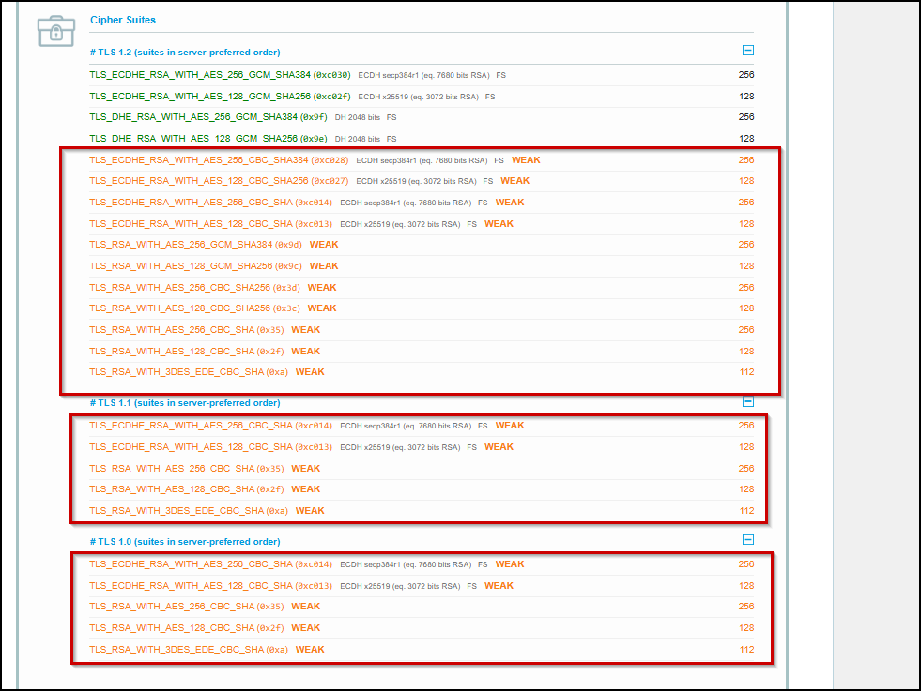
Proof of Concept 12.1.1

12.2 Application Vulnerable to BREACH Attack
Relative Risk
CWE | CWE-200
CVSS | 5.3
Observation / Description
Impact
Recommendation
Affected URL | Throughout the application
Proof of Concept

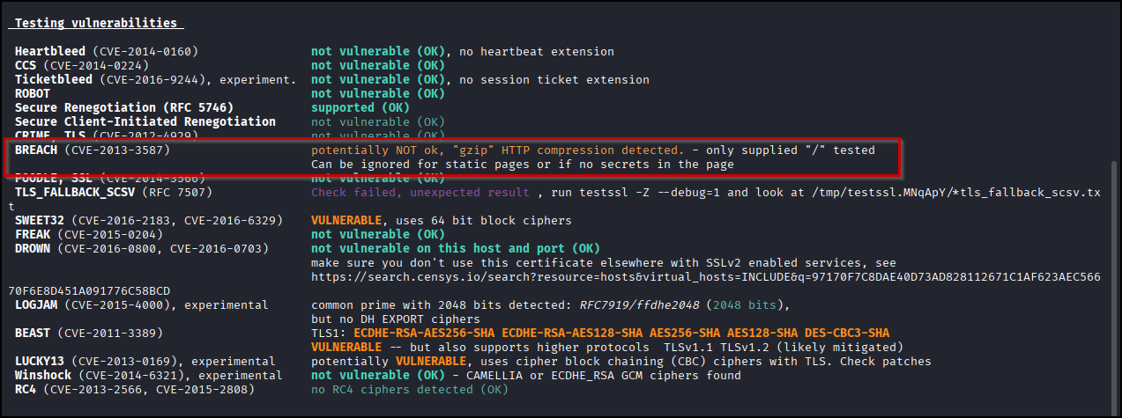
Proof of Concept 12.2.1

12.3 Application Vulnerable to BEAST Attack
Relative Risk
CWE | CWE-327
CVSS | 5.8
Observation / Description
Impact
Recommendation
Affected URL | Throughout the application
Proof of Concept

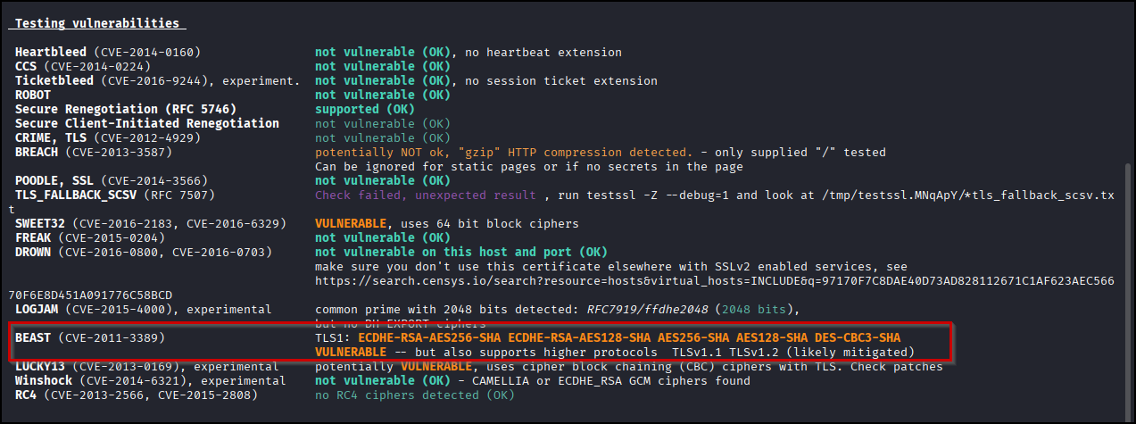
Proof of Concept 12.3.1

12.4 Application Vulnerable to Lucky13 Attack
Relative Risk
CWE | CWE-327
CVSS | 5.9
Observation / Description
Impact
Recommendation
Affected URL | Throughout the application
Proof of Concept

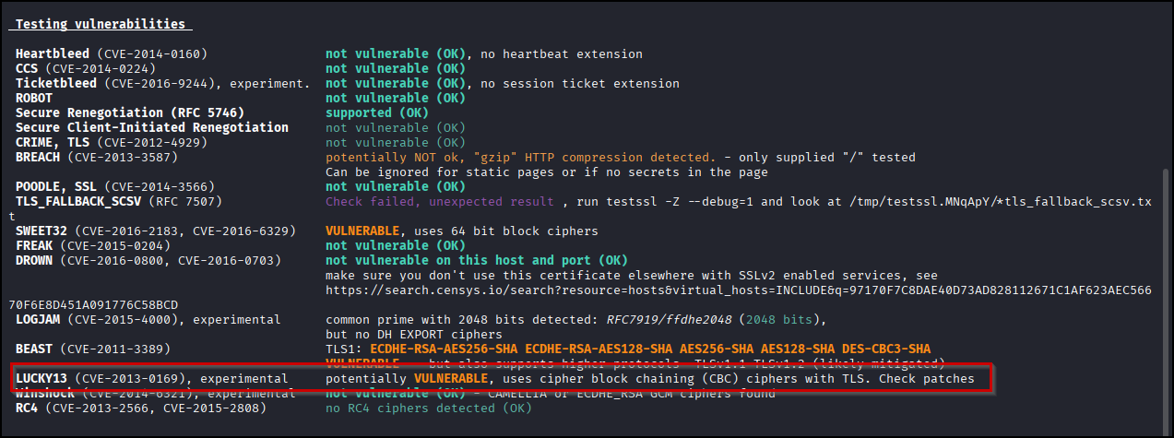
Proof of Concept 12.4.1

12.5 Cacheable HTTP Response
Relative Risk
CWE | CWE-525
CVSS | 4.3
Observation / Description
Impact
Recommendation
Affected URL | Throughout the application
Proof of Concept

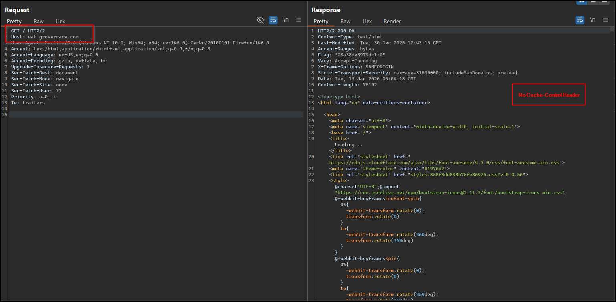
Proof of Concept 12.5.1

12.6 Improper Input Validation
Relative Risk
CWE | CWE-20
CVSS | 6.5
Observation / Description
Impact
Recommendation
Affected URL | https://uat.grovercare.com/layout/support
Proof of Concept

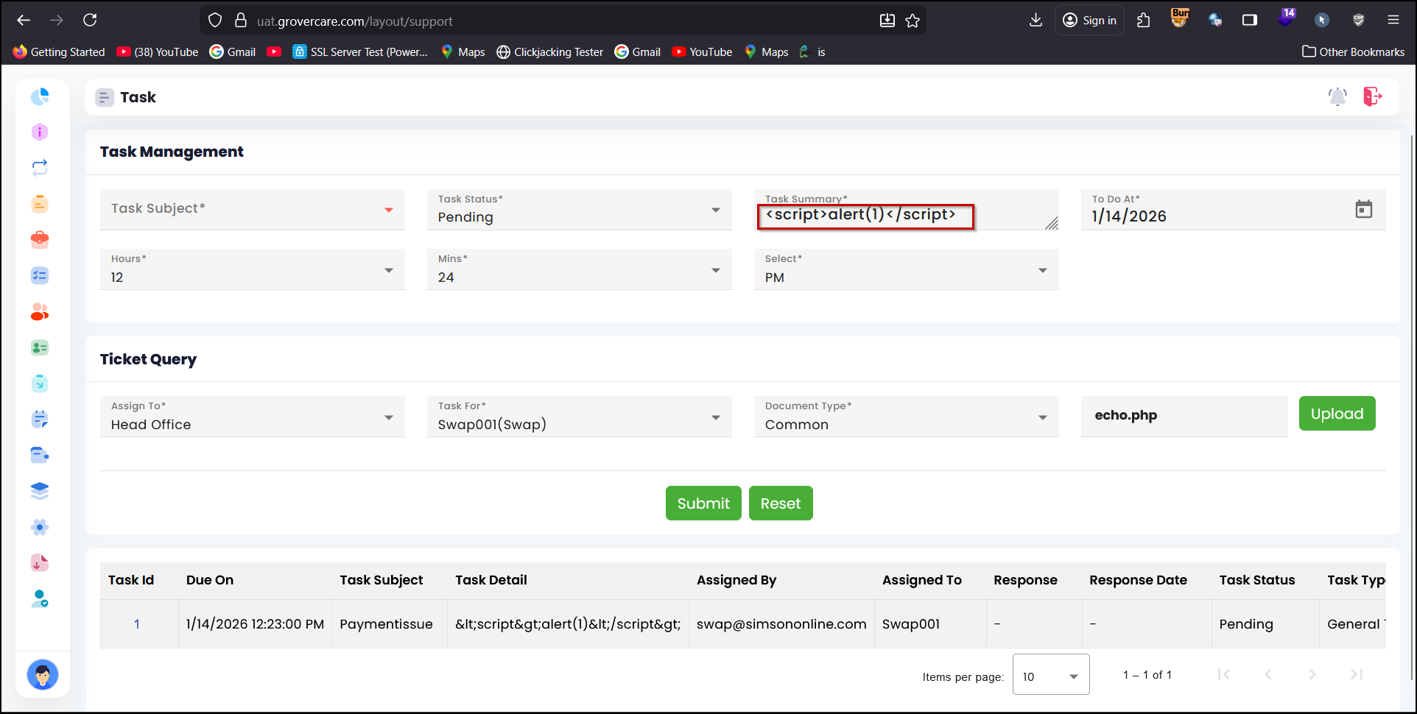
Proof of Concept 12.6.1

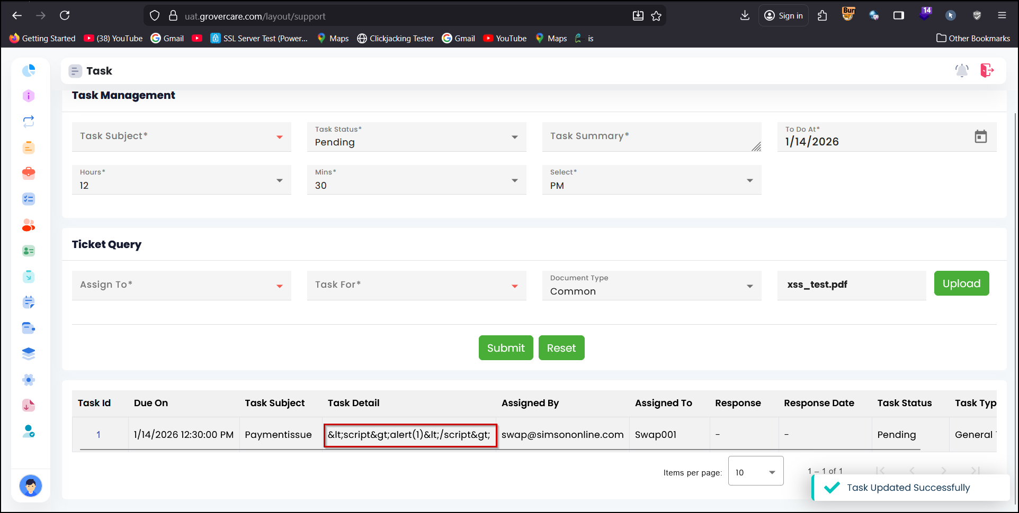
Proof of Concept 12.6.2

12.7 Vulnerable TLS Protocols Enabled
Relative Risk
CWE | CWE-327
CVSS | 5.9
Observation / Description
Impact
Recommendation
Affected URL | Throughout the application
Proof of Concept

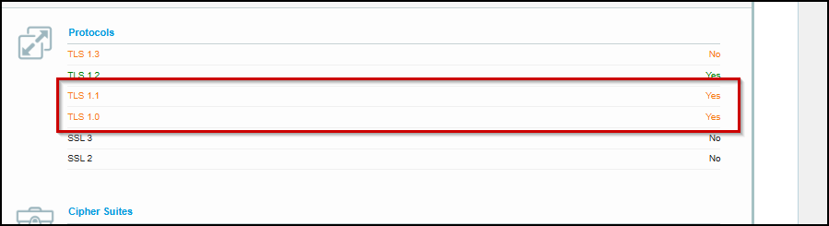
Proof of Concept 12.7.1

12.8 Trace Method Enabled
Relative Risk
CWE | CWE-693
CVSS | 2.0
Observation / Description
Impact
Recommendation
Affected URL | Throughout the application
Proof of Concept

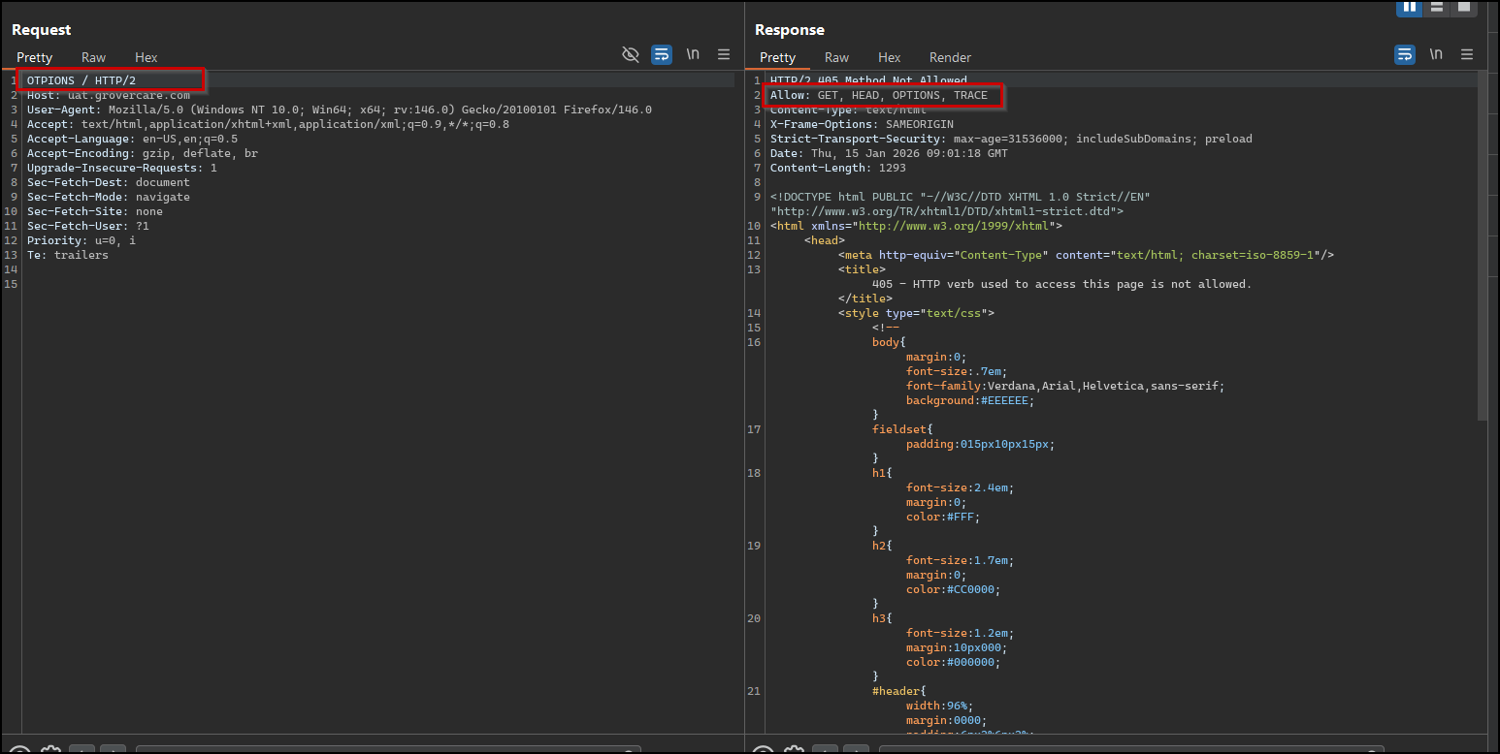
Proof of Concept 12.8.1

12.9 Missing Security Headers
Relative Risk
CWE | CWE-16
CVSS | 2.9
Observation / Description
Impact
Recommendation
Affected URL | Throughout the application
Proof of Concept

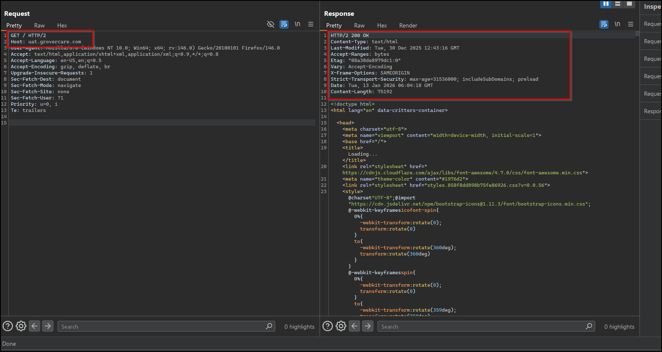
Proof of Concept 12.9.1

12.10 Cookies HTTPOnly Flag Not Set
Relative Risk
CWE | CWE-1004
CVSS | 2.5
Observation / Description
Impact
Recommendation
Affected URL | Throughout the application
Proof of Concept

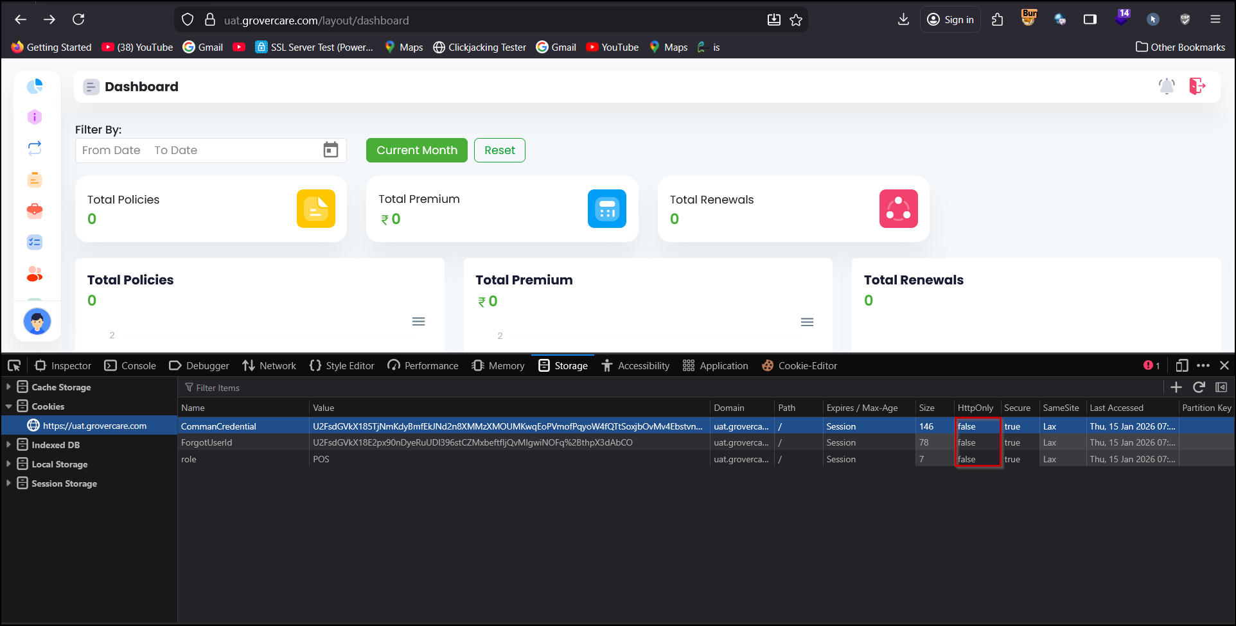
Proof of Concept 12.10.1

13.0 Tools and References
TOOLS:
The following tools were used for Security Testing:
- Nexpose
- Kali Linux
- Nmap
- Metasploit
- Nessus
- Some other proprietary scripts and tools were also used.
REFERENCES:
For application security visit owasp.org
https://cert.org/other_sources/tool_sources.html
https://securityfocus.com
https://projects.webappsec.org/w/page/13246978/ThreatClassification

14.0 High-Level Recommendations
Taking into consideration all issues that have been discovered, we highly recommend to:
- Conduct current vs. future IT/Security program review
- Conduct Static code analysis for codebase
- Establish Secure SDLC best practices, assign Security Engineer to a project to monthly review code, conduct SAST & DAST security testing
- Review Architecture of application
- Deploy Web Application Firewall solution to detect any malicious manipulations
- Continuously monitor logs for anomalies to detect abnormal behavior and fraud transactions. Dedicate security operations engineer to this task
- Implement Patch Management procedures for whole IT infrastructure and endpoints of employees and developers
- Continuously Patch production and development environments and systems on regular bases with latest releases and security updates
- Conduct annual Penetration test and quarterly Vulnerability Scanning against internal and external environment
- Develop and Conduct Security Awareness training for employees and developers
- Develop Incident Response Plan in case of Data breach or security incidents
- Analyze risks for key assets and resources
- Update codebase to conduct verification and sanitization of user input on both, client and server side
- Use only encrypted channels for communications
- Do not send any unnecessary data in requests and cookies
- Improve server and application configuration to meet security best practices
- Perform comprehensive penetration testing of all subdomains (including discovery and takeover checks)
- Conduct server security testing (host-level hardening, configuration, privilege escalation & supply-chain checks)
- Perform network and infrastructure testing (external/internal network, segmentation, firewall, cloud network controls)

15.0 Disclaimers and Restrictions
The following disclaimers and restrictions apply to this Vulnerability Assessment and Penetration Testing (VAPT) engagement and its findings:
1. Management Responsibility
The responsibility for the overall security posture, risk management, and remediation of identified vulnerabilities lies solely with the management of the client organization. Cybertryzub Infosec Private Limited , as the appointed VAPT auditor, has performed testing and analysis in accordance with the agreed-upon scope and methodology to provide an independent assessment of the current security state.
2. Scope and Authorization
All testing activities were performed strictly within the scope, IP ranges, and systems explicitly authorized in the engagement agreement. Any assessment outside the approved scope is beyond the auditor’s responsibility and has not been validated or reported.
3. Evidence Submission and Access
The accuracy of the findings is based on system access, credentials, and information provided by the client. It is the responsibility of the client to ensure that accurate, complete, and up-to-date data was made available during the assessment. Any restriction in access or information may have impacted the comprehensiveness of the test results.
4. Handling of Test Artifacts and Data
All data captured, including screenshots, proof-of-concepts, or logs, have been handled in accordance with confidentiality and data protection policies. The client organization is responsible for securely storing related evidence and remediation logs for at least one (1) year after the completion of this assessment. Any sharing of this report or associated evidence with third parties requires prior written consent from Cybertryzub Infosec Private Limited.
5. Limitations and Risks
While every reasonable effort has been made to identify vulnerabilities and assess risks, the following limitations apply:
- The testing represents a point-in-time snapshot of the environment.
- Undetected or latent vulnerabilities may exist due to:
  - Incomplete coverage caused by network or application restrictions,
  - Configuration changes after testing, or
  - Emerging threats and zero-day vulnerabilities.
- This report does not guarantee absolute security or immunity from future attacks.
6. Intended Use of the Report
This report is intended solely for the internal use of the client organization to understand, evaluate, and remediate identified vulnerabilities. It must not be distributed, published, or used for marketing, regulatory, or legal purposes without the express written consent of Cybertryzub Infosec Private Limited.
7. Implementation of Recommendations
All recommendations in this report should be validated and tested in a controlled, non-production environment before being applied to live systems. The auditor is not responsible for any operational issues, downtime, or data loss arising from improper implementation of suggested fixes.
8. Accuracy of Information
The findings and conclusions presented in this report are based on the information available at the time of testing. Cybertryzub Infosec Private Limited shall not be held liable for any inaccuracies, omissions, or misrepresentations arising from incomplete or incorrect information provided by the client.
9. Client Acknowledgment
The final report shall be deemed accepted upon acknowledgment by the authorized representative of the client organization. Such acceptance confirms that the client has reviewed and understood the scope, findings, and limitations of the assessment.

10. Confidentiality
This report and its contents are classified as Confidential. Unauthorized disclosure, distribution, or replication in whole or in part is strictly prohibited and may result in legal or contractual consequences.

15.0 Metadata Details of Audit
Sl No. | Audit Details
1 | Name of Auditee Organization | Grover Insurance Brokers Pvt. Ltd.
2 | Category of Organization | Private Sector
3 | Sector of Organization | Information_and_Communication_Technology
4 | Type of audit | Web Application Audit
5 | Details of web site/name of application/no. of servers, perimeter devices, other infrastructure | https://uat.grovercare.com/
6 | Reason for conducting Audit | Regulatory directions
7 | Standards Used for conducting Audit | OWASP, Cert-in
8 | Compliance to financial sector regulatory bodies guidelines/ circulars/directions like from RBI, IRDAI, SEBI, NPCI. | RBI
9 | Compliance to regulatory bodies guidelines/circulars/directions like from UIDAI, CCA, DoT, TRAI. | Not Applicable
10 | Compliance to CERT-In directions under sub-section (6) of section 70B of the IT Act, 2000 dated 28 April, 2022. | Yes
11 | Compliance to CEA (Cyber Security in Power Sector) guidelines 2021. | No
12 | Any other domestic regulation, directions, guidelines (Please Specify) | No
13 | Type of Audit Report  (First Audit Report/Follow up Report) | First Audit Report
14 | No. of vulnerabilities/ security issues reported during FIRST Audit | 10
15 | No. of days taken by Client to patch the vulnerabilities after submission of Audit report (In case follow-up audit was conducted) | NA
16 | Durations (in days) between end of FIRST audit and start of FOLLOW-UP/SECOND audit | NA
17 | No. of open issues after follow-up audits | NA
18 | Geographical detail of Client (State/UT)
19 | Date of Audit Completion | 15-01-2026
20 | Audit By (Auditor Name) | Mr. Deepanshu Kumar
21 | Review, Approved and Signed By (Auditor Name) | Shubham Raj Mourya
22 | Auditee Name
23 | Auditee Email ID (only Company Email ID)
24 | Company Address
25 | Company Website and contact Detail

