**Course Project**

**Maxim Spinov**

**Basic EE Lab II**

**EECE.2080**

**Date submitted** 28/04/2023

**Due date** 28/04/2023

1. **EQUIPMENT**

# Table 1. Equipment Used

|  |  |  |
| --- | --- | --- |
| **Equipment Type** | **Details** | |
| Analog Discovery 2 | *Make:* | Digilent |
| *Model:* | Analog Discovery 2 |
| *Serial Number:* |  |

# Table 2. Components Used

|  |  |
| --- | --- |
| **Component Type** | **Details** |
| Resistor | 470 ohm |
| Inductor | 10 mH |
| Capacitor | 0.022 µF |

1. **INTRODUCTION**

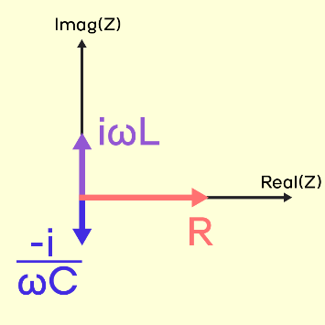In AC schemes impedance (Z) is used instead of resistance. Impedance is a complex value, real part of it is resistance and imaginary part is reactance. Resistance is provided with resistors (R), reactance (X) is provided with inductors ($X_{L}=iωL$) and capacitors ($X_{C}=\frac{-i}{ωC}$).

With inductors and capacitors in series and in parallel we have the same rules of addition of reactance as we had with resistance.

Ohm's law works with impedance the same way it works with resistance ($U=Z*I)$. In the lab resistance and reactance will be calculated based on voltage measurement and Ohm’s law and dependence of reactance on frequency ( $f= \frac{ω}{2π}$) will be observed.

So, total impedance as sum of impedances of all particles

$$iωL+\frac{-i}{ωC}+R=Z$$

It can be seen that with a certain frequency Z could be equal to R which will increase the power output as $P= \frac{U}{R^{2}}$ In this work the point of maximum power output(or voltage level) will be observed and this frequency will be determined.

1. **CIRCUIT DESCRIPTION**

* Resonant frequency * 100

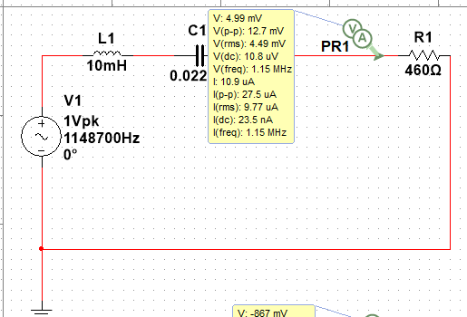

Used Components:

Resistor 470 Ohm

Capacitor 0.022 uF

Inductor 10 uH

* Resonant frequency * 10

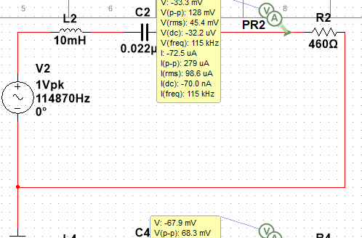

Used Components:

Resistor 470 Ohm

Capacitor 0.022 uF

Inductor 10 uH

* Resonant frequency

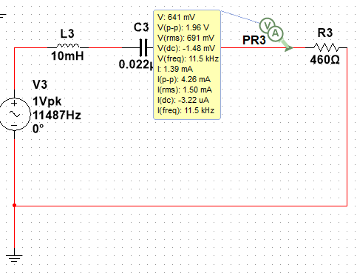

Used Components:

Resistor 470 Ohm

Capacitor 0.022 uF

Inductor 10 uH

* Resonant frequency / 10

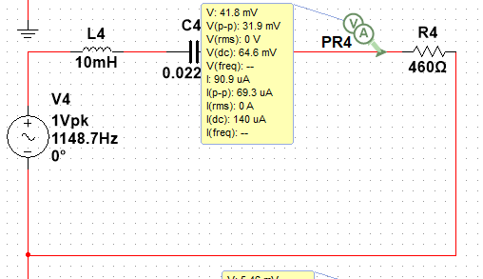

Used Components:

Resistor 470 Ohm

Capacitor 0.022 uF

Inductor 10 uH

* Resonant frequency / 100

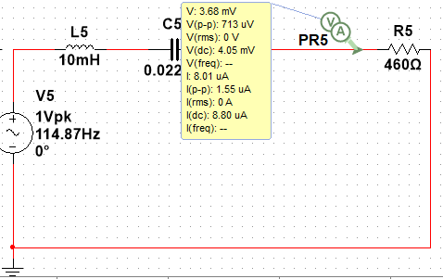

Used Components:

Resistor 470 Ohm

Capacitor 0.022 uF

Inductor 10 uH

1. **TESTING A SYSTEM**

In order to get resonance frequency somewhere around 10 kHz I choose capacitor around $C=((2*π*{10}^{4})^{2}*0.01)^{-1}=0.02533 μF;$ The closest value I have is 0.022 uF so be it. Then the resonant frequency is going to be ${10}^{-6}*0.022=({4π}^{2}f^{2}*0.01)^{-1}; f=10730 Hz$; according to the theory.

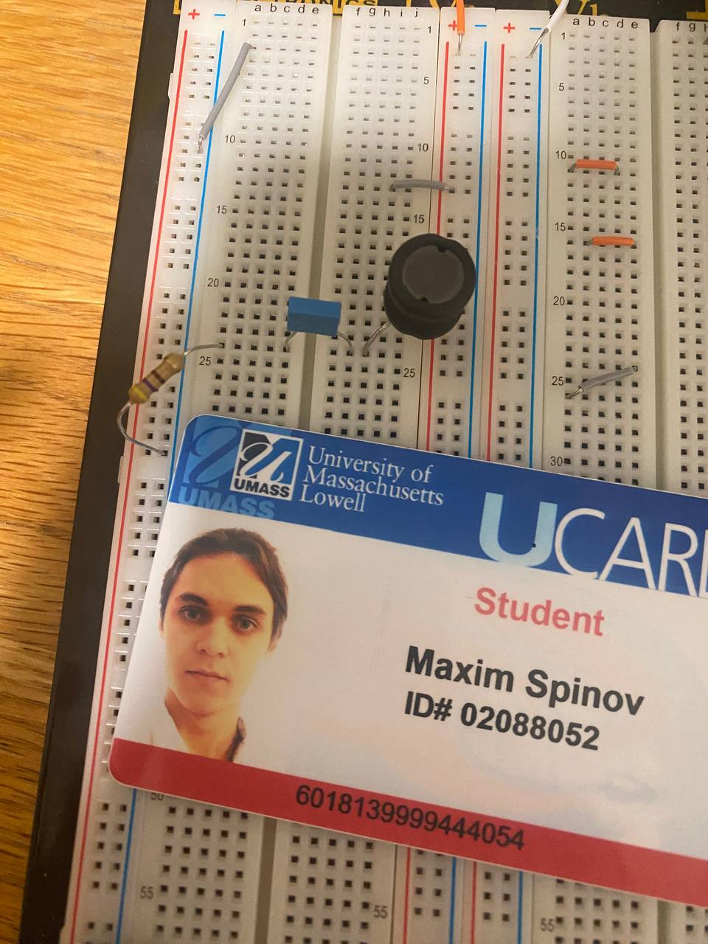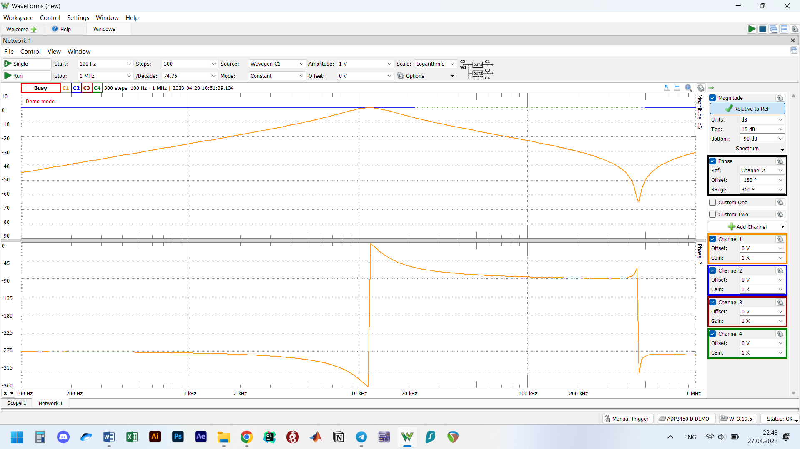

However, as can be seen on network analyzer screenshot and MATLAB output the actual resonant frequency is a little different.

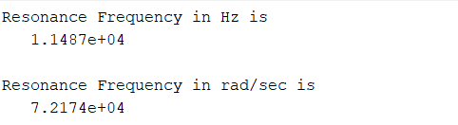

Now let’s plot voltage and **current** **(BONUS POINT)** curves vs frequency, the maximum current and voltage is also provided

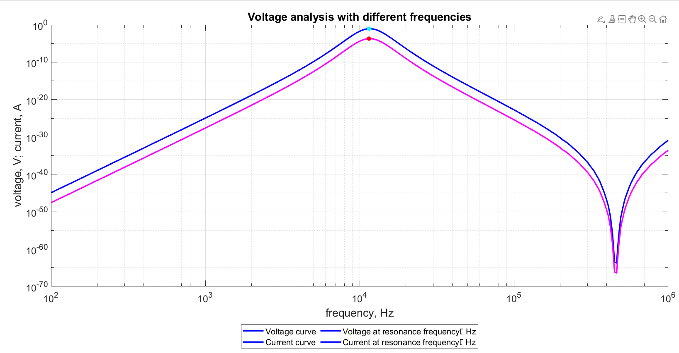

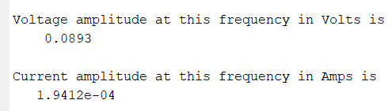

The Multisim model shows the same behavior, which confirms the theory

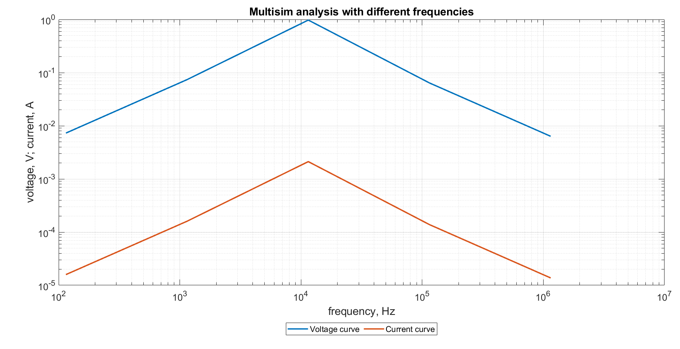

It again confirms resonance frequency around 10 kHz, 11487 Hz to be more precise.

1. **DISCUSSION**

The results confirm the theory and measured value of resonance frequency is close to calculated with error equals to 6.5%. This error occurred because of imperfection of inductor and capacitor. Apart from that there were no difficulties and it may be considered that theory was proven by experiment. Future improvements may include testing the circuit with different resistors and investigating the phasor diagram, as well as analyzing model with frequencies bigger than ${10}^{5}Hz$.