MEASURING SUCCESS IN TALENT MANAGEMENT

INTRODUCTION

Talent can mean different things to different businesses. Some use talent to describe their whole workforce, whereas others use it to define a combination of skills, performance ability, capability, and knowledge that make up an exceptional employee.

Either way, finding and keeping good talent is essential to an HR strategy – and business success. To acquire and retain successfully, HR teams need to monitor the success of their strategies using KPIs. Doing so will allow people teams to optimize and elevate their approach

Many organizations struggle with analysing and acting on the information they so painstakingly gather. Just 39% of LinkedIn’s talent professional respondents say they can draw meaningful insights from data. They also struggle to act on insights to solve existing problems and take advantage of new opportunities

The Tableau HR Scorecard is a framework designed to measure and evaluates the success of talent management strategies within an organization. It provides a way for HR professionals and business leaders to track and analyse key performance indicators (KPIs) related to workforce planning, recruitment, retention, and development.

PROBLEM DEFINITION AND DESIGN THINKING

EMPATHY

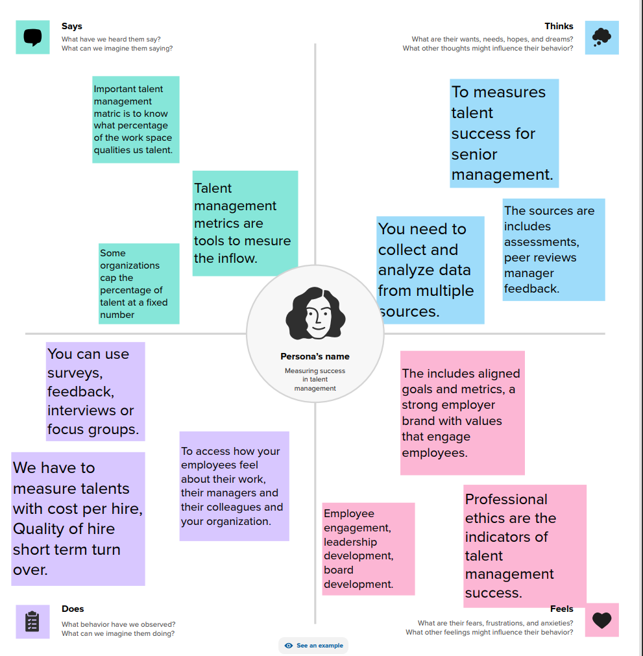

IDEATION AND BRAINSTORMING MAP

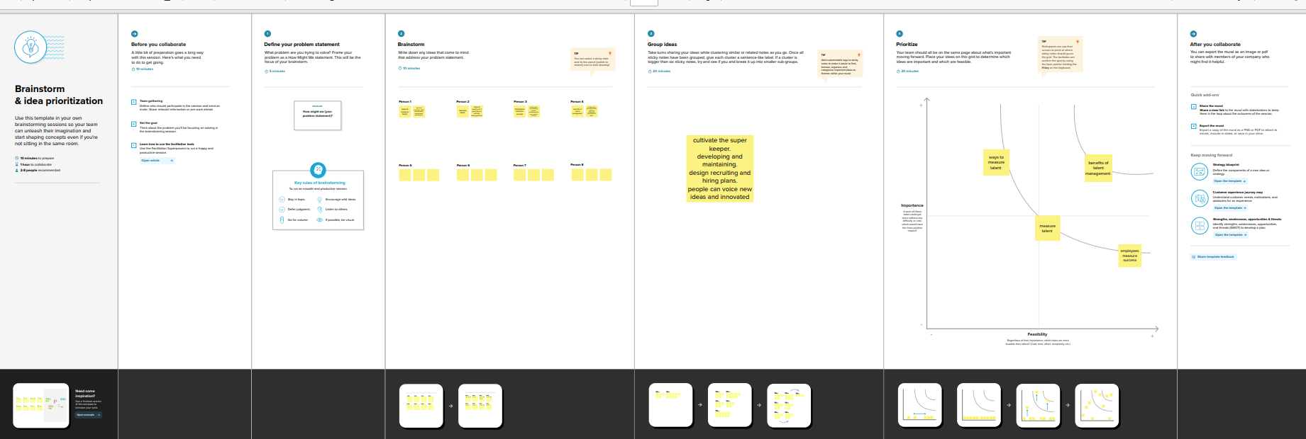

RESULT

DASHBOARD

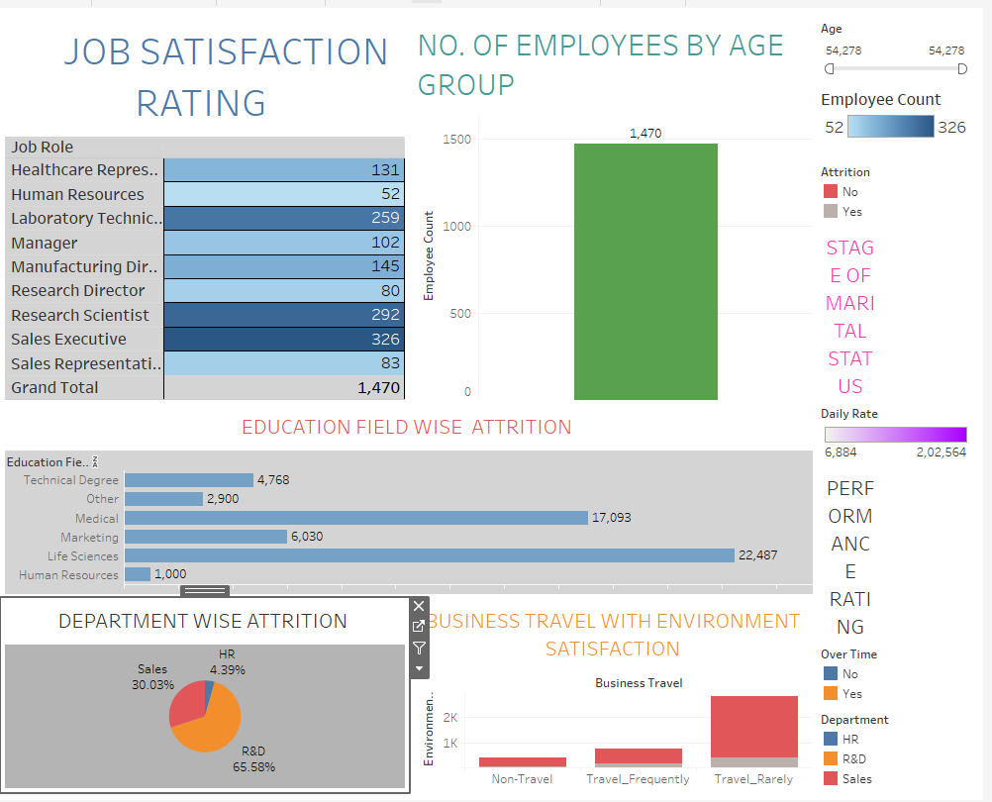

STORY

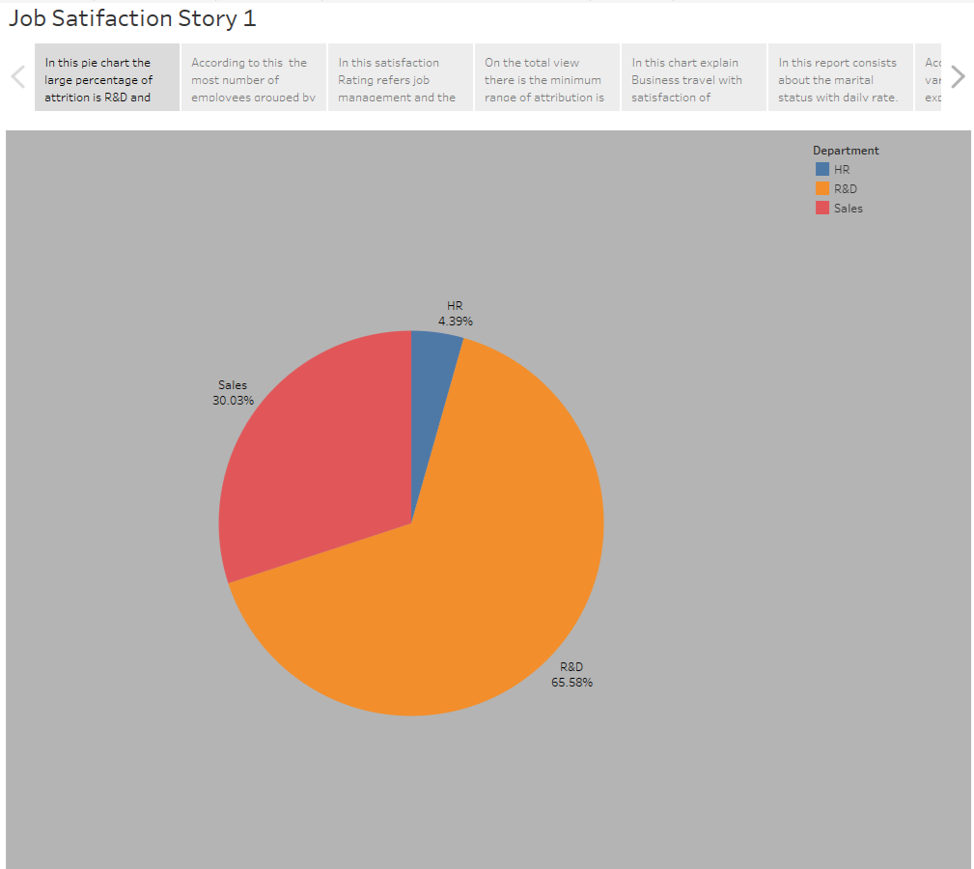

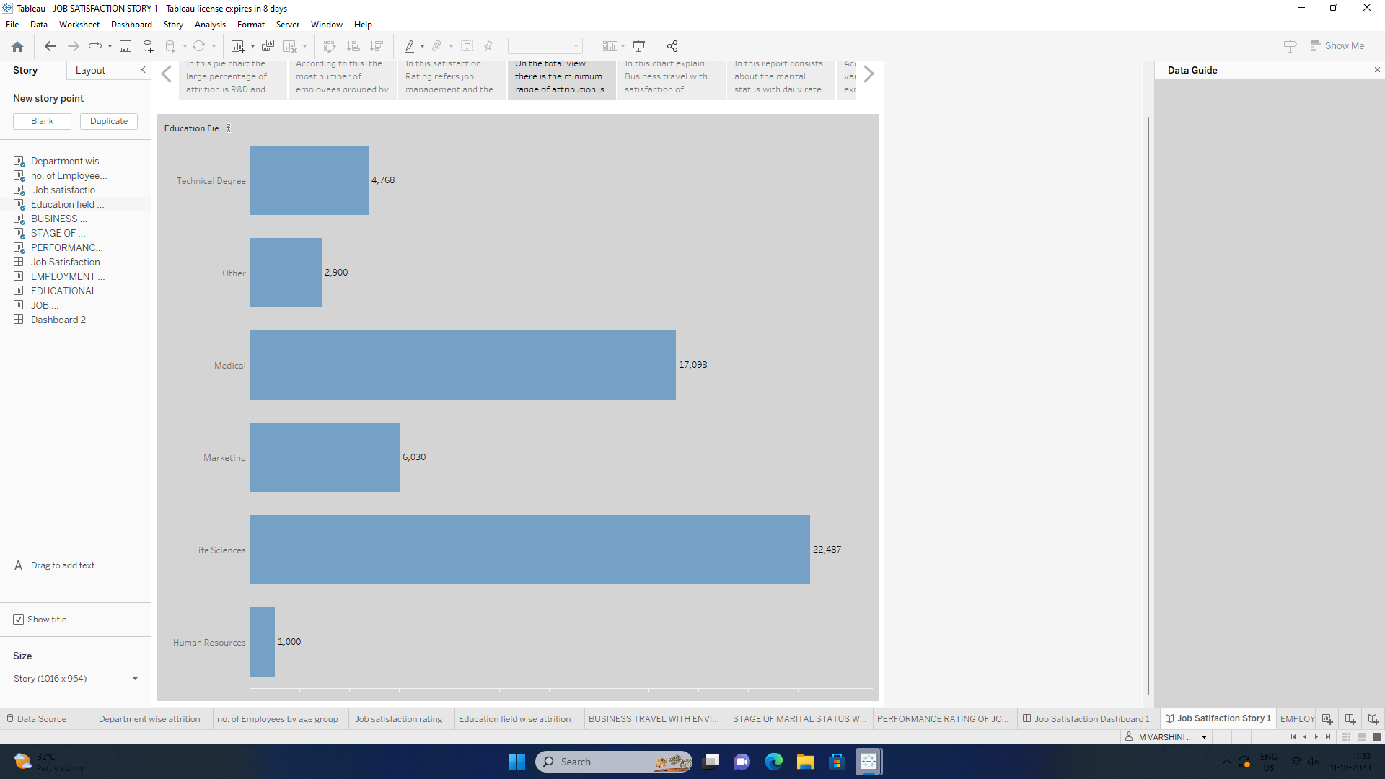

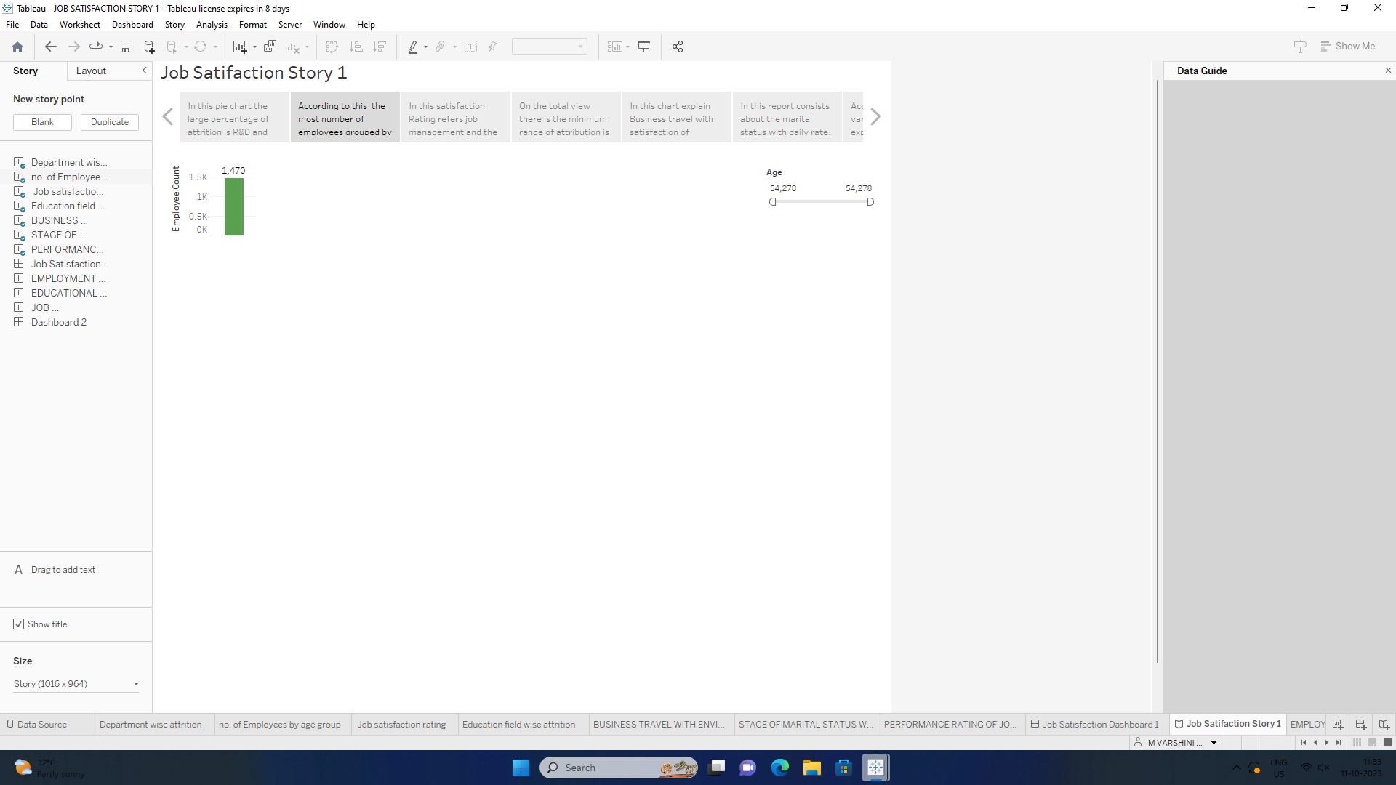

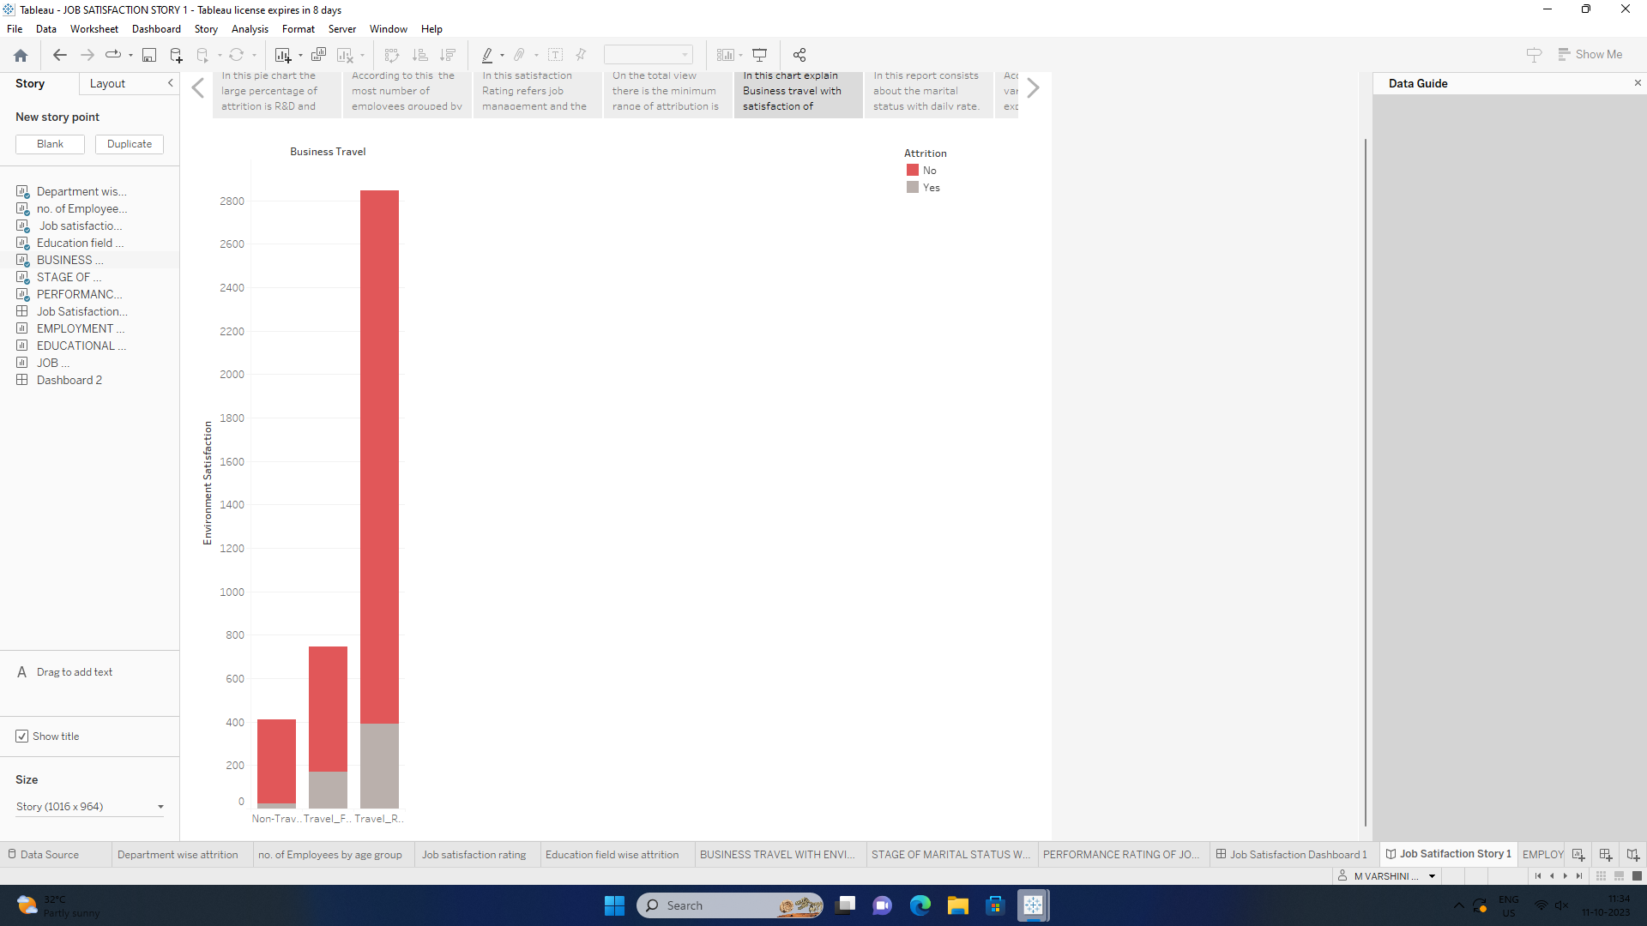

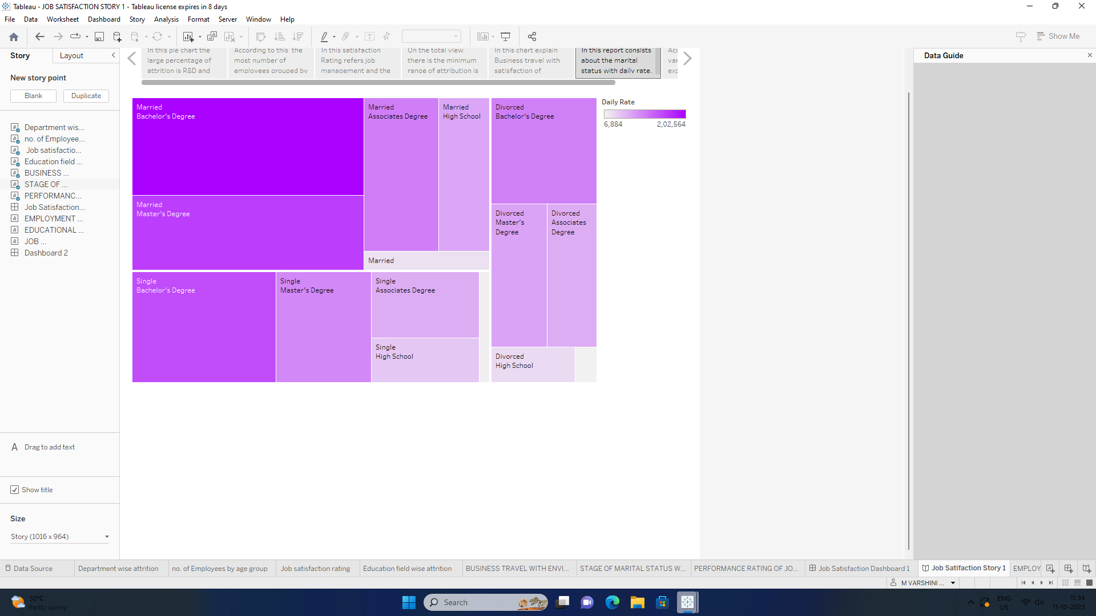

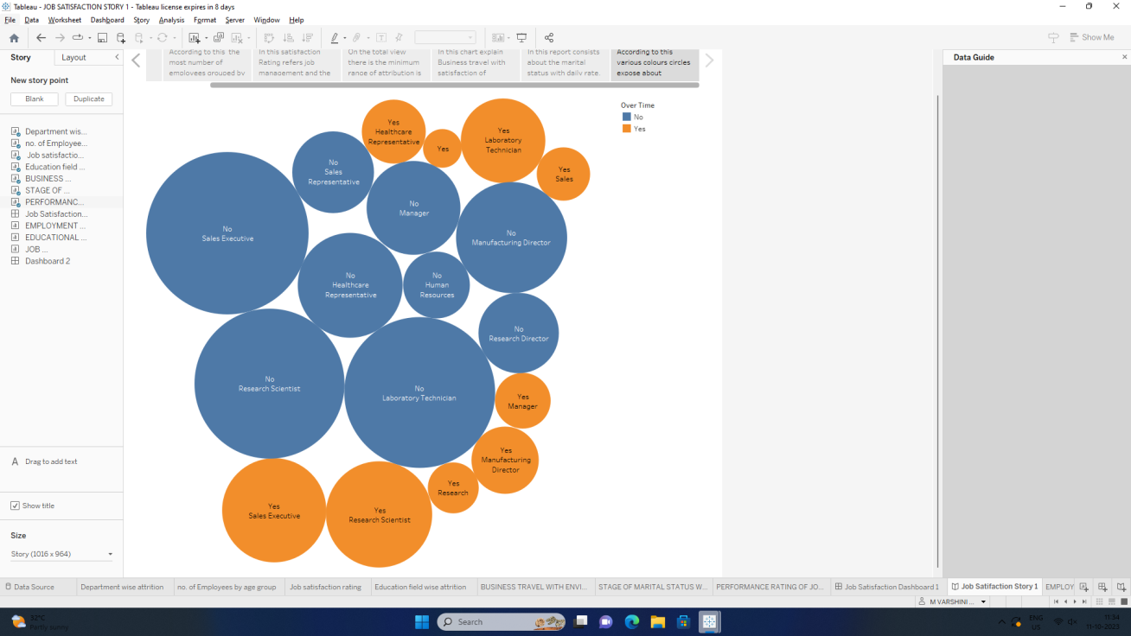

ADVANTAGES

* Help in ascertaining the right person is deployed in the right position.
* Contributes in retaining their top talent.
* Better hiring by hiring assessments
* Helps in understanding employees better and shaping their future.
* Promotes effective communication across different disciplines.

DISADVANTAGES

* The implementation of talent management program could be expensive in terms of time, resources and financial costs.
* Lack of support from line mangers can impede the level of commitment from employees.
* A core drawback of talent management is, it can contribute in raising the conflicts between HR and management by not reaching to proper agreement or consensus.

CONCLUSION

HR professionals play a pivotal role, and **measuring** their impact through KPIs and metrics is essential. These measurements provide actionable insights, guiding data-driven decisions and aligning HR strategies with broader business goals. Focusing on key talent management metrics enhances workforce efficiency and gives a competitive edge.

Talent management is an organization aims at ensuring employee recruitment, training and developing, performance reviews and their compensation. Workings towards enhancing a good talent management system in the organization ensure these components of human sources contributed to the success of the organization.