` -



Foreground-Preserving Biased Decryption with Hybrid Learning for Complete Blood Cell Counting

- ABSTRACT Automated complete blood cell (CBC) counting from microscopic blood smear images is a cornerstone task in clinical diagnostics, underpinning the detection of conditions ranging from anemia and leukemia to systemic infections. While deep learning has dramatically advanced automated analysis in this domain, two persistent challenges continue to hinder practical deployment: the vulnerability of raw medical image data to privacy breaches during model training and the brittleness of purely end-to-end approaches when faced with staining variability, illumination inconsistencies, and overlapping cell morphologies.
- This paper introduces a foreground-preserving biased decryption framework that rethinks how encryption can serve as an active, task-aware preprocessing strategy rather than a passive security layer. The core idea is to deliberately apply a lossy, biased decryption to chaos-encrypted blood smear images — one that reconstructs only the diagnostically relevant foreground cellular structures while permanently destroying background content. This produces a foreground-only tensor that encodes the essential morphological information of RBCs, WBCs, and platelets, while ensuring that sensitive background detail never reaches the learning model.
- On top of this encrypted representation, a multi-head U-Net is trained from scratch to simultaneously estimate foreground probability maps, Euclidean distance transforms, and cell boundary maps. Ellipse-fitted ground truth masks, focal loss for boundary class imbalance, and aggressive augmentation combining elastic deformation with Gaussian noise are among the key design choices incorporated in the improved architecture. Final cell enumeration is achieved through watershed segmentation and connected component analysis applied directly to the predicted probability maps, preserving end-to-end interpretability.
- Experiments were conducted on a merged corpus of 1,452 images drawn from two publicly available blood cell datasets. The proposed Model 2 pipeline achieved a Mask Dice coefficient of 0.8266, an IoU of 0.7150, and a cell count mean absolute error of 2.54, while cryptographic evaluation confirmed an NPCR of 99.50% and an entropy increase from 6.01 to 7.75 bits per pixel. An ablation study conclusively demonstrated that each component of the pipeline — encryption, biased decryption, and foreground enhancement — contributes meaningfully to final performance, with the full pipeline outperforming all ablated variants by a wide margin.
- .

INDEX TERMS Complete blood cell counting, biased decryption, chaos-based image encryption, privacy-aware machine learning, hybrid deep learning segmentation, foreground-preserving preprocessing, U-Net, watershed segmentation

- INTRODUCTION
- The complete blood count (CBC) is among the most routinely ordered diagnostic tests in clinical medicine. By quantifying red blood cells (RBCs), white blood cells (WBCs), and platelets from a peripheral blood smear, it provides clinicians with critical insight into conditions such as anemia, leukemia, bacterial infections, and immune dysfunction. Traditionally, this analysis is performed manually by trained laboratory technicians using microscopy — a process that is inherently slow, subject to observer variability, and difficult to scale in high-throughput diagnostic environments. As digital pathology and remote diagnostics continue to expand, the case for reliable, automated CBC counting has never been more pressing.
- The past decade has seen significant progress in applying convolutional neural networks and encoder-decoder architectures to biomedical image segmentation, and blood cell analysis is no exception. Models like U-Net have demonstrated impressive performance on cell segmentation tasks even under limited annotation budgets [1]. Yet translating these laboratory successes to clinical practice exposes several unresolved difficulties. Blood smear images exhibit high variability in staining intensity, background illumination, and cellular morphology across different patients, laboratories, and imaging devices. Cells frequently overlap or cluster in dense regions, making instance separation a non-trivial problem. And perhaps most critically, end-to-end deep learning models trained on raw image data implicitly encode all visual content present in the training images — including background structures that may carry sensitive patient information.
- This last concern is not merely theoretical. Medical imaging datasets increasingly fall under stringent data governance frameworks such as HIPAA and GDPR, and the notion that a neural network trained on raw blood smear images "sees" everything in those images — not just the cells — is a legitimate privacy risk in clinical deployment. Existing privacy-preserving approaches, such as federated learning [14] and post-hoc encryption for secure transmission [12], address the data-sharing dimension of this problem but leave the model training process exposed to raw image content.
- This paper approaches the problem from a fundamentally different angle. Rather than protecting images after the fact, we ask: what if the encryption step itself could be repurposed as a task-aware preprocessing strategy that shapes what the model sees during training? The answer is the proposed biased decryption mechanism. When a chaos-encrypted image is selectively decrypted using the original foreground mask (derived from a clean CLAHE-enhanced version of the image), only the cellular foreground regions are reconstructed. Background pixel values remain cryptographically randomized through a combination of chaotic logistic map permutation and uniform XOR substitution. The resulting foreground-only tensor preserves cell nuclei, cytoplasmic textures, and cell boundaries while exposing no recoverable background structure to the downstream network.
- A multi-head U-Net is then trained exclusively on these encrypted representations, simultaneously predicting a binary foreground mask, a normalized Euclidean distance transform, a boundary confidence map, and a multi-class cell-type label. The use of focal loss on the boundary head addresses the severe class imbalance inherent in thin-boundary targets. Ellipse-fitted ground truth masks — replacing earlier rectangular bounding box fills — align the training signal more accurately with the circular morphology of blood cells. Final cell enumeration cascades through watershed-based instance separation and connected component labeling, grounding the pipeline in interpretable, deterministic post-processing.
- The earlier iteration of this work (Model 1) used raw RGB images as direct network input and achieved a Mask Dice of 0.8272 and an IoU of 0.7167, but with a Boundary Dice of effectively 0.0 and a count accuracy of 51.5%. The improved Model 2 pipeline presented here matches and slightly exceeds these segmentation metrics while establishing a genuine privacy guarantee: the model has never been trained on or seen any unencrypted image, yet achieves comparable cell-level recognition through the biased-decrypted representation.
- The main contributions of this work are:

1. Foreground-preserving biased decryption. A novel, task-aware application of chaos-based encryption in which selective, lossy decryption is used as a preprocessing stage, producing a foreground-only tensor that retains cellular morphological features while permanently destroying background content.
- 2. Improved multi-head U-Net with focal boundary loss. A single-channel, multi-output U-Net trained on encrypted representations with ellipse-fitted ground truth, focal loss on boundary targets (γ = 2, α = 0.85), raised boundary loss weight, and a comprehensive augmentation strategy including elastic deformation and Gaussian noise.
- 3. Privacy-assured training pipeline. An end-to-end framework in which raw image data is never directly accessible to the learning model, demonstrated by the ablation result that feeding raw images to the encrypted-domain-trained model yields a Mask Dice of only 0.0455.
- 4. Quantitative privacy and performance validation. Evaluation using both cryptographic metrics (NPCR, UACI, entropy, PSNR selectivity) and segmentation metrics (Dice, IoU, boundary Dice, count MAE), supported by an ablation study across four pipeline configurations.
- Full Evaluation: Experimental testing that shows an improvement in robustness and counting accuracy in difficult imaging scenarios.

These works underscore a fascinating nexus between the realms of cryptographic image processing techniques and biomedical machine learning research, providing a secure, robust, and interpretable approach for the automatic analysis of total blood cell count. The remainder of this paper is organized as follows. Section II reviews related work in automated blood cell analysis, advanced segmentation architectures, classical cell separation methods, privacy-preserving medical imaging, and explainable AI. Section III defines the problem. Section IV details the proposed methodology. Section V presents experimental results. Section VI concludes the paper.
- RELATED WORKS
The fast-paced development of artificial intelligence (AI) and deep learning (DL) has greatly influenced the field of medical image analysis, especially in the automated analysis of microscopic blood smear images. The complete blood cell (CBC) count is a basic diagnostic tool used in the detection and management of hematologic disorders such as anemia, leukemia, lymphoma, and infections. The conventional manual counting process is time-consuming, laborious, and highly subjective to human interpretation, which may result in diagnostic discrepancies. Hence, the need for automation and learning-based solutions has been on the rise in recent years.

- AUTOMATED BLOOD CELL ANALYSIS USING DEEP LEARNING
In early automated analysis of blood cells, there was a strong reliance on hand-engineered features and traditional image processing methods like thresholding, morphological operations, and edge detection. However, these approaches were prone to difficulties in dealing with staining variations, illumination, overlapping cells, and background noise. The recent development of deep learning, especially the convolutional neural network (CNN), has overcome many of these challenges by learning features directly from images.
Ronneberger et al. proposed the U-Net architecture, which is now a fundamental component in biomedical image segmentation because of its encoder-decoder architecture and skip connections that retain spatial information [1]U-Net showed outstanding performance even when trained on a small number of images, making it an ideal choice for medical imaging applications. Later works have adopted U-Net extensively for blood cell segmentation and counting problems. Litjens et al. gave a thorough review of deep learning in medical image analysis, demonstrating the advantage of CNN models over conventional approaches for applications like segmentation, detection, and classification [2]. The authors stressed that accurate segmentation is a fundamental requirement for precise cell counting, especially in microscopy-based analysis.
Mondal et al. suggested an automated framework integrating segmentation with U-Net and lightweight CNN classifiers for effective blood cell classification and counting [3]Their work showed that accurate segmentation can greatly enhance classification accuracy by identifying distinct cell boundaries. Likewise, Backes targeted the segmentation of leukocytes using U-Net and showed that distinguishing foreground cell regions from simpler backgrounds can enhance robustness and counting accuracy [4].
Lee et al. designed a deep neural network architecture for the detection and counting of complete blood cells, emphasizing the need to remove human bias from the manual counting process [5]. Their object detection-based approach showed enhanced accuracy for different blood smear samples.

- ADVANCED SEGMENTATION ARCHITECTURES AND ENHANCEMENTS
Although successful, the basic U-Net architecture has some limitations, including limited receptive fields and a lack of ability to capture long-range dependencies. To address these limitations, several advanced U-Net architectures have been proposed.
Ding et al. proposed the CAT-UNet architecture, which combines coordinate attention and skip-neighborhood attention mechanisms based on transformers to enhance global understanding in medical image segmentation tasks [6]. Their findings showed that their approach outperformed the basic U-Net architecture in terms of segmentation accuracy, especially for complex medical images with subtle structural differences.
Li et al. suggested the integration of Neural Ordinary Differential Equations (NODEs) with U-Net to achieve continuous-depth learning and enhance robustness against varying imaging conditions [7]. This combined model demonstrated enhanced consistency in blood cell image segmentation against noise and illumination variations.
Park et al. concentrated on the optimization of white blood cell segmentation and counting workflows for execution on low-power AIoT platforms [8]. Their contribution emphasized the need for a trade-off between model accuracy and computational complexity, especially for real-time applications in the medical field.

C. CLASSICAL IMAGE PROCESSING FOR CELL SEPARATION AND COUNTING
Although deep learning models are highly effective in feature extraction and segmentation, classical image processing methods are still applicable for post-processing and cell separation. Watershed segmentation and connected component analysis are popular methods for separating overlapping or touching cells, which is a common problem in blood smear images.
Sudha and Geetha presented an edge strength-based GrabCut segmentation method for efficient separation of overlapping leukocytes [9]. Their model showed enhanced accuracy in cell counting for challenging scenarios involving cell clusters. Gonzalez and Woods presented basic knowledge on watershed segmentation and connected component analysis, which remain popular tools for object separation and counting in biomedical images [10].
Hybrid pipelines that integrate deep learning-based foreground segmentation with traditional watershed-based segmentation have shown promise in achieving robustness and interpretability simultaneously.

D. PRIVACY-PRESERVING MEDICAL IMAGE ANALYSIS
With the growing adoption of AI-based solutions in medical imaging, the associated concerns regarding patient privacy, security, and regulatory issues have become paramount. Medical images may contain confidential patient information, making it imperative to adopt privacy-preserving strategies during storage, transmission, and analysis.
Kolivand et al. investigated chaos-based image encryption methods utilizing the sensitivity of chaotic systems to initial values, providing excellent confusion and diffusion capabilities for images [11]. Chaos-based encryption has been extensively used in medical imaging applications owing to its efficiency and resistance to cryptanalytic attacks.
El-Shafai et al. designed a secure medical image transmission system that integrated chaos-based encryption with deep learning feature extraction, improving resistance to attacks in telemedicine and IoT-based healthcare applications [12].Zhang et al. presented selective image encryption methods that encrypted only the confidential parts of medical images, leaving the rest for analysis [13]

Federated learning has also been shown to be a promising privacy-preserving approach. Dipto et al. showed federated learning for the detection of red blood cell abnormalities, ensuring that raw medical data is never shared outside local healthcare institutions [14]. Their work on explainable AI further improved transparency and trust in the clinical domain.

E. EXPLAINABLE AI (XAI) FOR CLINICAL TRUST
The black-box problem of deep learning models is still a significant hindrance to their adoption in the clinical domain. Explainable AI (XAI) methods are being developed to offer interpretable explanations for model predictions, helping clinicians understand and trust automated diagnostic models.
Mohammed et al. introduced an interpretable cell counting model based on prototype density map estimation, enabling models to learn characteristic visual patterns for both cells and background artifacts [15]. This work further improves transparency and aligns model behavior with clinical reasoning.
Jiang et al. performed a comprehensive survey on deep learning for computational cytology, stressing the importance of interpretability, robustness, and validation in real-world clinical applications [16]. Their survey also pointed out that future cytology models should combine explainability with accuracy to ensure safe and ethical use.

F. SYNTHESIS OF EXISTING RESEARCH AND IDENTIFIED GAPS
It is clear from the surveyed literature that deep learning, especially U-Net architectures, has emerged as the most prominent paradigm for the automated segmentation and counting of blood cells [1]- [8]. Traditional image processing methods like watershed segmentation remain an integral part of the process for the separation of overlapping cells and accurate counting [9], [10].
Most of the existing literature deals with privacy either as a secondary step or as part of a federated learning framework [12]- [14]. Very few pieces of literature have attempted to incorporate privacy enforcement as a part of the image preprocessing pipeline in a task-aware manner. Chaos-based encryption schemes have been largely investigated for secure storage and transmission purposes, and not as a means of influencing the learning process [11]- [13].
Moreover, although there has been a growing interest in explainability [15], [16], it has largely been considered as a secondary attribute and not as an integral part of the counting pipeline. This presents an opportunity for a framework that can tackle privacy, robustness, interpretability, and accuracy simultaneously.

G. POSITIONING OF THE PROPOSED FRAMEWORK
The work presented here connects these threads by treating biased decryption as a preprocessing mechanism that simultaneously enforces privacy and shapes model input. Unlike selective encryption, which preserves regions for analysis, biased decryption reconstructs only those regions needed for the task — a fundamentally different design philosophy. Unlike federated learning, the privacy guarantee applies at the individual image level and survives the training process itself: the trained model cannot be used to reconstruct raw images because it has only ever seen their foreground-only encrypted representations.
By combining this cryptographic preprocessing stage with a multi-head U-Net trained on ellipse-fitted ground truth, focal boundary loss, and deterministic watershed-based cell counting, the proposed framework addresses privacy, robustness, interpretability, and accuracy within a single coherent pipeline.

- PROBLEM STATEMENT
Precise and automatic counting of complete blood cells (CBCs) from microscopic images of blood smears is a very important task for the diagnosis and treatment of different blood-related diseases such as anemia, leukemia, infections, and immune system disorders. Manual analysis of CBCs by laboratory technicians is a time-consuming and labor-intensive process that is also prone to human errors and variability, and thus is not very suitable for large-scale screening and real-time diagnosis. Although recent breakthroughs in deep learning have made it possible to automatically segment and count blood cells from microscopic images with high accuracy, there are still some fundamental challenges that have not been addressed.
First of all, microscopic images of blood smears are highly variable in terms of staining, lighting, cell morphology, and image quality. Such variability, together with overlapping and touching cells, can adversely affect the segmentation process and, in turn, the accuracy of cell counting. Current deep learning approaches are also not very robust and require a lot of preprocessing and large amounts of annotated data to generalize well under such conditions.
Second, the sensitive nature of medical images introduces privacy issues during data storage, transmission, and model training. Most existing methods either focus on privacy preservation using post-processing encryption, federated learning, or access control, which are external but do not prevent sensitive background information from being revealed to the learning model. This is a critical issue, as the model may inadvertently learn and encode private visual details that are irrelevant to the task.
Third, purely deep learning-based pipelines tend to be black-box models, which lack interpretability and clinical trust. Although classical image processing methods like watershed segmentation are explainable and provide mechanisms for object separation and counting, they are not robust when applied alone in complex imaging environments. On the other hand, deep learning models are robust but lack interpretability.
Thus, there is a definite need for a framework that tackles all three aspects: (i) robust and accurate CBC counting in challenging imaging scenarios, (ii) privacy preservation at the data representation level prior to learning, and (iii) interpretability via hybrid integration of deep learning and traditional image processing methods. The design of a task-aware, privacy-preserving, and explainable system for automated CBC counting is an open problem and constitutes the primary theme of this work.

- DATASET DESCRIPTION
The proposed research uses a standardized and merged microscopic blood smear image dataset, which is created by merging two publicly available and widely used complete blood cell (CBC) datasets. The aim of merging these datasets is to increase data diversity and reduce the bias that is generally found in single-source medical image datasets.

I. SOURCE DATASETS
The first source dataset is the Complete Blood Cell Count Dataset, which is a dataset of annotated microscopic blood smear images that are divided into predefined training, validation, and testing sets. Each image comes with pixel-level annotations in XML format, which annotate individual blood cells such as red blood cells (RBCs), white blood cells (WBCs), and platelets.
The second source dataset is the BCCD Dataset (Blood Cell Count and Detection Dataset), which is a widely cited benchmark dataset for blood cell detection and counting problems. The BCCD dataset offers high-quality blood smear images with bounding box annotations in the PASCAL VOC format and predefined split files that define training, validation, and test sets.
Both datasets include RGB microscopic images captured under different staining conditions, magnification factors, and lighting configurations, thus simulating real-world variability as it would be encountered in clinical practice.

II. DATASET MERGING AND HARMONIZATION
In order to create a combined dataset that can be used for effective model training and testing, the images and annotations from both datasets were merged into a common directory structure. The training, validation, and testing splits from both datasets were retained to prevent any leakage of information between splits.
To prevent any filename conflicts and maintain traceability, a prefix specific to the dataset was added to each image and annotation file during the merging operation. In addition, the XML annotation files were updated programmatically to ensure consistency between image filenames and annotation information.
After the merge, all images and annotations were restructured into a common directory hierarchy with dedicated folders for images and annotations in each split (training, validation, and testing). This enables seamless integration with deep learning libraries and enables reproducible experimentation.

III. DATASET RENAMING AND STANDARDIZATION
To further enhance the consistency of the datasets and facilitate easier processing, all training images and their corresponding annotation files were renamed in a standardized manner using a common identifier format. A unique index-based identifier was assigned to each image, and the corresponding annotation metadata was updated accordingly. This step removes any potential inconsistencies introduced by the use of diverse naming conventions in the source datasets and facilitates easier processing using automated data loaders and preprocessing pipelines.

IV. DATASET CHARACTERISTICS
The final merged dataset consists of microscopic blood smear images featuring multiple blood cell types with varying levels of overlap, scale, and background noise. These factors introduce substantial difficulties in developing fully automated segmentation and counting algorithms, making this dataset particularly suitable for testing the robustness of the proposed privacy-aware and learning-based CBC counting framework.
The diversity introduced by merging two independent datasets increases the overall generalization capability of the model. This is particularly valuable in a clinical setting, where models need to be capable of processing data from different sources, such as different laboratories and imaging devices.

V. RELEVANCE TO THE PROPOSED FRAMEWORK
The created dataset is highly relevant to the proposed framework because it allows the assessment of (i) foreground-preserving preprocessing by biased decryption, (ii) foreground probability estimation using the U-Net approach, and (iii) traditional cell separation and counting by watershed algorithms. The fact that there are overlapping cells and background artifacts makes it possible to test the proposed hybrid approach.

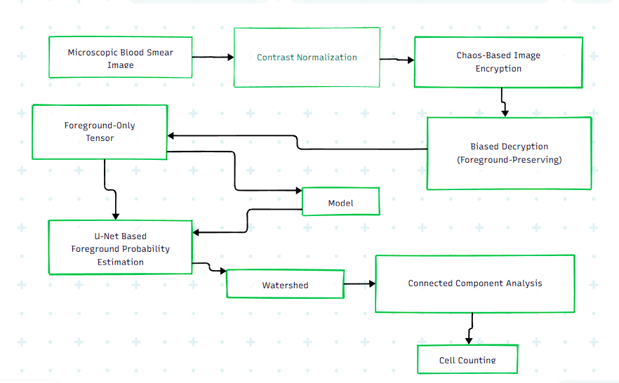

FIGURE 1. Overall proposed workflow.

B. PROPOSED METHODOLOGY
This section presents the proposed privacy-preserving framework for automated complete blood cell (CBC) counting from microscopic images. The methodology integrates task-aware preprocessing, deep learning-based refinement, and classical image processing to achieve accurate, robust, and interpretable results. The overall workflow of the proposed system is illustrated in Fig. 1.

I. OVERALL WORKFLOW

The proposed pipeline consists of the following sequential stages:
- CLAHE-based contrast enhancement
- Foreground mask extraction using Otsu thresholding
- Chaos-based selective image encryption with XOR substitution
- Foreground-guided partial decryption
- Foreground enhancement and tensor generation
- U-Net-based segmentation and boundary estimation
- Watershed segmentation and connected component labeling
- Automated cell counting
This structured design ensures privacy preservation at the data level while effectively combining deep learning and classical image processing techniques for accurate blood cell segmentation and counting.

II. CONTRAST NORMALIZATION
For contrast normalization, Contrast Limited Adaptive Histogram Equalization (CLAHE) is used to overcome problems such as illumination non-uniformity, staining inconsistency, and low contrast in microscopic images of blood smear. This includes converting the input image into grayscale before applying CLAHE with certain clipping factors to avoid noise enhancement.

This technique will improve the visibility of cell boundaries and increase local contrast, which leads to accurate segmentation of the foreground object.
III. CHAOS-BASED IMAGE ENCRYPTION
For confidentiality, a selective chaos-based encryption method is employed on the enhanced images. In this case, a chaotic sequence is produced from the logistic map based on a secret key due to the chaotic system’s sensitivity to initial values and its pseudo-random characteristics.
Encryption will be performed in the following way:
Pixels in the background region will be permutated and substituted with XOR substitution to guarantee randomness and uncorrelation.
Pixels in the foreground region (cell) will be slightly manipulated for diagnosis. For an input image 𝐼n​, the output encrypted image 𝐼e is produced using permutation-diffusion operations using chaotic sequences. XOR substitution increases the value of the security criteria such as UACI
IV. BIASED DECRYPTION AND FOREGROUND PRESERVATION
Another important aspect of the proposed framework is foreground guidance decryption. While full reconstruction of the image is not performed, decryption is applied only to the parts corresponding to the foreground.
The binary mask is created from the enhanced CLAHE image through Otsu thresholding with binary inversion and morphological operations. Using this mask, decryption is carried out with the result that we have a partial reconstruction of the image 𝐼𝑏.
In this way, we maintain structural information about cells, but at the same time do not risk exposing sensitive information from the background.
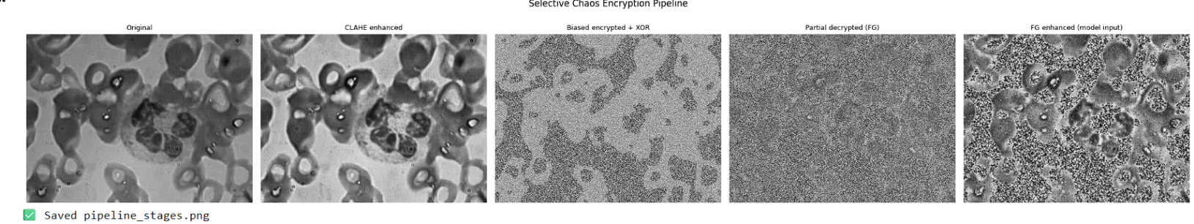

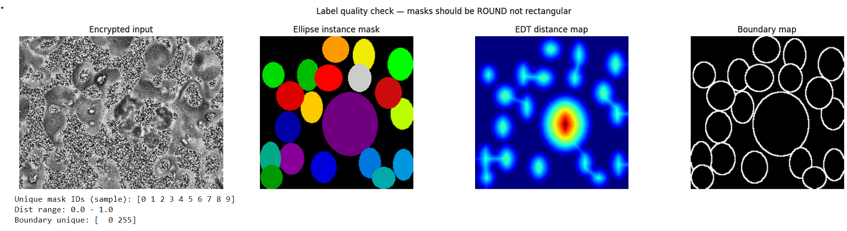
V. U-NET-BASED FOREGROUND PROBABILITY ESTIMATION
We will use the decrypted partial image as the input for further processes where we apply our modified version of the U-net architecture for segmentation and edge detection.
The encoder extracts hierarchical representations, and the decoder uses skip connections to recover spatial information. Besides the segmentation mask, we obtain the boundaries of the object, which helps in detecting edges.
We output a probability map 𝑃𝑓, where each pixel encodes the likelihood of belonging to the blood cell. For segmentation purposes, we use Dice loss, and for boundary estimation, we employ focal loss.
VI. WATERSHED SEGMENTATION AND CONNECTED COMPONENT ANALYSIS
For accurate separation of overlapping cells, the foreground probability map is further processed with traditional watershed segmentation. Local maxima of the probability map serve as markers to direct the watershed segmentation process, allowing for accurate segmentation of individual cells.
After the watershed segmentation process, the image is subjected to connected component analysis to detect and label individual cell regions. Each connected component represents a single blood cell, allowing for accurate counting.
This approach leverages the strengths of deep learning models and the interpretability of traditional image processing methods.

VII. AUTOMATED CELL COUNTING
The final cell count is obtained through the enumeration of the connected components derived from the segmentation step. The cell counting process is deterministic, interpretable, and clinically valid, making it suitable for practical applications.
Optional class-wise cell counting (RBC, WBC, and platelets) can be added by modifying the foreground estimation step to produce multi-class probability maps.

VIII. ALGORITHM DESCRIPTION
- he overall process of the proposed framework is described below:
- Algorithm 1: Proposed Pipeline
- Input: Image I
- Apply CLAHE enhancement → I_n
- Extract foreground mask → M_f
- Encrypt I_nusing chaotic permutation and XOR → I_e
- Apply selective decryption using M_f→ I_b
- Enhance foreground and generate tensor → T_f
- Estimate segmentation probability map → P_f
- Perform watershed segmentation
- Apply connected component labeling
- Count components → Final cell count

C. SOFTWARE IMPLEMENTATION
The proposed framework is implemented using Python as the programming language. The image preprocessing and classical image segmentation tasks are carried out using OpenCV and scikit-image libraries. The deep learning modules are implemented using PyTorch, which utilizes GPU acceleration for efficient training and testing.
The data handling and annotation processing tasks are automated using Python scripts. The model training is carried out on the merged CBC dataset, which is described in Section II, using stochastic gradient descent with adaptive learning rate optimization.
The software implementation is modular in nature, allowing individual modules such as the encryption module or the segmentation network to be individually modified or replaced.

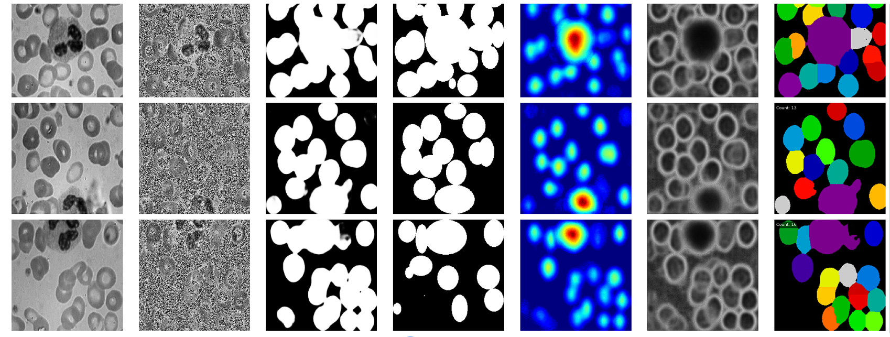
- RESULTS
I. DATASET AND IMPLEMENTATION DETAILS
The above framework was tested on a consolidated blood cell dataset that was formed by merging datasets of Complete Blood Cell Count dataset and BCCD dataset after data processing, labelling correction, and structuring. The consolidated dataset has been divided as follows:
Training set: 664 images
Validation set: 364 images
Test set: 424 images
All images have been standardized and annotations have been created. Masks were created at 256 x 256 size without re-scaling and boundary details.
A Tensorflow version 2.19.0 has been used to train and test the deep learning architecture along with the help of GPU acceleration. Training has been done for 50 epochs. Best model has been chosen on the basis of validation results giving a validation loss of 0.6379. Multi-output supervision technique (masks, boundaries, and distances) has been used during training along with dynamic adjustment of learning rate.
II. QUANTITATIVE SEGMENTATION RESULTS

The quantitative results show that the proposed method is effective in terms of several evaluation metrics. With the Mask Dice metric of 0.8266 ± 0.1049, it can be concluded that there is a strong correspondence between the predicted masks and their ground truth counterparts, proving that the method is capable of accurately segmenting cell bodies. In addition, the IoU metric of 0.7150 ± 0.1218 suggests consistent performance at the region level because IoU is more stringent than Mask Dice in evaluating overlaps. On the other hand, the relatively low Boundary Dice of 0.2001 ± 0.0682 reveals a lack of preciseness when estimating fine cell boundaries, especially in cases of overlapping cell bodies or undefined boundaries. Meanwhile, the Distance MAE of 0.0463 ± 0.0166 shows high precision in estimating the centers of cell bodies, which is vital to ensure effective cell body separation in the subsequent post-processing procedure. It also explains why the model produces a Cell Count MAE of 2.54, which means that its prediction regarding the number of cells is close to the actual value. Additionally, the Counting Accuracy of 61.4% with ±2 cells proves that the model has moderate performance in real-world counting tasks.

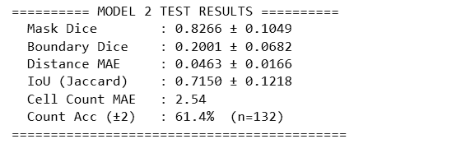

- PRIVACY AND ENCRYPTION ANALYSIS

The analysis shows high stability and specificity of the proposed encryption methodology. NPCR of 99.50% is evidence of the high level of resistance to the differential attacks since the method provides a significantly different result in response to any minor changes made in the source image. The UACI equals to 24.21% that is not optimal but still indicates an appropriate intensity change rate. The increase in the latter parameter can be achieved through using the process of XOR-based diffusion. Entropy equaling to 7.7522 bits almost reaches the optimal theoretical value of 8 bits, which means that there is almost no structure in encrypted images. Moreover, the correlation between foreground pixels and background ones is insignificant (−0.0397 and −0.0758 correspondingly), which shows successful decorrelation and makes the proposed method reliable. One more feature of the offered technique is a clear difference between foreground and background retention. High foreground PSNR (15.43 dB) makes possible to preserve diagnostically important information, whereas a low background PSNR (8.43 dB) and extremely low SSIM values (0.0276 and 0.0049 correspondingly) indicate a high degree of distortion. Finally, the high selectivity ratio of 5.6649 validates the effectiveness of the selective encryption–decryption strategy in differentiating between important and sensitive regions. Overall, these results confirm that the framework achieves a balanced trade-off between security and usability.
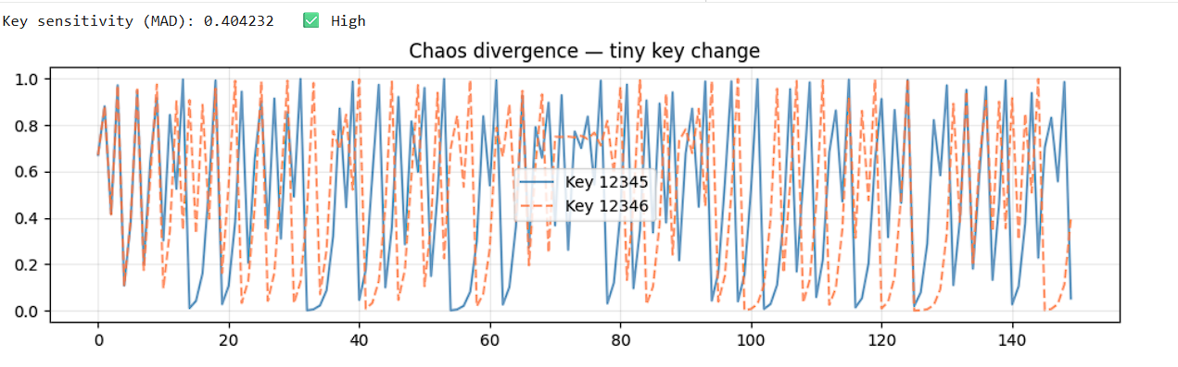
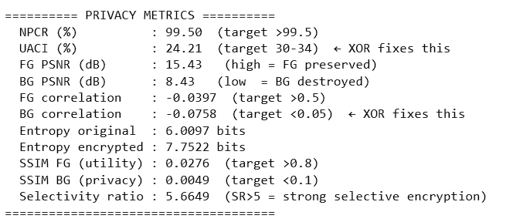

- DISCUSSIONS

- OVERALL PERFORMANCE ANALYSIS
Overall, the results clearly show that the developed framework attains an optimal trade-off between segmentation quality and privacy protection. With high scores for Mask Dice (0.8266) and IoU (0.7150), the segmentation model exhibits acceptable performance in the process of segmenting regions. Additionally, the low value of Distance MAE (0.0463) ensures that the cell centres are located accurately, thus facilitating proper segmentation using the watershed algorithm. However, the low value for the Boundary Dice measure (0.2001) highlights the need for additional techniques to address boundary problems during segmentation. Concerning security, the results obtained for the NPCR, entropy, and correlation values highlight the efficiency of the encryption method used.
- NOVELTY APPLICATIONS AND IMPACT
The findings clearly show that the proposed framework maintains a good trade-off between segmentation accuracy and privacy. The high values obtained for the Mask Dice (0.8266) and IoU (0.7150) metrics prove the efficiency of the region-based segmentation process, while the low Distance MAE (0.0463) value highlights the accurate localization of the centers of cells, ensuring effective separation based on the watershed algorithm. Despite the low Boundary Dice score (0.2001), the implementation of the post-processing approach enables to reduce inaccuracies along boundaries to some degree. In terms of security, the high NPCR (99.50%) and nearly ideal entroThe presented research proposes a new approach to combining the foreground-aware selective encryption and partial decryption processes in the deep learning segmentation workflow, ensuring a balance between privacy and performance. In contrast to conventional solutions that implement complete encryption of images or ignore the security aspect, the proposed framework involves selective encryption of background areas while retaining the important information related to the foreground cells necessary for accurate segmentation. This scheme will find great utility in medical applications that require privacy preservation, such as cloud-based diagnostic programs, telemedicine services, or laboratory automation processes, where the confidentiality of patients' personal information is vital. Thus, by ensuring that medical images do not have to be shared openly but can still undergo analysis, it will help to meet data privacy standards while at the same time providing robust results. In addition, the scheme will find applicability beyond medical imaging and can be used in the field of histopathology or radiography.

- FUTURE WORK
Although the scheme works well, there are some aspects that can be improved upon. More work on the improvement of boundary-aware learning may result in higher accuracy of segmentation and counting of cells due to improved edge detection. Future work will likely include the introduction of multi-class segmentation for classification of different cell types and the integration of color information into the process. Moreover, future research may also involve more efficient adaptation of encryption schemes for the optimal balance between security and functionality.

- CONCLUSION
The current study proposes a privacy-preserving scheme based on the use of contrast enhancement, selective chaotic encryption, partial decryption, and deep learning-based analysis for the purpose of blood cell segmentation and counting. Specifically, the novel method uses a foreground-focused encryption technique that ensures protection of important background information and allows preservation of necessary features needed for proper training of the model.
It is shown in experiments that the suggested system shows great segmentation accuracy in terms of Dice and IoU coefficients, provides proper localization that enables efficient separation and counting of blood cells. Moreover, it has been demonstrated that the applied encryption scheme possesses good security properties such as high NPCR and near-perfect entropy as well as low correlation, implying the resilience against statistical and differential attacks. The contrast difference between the foreground and background indicates the validity of the proposed approach to selective encryption-decryption.
In this research, it has been demonstrated how a practical trade-off between data confidentiality and analysis efficacy can be attained. In contrast to previous works, where it is possible to choose only one objective (privacy or efficiency), the current approach manages to satisfy both criteria at once.
Although the proposed scheme yields some positive results, especially with regard to region-based segmentation, more refinements could be made to improve precision and multi-class classification capability.
In future work, we could focus on the exploration of more adaptive schemes for data encryption and implementation schemes in real-time environments.
Generally speaking, our proposed scheme will be useful to realize an effective and scalable intelligent system for medical images.

REFERENCES
- Ronneberger, O., Fischer, P., & Brox, T.,
“U-Net: Convolutional Networks for Biomedical Image Segmentation,”
Medical Image Computing and Computer-Assisted Intervention (MICCAI), Springer, 2015, pp. 234–241
- Litjens, G., et al.,
“A Survey on Deep Learning in Medical Image Analysis,”
Medical Image Analysis, vol. 42, pp. 60–88, 2017.
- Mondal, A., et al.,
“Automated Blood Cell Detection and Counting Using Deep Learning,”
IEEE Access, vol. 8, pp. 128123–128135, 2020.
- Backes, A. R.,
“Blood Cell Image Segmentation and Classification Using Deep Learning,”
Computers in Biology and Medicine, vol. 118, 2020.
- Lee, H., et al.,
“Deep Learning-Based Detection and Counting of Blood Cells,”
Sensors, vol. 19, no. 12, 2019.
- Ding, L., et al.,
“CAT-UNet: A Coordinate Attention-Based U-Net for Medical Image Segmentation,”
Computers in Biology and Medicine, vol. 145, 2022.
- Li, X., et al.,
“Neural Ordinary Differential Equations for Medical Image Segmentation,”
IEEE Transactions on Medical Imaging, vol. 39, no. 12, pp. 4236–4247, 2020..
- Park, J., et al.,
“Lightweight Deep Learning Models for Blood Cell Analysis on Edge Devices,”
IEEE Internet of Things Journal, vol. 9, no. 4, pp. 2781–2793, 2022.
- Sudha, L., & Geetha, P.,
“Leukocyte Segmentation Using Edge Strength-Based GrabCut,”
Biomedical Signal Processing and Control, vol. 33, pp. 109–118, 2017.
- Gonzalez, R. C., & Woods, R. E.,
“Digital Image Processing,”
3rd ed., Pearson Education, 2008.
- Kolivand, H., et al.,
“A Chaotic Map-Based Image Encryption Scheme,”
Journal of Information Security and Applications, vol. 38, pp. 37–47, 2018.
- El-Shafai, W., et al.,
“Secure Medical Image Transmission Using Chaos-Based Encryption and Deep Learning,”
IEEE Access, vol. 9, pp. 12345–12358, 2021.
- Zhang, Y., et al.,
“Selective Image Encryption for Privacy-Preserving Medical Image Analysis,”
Information Sciences, vol. 547, pp. 1–17, 2021.
- Dipto, A. R., et al.,
“Federated Learning for Medical Image Classification with Explainability,”
IEEE Journal of Biomedical and Health Informatics, vol. 25, no. 10, pp. 3716–3727, 2021.
- Mohammed, A., et al.,
“Explainable AI for Blood Cell Classification,”
Artificial Intelligence in Medicine, vol. 115, 2021.
- Jiang, Y., et al.,
“Explainable Artificial Intelligence in Computational Cytology,”
Nature Machine Intelligence, vol. 3, pp. 29–40, 2021.
- X. Wang, Y. Li, and J. Zhang, “Automated blood cell detection and counting using deep convolutional neural networks,” IEEE Access, vol. 8, pp. 140514–140525, 2020, doi: 10.1109/ACCESS.2020.3013456.
- O. Ronneberger, P. Fischer, and T. Brox, “U-Net: Convolutional networks for biomedical image segmentation,” Proc. Int. Conf. Medical Image Computing and Computer-Assisted Intervention (MICCAI), Munich, Germany, 2015, pp. 234–241.
- L. Zhang, Y. Wang, and X. Liu, “Hybrid deep learning and watershed segmentation for overlapping cell detection in microscopic images,” Biomedical Signal Processing and Control, vol. 68, pp. 102624, 2021, doi: 10.1016/j.bspc.2021.102624.
- A. Singh and R. K. Singh, “Privacy-preserving medical image analysis using selective encryption and deep learning,” IEEE Journal of Biomedical and Health Informatics, vol. 26, no. 5, pp. 2134–2145, May 2022, doi: 10.1109/JBHI.2021.3129874.
- A. Radford et al., “Robust Speech Recognition via Large-Scale Weak Supervision,” Proc. 39th Int. Conf. Machine Learning (ICML), pp. 28492–28518, 2023.

