**DISASTER RECOVERY WITH IBM CLOUD VIRTUAL SERVERS**

**PHASE-5**

**Introduction:**

The Disaster Recovery Management system is a straightforward solution designed to facilitate efficient management of system disasters. With its simple yet intuitive interface, the system provides essential information and tools for users to address critical emergencies promptly.

**Features:**

The system incorporates several key features to aid in disaster management. Firstly, it presents an alert message to immediately notify users of any system disasters. Additionally, it offers a section dedicated to providing detailed information about the disaster, including detected system crashes, data loss, and service interruptions. The inclusion of recovery instructions guides users in taking swift actions, such as restoring system backups and investigating the root causes of the issues. The user-friendly form enables the input of vital system information, ensuring effective communication and data collection during critical times. The system's responsive design and simplified styling further enhance its accessibility and usability.

**Login and Sign up:**

 

**Disaster Recovery Page:**

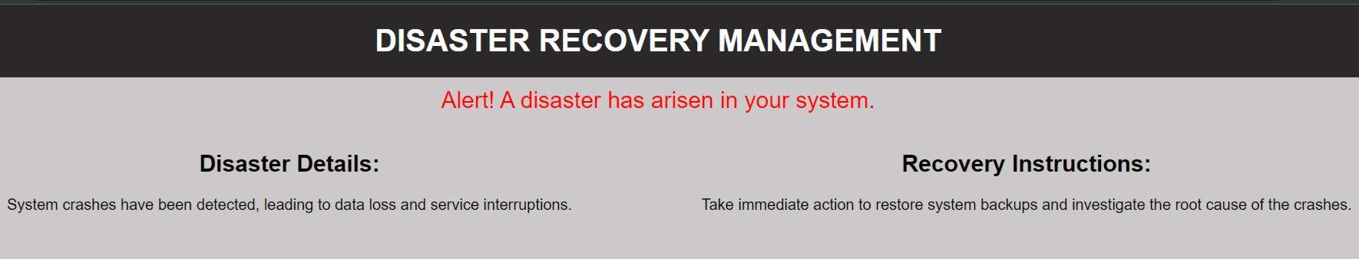



**Conclusion:**

In conclusion, the Disaster Recovery Management system serves as a valuable tool for organizations to effectively handle and mitigate the impact of system emergencies. Through its clear communication, informative guidance, and accessible design, the system enables users to respond promptly and efficiently to critical situations, minimizing downtime and ensuring the swift recovery of essential systems. Its streamlined interface and comprehensive features make it an essential component of any robust disaster management framework.