**DISASTER RECOVERY WITH IBM CLOUD VIRTUAL SERVERS**

**BATCH MEMBER**

**711221243052 : VARSHINI.S**

**PHASE -3**

**TOPIC : EARTHQUAKE DISASTER RECOVERY WITH IBM CLOUD VIRTUAL SERVERS**

**INTRODUCTION:**

* Disaster recovery management using IBM virtual servers in the cloud involves setting up a resilient and redundant infrastructure to ensure business continuity in the event of a disaster.
* IBM Cloud provides various services and tools that can be leveraged for effective disaster recovery.

**REQUIREMENTS:**

* **Risk Assessment**
* **Building and Infrastructure Safety**
* **Business Impact Analysis**
* **Emergency Response Plan**
* **Employee Training and Drills**
* **Communication and Notification**
* **Data Backup and Recovery**
* **Utilities and Services**
* **Incident Response Tea**
* **Testing and Evaluation**

**DIFFERENT FUNTIONS BASED ON REQUIREMENTS:**

Leveraging IBM Cloud virtual servers for earthquake recovery management involves setting up a resilient and flexible IT infrastructure to ensure rapid recovery and continuity of critical operations in the event of an earthquake or disaster.

1. **Data Backup and Recovery:**

* Utilize IBM Cloud Object Storage to regularly back up critical data and applications.
* Implement automated backup and snapshot schedules to ensure data is protected and can be restored quickly.
* Set up virtual servers at a disaster recovery site that can be used to restore backed-up data.

1. **Disaster Recovery Site:**

* Create a secondary data center or recovery site using IBM virtual servers in a geographically distant location.
* Ensure the secondary site is equipped with necessary resources, such as virtual servers, storage, and networking, to support recovery operations.

**3. Failover and Redundancy:**

* Configure IBM virtual servers with high availability across different availability zones or regions to ensure service continuity.
* Use IBM Cloud Load Balancer to distribute traffic across multiple virtual servers for load balancing and failover.

**4. Monitoring and Alerting:**

* Implement monitoring solutions like IBM Cloud Monitoring to track the health and performance of virtual servers.
* Configure alerts to notify administrators of issues and initiate automated recovery processes when necessary.

**5. Security and Access Control:**

* Implement robust security measures for IBM virtual servers using IBM Cloud Identity and Access Management (IAM).
* Ensure secure data transmission and storage with encryption.

**DATASET :**

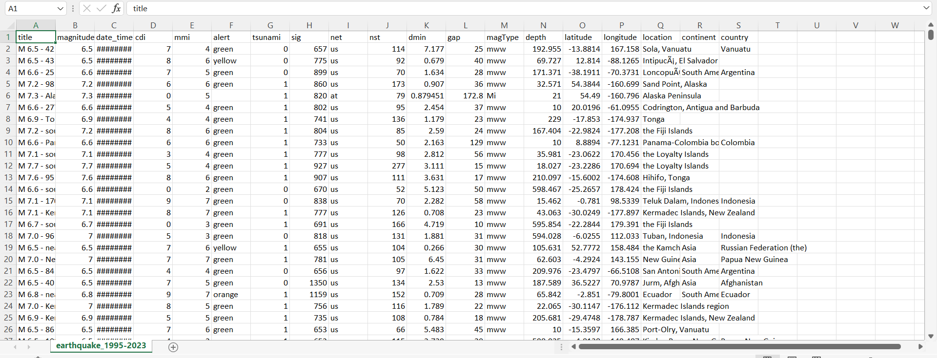

**PROGRAM:**

**STEP 1:IMPORT NECESSARY PACKAGES**

import numpy as np

import pandas as pd

df = pd.read_csv('.. /earthquake_data.csv')

df.info()

df.shape

df.dtypes

df.info()

df.describe()

**STEP 2:DUPLICATE AND NULL REPORT**

df.duplicated()

df.duplicated().sum()

df.isnull()

df.isnull().sum()

df['alert'].unique()

df['alert'].fillna('Unknown', inplace=True)

df.head(10)

**STEP 3:DATETIME TRANSFORMATIONS**

df['date_time'] = pd.to_datetime(df['date_time'], dayfirst=True)

df.info()

df['year'] = df['date_time'].dt.year

df["month"] = df["date_time"].dt.month_name()

df.head(10)

col = df.pop('month')

df.insert(3, col.name, col)

col = df.pop('year')

df.insert(3, col.name, col)

df.head(10)

**STEP 4:DATA VISUALISATION**

import seaborn as sns

import matplotlib.pyplot as plt

countries = df['country'].value_counts()

print(countries)

top_10_countries = (df['country'].value_counts()).iloc[:10]

print(top_10_countries)

top_10_countries.plot(kind='bar')

for index, value in enumerate(top_10_countries):

plt.text(index, value, str(value), ha='center', va='bottom')

plt.title('Countries with the most Earthquakes since 2001')

plt.xticks(rotation=45, horizontalalignment='right')

plt.show()

**OUTPUT:**

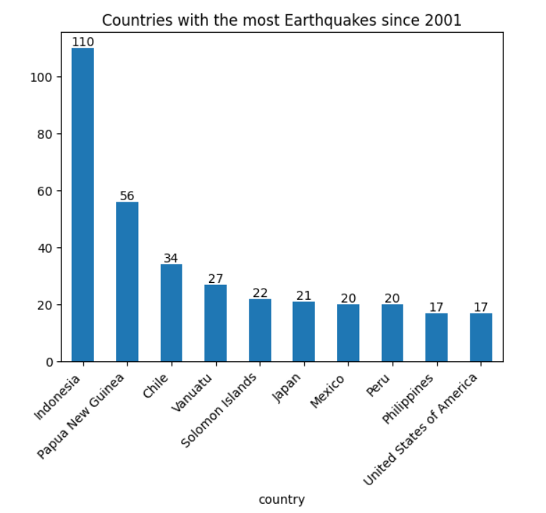

continents = (df['continent'].value_counts())

print(continents)

continents.plot()

for index, value in enumerate(continents):

plt.text(index, value, str(value), ha='center', va='bottom')

plt.title('Earthquake count per Continent since 2001')

plt.xticks(rotation=45, horizontalalignment='right')

**OUTPUT:**

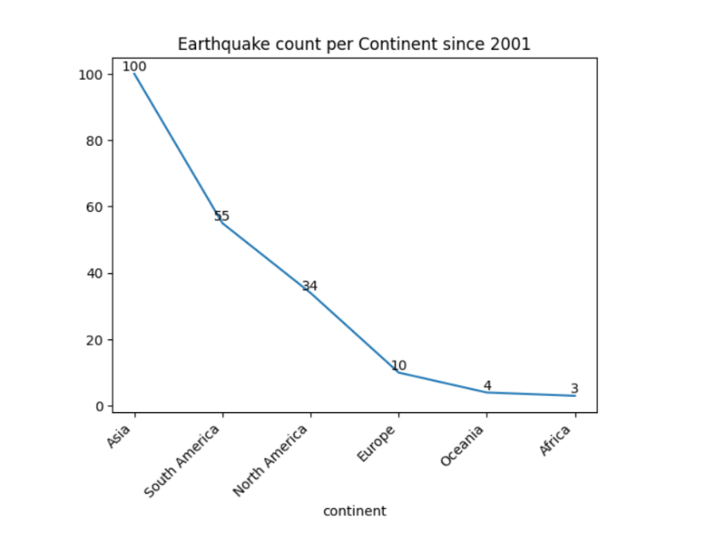

import plotly.express as px

fig = px.scatter_geo(

df,

lat='latitude',

lon='longitude',

color='magnitude',

size='depth',

hover_name='location',

projection='natural earth',

title='Earthquake Occurrences Worldwide'

)

fig.show()

**OUTPUT:**

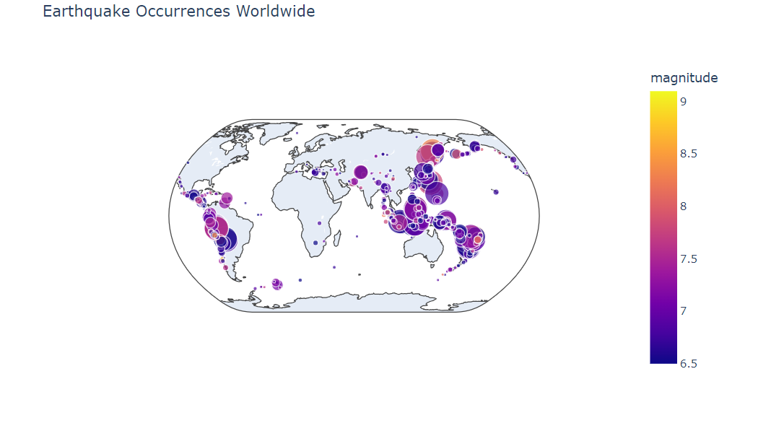

**STEP 5:HYPOTHESIS TESTING**

df_2001_2021 = df[df['date_time'].dt.year < 2022]

df_2001_2021.head(-10)

df_2001_2021.describe()

main_mean = df_2001_2021['magnitude'].mean()

main_mean

df_2022 = df[df['date_time'].dt.year == 2022]

df_2022.head(10)

df_2022.describe()

df_2001_2021['year'].value_counts()

df_2001_2021['year'].value_counts().mean()

df_2022.count()

from scipy import stats

significance_level = 0.05

significance_level

stats.ttest_ind(a=df_2022['magnitude'], b=df_2001_2021['magnitude'], equal_var=False)

**CONCLUSION:**

In conclusion, implementing earthquake disaster recovery using IBM Cloud virtual servers is a strategic and technologically advanced approach to safeguarding critical data and ensuring business continuity in the face of seismic events.

IBM Cloud virtual servers provide the foundation for a robust disaster recovery plan. They enable you to create a secondary infrastructure that is geographically distant, ensuring data and application availability even in the aftermath of an earthquake.

Incorporating IBM Cloud virtual servers into your earthquake disaster recovery plan enables organizations to proactively manage risk, protect data and applications, and maintain continuity of operations. It's a dynamic and evolving process that requires ongoing evaluation, testing, and adaptation to stay resilient and responsive in the face of potential seismic events. By prioritizing these aspects, organizations can ensure their readiness to respond effectively and recover swiftly in the event of an earthquake.