COLD CHAIN SUPPLY CHAIN
OPTIMIZATION

Integrated EOQ, Linear Programming & Monte Carlo Model
99.9%  Avg. Service Level | ₹1.84 Cr  Total Transport Cost | 500  Monte Carlo Iterations

Course  Optimization & Business Decision Analysis  Date of Submission  April 15, 2026 |  | Group Members  Student 1: Hritajit Pal  Roll No: 25BM6JP16  Student 2: Mainak Jana  Roll No: 25BM6JP28  Student 3: Varsha Das  Roll No: 25BM6JP57  Student 4: Yadavalli Sandeep  Roll No:25BM6JP61

1. Introduction
Cold chain logistics for pharmaceuticals and biologics is an essential area where products like mRNA vaccines (−80°C) and biosimilar drugs (+2°C to +8°C) are prone to spoilage due to their temperature sensitivity. In the Indian scenario, geographical variation and infrastructure differences make things difficult — bad decisions could lead to stockouts or wastage of costly biological materials in vital locations.
The problem being solved in this project involves three inter-related decision problems: (i) inventory management, i.e., determining how much to purchase and replenish, considering uncertain demand and lead time; (ii) allocating inventory from different warehouses to different regions while minimizing transportation cost; and (iii) risk simulation, i.e., estimating how uncertain demand impacts costs and service levels within a 90-day period.

2. Methodology

2.1 Data Architecture & Assumptions
Five warehouses, five different items, and six customer zones are all considered in the problem. The products, which are classified as biologics, oncology, and vaccines, range in price from ₹14.00 for the influenza vaccine to ₹1,200 for trastuzumab. The warehouses are situated in Mumbai, Delhi, Bengaluru, Chennai, and Kolkata, and their capacities range from 30,000 to 50,000 units. The North-East zone's daily consumer demand is 350 units, whereas the West zone's is 1,400 units. It was anticipated that the lead time distribution would be N (5, 1.5) days, the transportation cost per unit kilometer would be ₹2.5, the client demand would be regularly distributed, and stochastic temperature excursions would occur.

2.2 Inventory Optimisation: EOQ with Stochastic Lead Times
The traditional EOQ equation $Q^{*}=\sqrt{\frac{2DS}{H}}$ was adapted to account for the storage surcharge involved in maintaining a cold chain environment in the holding cost. The safety stock$SS=Z\sqrt{\underline{LT}σ_{D}^{2}+\underline{D^{2}σ_{LT}^{2}}}$ ,
where Z represents the z-score for service level. Reorder point ROP = $\underline{D} \underline{LT}+SS$ guarantees inventory replenishment before the safety stock is exhausted. The newsvendor model approach uses critical ratio CR = (p - c)/(p - v) to solve the decision-making process of vaccines.

2.3 Transportation Optimisation: Linear Programming
The distribution problem is cast as a balanced transportation problem using SciPy’s HiGHS LP solver. Minimizing total cost $\sum{}c_{ij}x_{ij}$, subject to the warehouse supply constraint and customer demands, where cost parameters include distances with rate ₹2.5/unit/km, multiplied by category surcharges: 1.5 for Vaccines, 1.2 for Biologics, and 1.0 for Oncology.

2.4 Stochastic Demand Simulation: Monte Carlo
Monte Carlo simulation with 500 iterations is conducted over 90 days, considering one day at a time for each product. It keeps track of inventory, a transport pipeline, stochastic demand generated by$N\left(\underline{D},σ_{D}\right)$
and excursions. Penalty for shortage is 10 times the cost per unit. Service level is expressed as 1 – avg-stockout-days/horizon.

3. Results & Analysis

3.1 Inventory Policy Parameters
The optimal parameters under peak demand conditions are summarised in Table 1 (for West Region, Demand of 1,400 units per day, SL = 0.98). The EOQ is higher for refrigerated products owing to their low cost/holding rates while the high cost premium of ultra-cold mRNA vaccine keeps the EOQ at an acceptable 2,811 units.

Product | EOQ (units) | Safety Stock | Reorder Point | Unit Cost | Temp. Range
mRNA COVID-19 Vaccine | 2,811 | 4,410 | 11,410 | ₹19.50 | −80°C to −60°C
Influenza Vaccine | 10,022 | 4,410 | 11,410 | ₹14.00 | +2°C to +8°C
Insulin Glargine | 9,055 | 4,410 | 11,410 | ₹28.50 | +2°C to +8°C
Adalimumab (Humira) | 4,279 | 4,410 | 11,410 | ₹580.00 | +2°C to +8°C
Trastuzumab (Herceptin) | 3,553 | 4,410 | 11,410 | ₹1,200 | +2°C to +8°C
Table 1: Optimal Inventory Parameters by Product (West Region, Peak Demand Scenario)

3.2 Transportation Allocation
The linear programming solver settles on a hub-and-spoke strategy. The cold hub based in Mumbai (-80°C) caters to North region alone. Delhi supplies Central; Bengaluru and Chennai serve south region demand; Kolkata supplies east. The total cost of transportation is calculated at ₹1,84,559,583, with the Influenza Vaccine being the most expensive (₹66,787,875), owing to the surcharge cost incurred due to its temperature and broad consumer demand.

3.3 Optimisation Dashboard
Figure 1 shows the final optimisation dashboard obtained from simulation analysis that includes EOQ distribution of products, LP transportation strategy, simulated service levels, as well as holding vs shortage cost breakdowns.

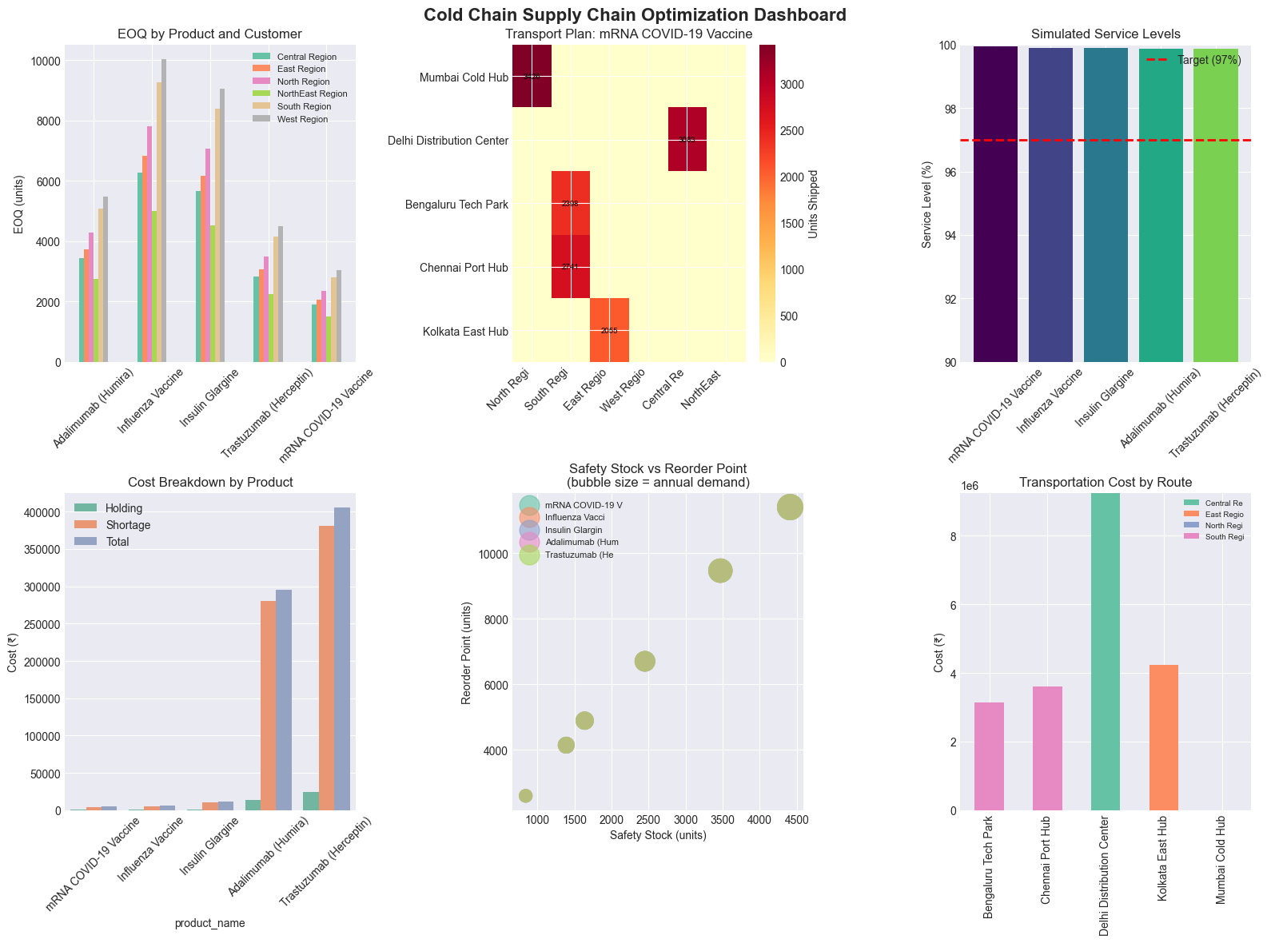
Figure 1: Optimisation Dashboard — EOQ Distribution, Transport Plan, Service Levels & Cost Breakdown

3.4 Monte Carlo Simulation and Results
All five drugs have been found to have a simulated service level that exceeds 99.8%, well beyond the objective set at 0.94-0.98. Nonetheless, stockout rates are between 6.0% (mRNA Vaccine) and 10.4% (Trastuzumab), indicating that although service levels are generally high, shortages may occur in some iterations. Shortage costs comprise the majority of total cost.

Product | Service Level | Stockout Prob. | Total Cost (90d) | Holding Cost | Shortage Cost
mRNA COVID-19 Vaccine | 99.93% | 6.0% | ₹5,067 | ₹666 | ₹4,277
Influenza Vaccine | 99.89% | 7.8% | ₹6,182 | ₹682 | ₹5,401
Insulin Glargine | 99.88% | 8.8% | ₹11,673 | ₹1,091 | ₹10,495
Adalimumab (Humira) | 99.87% | 9.6% | ₹2,95,061 | ₹14,064 | ₹2,80,886
Trastuzumab (Herceptin) | 99.87% | 10.4% | ₹4,05,154 | ₹24,191 | ₹3,80,839
Table 2: Monte Carlo Simulation Results (500 iterations, 90-day horizon)

4. Conclusions & Recommendations
The research shows that the EOQ–LP–Monte Carlo approach produces meaningful cold chain strategies for pharmaceutical supply chains at low cost. One key conclusion is that the cost of shortages dominates overall inventory costs for costly biological products (Adalimumab: ₹2,95,061; Trastuzumab: ₹4,05,154). As such, maximizing service rather than minimizing cost needs to be the focus of decision making.
Ultra-cold products need their own optimization solution because the storage cost is high enough that it requires small order sizes and frequent replenishments. Refrigerated products require larger replenishments and infrequent shipments. All five products maintain 99.8% and higher service levels, exceeding pharmaceutical industry standards.

Recommendations
- Apply temperature compatibility constraints to LP to remove infeasible warehouse-product pairs.
- Imposing minimum delivery requirements ensures that all six customer segments receive service (current West and North-East regions are unserved).
- Use fill rate metrics to measure the quality of service, instead of the current simple service level metric.
- Optimization should take into account all product-customer pairs in the system.
- Use cold chain data to calibrate temperature excursions.

Appendix A — Tools & Software
Python 3.11 was used throughout the project's implementation. The open-source libraries listed below were used:
NumPy and pandas: tabular computing and data handling.
SciPy is an LP transportation solver (scipy.optimize.linprog via HiGHS backend).
Seaborn and Matplotlib: dashboard creation and visualization.
File I/O, random-variate generation, and Monte Carlo simulation loops are examples of standard Python libraries.
No specialized hardware or cloud resources were needed; all calculations were completed on a regular laptop. The project repository contains the source code.

Appendix B — Bibliography
[1] Chopra, S. & Meindl, P. Supply Chain Management: Strategy, Planning, and Operation. 7th ed. Pearson, 2019.
[2] Silver, E. A., Pyke, D. F. & Thomas, D. J. Inventory and Production Management in Supply Chains. 4th ed. CRC Press, 2017.
[3] Hillier, F. S. & Lieberman, G. J. Introduction to Operations Research. 11th ed. McGraw-Hill, 2020.
[4] World Health Organization. Maintaining the cold chain for vaccines. WHO/IVB/15.03. Geneva: WHO, 2015.
[5] Pharmexcil. Indian Pharma Industry Overview 2024. Available at: https://www.pharmexcil.com.
[6] Virtanen, P., et al. SciPy 1.0: Fundamental Algorithms for Scientific Computing in Python. Nature Methods, 17(3), 261–272, 2020.

Appendix C — Student Contribution Table
The table below records the primary and supporting/reviewer roles for each team member across all project tasks. Contribution percentages sum to 100%.

Task / Activity | Mainak Jana 25BM6JP28 | Yadavalli Sandeep  25BM6JP61 | Hritajit Pal  25BM6JP16 | Varsha Das 25BM6JP57
Problem Identification | ✓ | ✓ | — | ✓
Literature Review | ✓ | — | ✓ | —
Data Collection | — | ✓ | ✓ | —
Mathematical Modelling | ✓ | — | — | ✓
Programming / Coding | — | ✓ | ✓ | ✓
Results & Analysis | ✓ | — | ✓ | —
Report Writing | — | ✓ | — | ✓
Contribution (%) | 25% | 25% | 25% | 25%

Note: ✓ = primary contributor; — = supporting/reviewer role. Percentages sum to 100%.

