**Name: Varsha JJ**

**Roll No: 48**

**Batch: B**

**Date: 01/04/2022**

**NETWORKING & SYSTEM ADMINISTRATION LAB**

**Experiment No.:1**

**Aim**

Identify the major components of a computer systems such as Motherboard, RAM modules, Daughter cards, Bus slots, SMPS, Internal storage devices and Interfacing ports.

**Procedure**

**Motherboard :**

A motherboard is one of the most essential parts of a computer system. It holds together many of the crucial components of a computer, including the central processing unit (CPU), memory and connectors for input and output devices. The base of a motherboard consists of a very firm sheet of non-conductive material, typically some sort of rigid plastic. Thin layers of copper or aluminium foil, referred to as traces, are printed onto this sheet. These traces are very narrow and form the circuits between the various components. In addition to circuits, a motherboard contains a number of sockets and slots to connect the other components. The motherboard can be said to be the basis of a personal computer since the essential components such as CPU, graphic card, RAM, hard drives, expansion slots, CMOS, [Mouse](https://digitalworld839.com/types-of-mouse-computer/), Keyboard, and the power supply are directly connected to it.

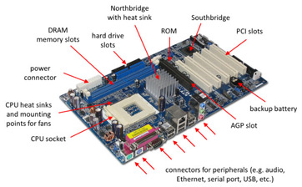

**RAM Modules :**

RAM, which stands for Random Access Memory, is a hardware device generally located on the motherboard of a computer and acts as an internal memory of the CPU. It allows CPU store data, program, and program results when you switch on the computer. It is the read and write memory of a computer, which means the information can be written to it as well as read from it.

RAM is a volatile memory, which means it does not store data or instructions permanently. When you switch on the computer the data and instructions from the hard disk are stored in the RAM, e.g., when the computer is rebooted, and when you open a program, the operating system (OS), and the program are loaded into RAM, generally from an HDD or SSD. CPU utilizes this data to perform the required tasks. As soon as you shut down the computer, the RAM loses the data. So, the data remains in the RAM as long as the computer is on and lost when the computer is turned off. The benefit of loading data into RAM is that reading data from the RAM is much faster than reading from the hard drive.

RAM comes in the form of a chip that is individually mounted on the motherboard or in the form of several chips on a small board connected to the motherboard. It is the main memory of a computer. It is faster to write to and read from as compared to other memories such as a hard disk drive (HDD), solid-state drive (SSD), optical drive, etc.

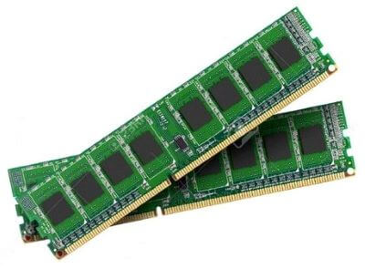

**Daughter cards :**

The daughter board is a computer hardware. It is also known as the piggyback board, riser card, daughter board, daughtercard or daughter card. A daughter board is a printed circuit board which is connected to the motherboard or expansion card. As compared to the motherboard, it is smaller in size. A daughter board does not act as an expansion card. An expansion card adds extra new functions to the computer. But a daughter board that is connected to the motherboard adds or supports the main functions of the motherboard.

Daughter boards are directly connected to the motherboards. You know that expansion cards are connected to the motherboard by using the bus and other serial interfaces.  But daughter board is directly connected to the board by soldering. As an update of the motherboard or expansion card, daughter boards are released to extend the features and services of the motherboard or expansion cards.

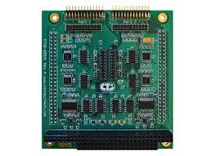

**BUS slots :**

A Bus slot or expansion port, an expansion slot is a connection or port inside a computer on the motherboard or riser card. It provides an installation point for a hardware expansion card to be connected.

An expansion slot is a socket on the motherboard that is used to insert an expansion card (or circuit board), which provides additional features to a computer such as video, sound, advanced graphics, Ethernet or memory.

The expansion card has an edge connector that fits precisely into the expansion slot as well as a row of contacts that is designed to establish an electrical connection between the motherboard and the electronics on the card, which are mostly integrated circuits. Depending on the form factor of the case and motherboard, a computer system generally can have anywhere from one to seven expansion slots. With a backplane system, up to 19 expansion cards can be installed.

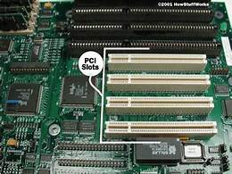

**SMPS :**

SMPS stands for Switched Mode Power Supply. It is an electronic gadget or module that comprises a combination of inductors, capacitors and semiconductor gadgets like diodes and MOSFETs. It is utilized to change over a specific DC voltage to another DC voltage level. It is utilized rather than straight or ohmic converters since of higher efficiency. It could be a key portion an in almost all domestic electronic equipments(like portable chargers, PC control supplies, etc). It works by employing a semiconductor switch like MOSFET to switch on-off the supply voltage at a specific exchanging recurrence to control the yield voltage. Varying the exchanging recurrence will alter the yield voltage.

Since the average time exchanging component i.e. the transistor remains in a dynamic state is less, the sum of control squandered or scattered as warm is exceptionally less when compared to Direct Controllers. This in turn leads to tall productivity of SMPS as the voltage drop over the pass transistor (or exchanging component) is exceptionally less.

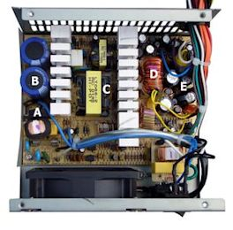

**Internal storage devices :**

Internal storage allows the data and applications to be loaded very rapidly into memory, ready for use. The data can be accessed much faster than data which is stored on an external storage device. This is because internal storage devices are connected directly to the motherboard and its data bus whereas external devices are connected through a hardware interface such as USB, which means they are considerably slower to access.

Internal storage also means that if the computer is moved around, it will still retain its most commonly used data. The main disadvantage of internal storage is that when the hard disk fails (and it will), all the data and applications may be lost. This can be avoided to some extent by using more than one hard disk within the machine. Each hard disk has a copy of all the data, so if one fails the other can carry on. This is called a RAID array. An alternative is to use external drives for backup.

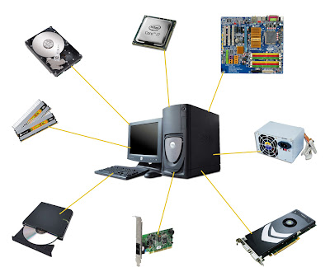

**Interfacing ports :**

A port is basically a physical docking point which is basically used to connect the external devices to the computer, or we can say that A port act as an interface between the computer and the external devices, e.g., we can connect hard drives, printers to the computer with the help of ports. A computer Port is an interface or a point of connection between the computer and its peripheral devices. Some of the common peripherals are mouse, keyboard, monitor or display unit, printer, speaker, flash drive etc. The main function of a computer port is to act as a point of attachment, where the cable from the peripheral can be plugged in and allows data to flow from and to the device. A computer port is also called as a Communication Port as it is responsible for communication between the computer and its peripheral device. Generally, the female end of the connector is referred to as a port and it usually sits on the motherboard. In Computers, communication ports can be divided into two types based on the type or protocol used for communication. They are Serial Ports and Parallel Ports. A serial port is an interface through which peripherals can be connected using a serial protocol which involves the transmission of data one bit at a time over a single communication line. The most common type of serial port is a D-Subminiature or a D-sub connector that carry RS-232 signals. A parallel port, on the other hand, is an interface through which the communication between a computer and its peripheral device is in a parallel manner.

