**Name: Varsha JJ**

**Roll No:48**

**Batch:B**

**Date:21/04/2022**

**NETWORKING & SYSTEM ADMINISTRATION LAB**

**Experiment No.: 5**

**Aim**

Familiarization of linux command.

**Procedure**

**39. read variable name :** To read the content of a line to a variable.

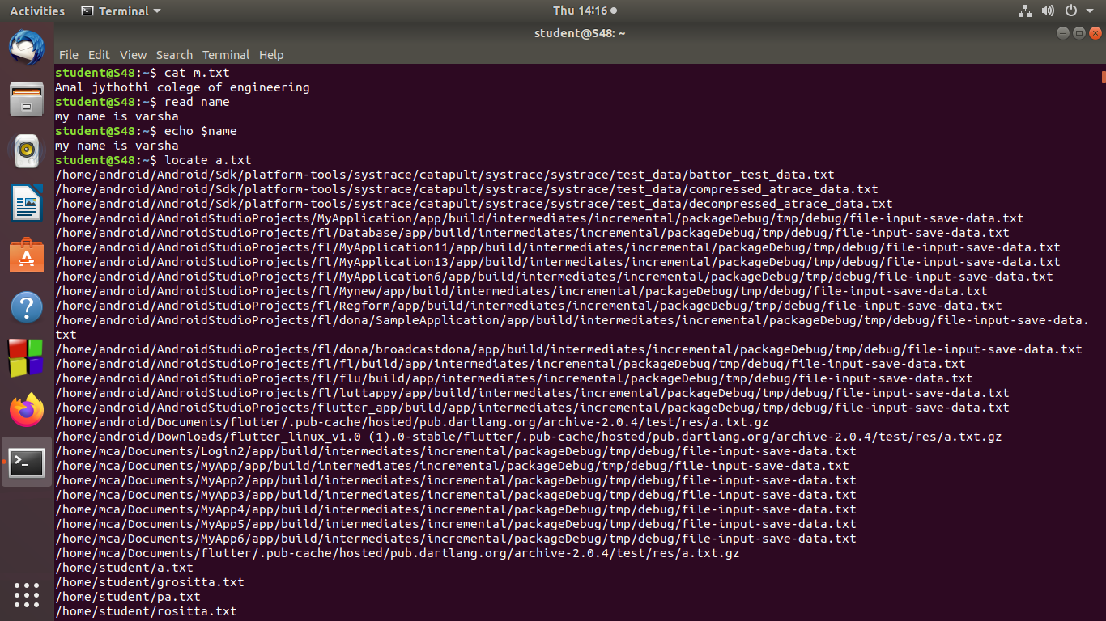

**40. locate filename :**The locate command is the quickest and simplest way to search for files and directories by their names.



**41. locate -i file name :** Ignore case distinctions when matching patterns.

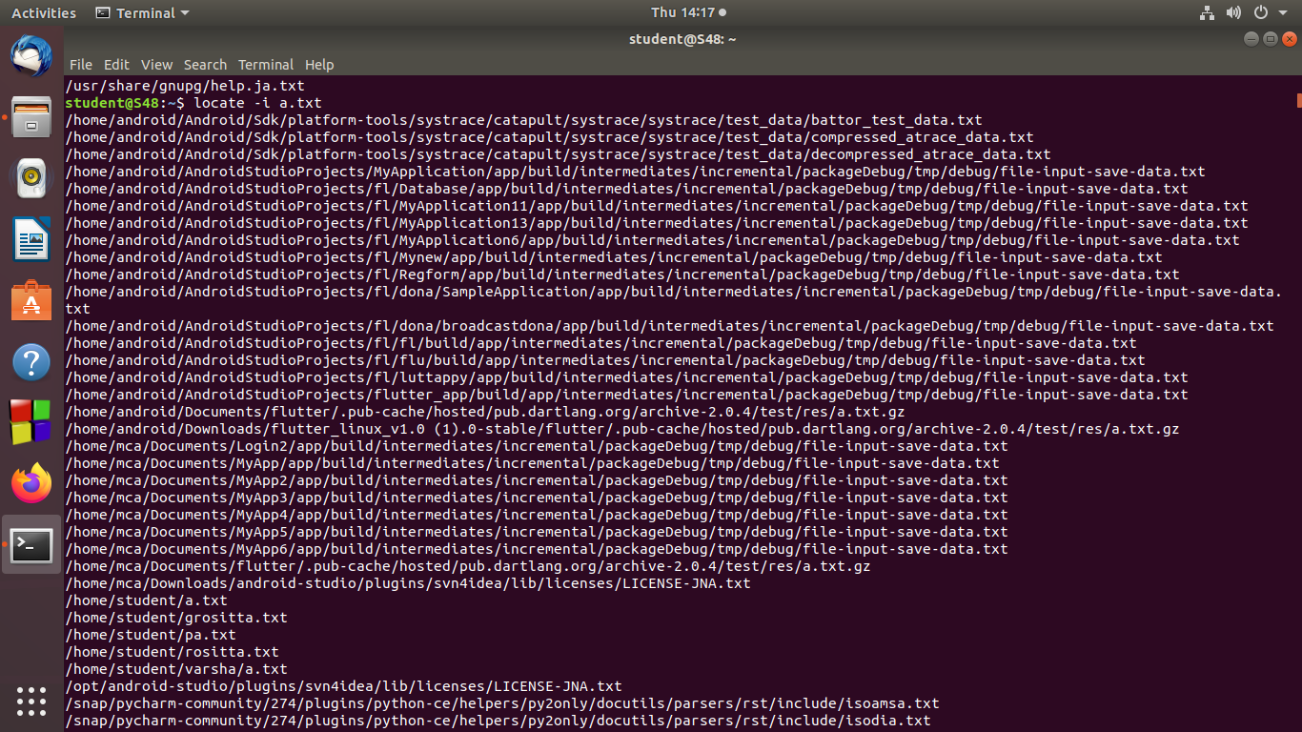

**42. find :** The find command lists the names of all the files under a directory with a given characteristic or set of characteristics.

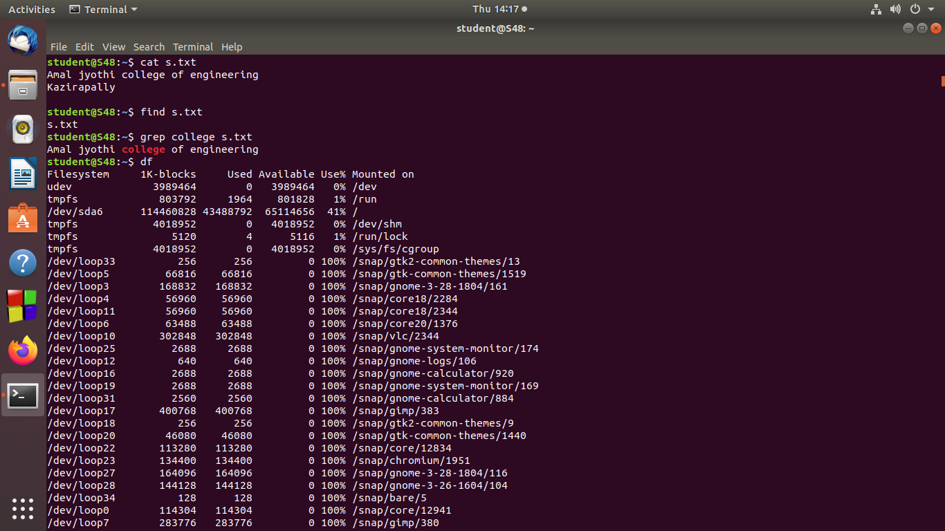

**43. grep pattern filename:**The grep filter searches a file for a particular pattern of characters, and displays all lines that contain that pattern.



**44. grep -i content-part filename:** For an case insensitive search.

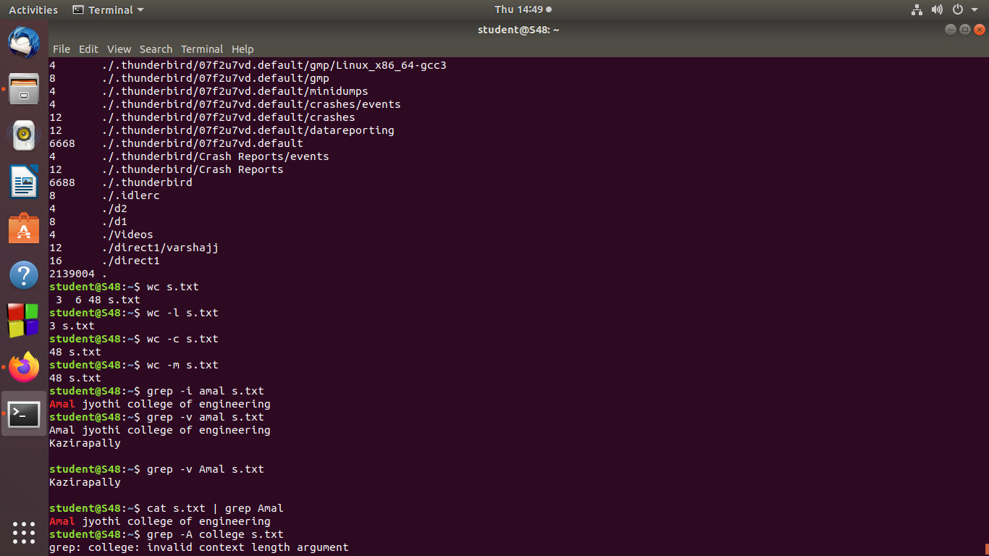

**45. grep -A1 content-part filename:** Displays searched line and lines after the result.

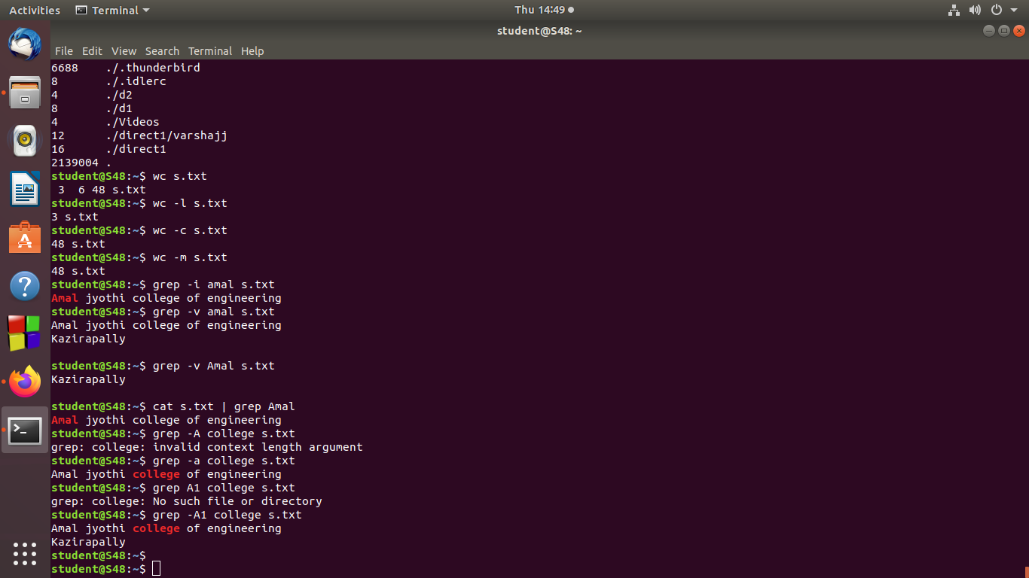

**46. df :** To get and display report on amount of free disk space available on Linux .



**47. df -m :**To display system disk space usage in terms of mega bytes.

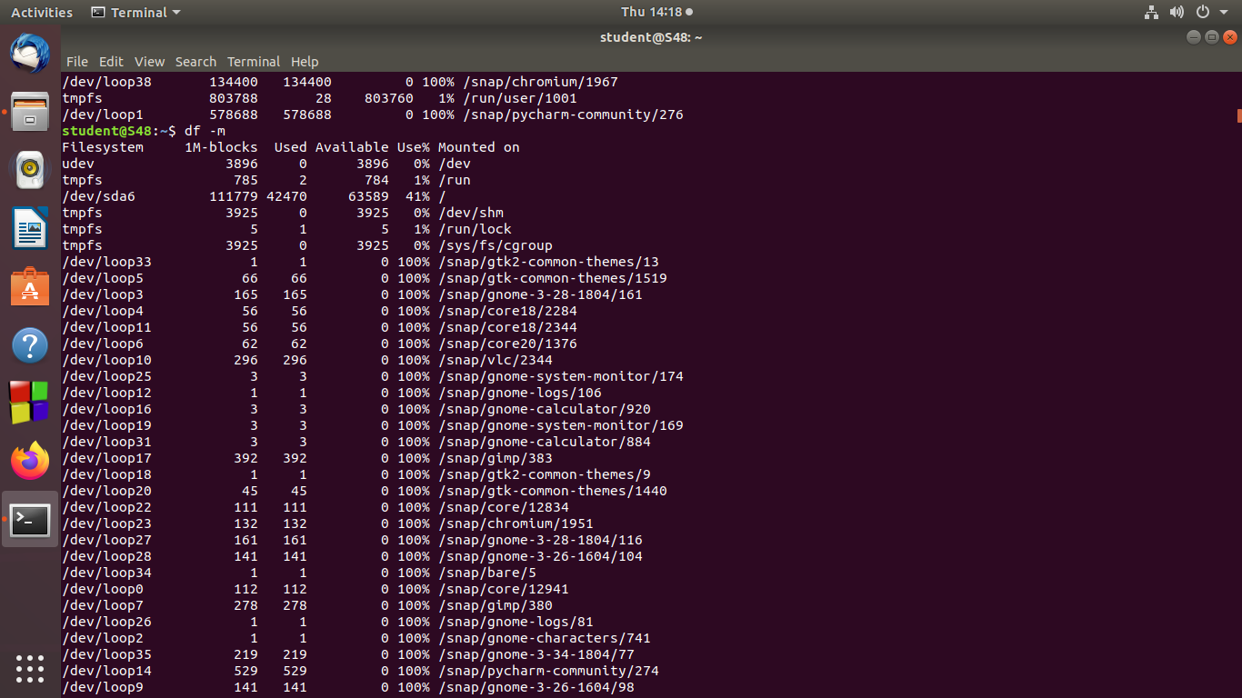

**48. du :** To display how many space directory use.

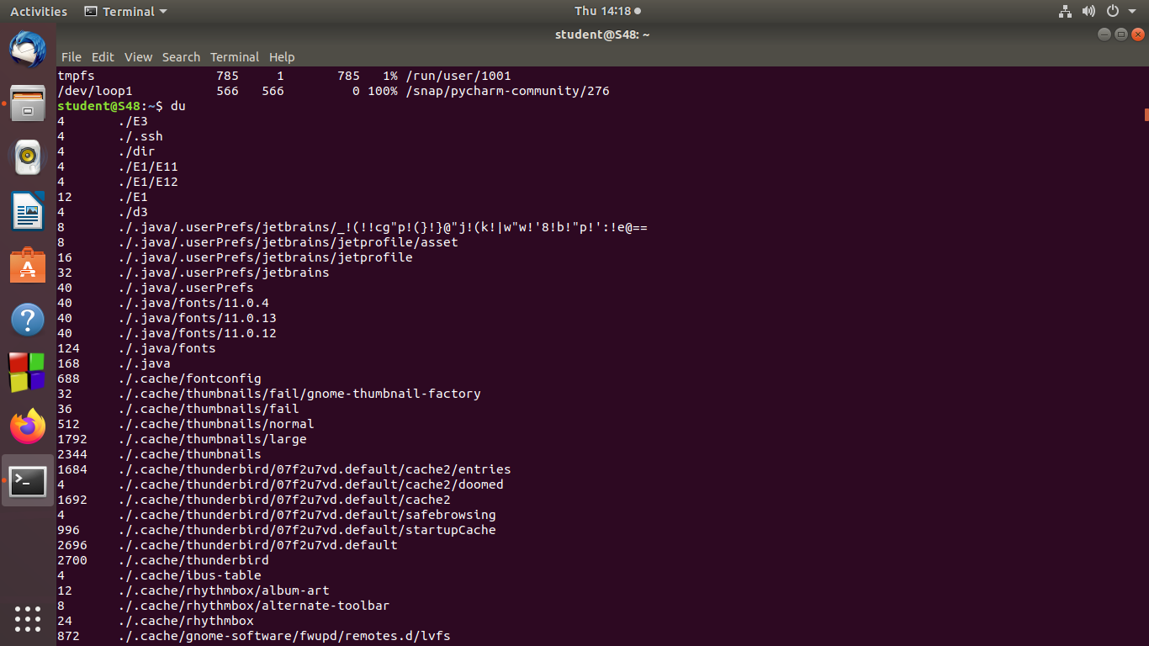

**49. wc :**For counting purpose,it is used to find the number of lines,the number of words,number of characters and number of bytes.



**50. wc -l filename :** Find the number of lines.



**51. wc -w filename :** Find the number of words.

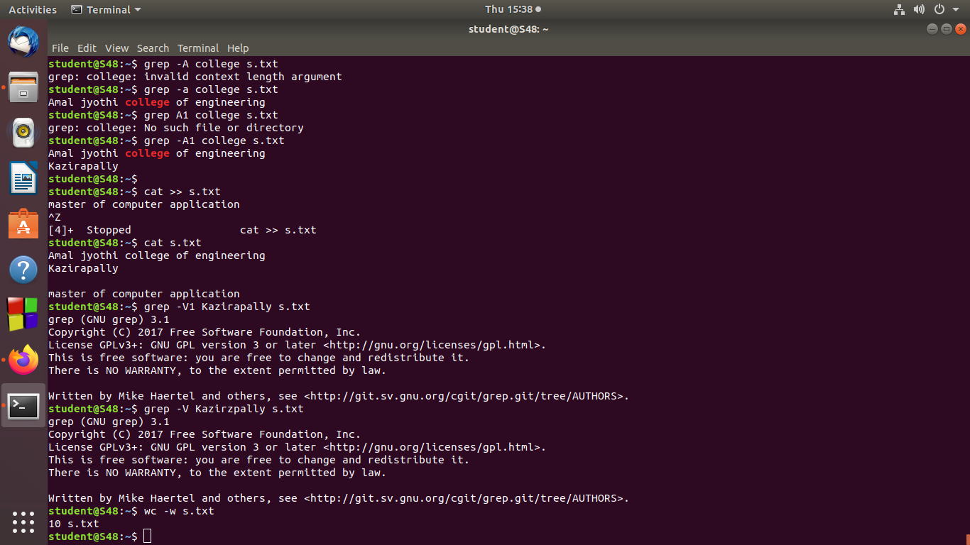

**52. wc -c filename :** Find the number of characters.



**53. wc -m filename :** Find the number of bytes.



**54. grep -B1 patten filename :** To display before a match of pattern.