**Name: Varsha JJ**

**Roll No:48**

**Batch:B**

**Date:24/03/2022**

**NETWORKING & SYSTEM ADMINISTRATION LAB**

**Experiment No.: 1**

**Aim**

Familiarization of linux command.

**Procedure**

1. **pwd :** The pwd command is used to display present working directory.

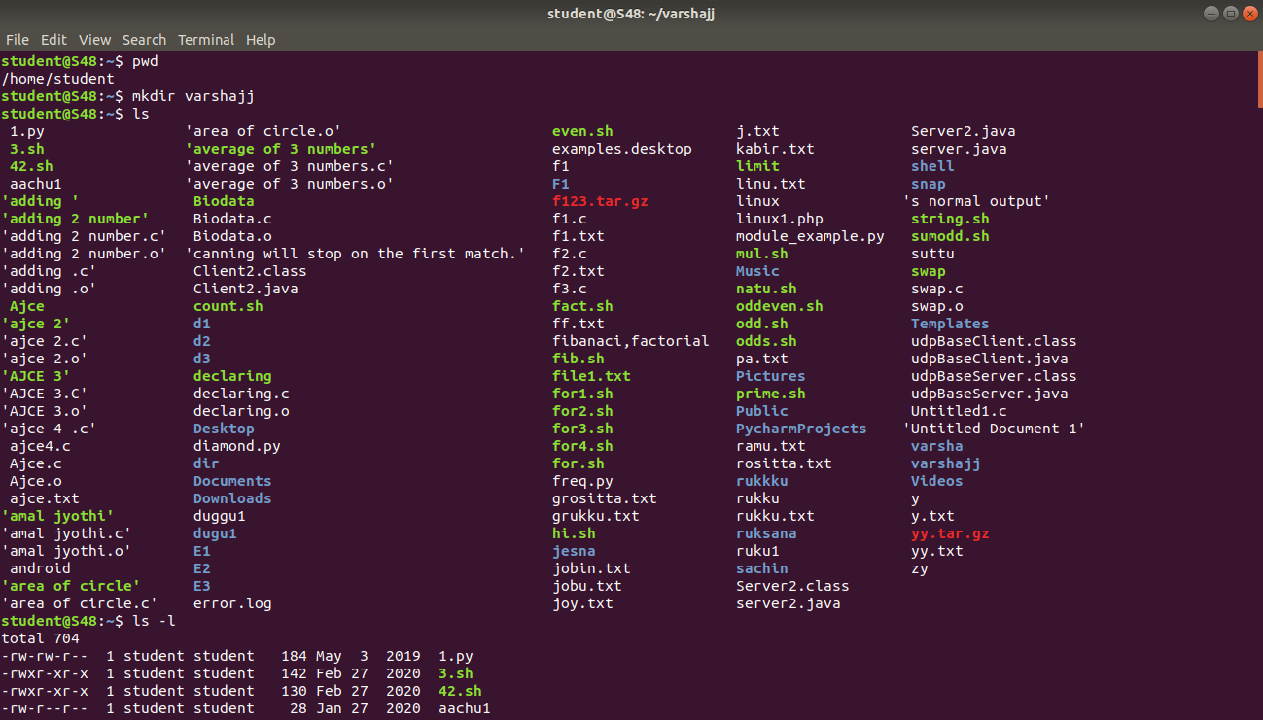

1. **mkdir :** This command is used to create a new directory.



1. **ls :** This command is used to display list of a content of a directory,



1. **ls -l :** long listing.



1. **ls –r :** It is used for showing sub directories.

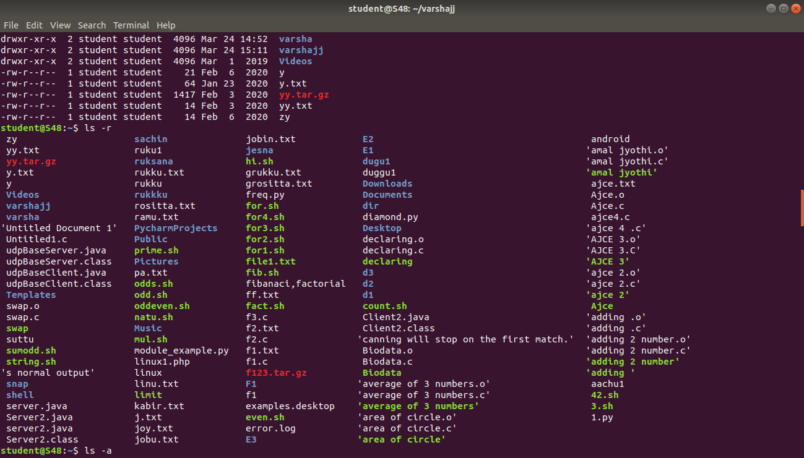

1. **ls –a :** List all files including hidden files starting with ‘.’.
2. **ls –al :** It will list all files and all directories.

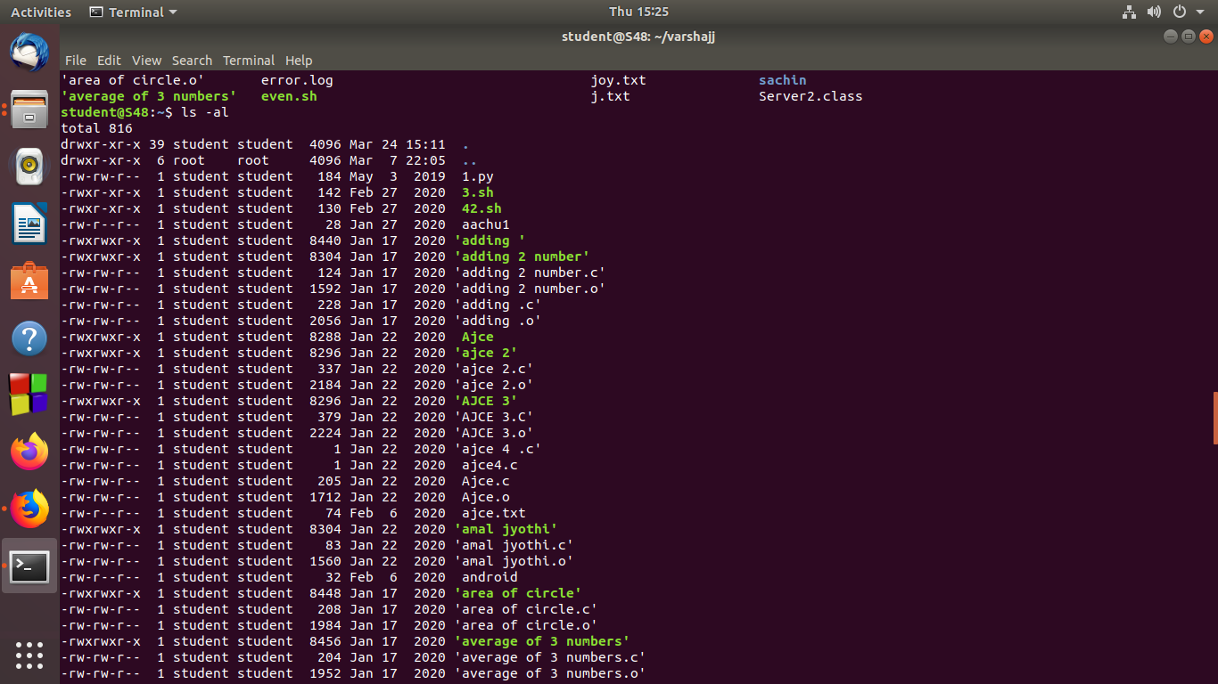

1. **ls –t :** It show all list of files in last modified order.

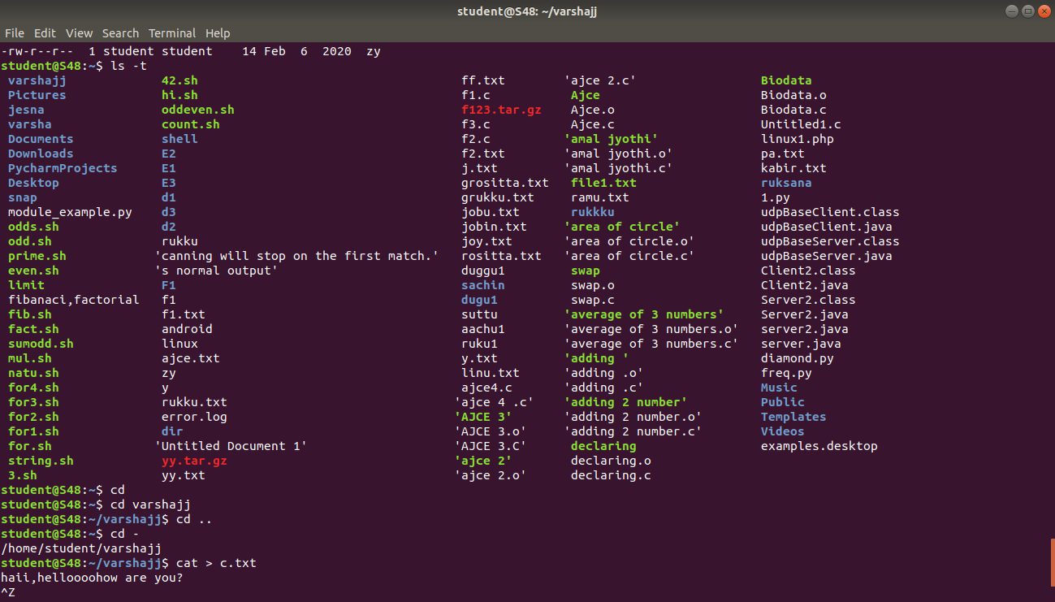

1. **cd :** This command is used to change the current working directory .

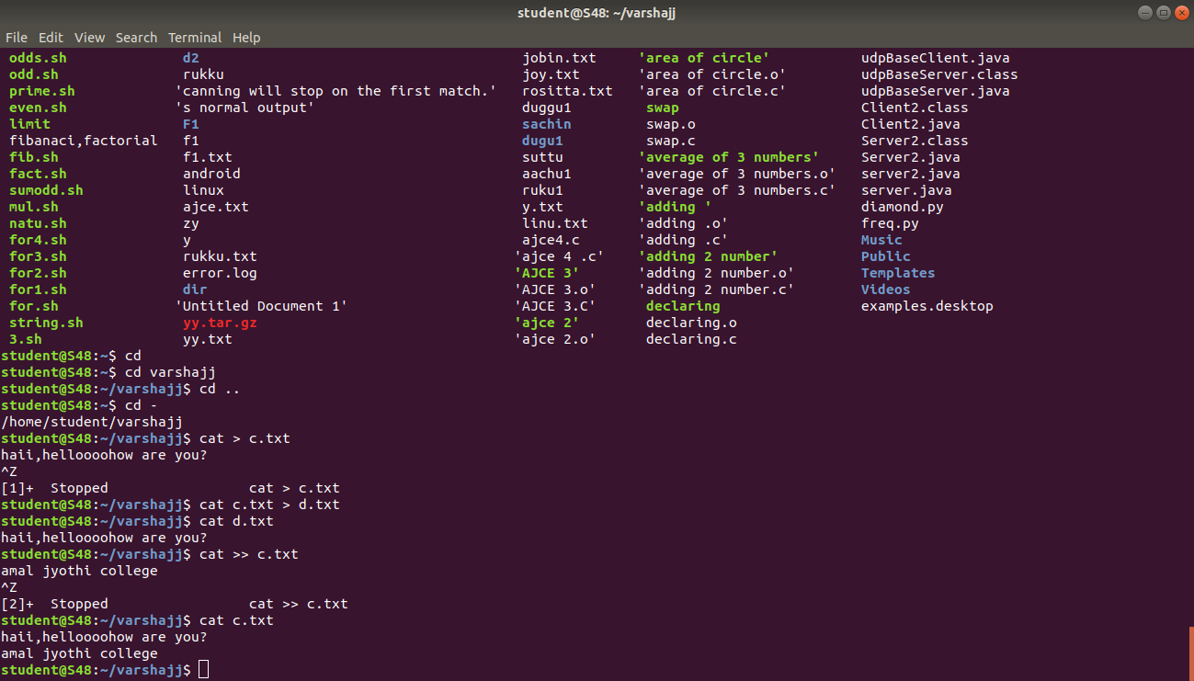

1. **cd .. :** Go to the previous directory.



1. **cd - :** To change to the previous directory from the current working directory.



1. **cat :** This command is used to display content of a file.



1. **cat > file name :** This command is used to create a file.



1. **cat >> file1 :** If a file named file1 already exists, it will be overwritten by the new, empty file with the same name. That is, if an attempt is made to create a file by using cat and the append operator, and the new file has the same name as an existing file, the existing file is, in fact, preserved rather than overwritten, and any new text is added to the end of the existing file.



1. **cat file1 >file2 :** The name of the file from which the output will come, the output redirection operator and the name of the file to be created. Then pressing ENTER causes the new file to be created and written to. For example, typing the following and then pressing ENTER creates a new file named file2 that contains a copy of the contents of file1. There is no effect on the contents of file1.

