**Name: Varsha JJ**

**Roll No: 48**

**Batch: RMCA-B**

**Date: 16/06/22**

**NETWORKING & SYSTEM ADMINISTRATION LAB**

**Experiment No.:**

**Aim**

KVM installation.

**Procedure**

1. **egrep -c '(vmx|svm)' /proc/cpuinfo:** 1 Before begin with installing KVM, check if CPU supports hardware virtualization.



If the command returns a value of **0**, your processor is not capable of running KVM. On the other hand, any other number means you can proceed with the installation.

1. **sudo kvm-ok** **:** check if system can use KVM acceleration .

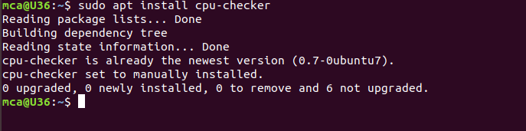

1. **sudo apt install cpu-checker** **:** To install cpu-checker.

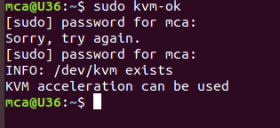

1. **sudo apt update** **:** To update the repositories.

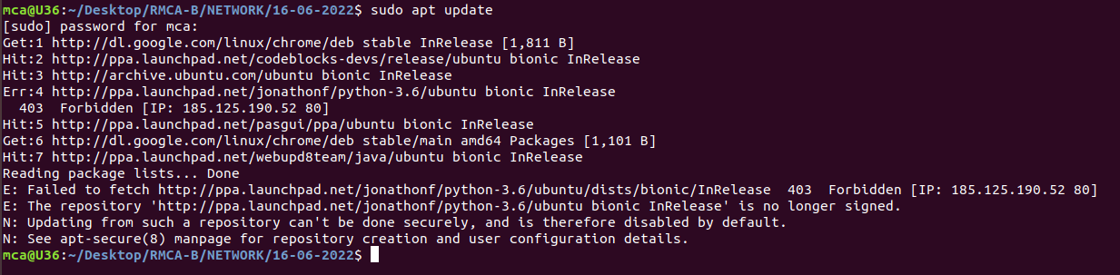

1. **sudo apt install qemu-kvm libvirt-daemon-system libvirt-clients bridge-utils :** Installing essential KVM packages.

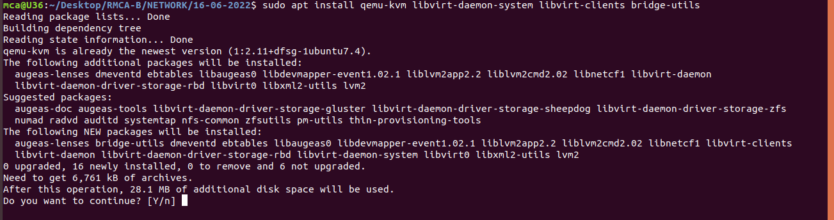

1. **virsh list –all** **:** ToConfirm the installation was successful .

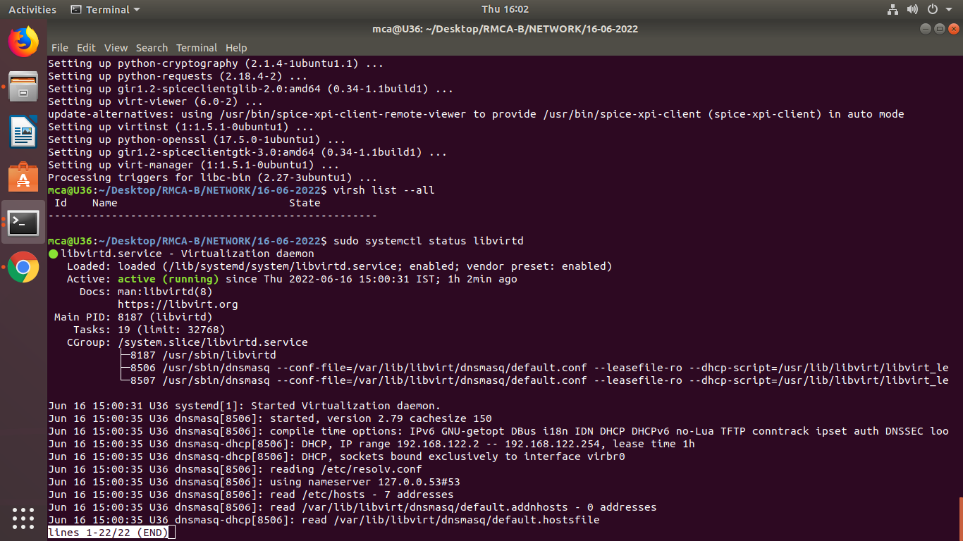

1. **sudo systemctl status libvirtd** **:** To check the status of libvirtd.



If the virtualization daemon is not active, activate it with the following command:

**sudo systemctl enable --now libvirtd**

**8.sudo apt install virt-manager :** To install virt-manager, a tool for creating and managing VMs.

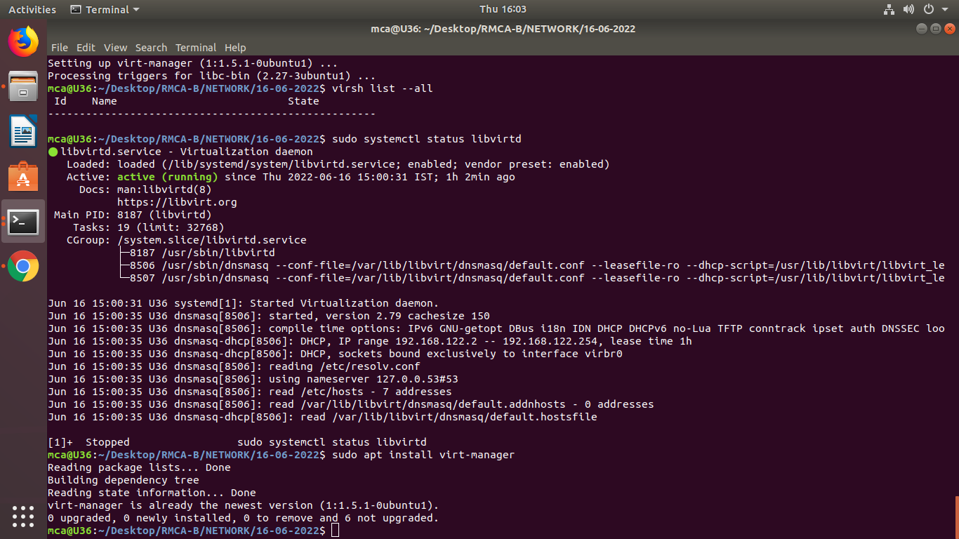

**9**.**sudo virt-manager :**ToStart virt-manager



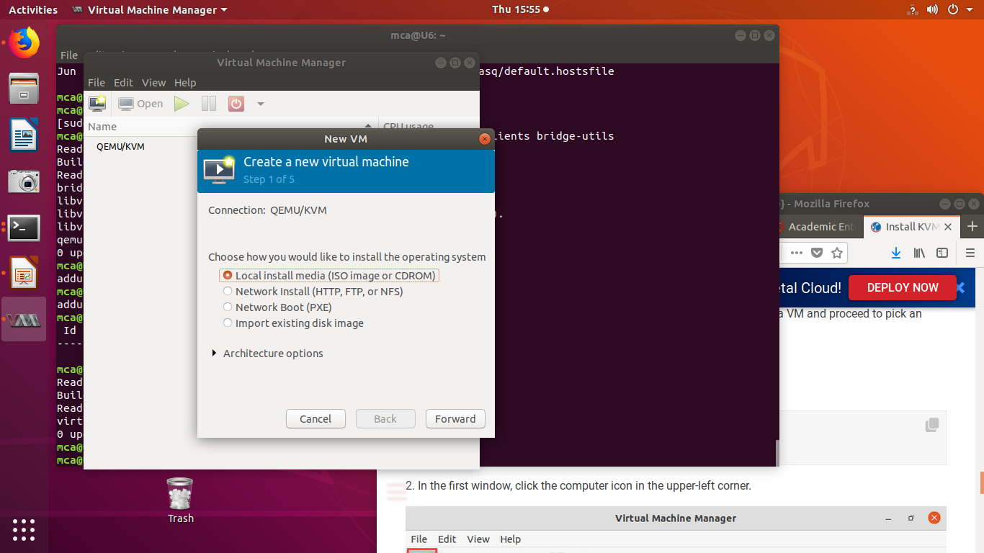

**10**.In the first window, click the computer icon in the upper-left corner.

In the dialogue box that opens, select the option to install the VM using an ISO image. Then click **Forward**.

In the next dialogue, click **Browse Local** and navigate to the path where you stored the ISO you wish to install.

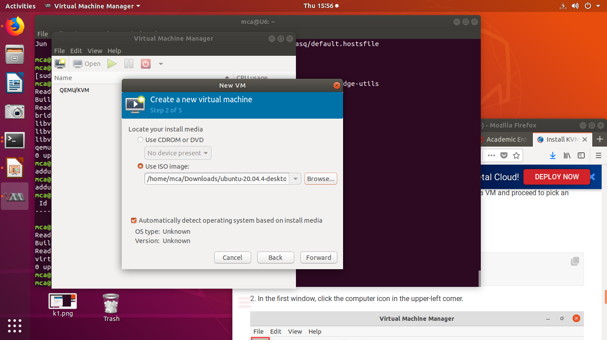

**12.**Enter the amount of RAM and the number of CPUs you wish to allocate to the VMand proceed to the next step.

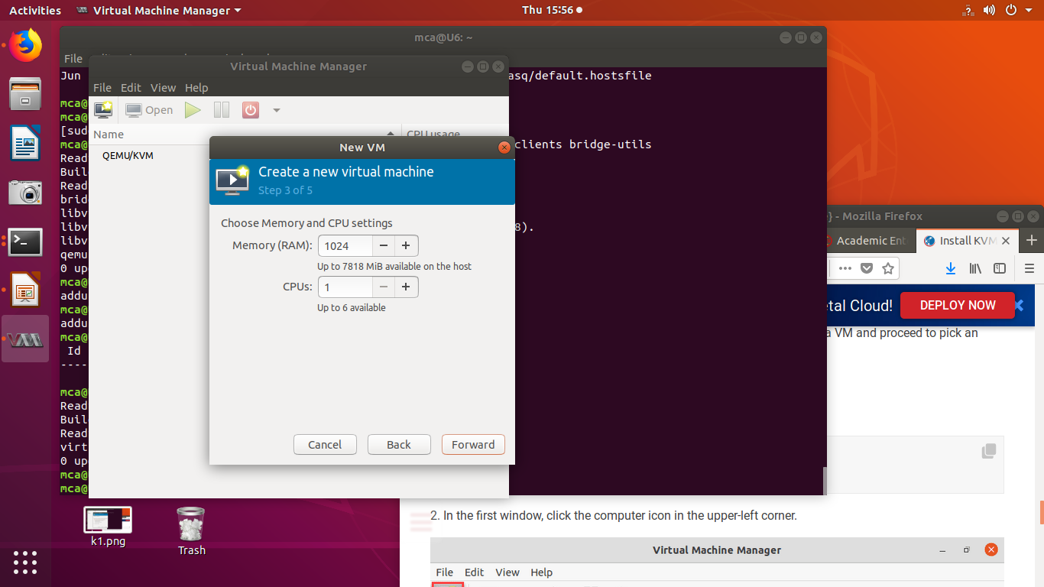

**13.**Allocate hard disk space to the VM. Click **Forward** to go to the last step.

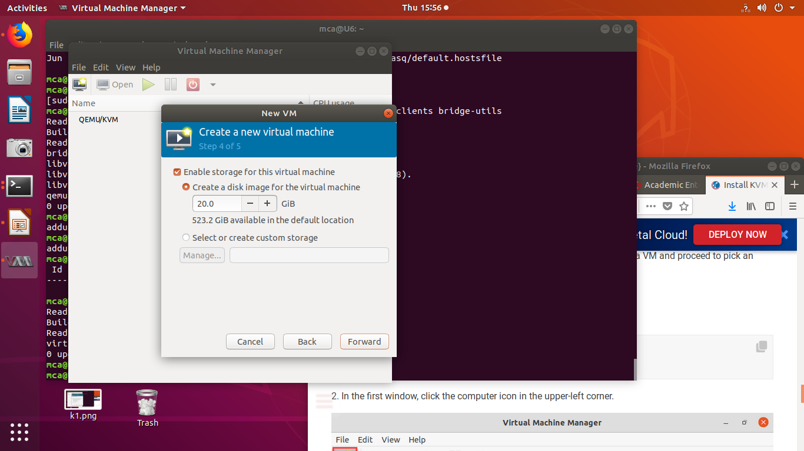

**14.**Specify the name for your VM and click **Finish** to complete the setup.

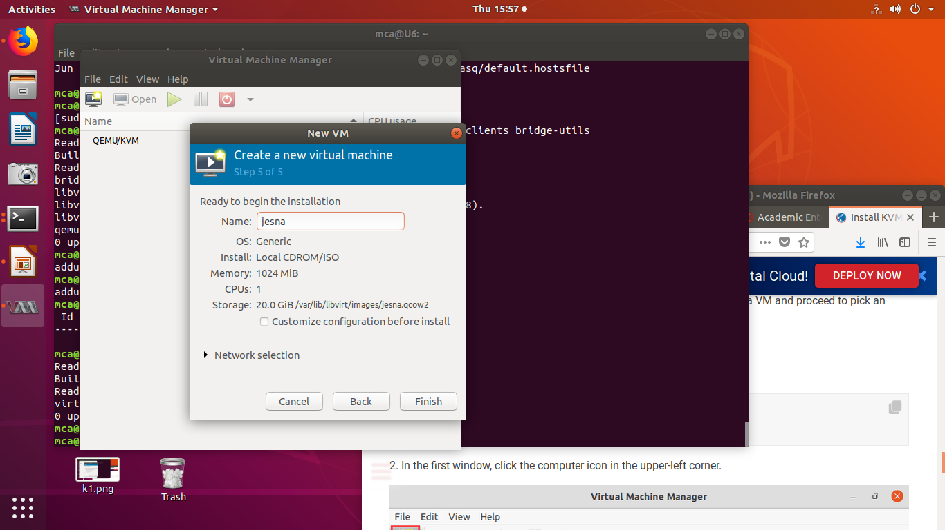

The VM starts automatically, prompting you to start installing the OS that’s on the ISO file.

