**Name: Varsha JJ**

**Roll No: 48**

**Batch: B**

**Date: 23/05/22**

**NETWORKING & SYSTEM ADMINISTRATION LAB**

**Experiment No.:**

**Aim**

Docker installation.

**Procedure**

**1.** Open the terminal on Ubuntu.

**2.** $ sudo apt-get remove docker docker-engine docker.io :

Remove any docker files that are running in the system, using the command:

After entering the above command, you will need to enter the password of the root and press enter.

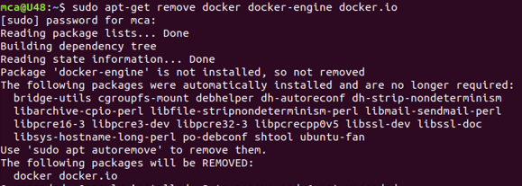

**3.**$ sudo apt-get update : To check if the system is up-to-date.



**4.**$ sudo apt install docker.io : To Install Docker .

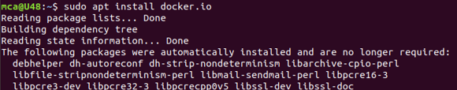

You’ll then get a prompt asking you to choose between y/n – choose y

**5.**$ sudo snap install docker : To Install all the dependency packages.



6. $ docker –version : Before testing Docker, check the version installed using the command.



7.$ sudo docker run hello-world : To Pull an image from the Docker hub using the command.

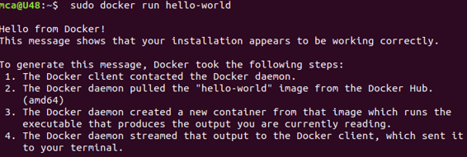

Here, hello-world is the docker image present on the Docker hub.

8. $ sudo docker images : To check if the docker image has been pulled and is present in your system .



9. $ sudo docker ps -a : *To display all the containers pulled.*

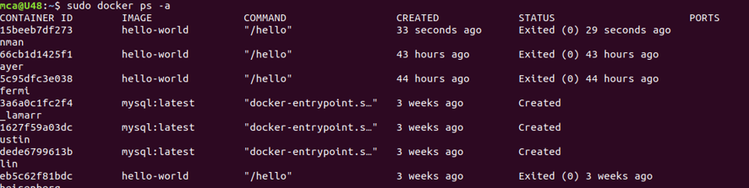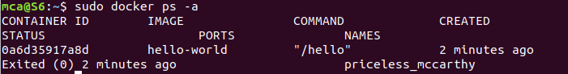

10. $ sudo docker ps : To check for containers in a running state.



**11**. **sudo docker run -dit --name tecmint-web -p 8080:80 v  /home/user/website/:/usr/local/apache2/htdocs/ httpd:2.4 :** To pull Docker Apache Container

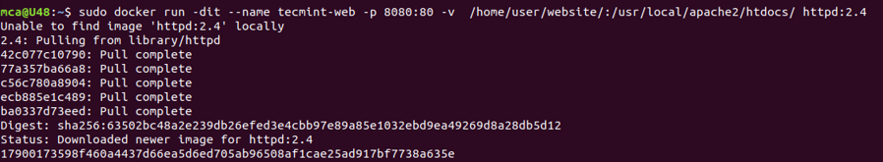

**12.$ sudo docker ps :** To check for containers in a running state

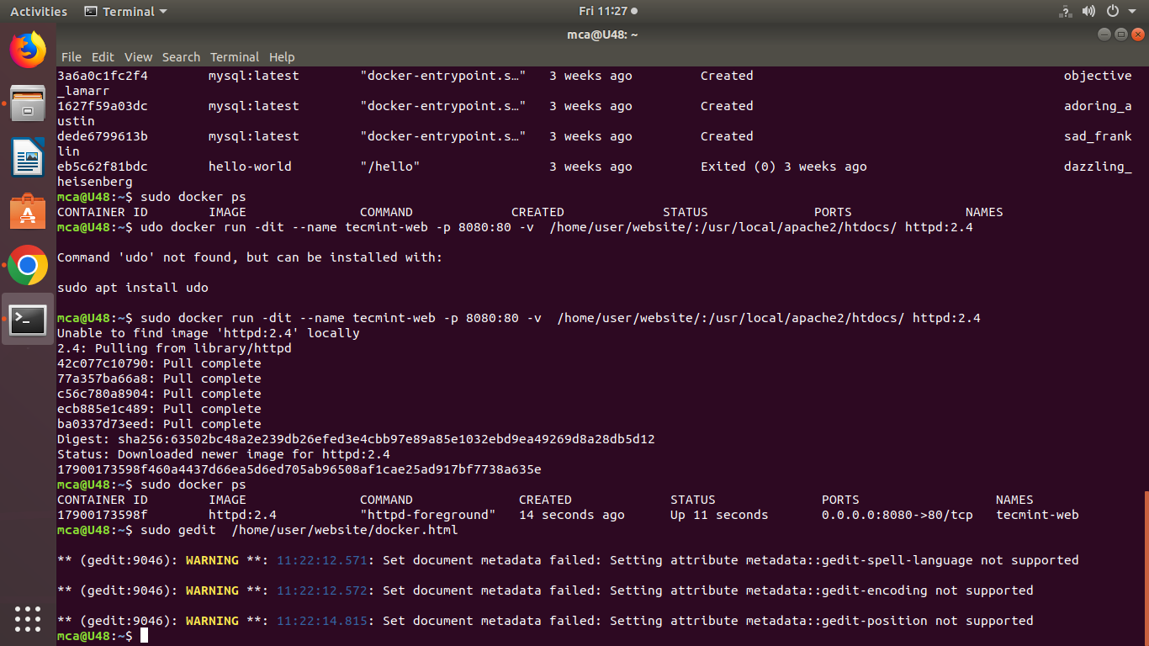

**13.$ sudo gedit  /home/user/website/docker.html :** create a simple web page named docker.html inside the /home/user/website directory.



Add the following sample HTML content to the file.

<!DOCTYPE html>

<html lang="en">

<head>

    <meta charset="UTF-8">

    <title>Learn Docker at Tecmint.com</title>

</head>

<body>

    <h1>Learn Docker With Us</h1>

</body>

</html>

Next, point your browser to **c** (where **Server-IP** is your host’s public IP address). You should be presented with the page we created previously.

Check Apache Page

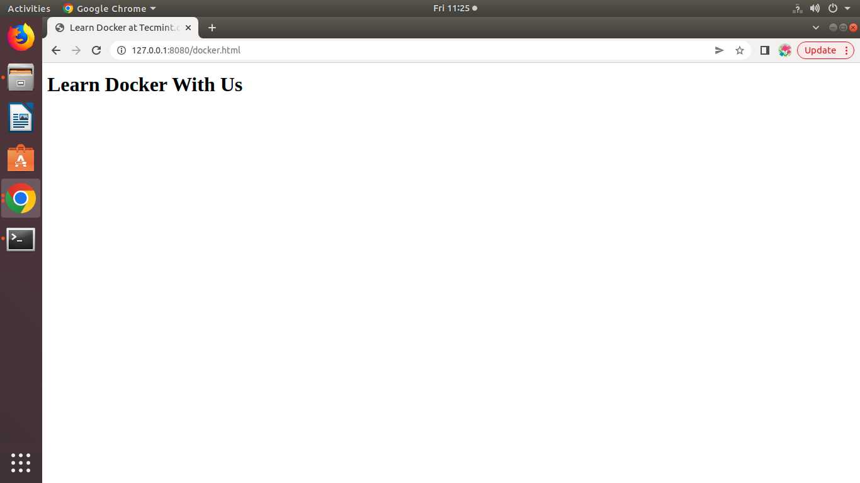

**14.$ sudo docker stop tecmint-web** :To stop the container.

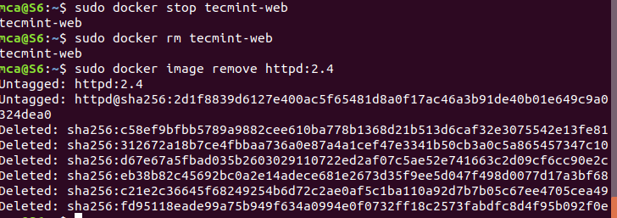

**15.$** **sudo docker rm tecmint-web** :To remove the container



**16.$ sudo docker image remove httpd:2.4 :** To finish cleaning up, and to delete the image that was used in the container .



Note that in all the above steps we never had to install the webserver on our host.