**Name: Varsha JJ**

**Roll No: 48**

**Batch: B**

**Date: 02/06/22**

**NETWORKING & SYSTEM ADMINISTRATION LAB**

**Experiment No.: 4**

**Aim**

Familiarization of windows command.

**Procedure**

**1. ipconfig :** Use to obtain an IP address automatically and  display the network settings currently assigned and given by a network.

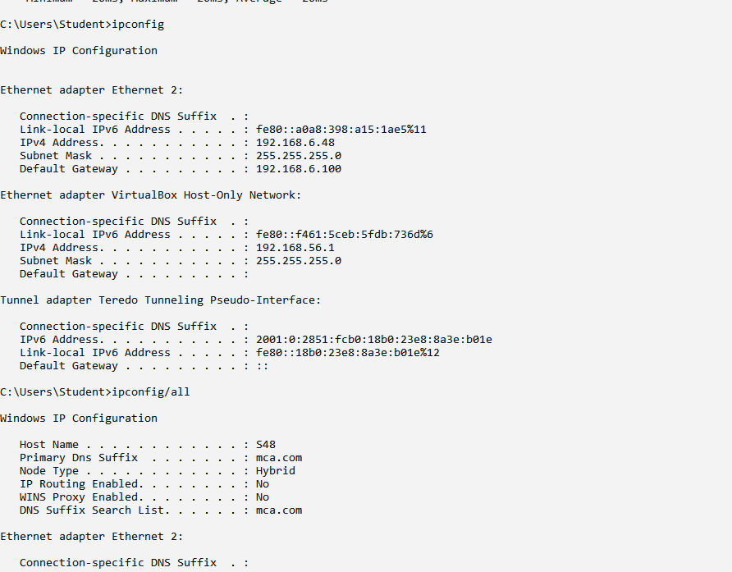

**2. ipconfig/all :** It displays the same IP addressing information for each adapter as the

default option. Additionally, it displays DNS and WINS settings for each adapter as

well as a whole host of additional information.



**3.nslookup:** Queries internet domain name servers interactively.

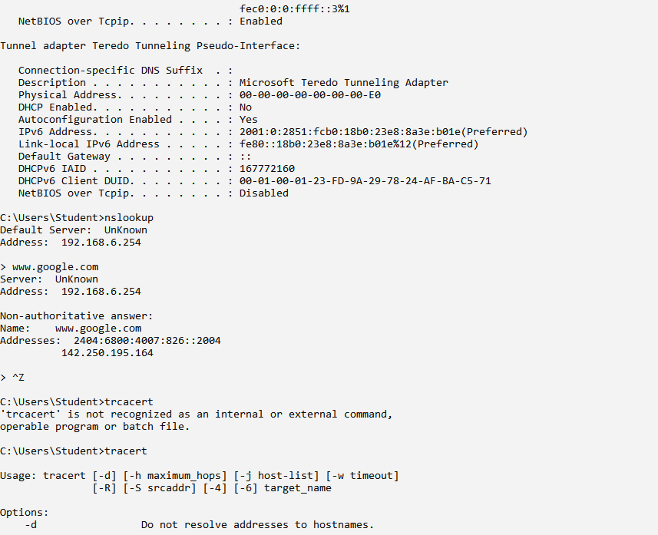

**4. tracert:** Used to show the path from the networked computer on which the tracert

command is being executed by a network device.

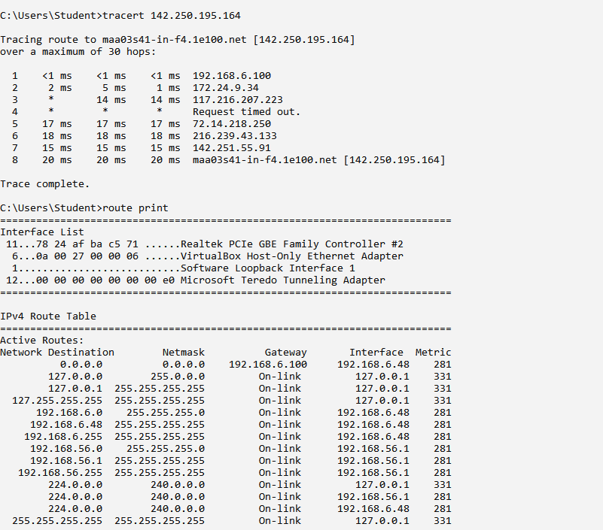

**5. route-print :** The route command allows you to make manual entries into the network

routing tables. The route command distinguishes between routes to hosts and routes to

networks by interpreting the network address of the Destination variable, which can be

specified either by symbolic name or numeric address.



**6. ping :** The ping command sends packets of data to a specific IP address on a network,

and then lets you know how long it took to transmit that data and get a response.

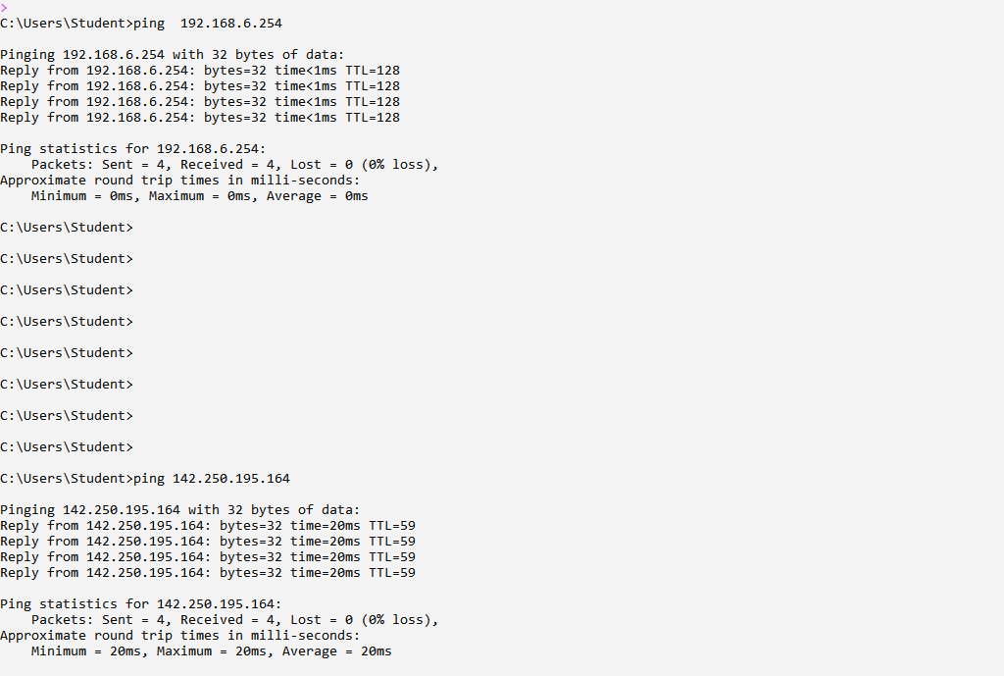

**7.netstat:** The netstat command generates displays that show network status and protocol

statistics.

