**Name: Varsha JJ**

**Roll No: 48**

**Batch: B**

**Date: 03/06/2022**

**ADVANCED DBMS LAB**

**Experiment No.: 1**

**Aim**

Perform CURD operation.

**Procedure**

**1.Create database :** MongoDB **use DATABASE_NAME** is used to create database. The command will create a new database if it doesn't exist, otherwise it will return the existing database.

**Syntax : use database name**

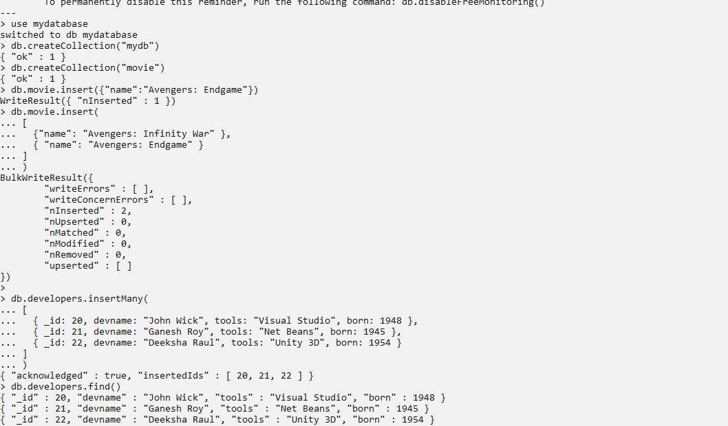

**2.Creating collection :** MongoDB creates collection automatically when you insert some documents.

**Syntax : db.createCollection(name, options)**



**3.Inserting value :** Is used to add or insert new documents into a collection in your database.

**Syntax : db.COLLECTION_NAME.insert(document)**



**Inserting one :** Allows you to insert one document into the collection.

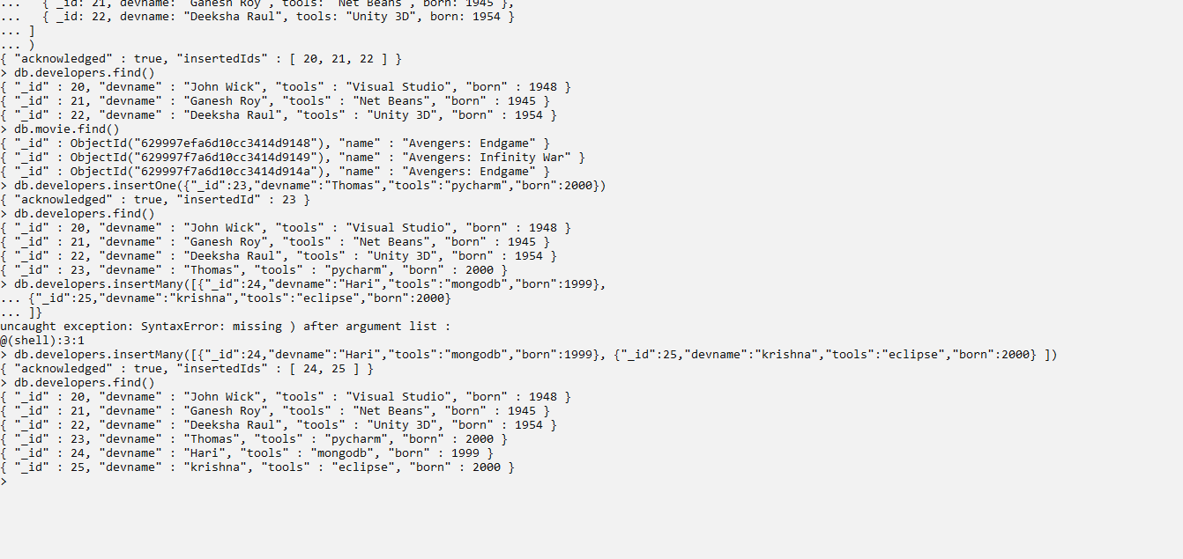

**Inserting many :** To insert multiple items at one time by calling the insertMany() method on the desired collection.

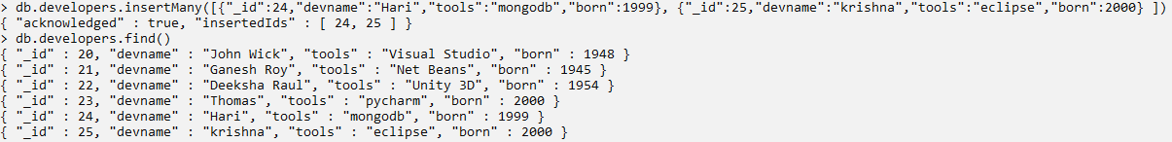

**4.Read: find()** to get all the documents from a collection.

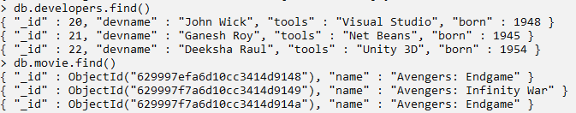

**5. Update :** Method is used to update or modify the existing documents of a collection.

**Update one :** We can update a currently existing record and change a single document with an update operation.

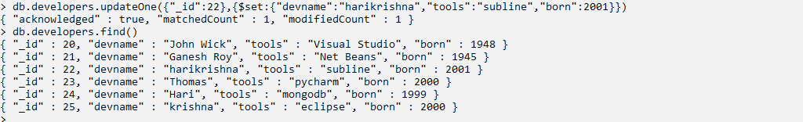

**Update many :** To update multiple items by passing in a list of items, just as we did when inserting multiple items.

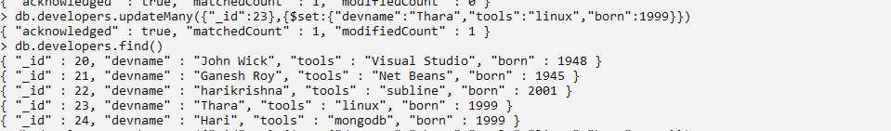

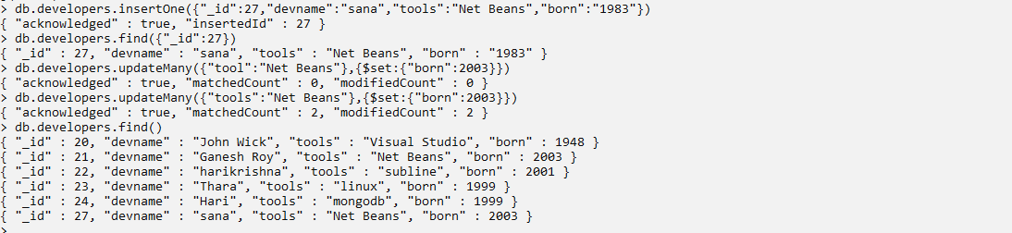

**6.Delete one :** To remove a document from a specified collection on the MongoDB server. A filter criteria is used to specify the item to delete. It deletes the first record that matches the provided filter.

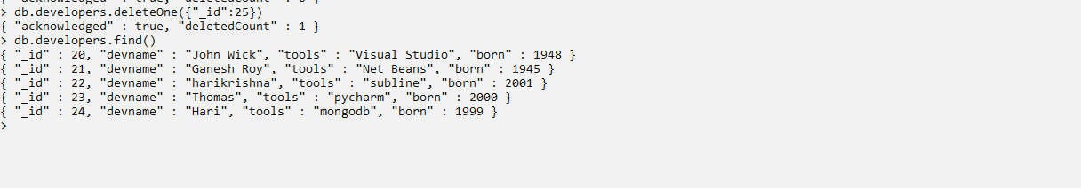

**Delete many:** To delete multiple documents from a desired collection with a single delete operation.

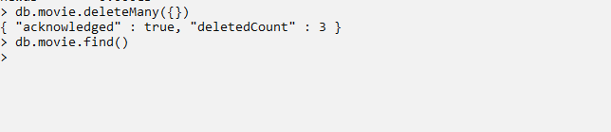

**7. Show :** Listing all databases.

