**Name: Varsha JJ**

**Roll No: 48**

**Batch: B**

**Date: 08/04/2022**

**ADVANCED DBMS LAB**

**Experiment No.: 3**

**AIM**

To familiarize DDL Commands - Alter, Drop, Truncate, Rename.

**Questions:**

1. Create a table emp with attributes empno number (4) as primary key, ename char (10), hiredate,

salary, commission. And insert the given 5 rows of data.

2. Modifying the structure of tables

a. Add new columns: sal number(7,2)

b. Dropping a column from a table: sal

c. Modifying existing column: ename varchar2(15)

d. Renaming the tables: emp to emp1

e. Truncating the tables:emp1

f. Destroying tables:emp

3. Create a table stud with sname varchar2(20) primary key , rollno number(10) not null,dob date not

null

4. Create a table student as regno number (6), mark number (3) check constraint (mark >=0 and mark

<=100));

5. Create a table cust with(custid number(6) constraint unique, name char(10)

**Procedure & Outputs**

**1.**CREATE DATABASE Employee;  
USE Employee;  
CREATE TABLE EMP (EMPNO INT(4) PRIMARY KEY,  
 ENAME CHAR(10),  
 HIREDATE DATE,  
 SALARY INT(8),  
 COMMISSION INT(8));

INSERT INTO EMP VALUES(199,'VARSHAK','2019-04-22',22000,2000),  
 (102,'JESNA','2020-05-3',80000,1000),  
 (103,'NEHA','2020-02-22',34000,500),  
 (104,'AKHILA','2018-09-3',37000,500),  
 (105,'HARI','2020-03-28',83000,1000);

SELECT*FROM EMP;

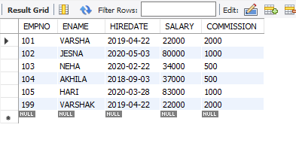

**2)a.** ALTER TABLE EMP ADD SAL INT;

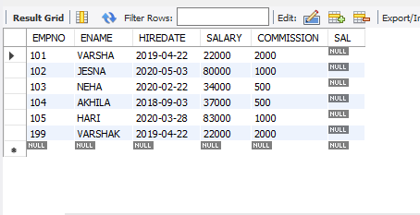

**b.** ALTER TABLE EMP DROP COLUMN SAL;

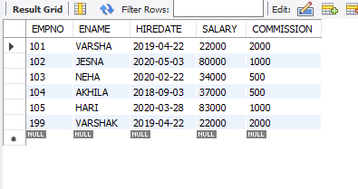

**c.** ALTER TABLE EMP MODIFY ENAME VARCHAR(15);

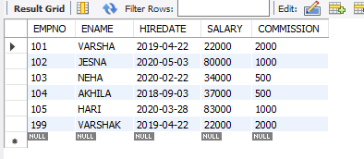

**d.** RENAME TABLE EMP TO EMP1;

SELECT*FROM EMP1;

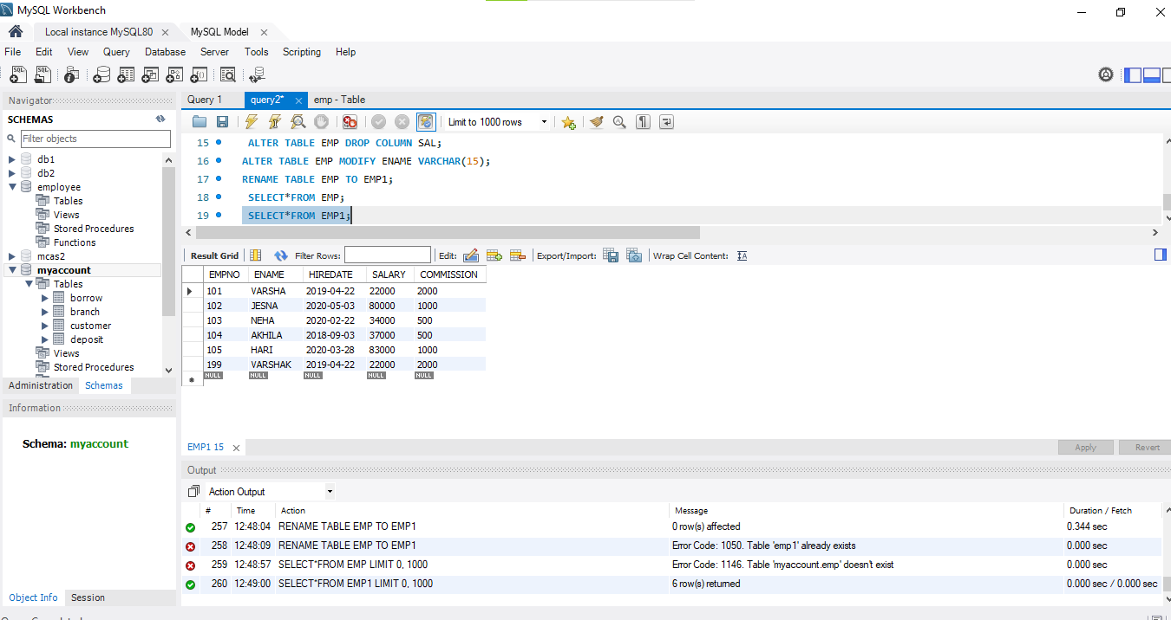

**e.** TRUNCATE TABLE EMP1;

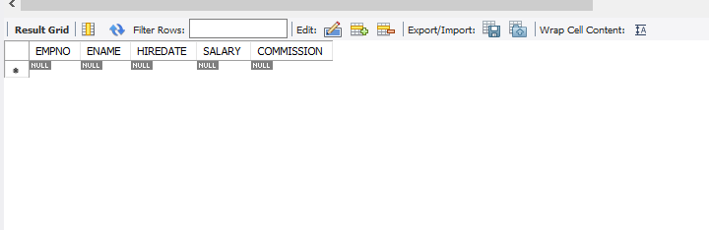

**f.** DESC EMP1;

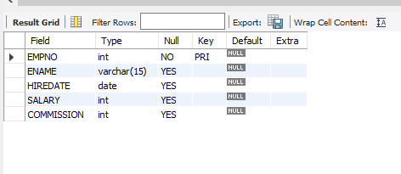

**3.** CREATE TABLE STUD(SNAME VARCHAR(20) PRIMARY KEY,ROLLNO INT NOT NULL,DOB DATE NOT NULL);

SELECT*FROM STUD;

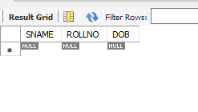

**4.** CREATE TABLE STUDENT(REGNO NUMERIC(6),MARK NUMERIC(3), CHECK (MARK >=0 AND MARK <= 100));

SELECT*FROM STUDENT;

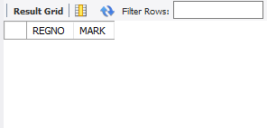

**5.** CREATE TABLE CUST(custid NUMERIC(6) UNIQUE, NAME CHAR(10));

SELECT*FROM CUST;

