**Name: Varsha JJ**

**Roll No: 48**

**Batch: B**

**Date: 19/04/2022**

**ADVANCED DBMS LAB**

**Experiment No.: 4**

**Aim :**

To familiarize with aggregate functions

**Questions**

1.List total loan

2.List total deposit

3.List total loan taken from KAROLBAGH branch

4.List total deposit of customers having account date later than 1-Jan-96

5.List total deposit of customers living in city NAGPUR

6.List maximum deposit of customer living in Bombay

7.List total deposit of customer having branch in BOMBAY

 8.Count total number of branch cities

9.Count total number of customers cities

10.Give branch names and branch wise deposit

11.Give city wise name and branch wise deposit

12.Give the branch wise loan of customer living in NAGPUR

13.Count total number of customers

14.Count total number of depositors branch wise

15.Give maximum loan from branch VRCE

16.Give the number of customers who are depositors as well as borrowers

**Procedure**

SELECT SUM(AMOUNT) FROM BORROW;

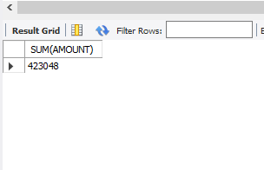

SELECT SUM(AMOUNT) FROM DEPOSIT;

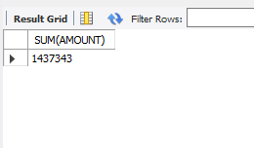

SELECT MAX(AMOUNT) FROM BORROW WHERE BNAME='KAROLBAGH';

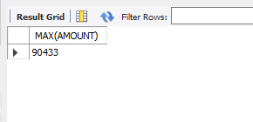

SELECT SUM(AMOUNT) FROM DEPOSIT WHERE ADATE>'1995-03-01';

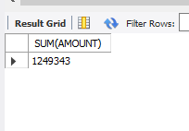

SELECT SUM(D1.AMOUNT) FROM DEPOSIT D1 , CUSTOMER C1 WHERE C1.CITY='NAGPUR' AND C1.CNAME=D1.CNAME;

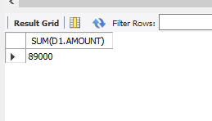

SELECT MAX(D1.AMOUNT) FROM DEPOSITE D1 ,CUSTOMER C1 WHERE C1.CITY='BOMBAY' AND C1.NAME=D1.NAME;

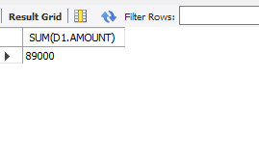

SELECT SUM(AMOUNT)FROM DEPOSIT,BRANCH WHERE CITY='BOMBAY';

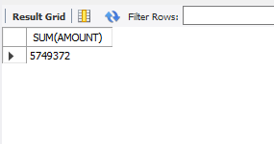

SELECT COUNT(CITY) FROM BRANCH;

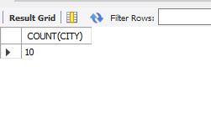

SELECT COUNT(CITY) FROM CUSTOMER;

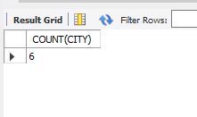

SELECT BNAME ,SUM(AMOUNT) FROM DEPOSIT GROUP BY BNAME;

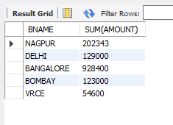

SELECT C1.CITY ,SUM(D1.AMOUNT) FROM CUSTOMER C1 ,DEPOSIT D1 WHERE D1.CNAME = C1.CNAME GROUP BY C1.CITY;

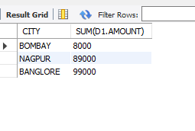

SELECT BNAME ,SUM(AMOUNT) FROM BORROW ,CUSTOMER WHERE CITY='NAGPUR' GROUP BY BNAME;

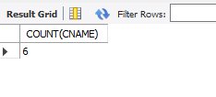

SELECT BNAME,COUNT(*)FROM DEPOSIT,CUSTOMER WHERE DEPOSIT.CNAME=CUSTOMER.CNAME GROUP BY BNAME;

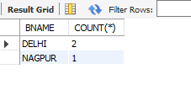

SELECT MAX(AMOUNT) FROM BORROW WHERE BNAME='VRCE';

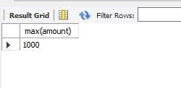

SELECT COUNT(DISTINCT(CNAME)) FROM CUSTOMER WHERE CNAME IN((SELECT CNAME DEPOSIT) IN (SELECT CNAME FROM BORROW));

