‘~’ tells that we are in the home directory

pwd command shows the present working directory.

Varsha@DESKTOP-VACD3SC MINGW64 ~ (main)

$ pwd

/c/Users/Varsha

Go to ‘This PC’ > c > users > Varsha

Then create a file named ‘project’ (it doesn’t contain any file)

Go to gitbash

Varsha@DESKTOP-VACD3SC MINGW64 ~ (main)

$ cd project

Varsha@DESKTOP-VACD3SC MINGW64 ~/project (main)

$

Creating a repo

Varsha@DESKTOP-VACD3SC MINGW64 ~/project (main)

$ git init

Initialized empty Git repository in C:/Users/Varsha/project/.git/

Go to the files > open the project file > in the search type ‘*.*’

It will show the git files

OR

Go to git bash > and type ‘ls -a’ command

Varsha@DESKTOP-VACD3SC MINGW64 ~/project (master)

$ ls -a

./ ../ .git/

It will show the git files

Varsha@DESKTOP-VACD3SC MINGW64 ~/project (master)

$ git status

On branch master

No commits yet

nothing to commit (create/copy files and use "git add" to track)

Go to files > create a text document named ‘arithmetic’ and write the program

void main()

{

int sum;

int a=10, b=20;

sum=a+b;

printf("Sum is %d", sum);

}

Go to gitbash and check git status

Varsha@DESKTOP-VACD3SC MINGW64 ~/project (master)

$ git status

On branch master

No commits yet

Untracked files:

(use "git add <file>..." to include in what will be committed)

arithmetic.txt

nothing added to commit but untracked files present (use "git add" to track)

The arithmetic.txt appeared in red which means that the file is not staged.

There are four steps:

1. Untracked
2. Staged
3. Commit
4. Push

To stage the file, we use git add command

Varsha@DESKTOP-VACD3SC MINGW64 ~/project (master)

$ git add arithmetic.txt

Now check the git status again

Varsha@DESKTOP-VACD3SC MINGW64 ~/project (master)

$ git status

On branch master

No commits yet

Changes to be committed:

(use "git rm --cached <file>..." to unstage)

new file: arithmetic.txt

Now, the arithmetic.txt file appeared in green which means that the file is staged and ready to commit.

To commit the file, we use the git commit command

Varsha@DESKTOP-VACD3SC MINGW64 ~/project (master)

$ git commit -m "Created a file and addition operation"

[master (root-commit) 7b6befb] Created a file and addition operation

1 file changed, 7 insertions(+)

create mode 100644 arithmetic.txt

Now, when we perform the git status command the working tree should be clean

Varsha@DESKTOP-VACD3SC MINGW64 ~/project (master)

$ git status

On branch master

nothing to commit, working tree clean

The file arithmetic.txt is committed to our local repo. Now, we have to push it to Github or remote repo.

Go to github and create your account.

1. Enter your email
2. Create a password
3. Enter a username
4. Solve the given puzzle
5. Enter the code received from mail.
6. Click on continue
7. Your account will be created

Create a repo named project, click on public and click on create.

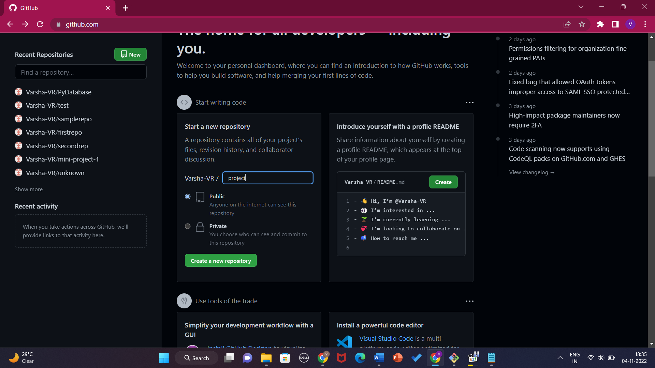

Now we will create an SSH key

Go to gitbash and type

Varsha@DESKTOP-VACD3SC MINGW64 ~/project (master)

$ ssh-keygen -o

Generating public/private rsa key pair.

Enter file in which to save the key (/c/Users/Varsha/.ssh/id_rsa):

/c/Users/Varsha/.ssh/id_rsa already exists.

Overwrite (y/n)? y

Enter passphrase (empty for no passphrase):

Enter same passphrase again:

Your identification has been saved in /c/Users/Varsha/.ssh/id_rsa

Your public key has been saved in /c/Users/Varsha/.ssh/id_rsa.pub

The key fingerprint is:

SHA256:HeWEu7cxoa0kpZ9f8+K930yJ/kbNuJOE1YYk5RYy3as Varsha@DESKTOP-VACD3SC

The key's randomart image is:

+---[RSA 3072]----+

| .=oo. |

| .+.+o..|

| ...ooo.|

| .o...o.o|

| So.+ +.+.|

| o + *E+.+|

| + + *++.|

| + o.=B.|

| ..o+=O|

+----[SHA256]-----+

Opening the file where the public key is saved using cat command.

Varsha@DESKTOP-VACD3SC MINGW64 ~/project (master)

$ cat /c/Users/Varsha/.ssh/id_rsa.pub

ssh-rsa  Varsha@DESKTOP-VACD3SC

Copy the content

Go to github and open settings

Click on SSH and GPG keys > click on new key > enter the title > paste the content > click on add SSH key

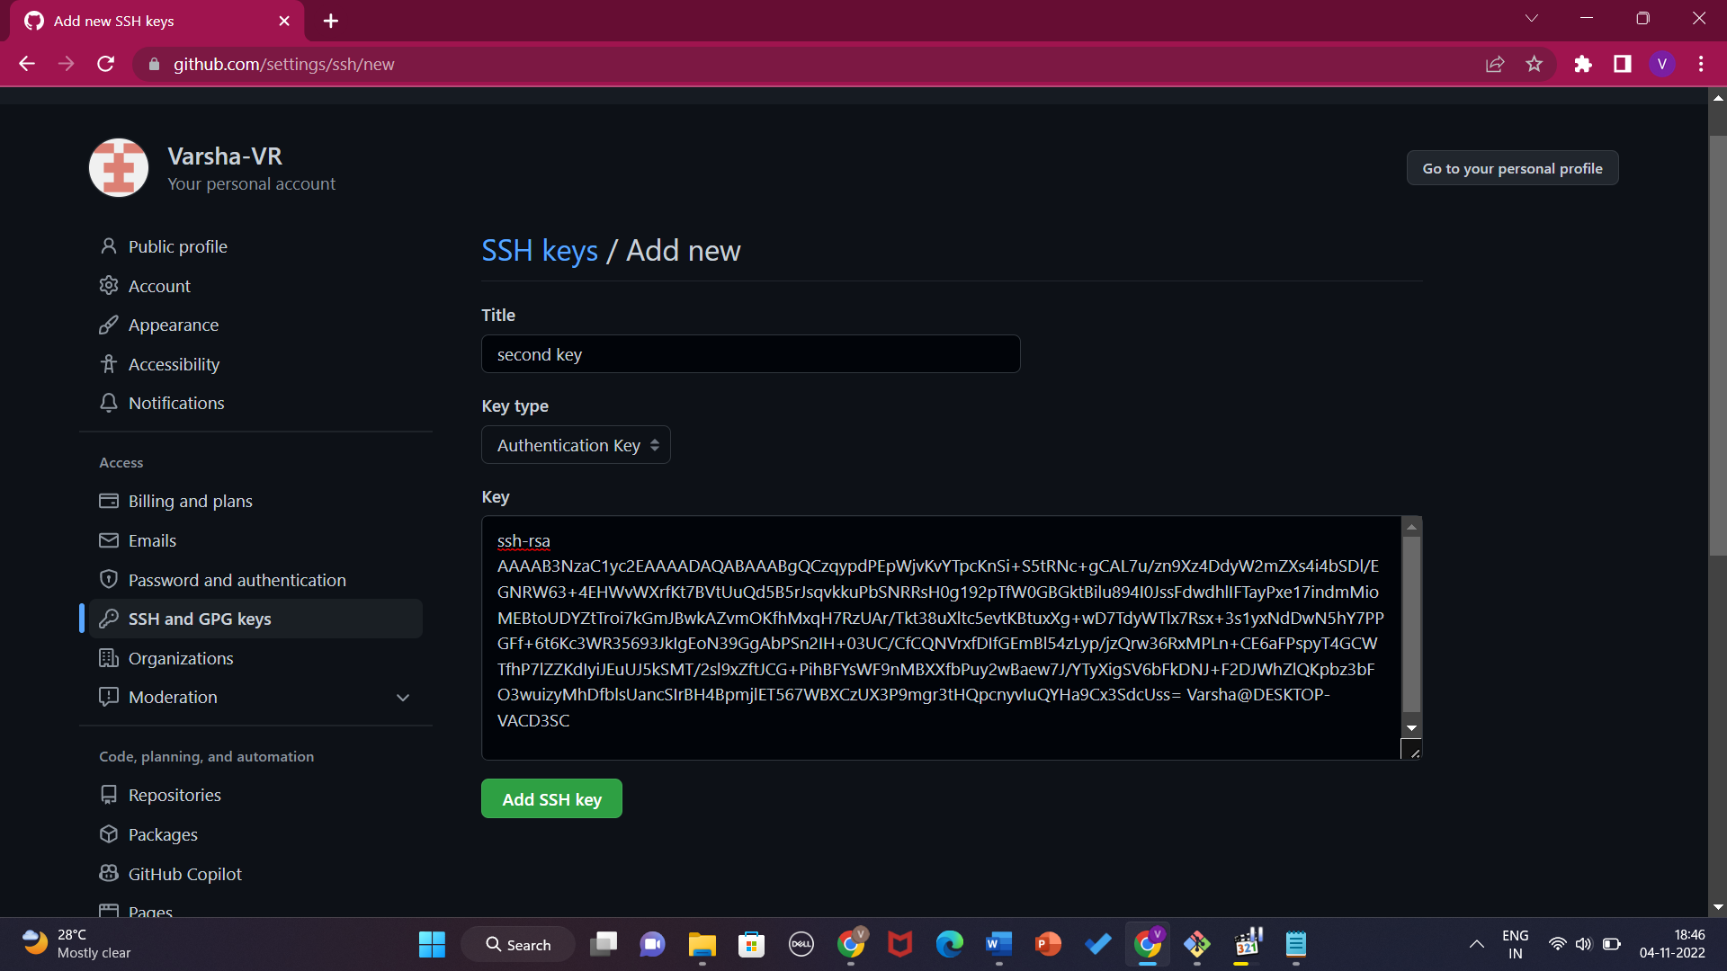

Go to github > open the project repo > and copy the second section code

Varsha@DESKTOP-VACD3SC MINGW64 ~/project (master)

$ git remote add origin git@github.com:Varsha-VR/project.git

Varsha@DESKTOP-VACD3SC MINGW64 ~/project (master)

$ git branch -M main

Varsha@DESKTOP-VACD3SC MINGW64 ~/project (main)

$ git push -u origin main

Enumerating objects: 3, done.

Counting objects: 100% (3/3), done.

Delta compression using up to 4 threads

Compressing objects: 100% (2/2), done.

Writing objects: 100% (3/3), 305 bytes | 152.00 KiB/s, done.

Total 3 (delta 0), reused 0 (delta 0), pack-reused 0

To github.com:Varsha-VR/project.git

* [new branch] main -> main

branch 'main' set up to track 'origin/main'.

Go to files > open the arithmetic file > and modify the changes

void main()

{

int sum, sub;

int a=10, b=20;

sum=a+b;

sub=a-b;

printf("Sum is %d", sum);

printf("Sub is %d", sub);

}

Go to gitbash and check the git status

Varsha@DESKTOP-VACD3SC MINGW64 ~/project (main)

$ git status

On branch main

Your branch is up to date with 'origin/main'.

Changes not staged for commit:

(use "git add <file>..." to update what will be committed)

(use "git restore <file>..." to discard changes in working directory)

modified: arithmetic.txt

no changes added to commit (use "git add" and/or "git commit -a")

The file again appears in red which again means that the file is not staged but this time it is showing modified.

Go to gitbash and stage the file, commit and push to github.

Varsha@DESKTOP-VACD3SC MINGW64 ~/project (main)

$ git add arithmetic.txt

Varsha@DESKTOP-VACD3SC MINGW64 ~/project (main)

$ git status

On branch main

Your branch is up to date with 'origin/main'.

Changes to be committed:

(use "git restore --staged <file>..." to unstage)

modified: arithmetic.txt

Varsha@DESKTOP-VACD3SC MINGW64 ~/project (main)

$ git commit -m "subtraction operation"

[main 630622a] subtraction operation

1 file changed, 3 insertions(+), 1 deletion(-)

Varsha@DESKTOP-VACD3SC MINGW64 ~/project (main)

$ git push origin main

Enumerating objects: 5, done.

Counting objects: 100% (5/5), done.

Delta compression using up to 4 threads

Compressing objects: 100% (2/2), done.

Writing objects: 100% (3/3), 340 bytes | 170.00 KiB/s, done.

Total 3 (delta 0), reused 0 (delta 0), pack-reused 0

To github.com:Varsha-VR/project.git

7b6befb..630622a main -> main

Go to github > refresh the page > click on the new commit > you can view the changes > the red ones are the old > the green ones are the modified

