**Day7 Solutions:**

**What is a package manager in Linux?**

In simpler words, a package manager is a tool that allows users to install, remove, upgrade, configure and manage software packages on an operating system. The package manager can be a graphical application like a software center or a command line tool like apt-get or pacman.

You’ll often find me using the term ‘package’ in tutorials and articles, To understand package manager, you must understand what a package is.

**What is a package?**

A package is usually referred to an application but it could be a GUI application, command line tool or a software library (required by other software programs). A package is essentially an archive file containing the binary executable, configuration file and sometimes information about the dependencies.

**Different kinds of package managers**

Package Managers differ based on packaging system but same packaging system may have more than one package manager.

For example, RPM has Yum and DNF package managers. For DEB, you have apt-get, aptitude command line based package managers.

**7.1- You have to install docker and jenkins in your system from your terminal using package managers**

For Docker Installation:

sudo apt-get install [docker.io](http://docker.io)

For Jenkins Installation:

1. Jenkins requires Java Runtime environment(JRE). Run below To install OpenJDK11 sudo apt-get install openjdk-11-jdk and java –version
2. Import GPG key:

curl -fsSL <https://pkg.jenkins.io/debian-stable/jenkins.io.key> | sudo tee /usr/share/keyrings/jenkins-keyring.asc > /dev/null

1. Add Jenkin Repository and provide Authentication key:

echo deb [signed-by=/usr/share/keyrings/jenkins-keyring.asc] <https://pkg.jenkins.io/debian-stable> binary/ | sudo tee /etc/apt/sources.list.d/jenkins.list > /dev/null

1. Update the repository and Install Jenkins: sudo apt update

sudo apt install jenkins -y

sudo systemctl status jenkins

### ****systemctl and systemd****:

systemctl is used to examine and control the state of “systemd” system and service manager. systemd is system and service manager for Unix like operating systems(most of the distributions, not all).

**7.2- check the status of docker service in your system** (make sure you completed above tasks, else docker won't be installed)

docker --version

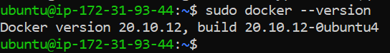

**7.3- Stop the service Jenkins and post before and after screenshots**

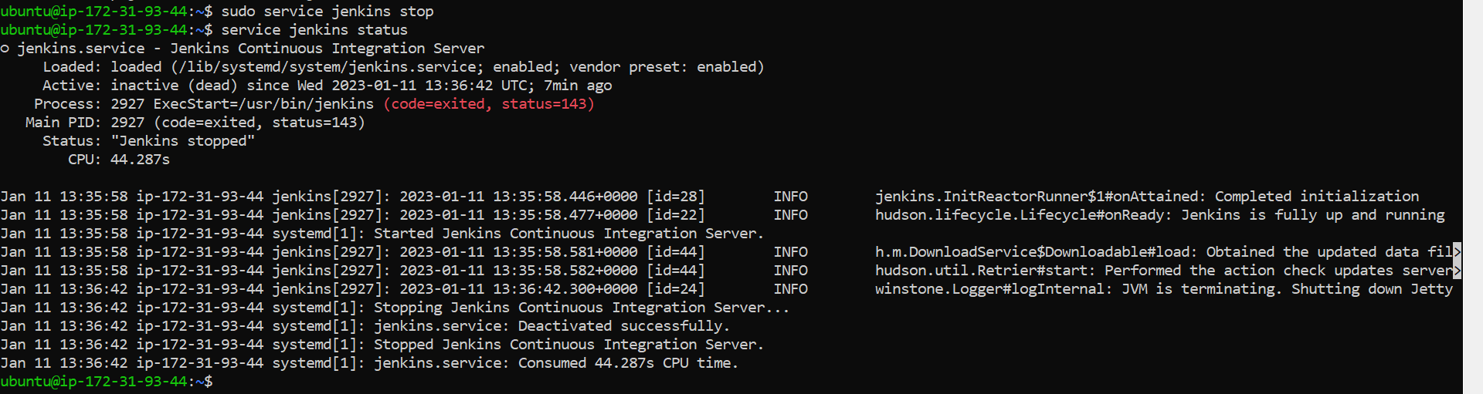

**7.4- systemctl vs service**

eg. systemctl status docker vs service docker status

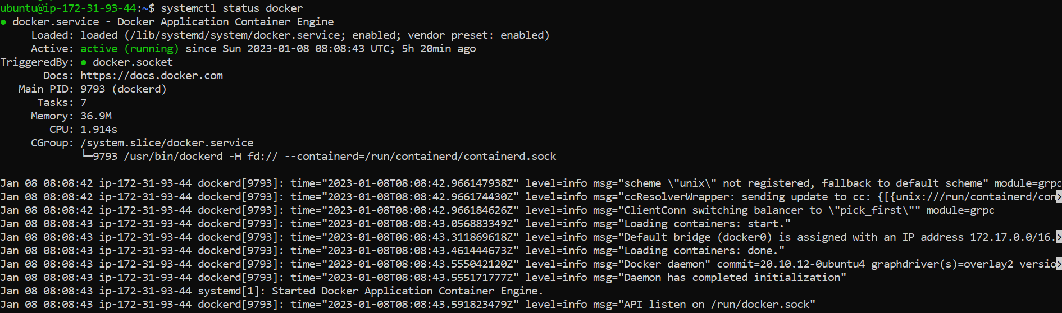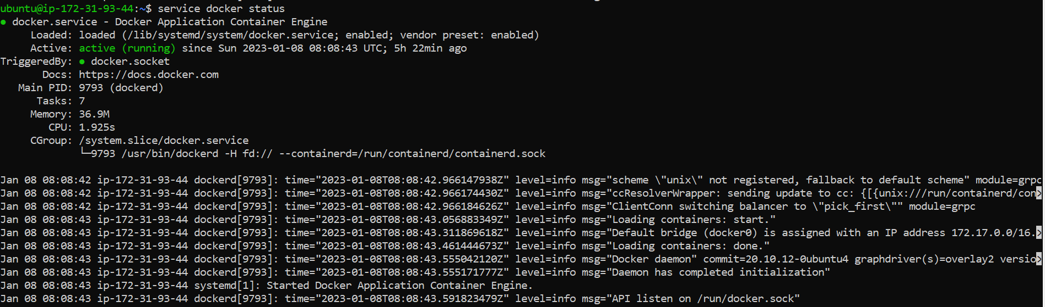

Both are giving similar outputs. Docker uses a daemon-based architecture where the CLI connects to a long-lived process running separately on your machine or a remote host. CLI commands won’t work and your containers will usually go offline if the daemon stops.

systemctl status docker

Check what’s displayed under “Active.” If you see **active (running)** in green, the Docker daemon is running and your containers should be up. An active state of **inactive** indicates the service has stopped. Try to bring it up by running systemctl start docker. The status should change to **active (running)** after the daemon starts.

If you see the status of **failed** in red, the daemon couldn’t start due to an error. You should review the service’s startup logs shown later in the **systemctl** command output as these usually contain hints that let you work out what went wrong.

**Troubleshooting:**

When there’s no obvious resolution available, manually start the daemon in debugging mode to get more information on its startup routine.

dockerd --debug

Rebooting your host machine or restarting the Docker service with systemctl restart docker can help alleviate transient issues too.