**Examine Weather Trends**

**Data Exploration:**

* Used simple select and describe statements to familiarize myself with all the tables.

SELECT DISTINCT(CITY) FROM CITY_LIST

WHERE COUNTRY='United States';

* Look for closest local city in city_list table.

**Data Extraction:**

Used SQL statements to pull average global temperature from global_data table.

SELECT year, avg_temp from global_data order by year;

Used SQL statements to pull average local temperature from city_data table. City used is San Jose.

SELECT year, avg_temp, city from city_data

where city='San Jose' order by year;

**Moving average calculation:**

San Jose had data from 1849 to 2013 but global table had data from 1750 to 2015 so common period was taken from 1849 to 2013 for analysis purposes. But, we can’t take moving average from 1849 due to lack of data, we include analysis from 1855 to 2013.

7 year moving average was calculated for 1855 to 2013 using average function in excel for both global temp and San Jose temp.

A line chart was drawn in excel using Line chart type from Charts in excel.

Moving Average was calculated using Average function in excel and average of last 7 years were taken in excel for both Global and San Jose temperatures to come up with moving average for year 1855.

Please see screenshot for Moving average calculation in excel as below:

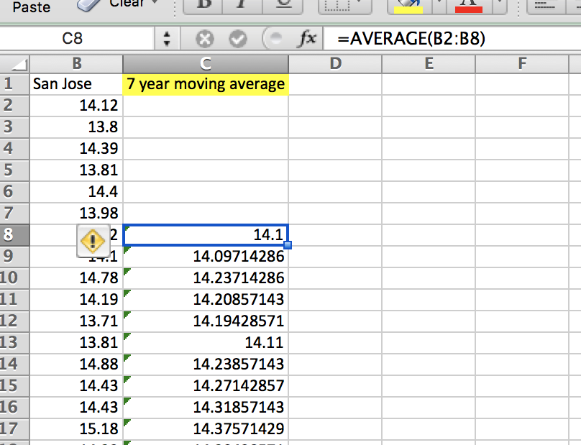

**Line Chart**

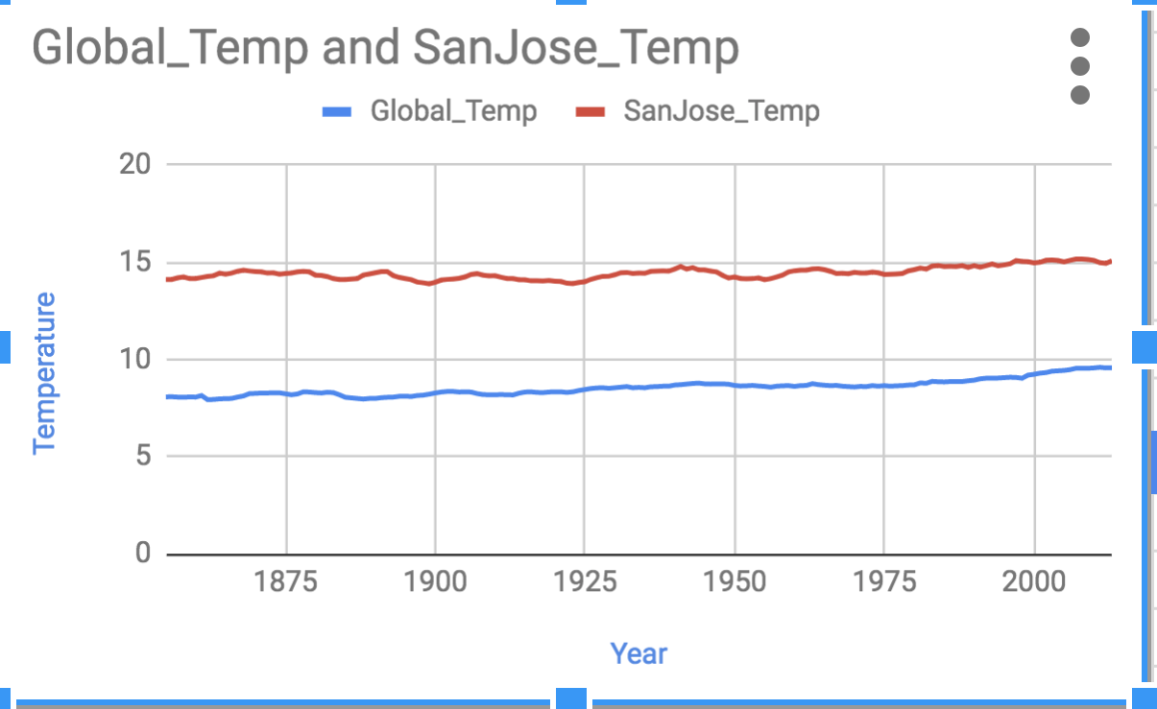

**Findings:**

* It seems that San Jose is usually hotter than the global temperature as maximum temperature is +7 units greater than maximum global temperature.
* Average temperature in San Jose is +6 units greater than average global temperature.
* Also, since the data is available from 1849 as compared to global for which data is available from 1750 which is a lag of 99 years, we can also infer that San Jose is comparatively newer city than most cities in world.
* One similarity between the global and local temperature is that both seem to be rising in recent years as San Jose had highest recorded temperature in 2013 and global had highest recorded temperature in 2015.

|  |  |  |
| --- | --- | --- |
| **Metric** | **Global** | **San Jose** |
| Time period | 1750-2015 | 1849-2013 |
| Maximum Temp | 9.83 | 16.23 |
| Minimum Temp | 5.78 | 13.22 |
| Average Temp | 8.36 | 14.45 |