**Week3_** **Spring Core_Maven_HandsOn**

**Exercise 1: Configuring a Basic Spring Application**

**Code:**

applicationContext.xml:

<?xml version="1.0" encoding="UTF-8"?>

<beans xmlns="http://www.springframework.org/schema/beans"

xmlns:xsi="http://www.w3.org/2001/XMLSchema-instance"

xsi:schemaLocation="

http://www.springframework.org/schema/beans

http://www.springframework.org/schema/beans/spring-beans.xsd">

<bean id="bookRepository" class="com.library.repository.BookRepository"/>

<bean id="bookService" class="com.library.service.BookService">

<property name="bookRepository" ref="bookRepository"/>

</bean>

</beans>

BookRepository.java:

package com.library.repository;

public class BookRepository {

public void saveBook(String bookName) {

System.out.println("Book '" + bookName + "' saved to the database.");

}

}

BookService.java:

package com.library.service;

import com.library.repository.BookRepository;

public class BookService {

private BookRepository;

public void setBookRepository(BookRepository bookRepository) {

this.bookRepository = bookRepository;

}

public void addBook(String bookName) {

System.out.println("Adding book: " + bookName);

bookRepository.saveBook(bookName);

}

}

AppMain.java :

import org.springframework.context.ApplicationContext;

import org.springframework.context.support.ClassPathXmlApplicationContext;

import com.library.service.BookService;

public class AppMain {

public static void main(String[] args) {

ApplicationContext context = new ClassPathXmlApplicationContext("applicationContext.xml");

BookService = (BookService) context.getBean("bookService");

bookService.addBook("Spring in Action");

}

}

pom.xml:

<dependencies>

<dependency>

<groupId>org.springframework</groupId>

<artifactId>spring-context</artifactId>

<version>5.3.29</version>

</dependency>

</dependencies>

**Output:**

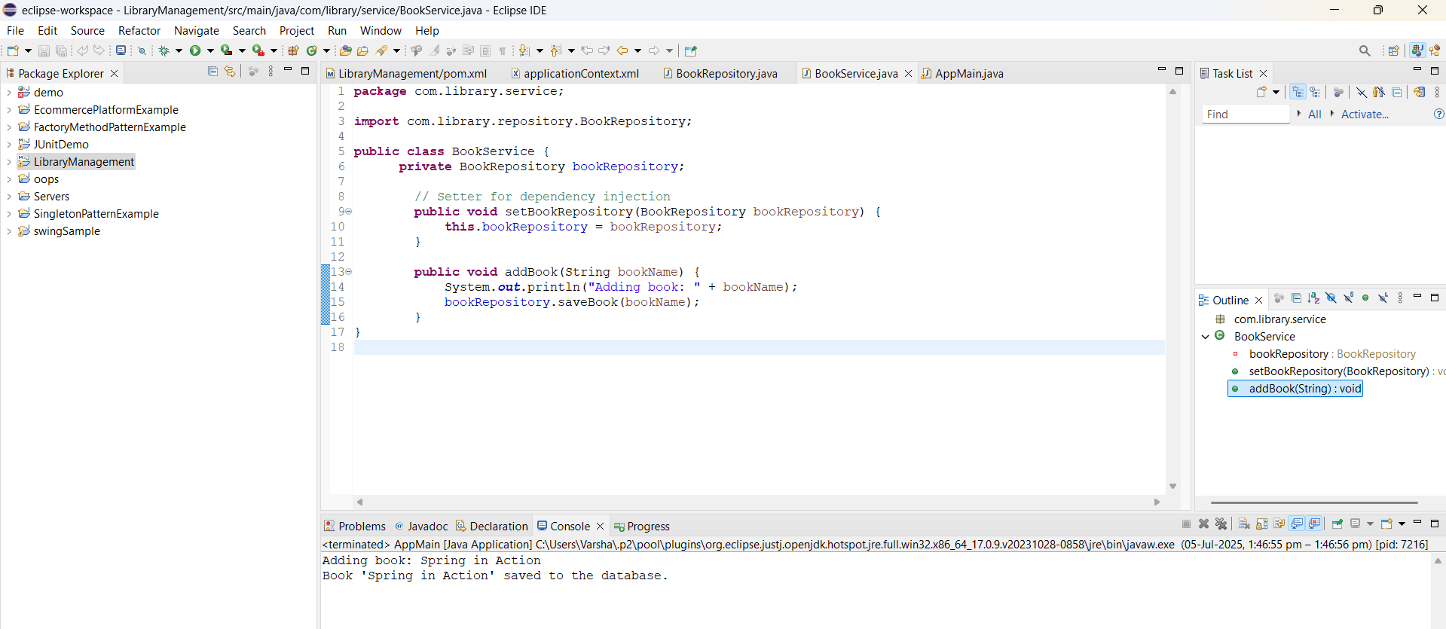

**Exercise 2: Implementing Dependency Injection**

**Code:**

applicationContext.xml:

<?xml version="1.0" encoding="UTF-8"?>

<beans xmlns="http://www.springframework.org/schema/beans"

xmlns:xsi="http://www.w3.org/2001/XMLSchema-instance"

xsi:schemaLocation="

http://www.springframework.org/schema/beans

http://www.springframework.org/schema/beans/spring-beans.xsd">

<bean id="bookRepository" class="com.library.repository.BookRepository"/>

<bean id="bookService" class="com.library.service.BookService">

<property name="bookRepository" ref="bookRepository"/>

</bean>

</beans>

BookService.java:

package com.library.service;

import com.library.repository.BookRepository;

public class BookService {

private BookRepository bookRepository;

public void setBookRepository(BookRepository bookRepository) {

this.bookRepository = bookRepository;

}

public void addBook(String bookName) {

System.out.println("Adding book: " + bookName);

bookRepository.saveBook(bookName); // use injected repository

}

}

BookRepository.java:

package com.library.repository;

public class BookRepository {

public void saveBook(String bookName) {

System.out.println("Book '" + bookName + "' saved to the database.");

}

}

LibraryManagementApplication.java:

import org.springframework.context.ApplicationContext;

import org.springframework.context.support.ClassPathXmlApplicationContext;

import com.library.service.BookService;

public class LibraryManagementApplication {

public static void main(String[] args) {

ApplicationContext context = new ClassPathXmlApplicationContext("applicationContext.xml");

BookService bookService = (BookService) context.getBean("bookService");

bookService.addBook("The Great Gatsby");

}

}

**Output:**

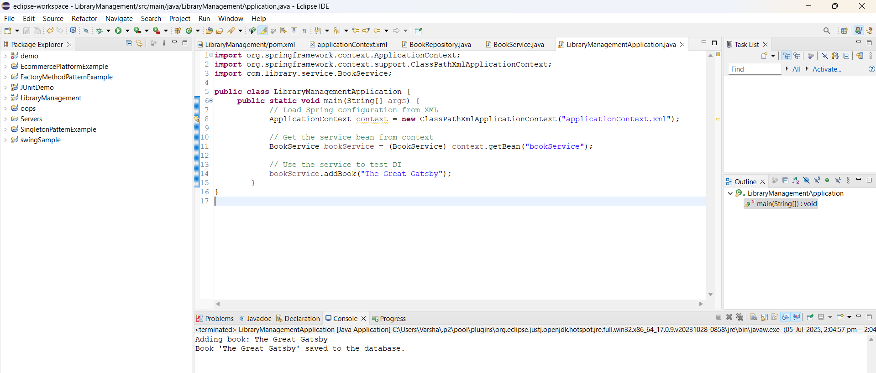

**Exercise 4: Creating and Configuring a Maven Project**

**Code:**

applicationContext.xml:

<?xml version="1.0" encoding="UTF-8"?>

<beans xmlns="http://www.springframework.org/schema/beans"

xmlns:xsi="http://www.w3.org/2001/XMLSchema-instance"

xsi:schemaLocation="

http://www.springframework.org/schema/beans

http://www.springframework.org/schema/beans/spring-beans.xsd">

<bean id="bookRepository" class="com.library.repository.BookRepository"/>

<bean id="bookService" class="com.library.service.BookService">

<property name="bookRepository" ref="bookRepository"/>

</bean>

</beans>

BookRepository.java:

package com.library.repository;

public class BookRepository {

public void saveBook(String bookName) {

System.out.println("Book '" + bookName + "' saved to the database.");

}

}

BookService.java:

package com.library.service;

import com.library.repository.BookRepository;

public class BookService {

private BookRepository;

public void setBookRepository(BookRepository bookRepository) {

this.bookRepository = bookRepository;

}

public void addBook(String bookName) {

System.out.println("Adding book: " + bookName);

bookRepository.saveBook(bookName);

}

}

AppMain.java :

import org.springframework.context.ApplicationContext;

import org.springframework.context.support.ClassPathXmlApplicationContext;

import com.library.service.BookService;

public class AppMain {

public static void main(String[] args) {

ApplicationContext context = new ClassPathXmlApplicationContext("applicationContext.xml");

BookService = (BookService) context.getBean("bookService");

bookService.addBook("Spring in Action");

}

}

pom.xml:

<project xmlns="http://maven.apache.org/POM/4.0.0"

xmlns:xsi="http://www.w3.org/2001/XMLSchema-instance"

xsi:schemaLocation="http://maven.apache.org/POM/4.0.0

http://maven.apache.org/xsd/maven-4.0.0.xsd">

<modelVersion>4.0.0</modelVersion>

<groupId>com.library</groupId>

<artifactId>LibraryManagement</artifactId>

<version>1.0-SNAPSHOT</version>

<dependencies>

<dependency>

<groupId>org.springframework</groupId>

<artifactId>spring-context</artifactId>

<version>5.3.29</version>

</dependency>

<dependency>

<groupId>org.springframework</groupId>

<artifactId>spring-aop</artifactId>

<version>5.3.29</version>

</dependency>

<dependency>

<groupId>org.springframework</groupId>

<artifactId>spring-webmvc</artifactId>

<version>5.3.29</version>

</dependency>

<dependency>

<groupId>javax.servlet</groupId>

<artifactId>javax.servlet-api</artifactId>

<version>4.0.1</version>

<scope>provided</scope>

</dependency>

</dependencies>

<build>

<plugins>

<plugin>

<groupId>org.apache.maven.plugins</groupId>

<artifactId>maven-compiler-plugin</artifactId>

<version>3.8.1</version>

<configuration>

<source>1.8</source>

<target>1.8</target>

</configuration>

</plugin>

</plugins>

</build>

</project>

**Output:**

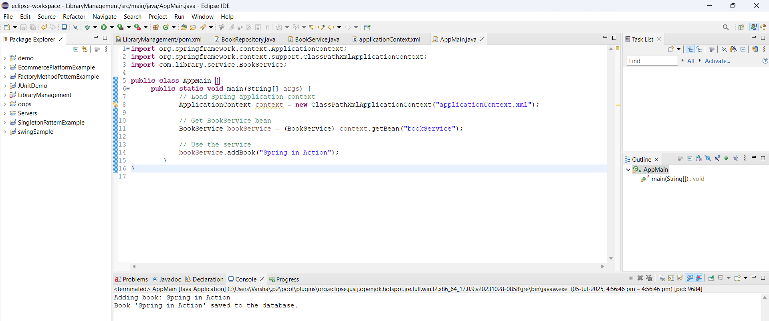

**Exercise 5: Configuring the Spring IoC Container**

**Code:**

applicationContext.xml:

<?xml version="1.0" encoding="UTF-8"?>

<beans xmlns="http://www.springframework.org/schema/beans"

xmlns:xsi="http://www.w3.org/2001/XMLSchema-instance"

xsi:schemaLocation="

http://www.springframework.org/schema/beans

http://www.springframework.org/schema/beans/spring-beans.xsd">

<bean id="bookRepository" class="com.library.repository.BookRepository"/>

<bean id="bookService" class="com.library.service.BookService">

<property name="bookRepository" ref="bookRepository"/>

</bean>

</beans>

BookRepository.java:

package com.library.repository;

public class BookRepository {

public void saveBook(String bookName) {

System.out.println("Book '" + bookName + "' saved to the database.");

}

}

BookService.java:

package com.library.service;

import com.library.repository.BookRepository;

public class BookService {

private BookRepository bookRepository;

public void setBookRepository(BookRepository bookRepository) {

this.bookRepository = bookRepository;

}

public void addBook(String title) {

System.out.println("Adding book: " + title);

bookRepository.saveBook(title);

}

}

LibraryManagementApplication.java:

import org.springframework.context.ApplicationContext;

import org.springframework.context.support.ClassPathXmlApplicationContext;

import com.library.service.BookService;

public class LibraryManagementApplication {

public static void main(String[] args) {

ApplicationContext context = new ClassPathXmlApplicationContext("applicationContext.xml");

BookService bookService = (BookService) context.getBean("bookService");

bookService.addBook("Clean Code");

}

}

**Output:**

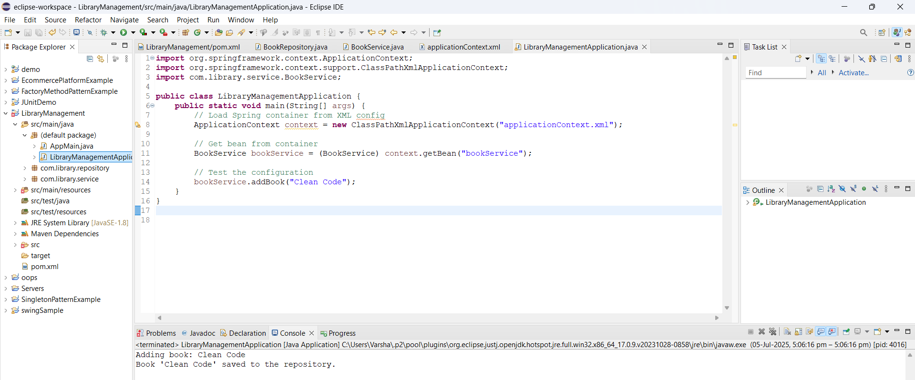

**Exercise 7: Implementing Constructor and Setter Injection**

**Code:**

BookService.java:

package com.library.service;

import com.library.repository.BookRepository;

public class BookService {

private BookRepository bookRepository;

private String libraryName;

public BookService(String libraryName) {

this.libraryName = libraryName;

}

public void setBookRepository(BookRepository bookRepository) {

this.bookRepository = bookRepository;

}

public void addBook(String title) {

System.out.println("Library: " + libraryName);

System.out.println("Adding book: " + title);

bookRepository.saveBook(title);

}

}

BookRepository.java:

package com.library.repository;

public class BookRepository {

public void saveBook(String title) {

System.out.println("Book '" + title + "' saved to the repository.");

}

}

applicationContext.xml:

<?xml version="1.0" encoding="UTF-8"?>

<beans xmlns="http://www.springframework.org/schema/beans"

xmlns:xsi="http://www.w3.org/2001/XMLSchema-instance"

xsi:schemaLocation="http://www.springframework.org/schema/beans

https://www.springframework.org/schema/beans/spring-beans.xsd">

<bean id="bookRepository" class="com.library.repository.BookRepository"/>

<bean id="bookService" class="com.library.service.BookService">

<constructor-arg value="Central Library"/>

<property name="bookRepository" ref="bookRepository"/>

</bean>

</beans>

LibraryManagementApplication.java:

import org.springframework.context.ApplicationContext;

import org.springframework.context.support.ClassPathXmlApplicationContext;

import com.library.service.BookService;

public class LibraryManagementApplication {

public static void main(String[] args) {

ApplicationContext context = new ClassPathXmlApplicationContext("applicationContext.xml");

BookService bookService = (BookService) context.getBean("bookService");

bookService.addBook("The Pragmatic Programmer");

}

}

**Output:**

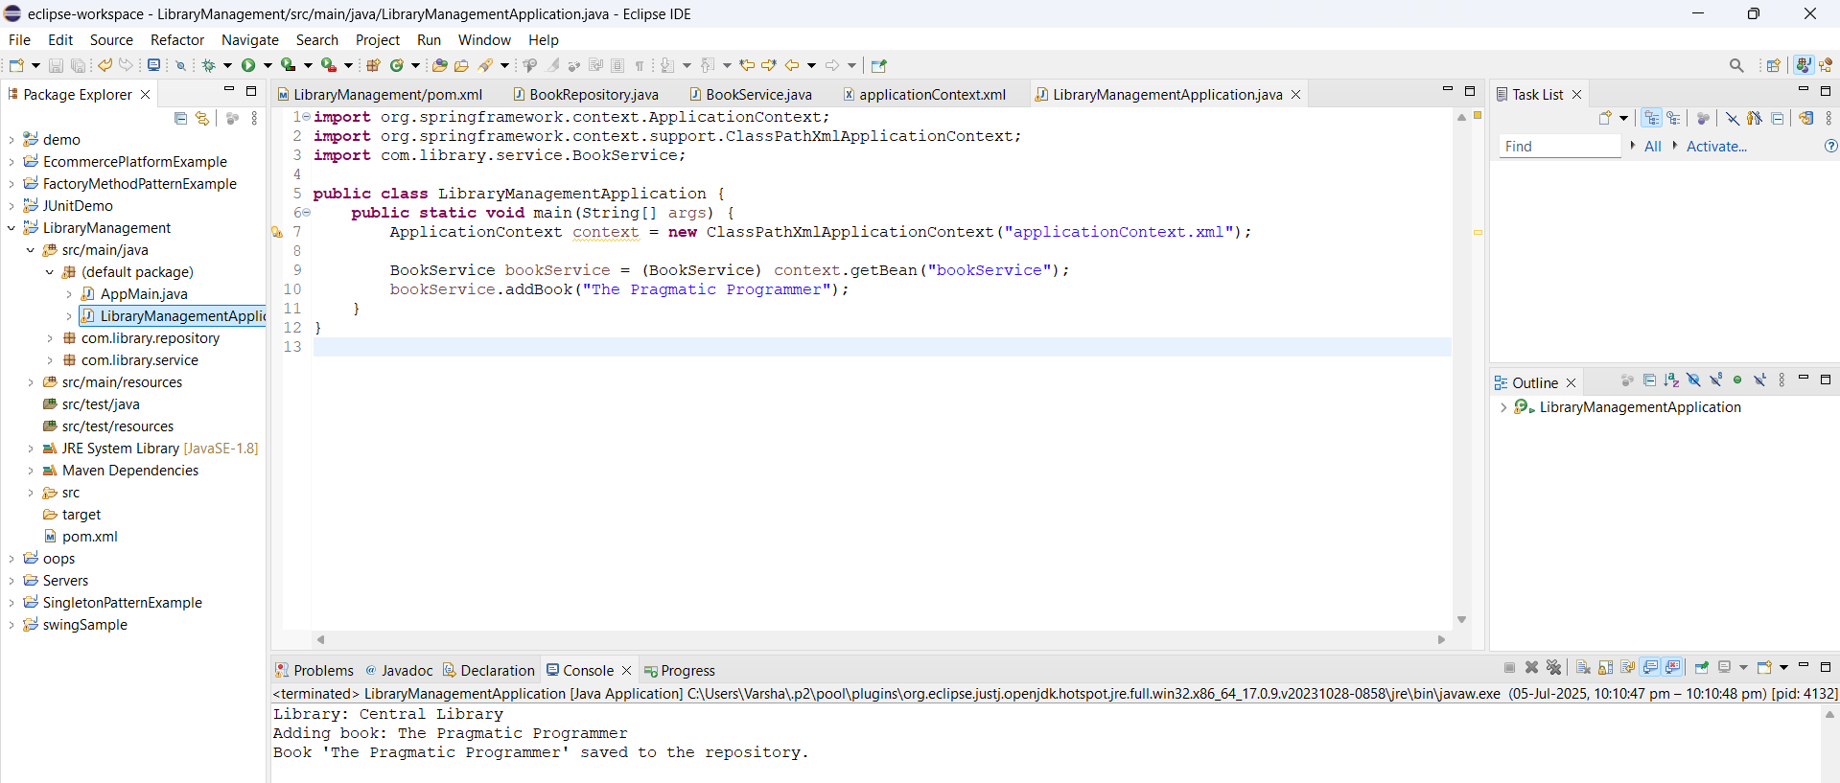

**Exercise 9: Creating a Spring Boot Application**

**Code:**

Book.java:

package com.library.entity;

import jakarta.persistence.*;

@Entity

public class Book {

@Id

@GeneratedValue(strategy = GenerationType.IDENTITY)

private Long id;

private String title;

private String author;

public Book() {}

public Book(String title, String author) {

this.title = title;

this.author = author;

}

public Long getId() { return id; }

public void setId(Long id) { this.id = id; }

public String getTitle() { return title; }

public void setTitle(String title) { this.title = title; }

public String getAuthor() { return author; }

public void setAuthor(String author) { this.author = author; }

}

BookRepository.java:

package com.library.repository;

import com.library.entity.Book;

import org.springframework.data.jpa.repository.JpaRepository;

public interface BookRepository extends JpaRepository<Book, Long> {

}

BookController.java:

package com.library.controller;

import com.library.entity.Book;

import com.library.repository.BookRepository;

import org.springframework.beans.factory.annotation.Autowired;

import org.springframework.web.bind.annotation.*;

import java.util.List;

@RestController

@RequestMapping("/api/books")

public class BookController {

@Autowired

private BookRepository bookRepository;

@GetMapping

public List<Book> getAllBooks() {

return bookRepository.findAll();

}

@GetMapping("/{id}")

public Book getBookById(@PathVariable Long id) {

return bookRepository.findById(id).orElse(null);

}

@PostMapping

public Book createBook(@RequestBody Book book) {

return bookRepository.save(book);

}

@PutMapping("/{id}")

public Book updateBook(@PathVariable Long id, @RequestBody Book updatedBook) {

return bookRepository.findById(id).map(book -> {

book.setTitle(updatedBook.getTitle());

book.setAuthor(updatedBook.getAuthor());

return bookRepository.save(book);

}).orElse(null);

}

@DeleteMapping("/{id}")

public void deleteBook(@PathVariable Long id) {

bookRepository.deleteById(id);

}

}

application.properties:

spring.datasource.url=jdbc:h2:mem:librarydb

spring.datasource.driverClassName=org.h2.Driver

spring.datasource.username=sa

spring.datasource.password=

spring.jpa.database-platform=org.hibernate.dialect.H2Dialect

spring.jpa.hibernate.ddl-auto=update

spring.h2.console.enabled=true

spring.h2.console.path=/h2-console

spring.jpa.show-sql=true

LibraryManagementApplication.java:

package com.library;

import org.springframework.boot.SpringApplication;

import org.springframework.boot.autoconfigure.SpringBootApplication;

@SpringBootApplication

public class LibraryManagementApplication {

public static void main(String[] args) {

SpringApplication.run(LibraryManagementApplication.class, args);

}

}

GET - http://localhost:8080/api/books

POST - http://localhost:8080/api/books

{

"title": "Clean Code",

"author": "Robert C. Martin"

}

GET - http://localhost:8080/api/books/1

PUT - http://localhost:8080/api/books/1

DELETE - http://localhost:8080/api/books/1

H2 Console: <http://localhost:8080/h2-console>

* JDBC URL: jdbc:h2:mem:librarydb

**Output:**

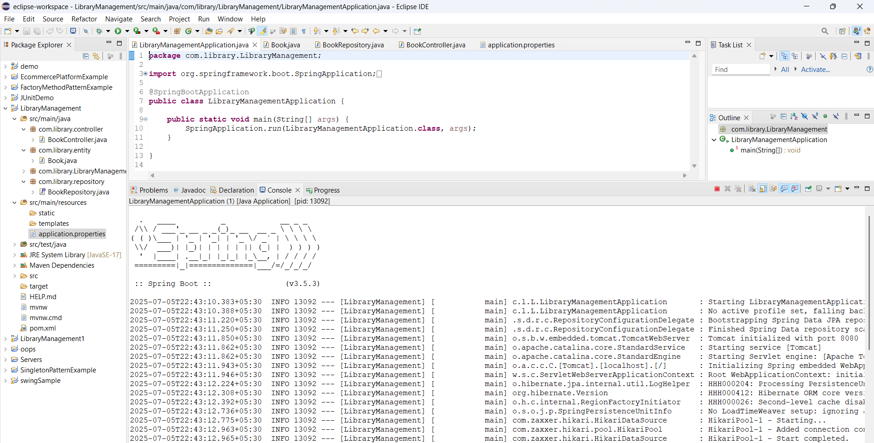

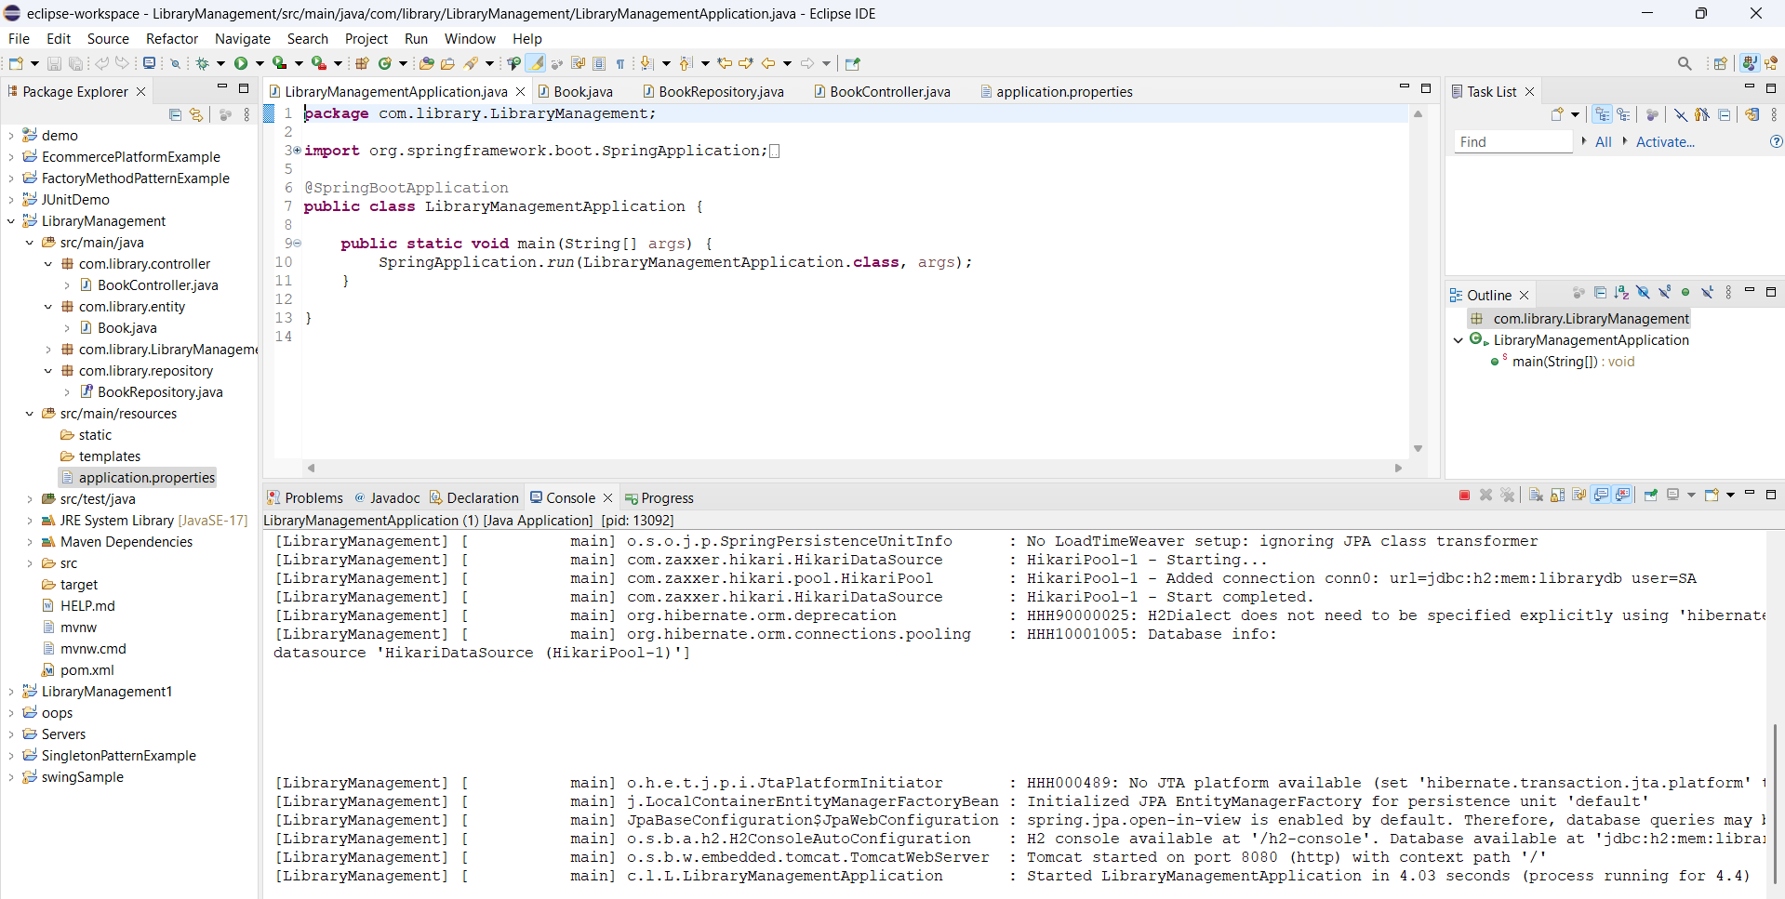

**Week3_** **Spring Data JPA with Spring Boot_HandsOn**

**1. Spring Data JPA - Quick Example:**

**An Eclipse Project using Spring Initializr :**

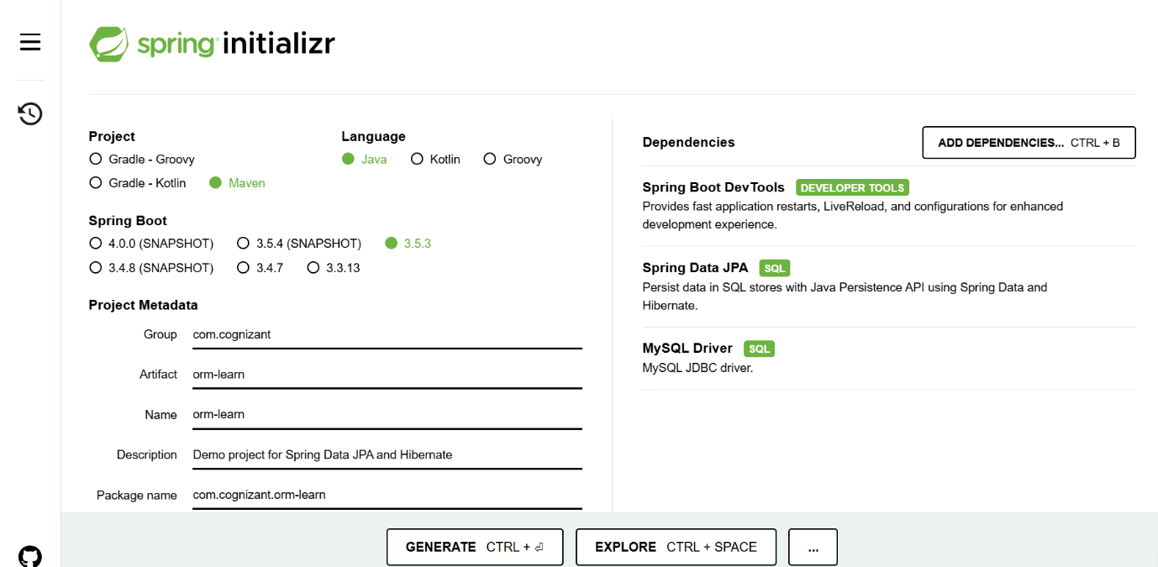

**Schema and table created in MySQL Workbench:**

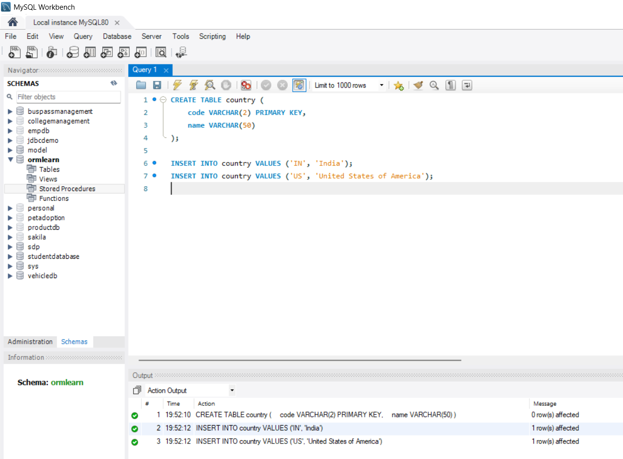

**Code:**

OrmLearnApplication.java:

package com.cognizant.orm_learn;

import org.slf4j.Logger;

import org.slf4j.LoggerFactory;

import org.springframework.boot.SpringApplication;

import org.springframework.boot.autoconfigure.SpringBootApplication;

@SpringBootApplication

public class OrmLearnApplication {

private static final Logger LOGGER = LoggerFactory.getLogger(OrmLearnApplication.class);

public static void main(String[] args) {

SpringApplication.run(OrmLearnApplication.class, args);

LOGGER.info("Inside main");

}

}

application.properties:

spring.application.name=orm-learn

logging.level.org.springframework=info

logging.level.com.cognizant=debug

logging.level.org.hibernate.SQL=trace

logging.level.org.hibernate.type.descriptor.sql=trace

logging.pattern.console=%d{dd-MM-yy} %d{HH:mm:ss.SSS} %-20.20thread %5p %-25.25logger{25} %25M %4L %m%n

spring.datasource.driver-class-name=com.mysql.cj.jdbc.Driver

spring.datasource.url=jdbc:mysql://localhost:3306/ormlearn

spring.datasource.username=root

spring.datasource.password=root

spring.jpa.hibernate.ddl-auto=update

spring.jpa.properties.hibernate.dialect=org.hibernate.dialect.MySQLDialect

Country.java:

package com.cognizant.orm_learn.entity;

import jakarta.persistence.Entity;

import jakarta.persistence.Id;

@Entity

public class Country {

@Id

private String code;

private String name;

public String getCode() {

return code;

}

public void setCode(String code) {

this.code = code;

}

public String getName() {

return name;

}

public void setName(String name) {

this.name = name;

}

}

CountryRepository.java:

package com.cognizant.orm_learn.repository;

import org.springframework.data.jpa.repository.JpaRepository;

import com.cognizant.orm_learn.entity.Country;

public interface CountryRepository extends JpaRepository<Country, String> {

}

CountryService.java:

package com.cognizant.orm_learn.service;

import java.util.List;

import org.springframework.beans.factory.annotation.Autowired;

import org.springframework.stereotype.Service;

import com.cognizant.orm_learn.entity.Country;

import com.cognizant.orm_learn.repository.CountryRepository;

@Service

public class CountryService {

@Autowired

private CountryRepository countryRepository;

public List<Country> getAllCountries() {

return countryRepository.findAll();

}

public Country getCountry(String code) {

return countryRepository.findById(code).orElse(null);

}

}

CountryController.java:

package com.cognizant.orm_learn.controller;

import org.springframework.beans.factory.annotation.Autowired;

import org.springframework.web.bind.annotation.*;

import com.cognizant.orm_learn.entity.Country;

import com.cognizant.orm_learn.service.CountryService;

import java.util.List;

@RestController

@RequestMapping("/countries")

public class CountryContoller {

@Autowired

private CountryService countryService;

@GetMapping

public List<Country> getAll() {

return countryService.getAllCountries();

}

@GetMapping("/{code}")

public Country getByCode(@PathVariable String code) {

return countryService.getCountry(code);

}

}

pom.xml:

<?xml version="1.0" encoding="UTF-8"?>

<project xmlns="http://maven.apache.org/POM/4.0.0" xmlns:xsi="http://www.w3.org/2001/XMLSchema-instance"

xsi:schemaLocation="http://maven.apache.org/POM/4.0.0 https://maven.apache.org/xsd/maven-4.0.0.xsd">

<modelVersion>4.0.0</modelVersion>

<parent>

<groupId>org.springframework.boot</groupId>

<artifactId>spring-boot-starter-parent</artifactId>

<version>3.5.3</version>

<relativePath/> <!-- lookup parent from repository -->

</parent>

<groupId>com.cognizant</groupId>

<artifactId>orm-learn</artifactId>

<version>0.0.1-SNAPSHOT</version>

<name>orm-learn</name>

<description>Demo project for Spring Data JPA and Hibernate</description>

<url/>

<licenses>

<license/>

</licenses>

<developers>

<developer/>

</developers>

<scm>

<connection/>

<developerConnection/>

<tag/>

<url/>

</scm>

<properties>

<java.version>17</java.version>

</properties>

<dependencies>

<dependency>

<groupId>org.springframework.boot</groupId>

<artifactId>spring-boot-starter-data-jpa</artifactId>

</dependency>

<dependency>

<groupId>org.springframework.boot</groupId>

<artifactId>spring-boot-starter-web</artifactId>

</dependency>

<dependency>

<groupId>com.mysql</groupId>

<artifactId>mysql-connector-j</artifactId>

<scope>runtime</scope>

</dependency>

<dependency>

<groupId>org.springframework.boot</groupId>

<artifactId>spring-boot-devtools</artifactId>

<scope>runtime</scope>

<optional>true</optional>

</dependency>

<dependency>

<groupId>org.springframework.boot</groupId>

<artifactId>spring-boot-starter-test</artifactId>

<scope>test</scope>

</dependency>

</dependencies>

<build>

<plugins>

<plugin>

<groupId>org.springframework.boot</groupId>

<artifactId>spring-boot-maven-plugin</artifactId>

</plugin>

</plugins>

</build>

</project>

Output:

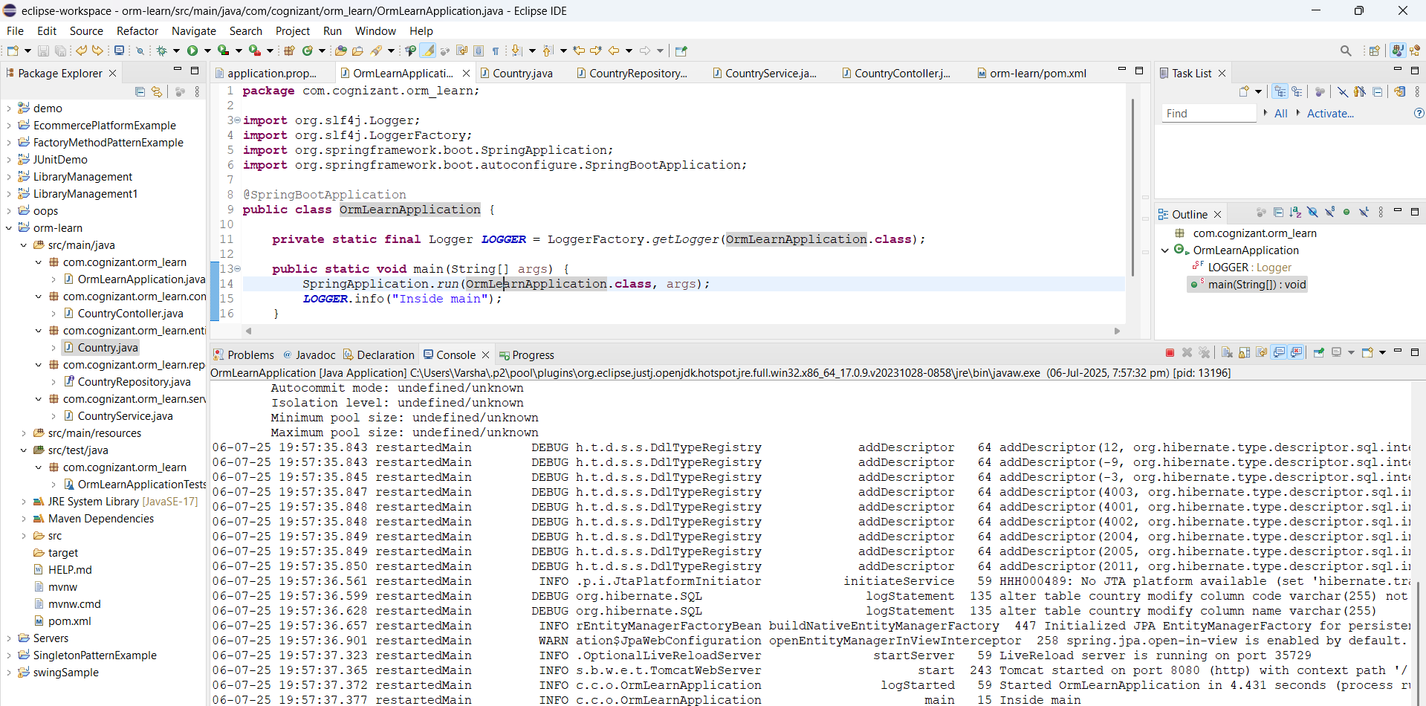

**Code:**

Country.java:

package com.cognizant.orm_learn.model;

import jakarta.persistence.Column;

import jakarta.persistence.Entity;

import jakarta.persistence.Id;

import jakarta.persistence.Table;

@Entity

@Table(name = "country")

public class Country {

@Id

@Column(name = "code")

private String code;

@Column(name = "name")

private String name;

public String getCode() {

return code;

}

public void setCode(String code) {

this.code = code;

}

public String getName() {

return name;

}

public void setName(String name) {

this.name = name;

}

@Override

public String toString() {

return "Country [code=" + code + ", name=" + name + "]";

}

}

CountryRepository.java:

package com.cognizant.orm_learn.repository;

import org.springframework.data.jpa.repository.JpaRepository;

import org.springframework.stereotype.Repository;

import com.cognizant.orm_learn.model.Country;

@Repository

public interface CountryRepository extends JpaRepository<Country, String> {

}

CountryService.java:

package com.cognizant.orm_learn.service;

import java.util.List;

import org.springframework.beans.factory.annotation.Autowired;

import org.springframework.stereotype.Service;

import org.springframework.transaction.annotation.Transactional;

import com.cognizant.orm_learn.model.Country;

import com.cognizant.orm_learn.repository.CountryRepository;

@Service

public class CountryService {

@Autowired

private CountryRepository;

@Transactional

public List<Country> getAllCountries() {

return countryRepository.findAll();

}

}

CountryController.java:

package com.cognizant.orm_learn.controller;

import org.springframework.beans.factory.annotation.Autowired;

import org.springframework.web.bind.annotation.*;

import com.cognizant.orm_learn.model.Country;

import com.cognizant.orm_learn.service.CountryService;

import java.util.List;

@RestController

@RequestMapping("/countries")

public class CountryController {

@Autowired

private CountryService countryService;

@GetMapping

public List<Country> getAll() {

return countryService.getAllCountries();

}

@GetMapping("/{code}")

public Country getByCode(@PathVariable String code) {

return countryService.getCountry(code);

}

}

OrmLearnApplication.java:

package com.cognizant.orm_learn;

import java.util.List;

import org.slf4j.Logger;

import org.slf4j.LoggerFactory;

import org.springframework.boot.SpringApplication;

import org.springframework.boot.autoconfigure.SpringBootApplication;

import org.springframework.context.ApplicationContext;

import com.cognizant.orm_learn.model.Country;

import com.cognizant.orm_learn.service.CountryService;

@SpringBootApplication

public class OrmLearnApplication {

private static final Logger LOGGER = LoggerFactory.getLogger(OrmLearnApplication.class);

private static CountryService countryService;

public static void main(String[] args) {

ApplicationContext context = SpringApplication.run(OrmLearnApplication.class, args);

countryService = context.getBean(CountryService.class);

testGetAllCountries();

}

private static void testGetAllCountries() {

LOGGER.info("Start");

List<Country> countries = countryService.getAllCountries();

LOGGER.debug("countries={}", countries);

LOGGER.info("End");

}

}

**Output:**

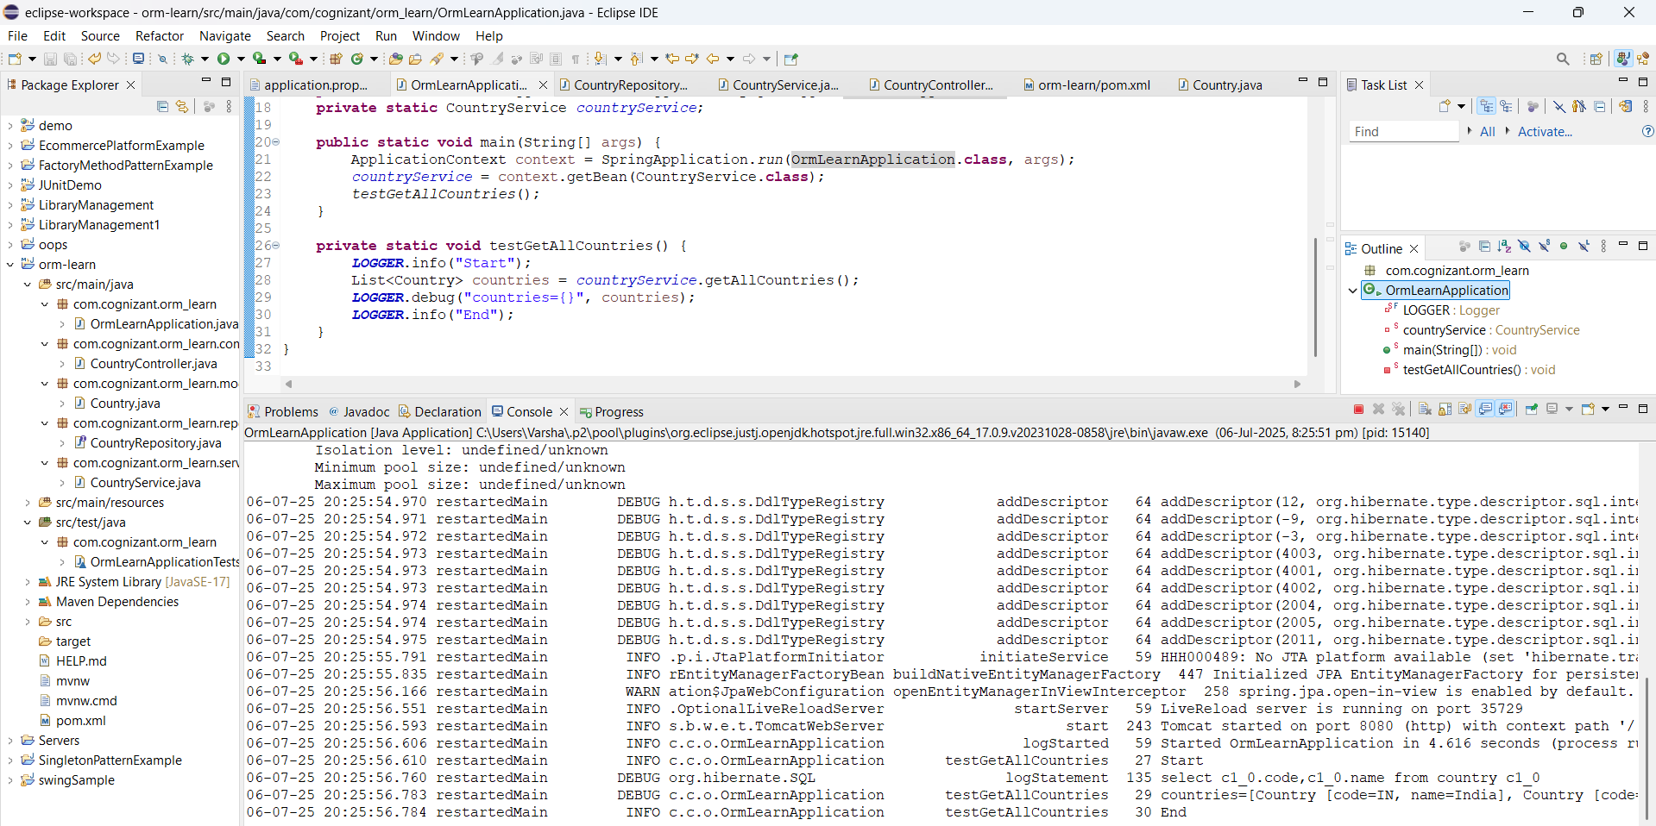

**2. Difference between JPA, Hibernate and Spring Data JPA:**

**JPA (Java Persistence API):**

* A **Java specification (JSR 338)** for object-relational mapping (ORM).
* **API / Interface**, no implementation.
* It provides standard interfaces like EntityManager, @Entity, @Id, @OneToMany, etc.
* It is used for mapping Java objects to database tables and managing their lifecycle.
* It requires an **implementation** (like Hibernate, EclipseLink).
* **Example:** javax.persistence.Entity, javax.persistence.Query

**Hibernate:**

* A **popular implementation** of the JPA specification.
* **Library / Framework**
* It provides actual logic for persisting entities, session handling, caching, fetching strategies, etc.
* It supports Native Hibernate APIs (Session, Criteria) and JPA APIs (EntityManager)
* It is used when you want more control or need specific Hibernate features.
* **Example Code:**

Session = sessionFactory.openSession();

session.save(entity);

session.close();

* Hibernate is the **engine** that does the work behind JPA.

**Spring Data JPA:**

* A **Spring module** that simplifies JPA usage and eliminates boilerplate code.
* **Abstraction layer over JPA**
* **It requires** a JPA provider like Hibernate under the hood.
* It provides auto-implemented repositories (e.g., JpaRepository), query derivation, paging, sorting, etc.
* **Example Code:**

public interface EmployeeRepository extends JpaRepository<Employee, Integer> {}

* Spring Data JPA makes working with JPA easier, faster, and more readable.

| **Feature** | **JPA** | **Hibernate** | **Spring Data JPA** |
| --- | --- | --- | --- |
| **Type** | Specification (API) | ORM Framework | Spring Module |
| **Provides** | Interfaces & Annotations | JPA Implementation + Extra Features | Abstraction over JPA + Boilerplate Reduction |
| **Requires** | Implementation (e.g., Hibernate) | Used directly or via JPA | Requires JPA provider (e.g., Hibernate) |
| **Common Use** | Standardized persistence | Custom ORM behavior | Simplified persistence in Spring apps |
| **Example Class** | EntityManager | Session | JpaRepository, CrudRepository |

**Hibernate implementation:**

**Code:**

pom.xml:

<dependencies>

<dependency>

<groupId>org.hibernate</groupId>

<artifactId>hibernate-core</artifactId>

<version>6.4.4.Final</version>

</dependency>

<dependency>

<groupId>mysql</groupId>

<artifactId>mysql-connector-java</artifactId>

<version>8.0.36</version>

</dependency>

<dependency>

<groupId>org.slf4j</groupId>

<artifactId>slf4j-simple</artifactId>

<version>2.0.13</version>

</dependency>

</dependencies>

Employee.java:

package com.example.hibernate;

import jakarta.persistence.*;

@Entity

@Table(name = "employee")

public class Employee {

@Id

@GeneratedValue(strategy = GenerationType.IDENTITY)

private int id;

@Column(name = "name")

private String name;

public Employee() {}

public Employee(String name) {

this.name = name;

}

public int getId() { return id; }

public void setId(int id) { this.id = id; }

public String getName() { return name; }

public void setName(String name) { this.name = name; }

@Override

public String toString() {

return "Employee [id=" + id + ", name=" + name + "]";

}

}

hibernate.cfg.xml:

<?xml version="1.0" encoding="utf-8"?>

<!DOCTYPE hibernate-configuration PUBLIC

"-//Hibernate/Hibernate Configuration DTD 3.0//EN"

"http://hibernate.sourceforge.net/hibernate-configuration-3.0.dtd">

<hibernate-configuration>

<session-factory>

<property name="connection.driver_class">com.mysql.cj.jdbc.Driver</property>

<property name="connection.url">jdbc:mysql://localhost:3306/ormlearn</property>

<property name="connection.username">root</property>

<property name="connection.password">root</property>

<property name="dialect">org.hibernate.dialect.MySQL8Dialect</property>

<property name="show_sql">true</property>

<property name="hbm2ddl.auto">update</property>

<mapping class="com.example.hibernate.Employee"/>

</session-factory>

</hibernate-configuration>

HibernateMain.java:

package com.example.hibernate;

import org.hibernate.*;

import org.hibernate.cfg.Configuration;

public class HibernateMain {

public static void main(String[] args) {

Configuration cfg = new Configuration();

cfg.configure("hibernate.cfg.xml");

SessionFactory factory = cfg.buildSessionFactory();

Session session = factory.openSession();

Transaction tx = null;

try {

tx = session.beginTransaction();

Employee emp = new Employee("Alice");

session.save(emp);

@SuppressWarnings("unchecked")

var employees = session.createQuery("from Employee").list();

for (Object e : employees) {

System.out.println(e);

}

tx.commit();

} catch (HibernateException e) {

if (tx != null) tx.rollback();

e.printStackTrace();

} finally {

session.close();

factory.close();

}

}

}

**Output:**

Sample output:

select employee0_.id as id1_0_,

employee0_.name as name2_0_

from employee employee0_

Employee [id=1, name=Alice]

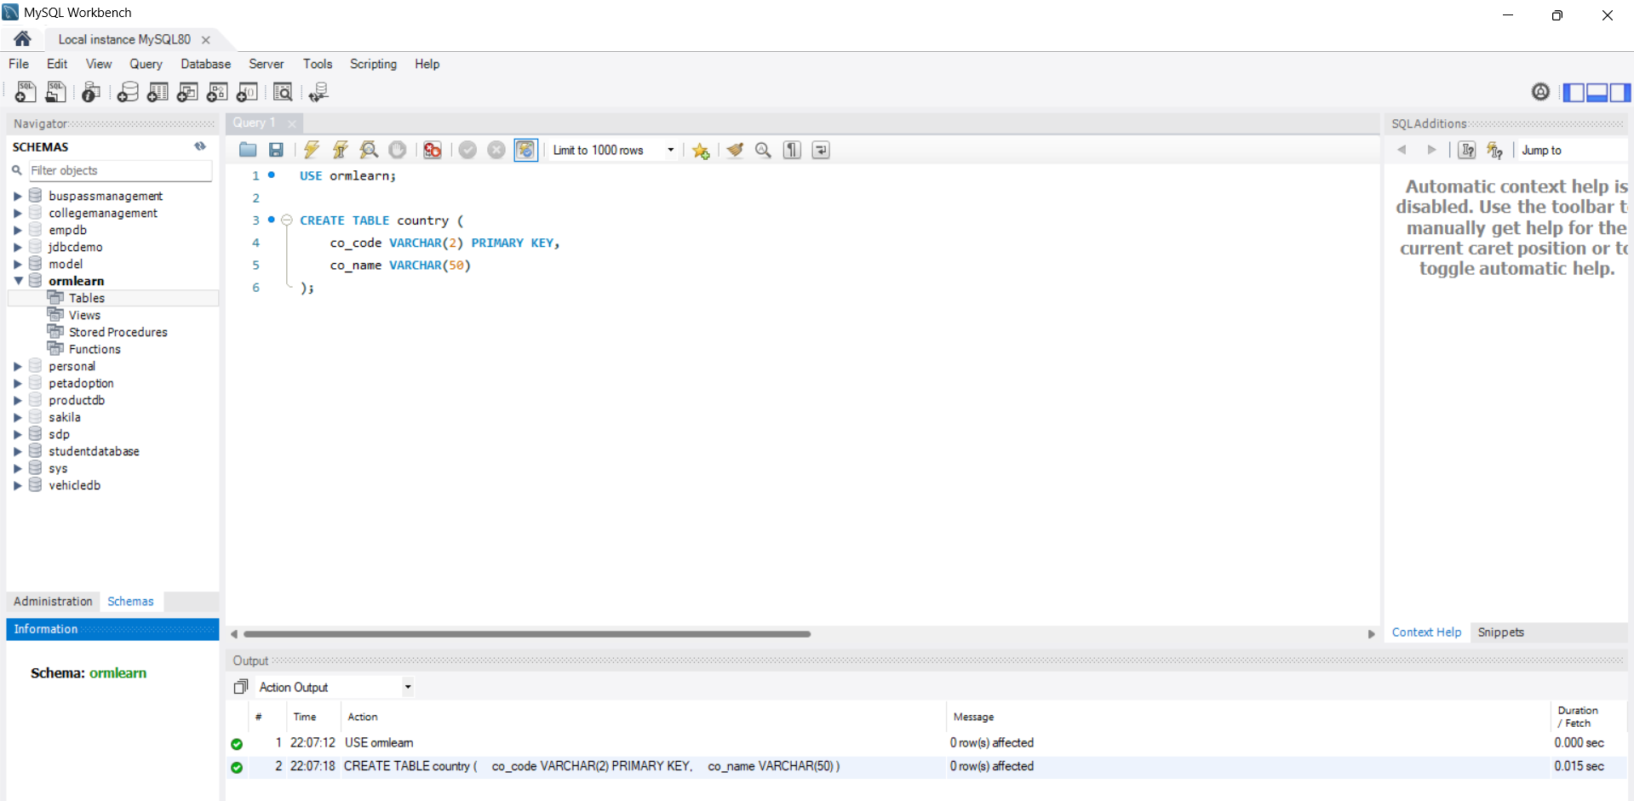

**Spring Data JPA Implementation:**

**Code:**

Employee.java:

package com.example.ormlearn.entity;

import jakarta.persistence.*;

@Entity

@Table(name = "employee")

public class Employee {

@Id

@GeneratedValue(strategy = GenerationType.IDENTITY)

private int id;

@Column(name = "name")

private String name;

public Employee() {}

public int getId() { return id; }

public void setId(int id) { this.id = id; }

public String getName() { return name; }

public void setName(String name) { this.name = name; }

@Override

public String toString() {

return "Employee [id=" + id + ", name=" + name + "]";

}

}

EmployeeRepository.java:

package com.example.ormlearn.repository;

import org.springframework.data.jpa.repository.JpaRepository;

import com.example.ormlearn.entity.Employee;

public interface EmployeeRepository extends JpaRepository<Employee, Integer> {

}

EmployeeService.java:

package com.example.ormlearn.service;

import java.util.List;

import org.springframework.beans.factory.annotation.Autowired;

import org.springframework.stereotype.Service;

import org.springframework.transaction.annotation.Transactional;

import com.example.ormlearn.entity.Employee;

import com.example.ormlearn.repository.EmployeeRepository;

@Service

public class EmployeeService {

@Autowired

private EmployeeRepository employeeRepository;

@Transactional

public void addEmployee(Employee employee) {

employeeRepository.save(employee);

}

public List<Employee> getAllEmployees() {

return employeeRepository.findAll();

}

}

EmployeeController.java:

package com.example.ormlearn.controller;

import com.example.ormlearn.entity.Employee;

import com.example.ormlearn.service.EmployeeService;

import org.springframework.beans.factory.annotation.Autowired;

import org.springframework.web.bind.annotation.*;

import java.util.List;

@RestController

@RequestMapping("/employees")

public class EmployeeController {

@Autowired

private EmployeeService employeeService;

@PostMapping

public void add(@RequestBody Employee employee) {

employeeService.addEmployee(employee);

}

@GetMapping

public List<Employee> getAll() {

return employeeService.getAllEmployees();

}

}

OrmLearnApplication.java:

package com.example.ormlearn;

import org.springframework.boot.SpringApplication;

import org.springframework.boot.autoconfigure.SpringBootApplication;

@SpringBootApplication

public class OrmLearnApplication {

public static void main(String[] args) {

SpringApplication.run(OrmLearnApplication.class, args);

}

}

application.properties:

spring.datasource.url=jdbc:mysql://localhost:3306/ormlearn

spring.datasource.username=root

spring.datasource.password=root

spring.datasource.driver-class-name=com.mysql.cj.jdbc.Driver

spring.jpa.hibernate.ddl-auto=update

spring.jpa.show-sql=true

**Output:**

Sample Output:

INFO Start

DEBUG employees=[Employee [id=1, name=Alice], Employee [id=2, name=Bob]]

INFO End

