**Week6_ ReactJS-HOL_HandsOn**

**Exercise 1: Create a new React Application**

**Code:**

**Steps to create and install a react app:**

1. npm install -g create-react-app

2. npx create-react-app myfirstreact

3. cd myfirstreact

App.js:

import React from 'react';

function App() {

return (

<div>

<h1>Welcome to the first session of React</h1>

</div>

);

}

export default App;

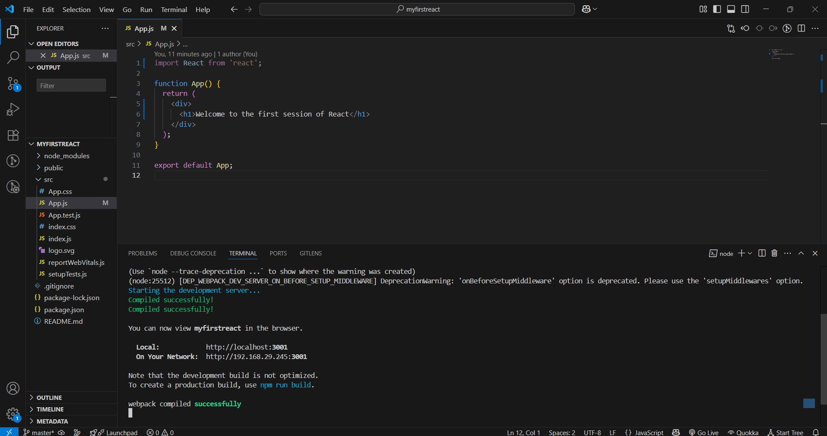**Output:**

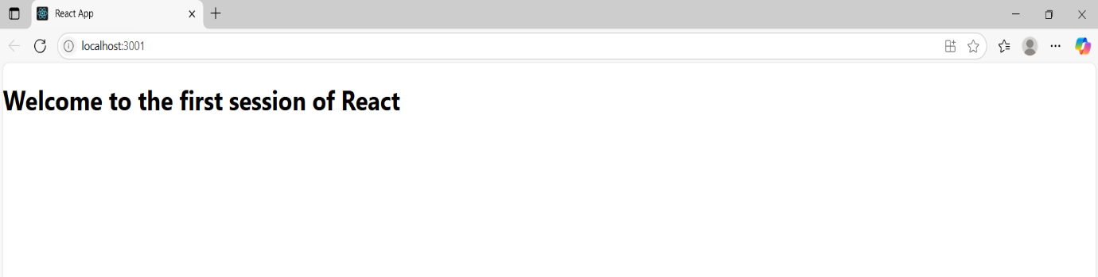

**Exercise 2: Create a react app for Student Management Portal using multiple components**

**Code:**

**Steps to create a react app:**

1. npx create-react-app StudentApp

2. cd StudentApp

Home.js:

import React from 'react';

class Home extends React.Component {

render() {

return (

<div>

<h2>Welcome to the Home page of Student Management Portal</h2>

</div>

);

}

}

export default Home;

About.js:

import React from 'react';

class About extends React.Component {

render() {

return (

<div>

<h2>Welcome to the About page of the Student Management Portal</h2>

</div>

);

}

}

export default About;

Contact.js:

import React from 'react';

class Contact extends React.Component {

render() {

return (

<div>

<h2>Welcome to the Contact page of the Student Management Portal</h2>

</div>

);

}

}

export default Contact;

App.js:

import React from 'react';

import Home from './Components/Home';

import About from './Components/About';

import Contact from './Components/Contact';

function App() {

return (

<div>

<Home />

<About />

<Contact />

</div>

);

}

export default App;

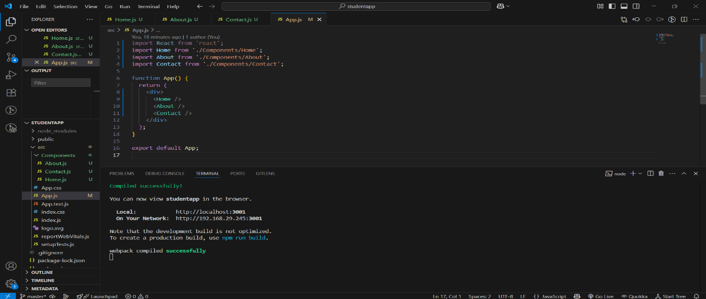**Output:**

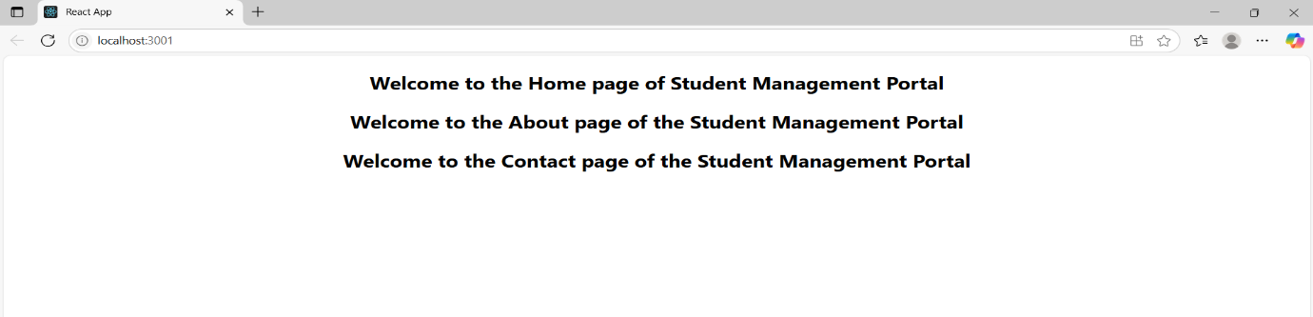

**Exercise 3: Create a react app for Student Management Portal named scorecalculatorapp**

**Code:**

**Step to create react app:**

1. npx create-react-app scorecalculatorapp

CalculatorScore.js:

import React from 'react';

import '../Stylesheets/mystyle.css';

function CalculateScore(props) {

  const { name, school, total, goal } = props;

  const average = (total / goal).toFixed(2);

  return (

    <div className="score-card">

      <h2>Student Score Calculator</h2>

      <p><strong>Name:</strong> {name}</p>

      <p><strong>School:</strong> {school}</p>

      <p><strong>Total Marks:</strong> {total}</p>

      <p><strong>Goal:</strong> {goal}</p>

      <p><strong>Average Score:</strong> {average}</p>

    </div>

  );

}

export default CalculateScore;

mystyle.css:

.score-card {

  background-color: #f2f2f2;

  padding: 20px;

  margin: 30px auto;

  width: 400px;

  border-radius: 10px;

  box-shadow: 0 0 10px #aaa;

  font-family: Arial, sans-serif;

}

.score-card h2 {

  color: #2e86de;

  text-align: center;

}

.app-container {

  display: flex;

  flex-direction: column;

  align-items: center;

  background-color: #ffffff;

  min-height: 100vh;

  padding: 40px 20px;

}

.main-title {

  font-size: 28px;

  color: #2c3e50;

  margin-bottom: 30px;

  font-family: 'Segoe UI', sans-serif;

  text-align: center;

}

App.js:

import React from 'react';

import './Stylesheets/mystyle.css';

import CalculateScore from './Components/CalculateScore';

function App() {

  return (

    <div className="app-container">

      <h1 className="main-title">Score Calculator App</h1>

      <CalculateScore

        name="Anjali Sharma"

        school="Oxford Public School"

        total={420}

        goal={500}

      />

    </div>

  );

}

export default App;

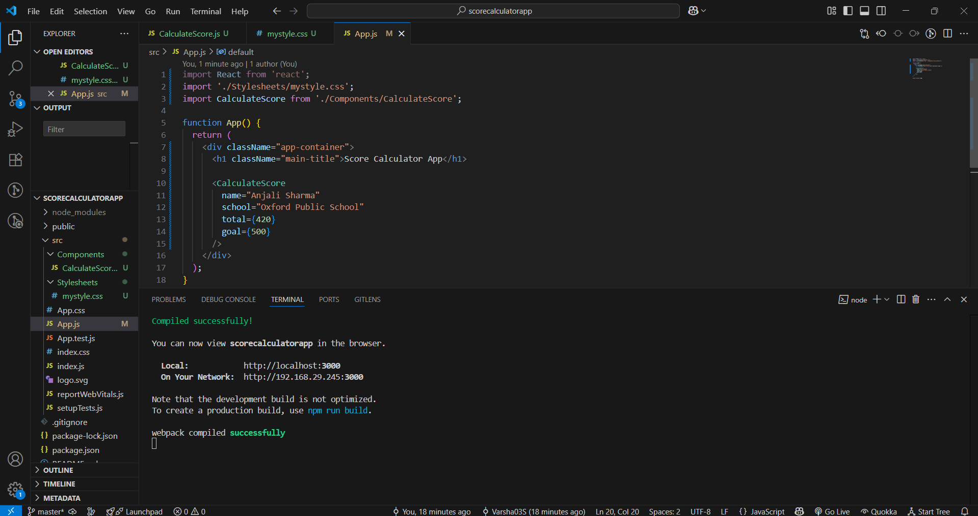**Output:**

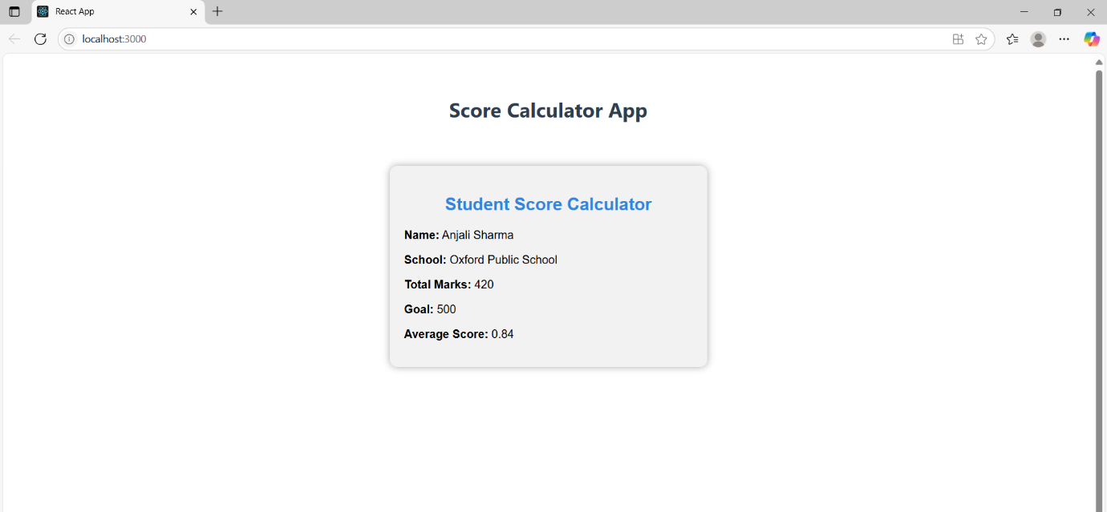

**Exercise 4: Create react app with lifecycle hooks**

**Code:**

**Steps to create react app:**

npx create-react-app blogapp

cd blogapp

Post.js:

import React from 'react';

class Post extends React.Component {

render() {

const { title, body } = this.props;

return (

<div style={{ marginBottom: '20px' }}>

<h3>{title}</h3>

<p>{body}</p>

</div>

);

}

}

export default Post;

Posts.js:

import React, { Component } from 'react';

class Posts extends Component {

  constructor(props) {

    super(props);

    this.state = {

      posts: [],

      error: null

    };

  }

  componentDidMount() {

    this.loadPosts();

  }

  loadPosts() {

    const samplePosts = [

      {

        id: 1,

        title: "Top 5 React Hooks You Should Know",

        body: "React hooks like useEffect, useState, useContext, useRef, and useReducer make functional components powerful. Learn how they work and when to use them."

      },

      {

        id: 2,

        title: "Understanding JavaScript Closures",

        body: "Closures are one of the most important concepts in JavaScript. This post explains closures with simple examples and diagrams."

      },

      {

        id: 3,

        title: "Tips for Writing Clean Code",

        body: "Writing clean and maintainable code is crucial for long-term success. Discover top practices like meaningful naming, DRY principle, and consistent formatting."

      }

    ];

    setTimeout(() => {

      this.setState({ posts: samplePosts });

    }, 1000);

  }

  componentDidCatch(error, info) {

    this.setState({ error });

    alert('Something went wrong: ' + error.message);

  }

  render() {

    const { posts } = this.state;

    return (

      <div style={{ padding: '20px' }}>

        <h2 style={{ textAlign: 'center', color: '#333' }}>Latest Blog Posts</h2>

        {posts.length === 0 ? (

          <p>Loading posts...</p>

        ) : (

          posts.map(post => (

            <div key={post.id} style={{ borderBottom: '1px solid #ccc', marginBottom: '20px' }}>

              <h3 style={{ color: '#2c3e50' }}>{post.title}</h3>

              <p>{post.body}</p>

            </div>

          ))

        )}

      </div>

    );

  }

}

export default Posts;

App.js:

import React from 'react';

import './App.css';

import Posts from './Posts';

function App() {

  return (

    <div className="App">

      <h1>Score Calculator App</h1>

      <Posts />

    </div>

  );

}

export default App;

**Output:**

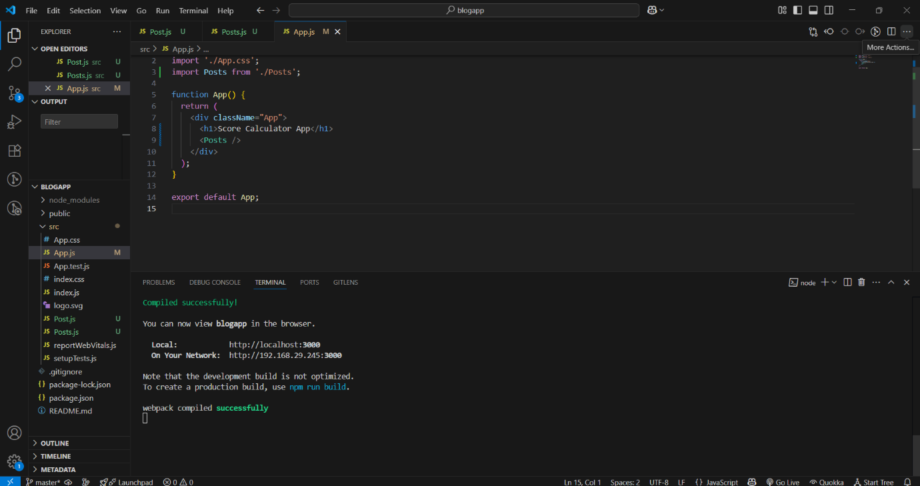

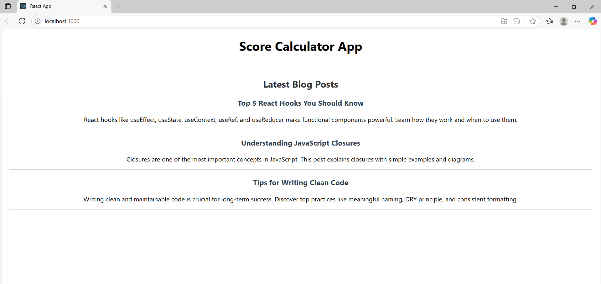

**Exercise 5: Displays the detail of the cohorts using react component**

**Code:**

CohortDetails.js:

import React from 'react';

import styles from './CohortDetails.module.css';

function CohortDetails({ name, trainer, status, startDate }) {

  const headingStyle = {

    color: status.toLowerCase() === 'ongoing' ? 'green' : 'blue'

  };

  return (

    <div className={styles.box}>

      <h3 style={headingStyle}>{name}</h3>

      <dl>

        <dt>Trainer</dt>

        <dd>{trainer}</dd>

        <dt>Status</dt>

        <dd>{status}</dd>

        <dt>Start Date</dt>

        <dd>{startDate}</dd>

      </dl>

    </div>

  );

}

export default CohortDetails;

CohortDetails.module.css

.container {

  display: flex;

  justify-content: center;

  gap: 20px;

  margin-top: 50px;

  flex-wrap: wrap;

}

.box {

  width: 300px;

  display: inline-block;

  margin: 10px;

  padding: 10px 20px;

  border: 1px solid black;

  border-radius: 10px;

}

dt {

  font-weight: 500;

}

App.js:

import React from 'react';

import CohortDetails from './CohortDetails';

import styles from './CohortDetails.module.css';

function App() {

  const cohortData = [

    {

      name: "React Cohort 2025",

      trainer: "Rohit",

      status: "ongoing",

      startDate: "July 15, 2025"

    },

    {

      name: "Java Cohort 2025",

      trainer: "Amit Kumar",

      status: "completed",

      startDate: "April 10, 2025"

    },

    {

      name: "Python Cohort 2025",

      trainer: "Sneha",

      status: "ongoing",

      startDate: "August 1, 2025"

    }

  ];

  return (

    <div className={styles.container}>

      {cohortData.map((cohort, index) => (

        <CohortDetails

          key={index}

          name={cohort.name}

          trainer={cohort.trainer}

          status={cohort.status}

          startDate={cohort.startDate}

        />

      ))}

    </div>

  );

}

export default App;

**Output:**

