TIMING-DRIVEN RTL OPTIMIZATION
OF A PIPELINED 32-BIT ALU
A Static Timing Analysis (STA) Study
Post-Synthesis Timing Report
Author | Varsha R S
HDL | Verilog HDL
EDA Tool | Xilinx Vivado 2016.4
Target Device | Xilinx Zynq-7000 XC7Z020
Analysis Type | Post-Synthesis Static Timing Analysis (STA)

Abstract
This report presents the RTL design, synthesis, and timing-driven optimization of a parameterized, pipelined 32-bit Arithmetic Logic Unit (ALU) described in Verilog HDL. The project emphasizes Static Timing Analysis (STA) rather than physical hardware implementation: the design was synthesized for a Xilinx Zynq-7000 XC7Z020 device using Vivado 2016.4, and its post-synthesis timing behaviour was characterized across a sweep of clock constraints from 100 MHz to 400 MHz.
The initial architecture sustained timing closure up to approximately 240 MHz and failed once the applied constraint exceeded this natural limit. Analysis of the Worst Negative Slack (WNS) and Total Negative Slack (TNS) reports identified the combinational datapath as the bottleneck. An additional pipeline stage was introduced to shorten the critical path, after which the design was re-synthesized under identical constraints. The optimized architecture achieved timing closure up to approximately 337 MHz, improving the estimated maximum operating frequency (Fmax) from 240.33 MHz to 337.50 MHz — an improvement of close to 40%. This report documents the architecture, the STA methodology, the complete frequency-sweep results, and the engineering conclusions drawn from them.

1. Project Specifications
The design was implemented and evaluated under the following specifications. All timing figures reported in this document are post-synthesis, tool-estimated values obtained from Vivado's timing engine; no place-and-route or on-board implementation was performed, consistent with the STA-only scope of this project.
Parameter | Value
HDL | Verilog
EDA Tool | Xilinx Vivado 2016.4
Target Device | XC7Z020 (Zynq-7000 family)
Data Width | 32-bit
Operations Supported | ADD, SUB, AND, OR, XOR
Reset Type | Synchronous
Analysis Performed | Post-Synthesis Static Timing Analysis (STA)

2. System Architecture and Block Diagram
The ALU is organised as a 4-stage synchronous pipeline so that the single, wide combinational operation required by a 32-bit ALU can be split across multiple clock cycles, reducing the combinational delay seen by any one pipeline stage. Operands A and B are registered at the input, the arithmetic/logic operation is computed in the second stage, the opcode-controlled result multiplexer resolves the correct operation in the third stage, and the final result is registered before being driven out. All four stages, along with the internal pipeline registers, are updated on the same system clock and synchronous reset.
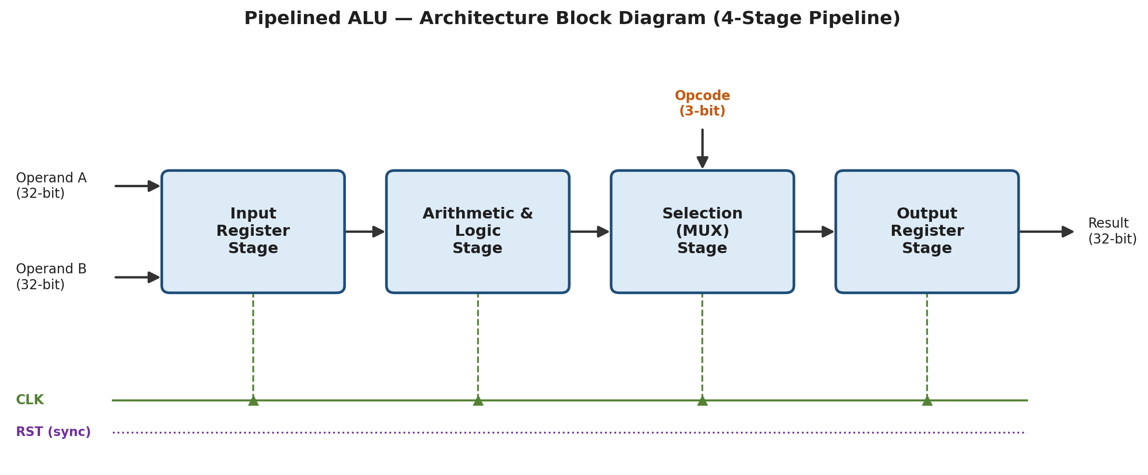
Figure 1. Top-level architecture / block diagram of the pipelined 32-bit ALU.

2.1 Pipeline Stage Description
- Input Register Stage — Latches the 32-bit operands A and B on the active clock edge, isolating the data-path from input timing variation and providing a clean launch point for the arithmetic stage.
- Arithmetic & Logic Stage — Computes all candidate results (ADD, SUB, AND, OR, XOR) in parallel combinational logic; this stage historically contained the longest combinational path in the design.
- Selection (MUX) Stage — Uses the registered 3-bit opcode to select the correct result among the candidate outputs computed in the previous stage.
- Output Register Stage — Registers the selected result before it is presented at the ALU output, defining a clean, timing-closed boundary for downstream logic.

3. Static Timing Analysis: Concepts and Definitions
Static Timing Analysis (STA) verifies that every timing path in a synthesized design can transfer data correctly at the specified clock frequency, without simulating the design's functional behaviour. STA checks two fundamental requirements at every flip-flop-to-flip-flop path: the setup requirement (data must arrive early enough before the next clock edge) and the hold requirement (data must remain stable long enough after the clock edge). The figure below illustrates the launch-capture flip-flop model used to evaluate the setup requirement, which is the dominant constraint in this study.
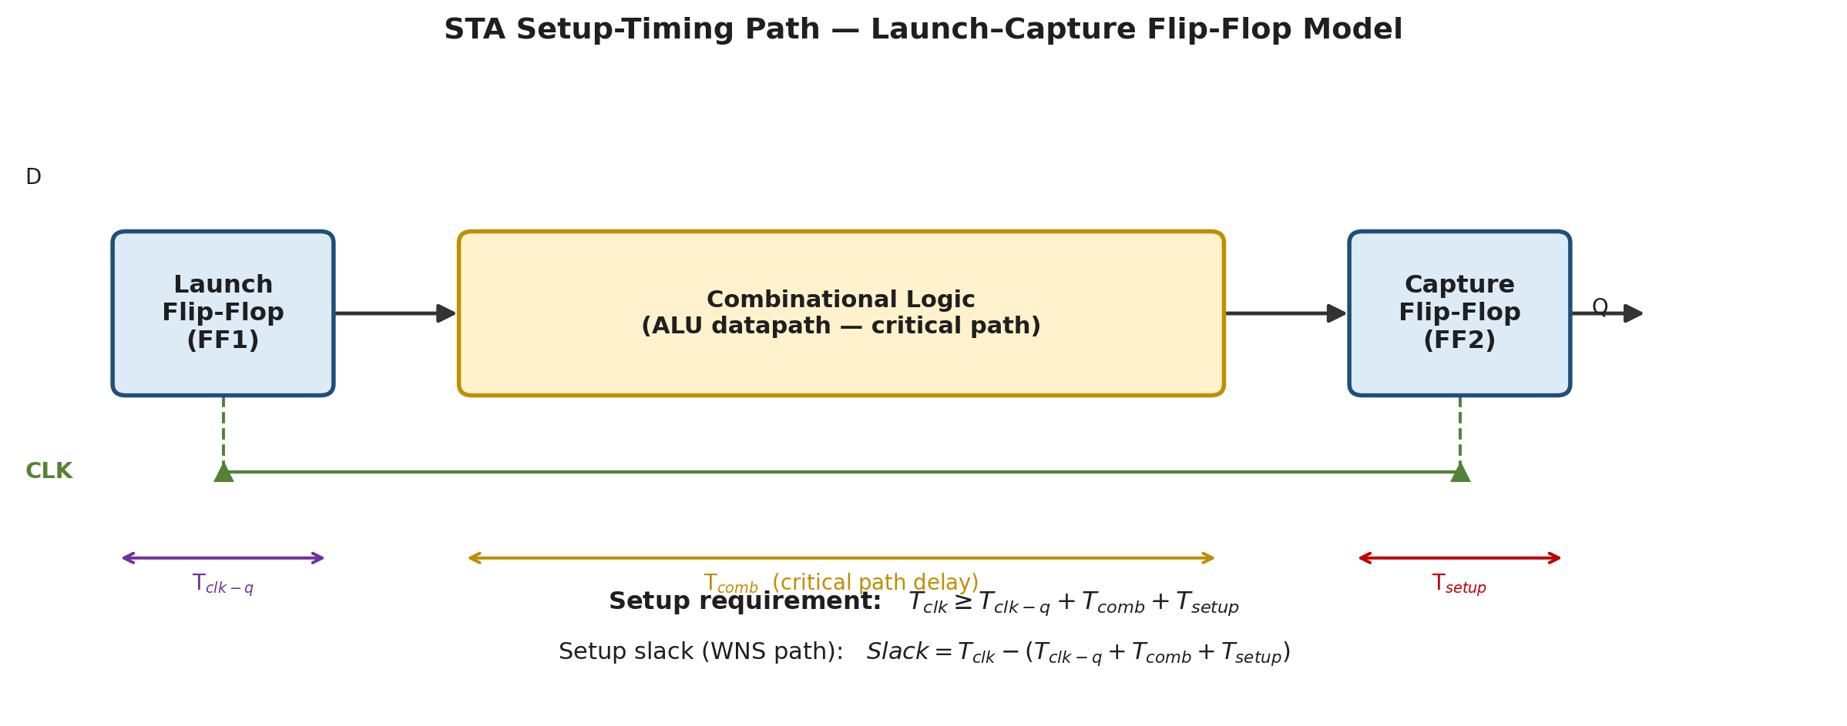
Figure 2. Launch–capture flip-flop model used for setup-timing analysis. FF1 launches data through the combinational ALU data-path, which must arrive at FF2 with enough margin before the next active clock edge.

3.1 Definitions of Key STA Terms
The table below defines every timing metric referenced in this report, in the order they are typically read from a Vivado timing summary report.
Term | Symbol | Definition
Clock Period | T_clk | The total time available for one clock cycle, as fixed by the applied clock constraint (create_clock). Determines the budget against which all setup paths are checked.
Setup Time | T_su | The minimum time before the active clock edge that data at a flip-flop's D input must remain stable for it to be captured correctly. Violating this causes incorrect data capture.
Hold Time | T_h | The minimum time after the active clock edge that data at a flip-flop's D input must remain stable. Violating this corrupts the captured value even though setup was met.
Clock-to-Q Delay | T_clk-q | The propagation delay from the active clock edge at a flip-flop's clock pin to the point where valid data appears at its Q output.
Critical Path Delay | T_comb | The delay of the longest combinational logic path between a launching and a capturing flip-flop; this is the single largest factor limiting the maximum achievable clock frequency.
WNS | Worst Negative Slack | The single worst (most negative, or least positive) setup slack value found among all timing endpoints in the design. WNS ≥ 0 means every setup path in the design meets timing; WNS < 0 means at least one path is violating setup timing by that amount.
TNS | Total Negative Slack | The arithmetic sum of the setup slack of every endpoint whose slack is negative. TNS = 0 means no endpoint fails; a larger-magnitude negative TNS indicates either more failing endpoints or larger individual violations, giving a sense of the overall scale of the timing problem beyond the single worst path.
WHS | Worst Hold Slack | The single worst hold-timing slack value found among all endpoints. Unlike setup, hold violations cannot be fixed by lowering the clock frequency, since hold timing does not depend on the clock period.
THS | Total Hold Slack | The sum of the hold slack of every endpoint whose hold slack is negative, analogous to TNS but for the hold check.
WPWS | Worst Pulse-Width Slack | The worst-case margin between the minimum clock pulse width required by the sequential cells in the design and the actual high/low pulse width produced by the clock network.
TPWS | Total Pulse-Width Slack | The sum of all failing pulse-width slack values across the design, analogous to TNS but for the pulse-width check.
Setup Slack | Slack | Slack = T_clk − (T_clk-q + T_comb + T_su). Positive slack means the path finishes early (timing met); negative slack means the path is too slow for the given constraint (timing violated).
Fmax | Estimated Fmax | The theoretical maximum operating frequency the synthesized netlist can support, computed as Fmax (MHz) = 1000 / Critical Path Delay (ns). This is a tool-estimated ceiling based purely on the critical path, independent of the constraint that was actually applied.

4. RTL Optimization Methodology
The initial RTL was synthesized and constrained at progressively higher clock frequencies. At each step, the Vivado timing summary was inspected: when WNS became negative, it confirmed that the critical path exceeded the available clock period at that constraint. Rather than making speculative RTL edits, the exact stage responsible for the critical path was identified from the timing report, and a pipeline register was inserted at that point to split the combinational delay across two clock cycles. The design was then re-synthesized under the same constraint set to verify that the violation was resolved before moving to a tighter constraint. This iterative, measurement-driven loop is summarized below.
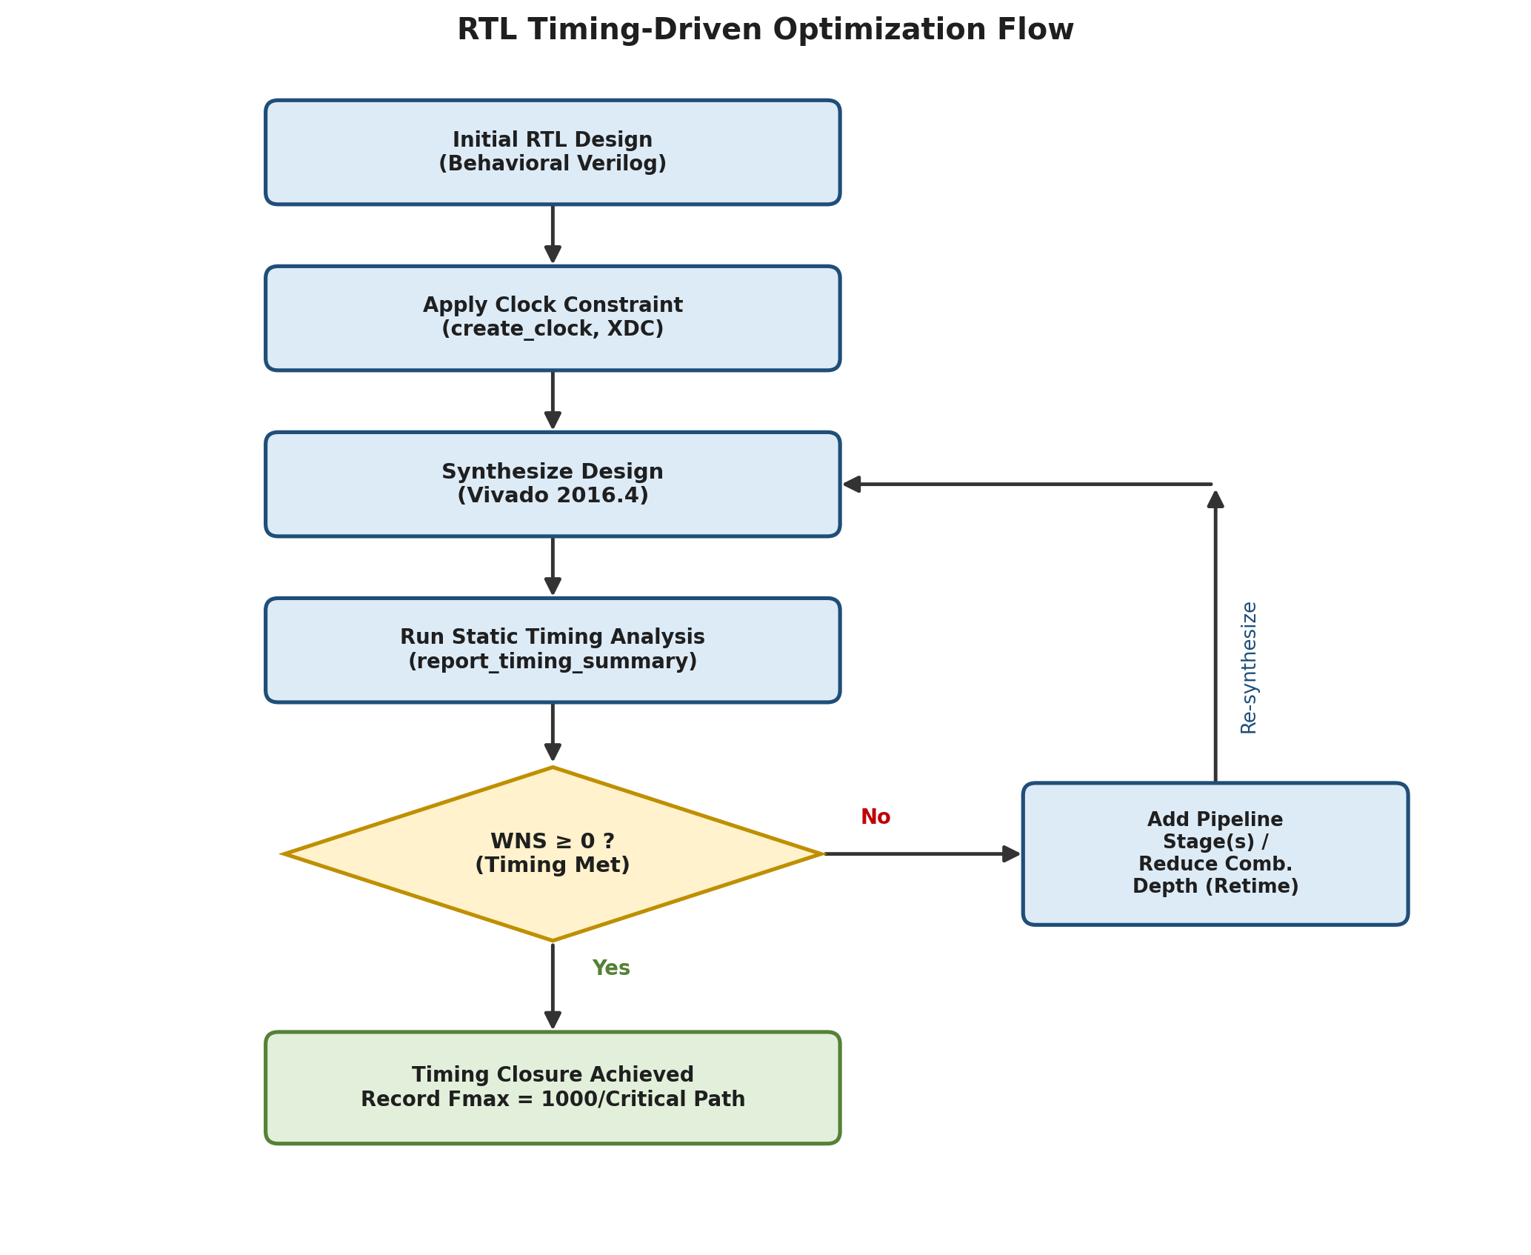
Figure 3. Iterative, STA-driven RTL optimization methodology followed in this project.

5. Frequency Sweep Analysis
Each subsection below reports the raw STA metrics obtained at a specific clock constraint, together with the engineering interpretation drawn from those numbers.

100 MHz — Initial RTL
Clock Period = 10.000 ns WNS = +5.839 ns TNS = +0.000 ns
Critical Path Delay = 4.161 ns Estimated Fmax = 1000 / 4.161 = 240.33 MHz
Interpretation
Positive WNS confirms that the setup timing requirement is satisfied with substantial margin. Zero TNS indicates no failing endpoints anywhere in the design. Because the constraint (10.000 ns) is far looser than the actual critical path (4.161 ns), most of the available clock period is unused, which is reflected in the large positive slack.
Engineering Observation
This operating point was used as a baseline to characterize the natural, unconstrained timing behaviour of the initial RTL before any frequency pressure was applied.

200 MHz — Initial RTL
Clock Period = 5.000 ns WNS = +0.839 ns TNS = +0.000 ns
Critical Path Delay = 4.161 ns Estimated Fmax = 1000 / 4.161 = 240.33 MHz
Interpretation
Positive WNS confirms that setup timing is still met, but the margin has narrowed considerably compared to the 100 MHz run, since the clock period is now much closer to the critical path delay. Zero TNS confirms no endpoints are failing yet.
Engineering Observation
This point marks the transition zone: the design is approaching its natural frequency limit, and any further increase in constraint is expected to expose the critical path.

300 MHz — Initial RTL
Clock Period = 3.333 ns WNS = -0.828 ns TNS = -7.484 ns
Critical Path Delay = 4.161 ns Estimated Fmax = 1000 / 4.161 = 240.33 MHz
Interpretation
Negative WNS shows that the critical path delay (4.161 ns) now exceeds the available clock period (3.333 ns), producing a setup violation. The non-zero TNS confirms that multiple endpoints along the same critical logic cone are failing simultaneously, not just a single isolated path.
Engineering Observation
This failure is the trigger point for RTL optimization: it identifies precisely where combinational depth must be reduced through pipelining.

300 MHz — Optimized RTL
Clock Period = 3.333 ns WNS = +0.370 ns TNS = +0.000 ns
Critical Path Delay = 2.963 ns Estimated Fmax = 1000 / 2.963 = 337.50 MHz
Interpretation
After inserting an additional pipeline register to break the combinational cloud, the critical path fell from 4.161 ns to 2.963 ns. WNS is positive again and TNS returns to zero, confirming that timing closure is restored at the same 300 MHz constraint that previously failed.
Engineering Observation
This is the first data point demonstrating that architectural, RTL-level pipelining — rather than tool-level effort or strategy tweaks — resolved the violation.

330 MHz — Optimized RTL
Clock Period = 3.030 ns WNS = +0.062 ns TNS = +0.000 ns
Critical Path Delay = 2.968 ns Estimated Fmax = 1000 / 2.968 = 336.93 MHz
Interpretation
WNS remains positive but has shrunk to just +0.062 ns, indicating the design is now very close to its true frequency ceiling. TNS is still zero, so no endpoints have failed.
Engineering Observation
This point was used to narrow down the practical Fmax ceiling of the optimized architecture before violations reappear.

337 MHz — Optimized RTL
Clock Period = 2.967 ns WNS = +0.002 ns TNS = +0.000 ns
Critical Path Delay = 2.965 ns Estimated Fmax = 1000 / 2.965 = 337.27 MHz
Interpretation
WNS is only marginally positive (+0.002 ns) — essentially the tightest constraint at which the optimized RTL still meets timing. This closely matches the Fmax estimated from the critical path delay, cross-validating the STA-derived Fmax figure.
Engineering Observation
This constraint represents the practical, tool-verified maximum operating frequency of the optimized ALU.

340 MHz — Optimized RTL
Clock Period = 2.941 ns WNS = -0.022 ns TNS = -0.063 ns
Critical Path Delay = 2.963 ns Estimated Fmax = 1000 / 2.963 = 337.50 MHz
Interpretation
A small negative WNS shows the constraint has finally exceeded what the optimized RTL can support. The small-magnitude negative TNS confirms only a few endpoints are marginally failing, consistent with operating just beyond the true Fmax.
Engineering Observation
This data point confirms the upper boundary of timing closure identified at 337 MHz.

400 MHz — Optimized RTL
Clock Period = 2.500 ns WNS = -0.463 ns TNS = -7.563 ns
Critical Path Delay = 2.963 ns Estimated Fmax = 1000 / 2.963 = 337.50 MHz
Interpretation
The constraint is now well beyond the achievable frequency; WNS and TNS both show large negative values, confirming that the optimized RTL cannot be pushed to 400 MHz without further architectural changes such as deeper pipelining or logic restructuring.
Engineering Observation
This point establishes a clear upper stress-test boundary beyond which further optimization would be required.

6. Overall Comparison
The table below consolidates every constraint point evaluated in this study, allowing the initial and optimized architectures to be compared directly. Rows shaded green met timing (WNS ≥ 0); rows shaded orange failed timing (WNS < 0).
Freq (MHz) | Period (ns) | WNS (ns) | TNS (ns) | Crit. Path (ns) | Fmax (MHz)
100 | 10.000 | +5.839 | +0.000 | 4.161 | 240.33
200 | 5.000 | +0.839 | +0.000 | 4.161 | 240.33
300 | 3.333 | -0.828 | -7.484 | 4.161 | 240.33
300 | 3.333 | +0.370 | +0.000 | 2.963 | 337.50
330 | 3.030 | +0.062 | +0.000 | 2.968 | 336.93
337 | 2.967 | +0.002 | +0.000 | 2.965 | 337.27
340 | 2.941 | -0.022 | -0.063 | 2.963 | 337.50
400 | 2.500 | -0.463 | -7.563 | 2.963 | 337.50
Table 2. Consolidated timing results across the full frequency sweep. The third and fourth rows at 300 MHz contrast the initial (failing) and optimized (passing) RTL under an identical constraint.

7. Results and Discussion
The initial RTL sustained timing closure up to approximately 240 MHz and failed once the constraint reached 300 MHz, where WNS turned negative (−0.828 ns) and TNS reached −7.484 ns, confirming a genuine, multi-endpoint setup violation rather than a marginal single-path failure.
After inserting an additional pipeline stage, the critical path fell from 4.161 ns to approximately 2.963 ns — a reduction of nearly 29% — which directly raised the estimated Fmax from 240.33 MHz to 337.50 MHz. Timing closure was successfully verified at 300 MHz, 330 MHz, and 337 MHz on the optimized RTL, while 340 MHz and 400 MHz constraints reproduced setup violations, confirming that the new critical path had a firm, measurable ceiling consistent with the Fmax estimate.
This progression — baseline characterization, violation detection via WNS/TNS, targeted pipelining at the identified bottleneck, and re-verification under the same constraints — demonstrates the practical value of STA-driven optimization over unguided or trial-and-error RTL modification.

8. Conclusion
This project demonstrates a complete, timing-driven RTL optimization workflow for a pipelined 32-bit ALU. Rather than optimizing blindly, clock constraints were progressively tightened, WNS and TNS were analyzed at each step, and RTL changes were made only after a specific violation had been identified in the timing report. The optimized architecture improved the estimated maximum operating frequency by approximately 40% (from 240.33 MHz to 337.50 MHz), while the underlying pipeline structure, timing paths, and STA metrics used throughout this study are documented in Figures 1–3 and Tables 1–2. The results highlight the central role of pipelining and Static Timing Analysis in achieving high-performance digital design closure.

