SPI Multi-Slave Controller
Design Report

Tool | Xilinx Vivado 2016.4
Language | Verilog HDL
Simulation | XSim Behavioral Simulation (run 1000 ns)
Date | July 2026

1. Project Overview
This project implements a complete SPI (Serial Peripheral Interface) communication system in Verilog, consisting of four modules:
Module | File | Role
spi_top | spi_top.v | Top-level integration
spi_master_fsm | spi_master_fsm.v | Initiates and controls all transactions
spi_slave (×2) | spi_slave.v | Receives data, sends MISO feedback
tb_spi_top | tb_spi_top.v | Functional verification testbench

The design supports slave selection via slave_select, even-parity protection on every byte, and a MISO feedback protocol that returns ACK/NACK status from the active slave back to the master.

2. System Block Diagram
The system is organised as a single top-level module, spi_top, that instantiates one master FSM and two independently-selectable slave instances sharing a common SCLK/MOSI bus. A 2:1 multiplexer steers the correct slave's MISO line back to the master based on slave_select.
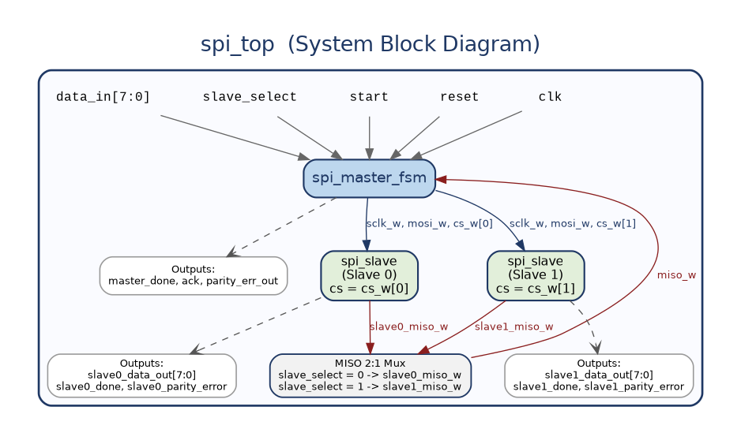
Figure 1 — spi_top system block diagram showing master, dual slaves, MISO mux, and port connectivity.

3. Signal Description

3.1 Top-Level Ports
Port | Dir | Width | Description
clk | In | 1 | System clock — master FSM runs on this
reset | In | 1 | Active-high asynchronous reset
start | In | 1 | Pulse high for 1 cycle to begin a transaction
slave_select | In | 1 | 0 = Slave0, 1 = Slave1
data_in | In | 8 | Byte to transmit
master_done | Out | 1 | Pulses 1 for 1 clock when transaction is complete
ack | Out | 1 | 1 = slave acknowledged (no parity error)
parity_err_out | Out | 1 | 1 = slave detected parity mismatch
slave0_data_out | Out | 8 | Data byte received by Slave 0
slave0_parity_error | Out | 1 | 1 = parity error at Slave 0
slave0_done | Out | 1 | Slave 0 transfer complete flag
slave1_data_out | Out | 8 | Data byte received by Slave 1
slave1_parity_error | Out | 1 | 1 = parity error at Slave 1
slave1_done | Out | 1 | Slave 1 transfer complete flag

3.2 Internal Wires
Wire | Description
sclk_w | SPI clock, shared to both slaves
mosi_w | Data line, shared to both slaves
cs_w[1:0] | Active-low chip-selects: [0] -> Slave0, [1] -> Slave1
miso_w | Muxed MISO input to master
slave0_miso_w | Slave 0 feedback line
slave1_miso_w | Slave 1 feedback line

4. SPI Protocol

4.1 Chip-Select Convention
slave_select | cs_w[1:0] | cs_w[0] | cs_w[1] | Active Slave
0 | 2'b10 | 0 (active) | 1 (idle) | Slave 0
1 | 2'b01 | 1 (idle) | 0 (active) | Slave 1

4.2 Frame Format (10 SCLK Rising Edges)
Each transaction is 10 SCLK rising edges long: 8 edges shift out the data byte MSB-first, the 9th edge sends the even-parity bit, and the 10th edge is a dedicated feedback edge during which the addressed slave drives MISO with its ACK/NACK response.
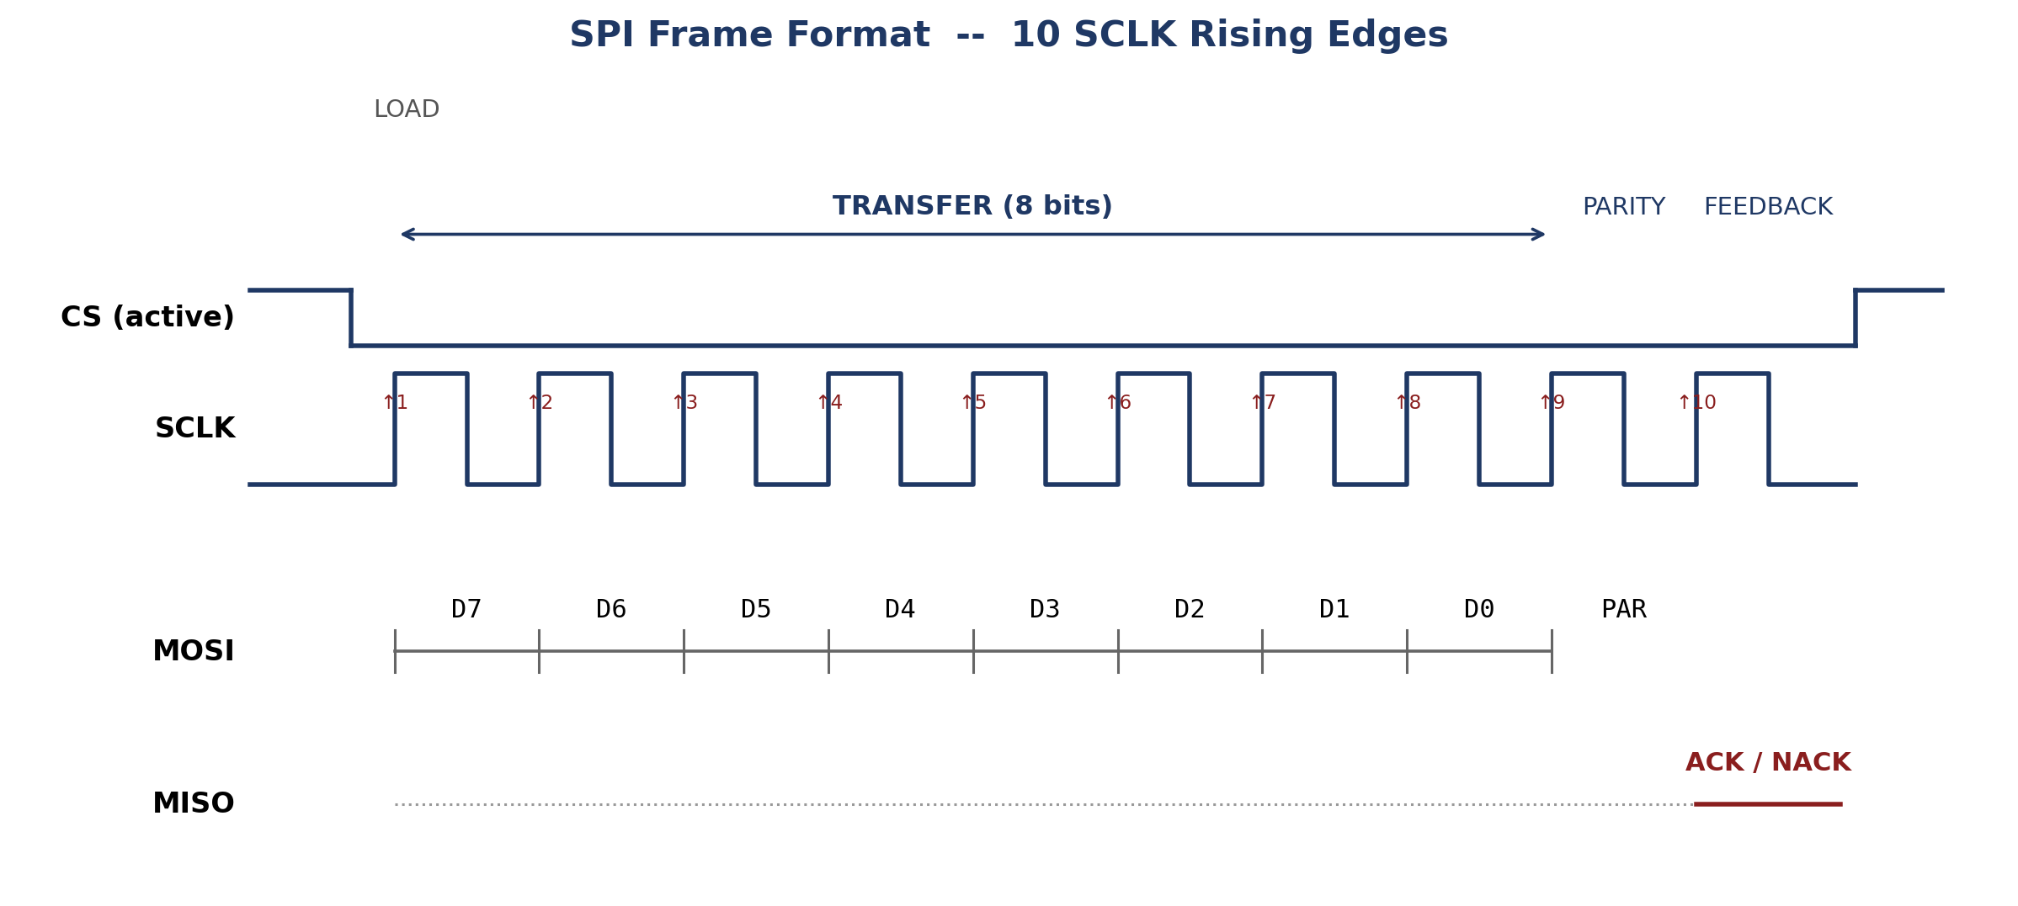
Figure 2 — SPI frame format: LOAD, 8-bit TRANSFER, PARITY bit, and FEEDBACK edge.

4.3 Parity Convention
parity_bit = ^data_in = data_in[7] ^ data_in[6] ^ ... ^ data_in[0] (even parity)

Slave check: if (mosi_received == ^shift_reg) -> no error
else -> parity_error = 1

Data | Binary | Parity bit
0xA5 | 1010_0101 | 0
0x3C | 0011_1100 | 0

5. Master FSM — spi_master_fsm

5.1 State Diagram
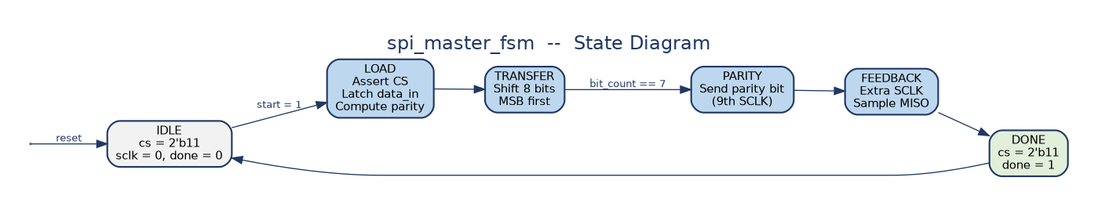
Figure 3 — spi_master_fsm state diagram: IDLE -> LOAD -> TRANSFER -> PARITY -> FEEDBACK -> DONE -> IDLE.

5.2 State Truth Table
State | sclk | cs | mosi | Key Action
IDLE | 0 | 11 | — | Wait for start. Clear ack, parity_err_out
LOAD | 0 | Select | — | Assert CS, latch data_in, compute parity_bit = ^data_in, bit_count = 0
TRANSFER | Toggle | Active | shift_reg[7] | Output MSB first on sclk = 0; shift left; repeat x8
PARITY | Toggle | Active | parity_bit | Output 9th bit (even parity) on sclk = 0
FEEDBACK | Toggle | Active | — | Wait 1 SCLK, then sample miso -> ack, ~miso -> parity_err_out
DONE | 0 | 11 | — | Deselect slaves; assert done = 1 for 1 cycle; -> IDLE

6. Slave FSM — spi_slave

6.1 State Diagram
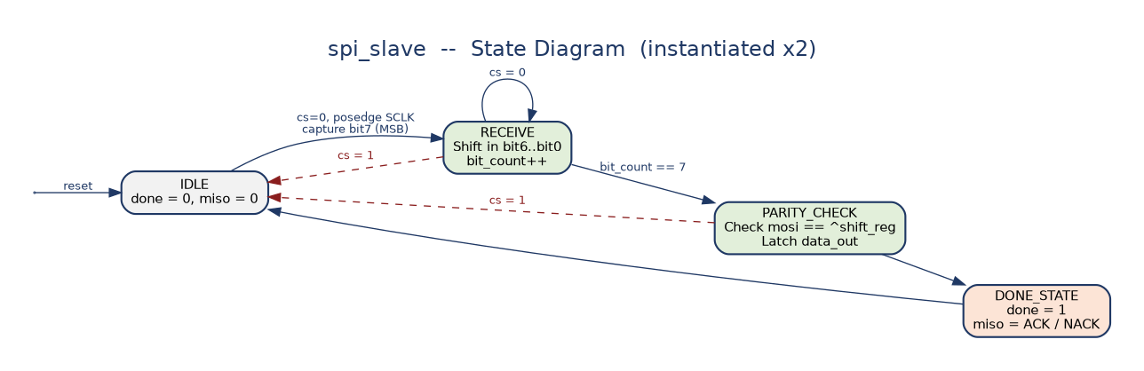
Figure 4 — spi_slave state diagram (identical logic instantiated for Slave 0 and Slave 1, gated by each instance's own cs input).

6.2 State Details
State | SCLK Posedge | cs Guard | Action
IDLE | 1 | cs = 0 | Capture MSB into shift_reg. bit_count = 1. -> RECEIVE
RECEIVE | 2–8 | cs = 0 else -> IDLE | Shift in next bit. When bit_count == 7 -> PARITY_CHECK
PARITY_CHECK | 9 | cs = 0 else -> IDLE | Check mosi == ^shift_reg. Set parity_error. Latch data_out
DONE_STATE | 10 | — | done = 1. miso = 1 (ACK) or miso = 0 (NACK). -> IDLE

7. MISO Feedback Timing
The 10th SCLK edge is reserved for feedback: the addressed slave transitions to DONE_STATE and drives MISO with its ACK (1) or NACK (0) result one half-cycle ahead of when the master's FEEDBACK state samples it, guaranteeing a stable setup time at the sampling edge.
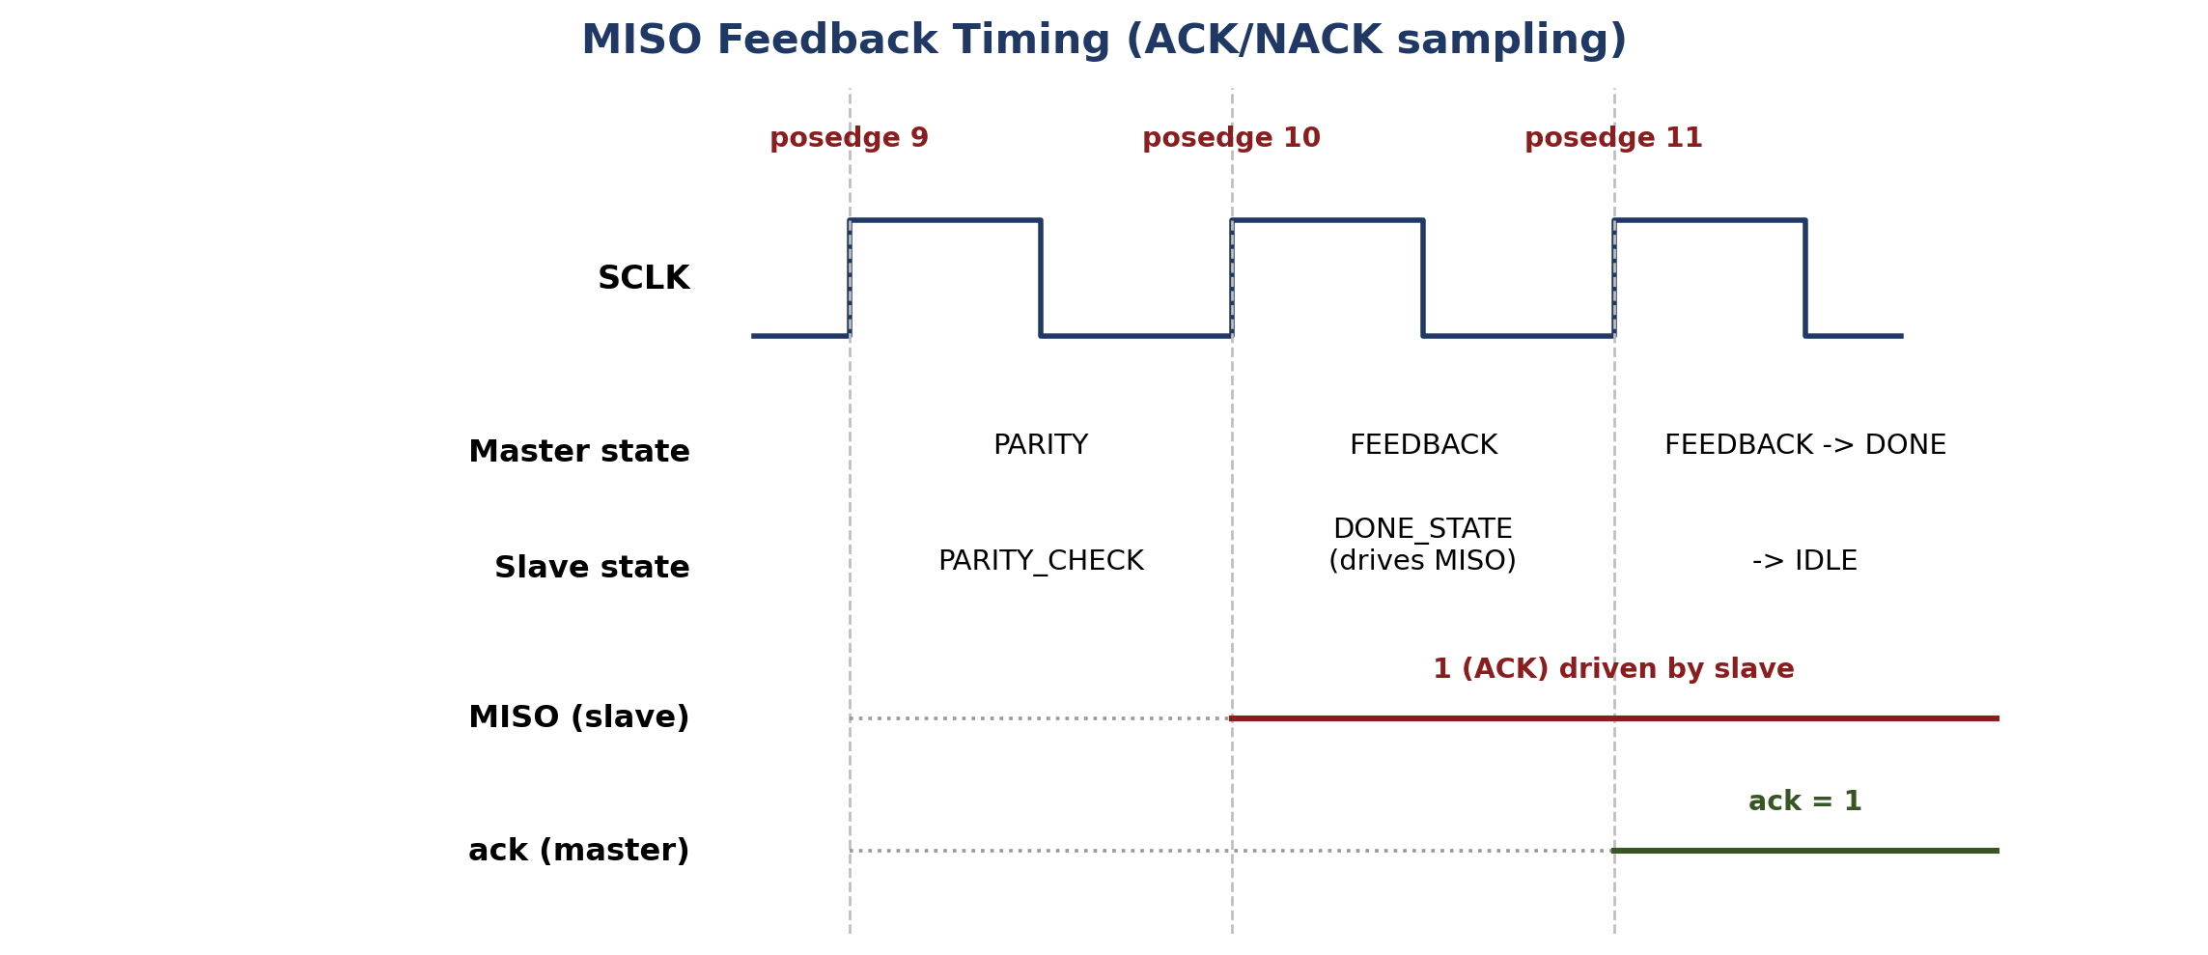
Figure 5 — MISO is driven by the slave at posedge 10 (DONE_STATE) and sampled by the master at posedge 11, producing ack = 1.

8. Simulation Results

8.1 Test Configuration
Parameter | Value
Clock period | 10 ns (100 MHz)
Simulation duration | 1000 ns (run 1000 ns)
Test 1 | 0xA5 -> Slave 0 (slave_select = 0)
Test 2 | 0x3C -> Slave 1 (slave_select = 1)

8.2 XSim Waveform Capture
The waveform below is the XSim simulation window covering both transactions end-to-end (0–605 ns). A detailed signal-by-signal interpretation is given separately in Section 9.
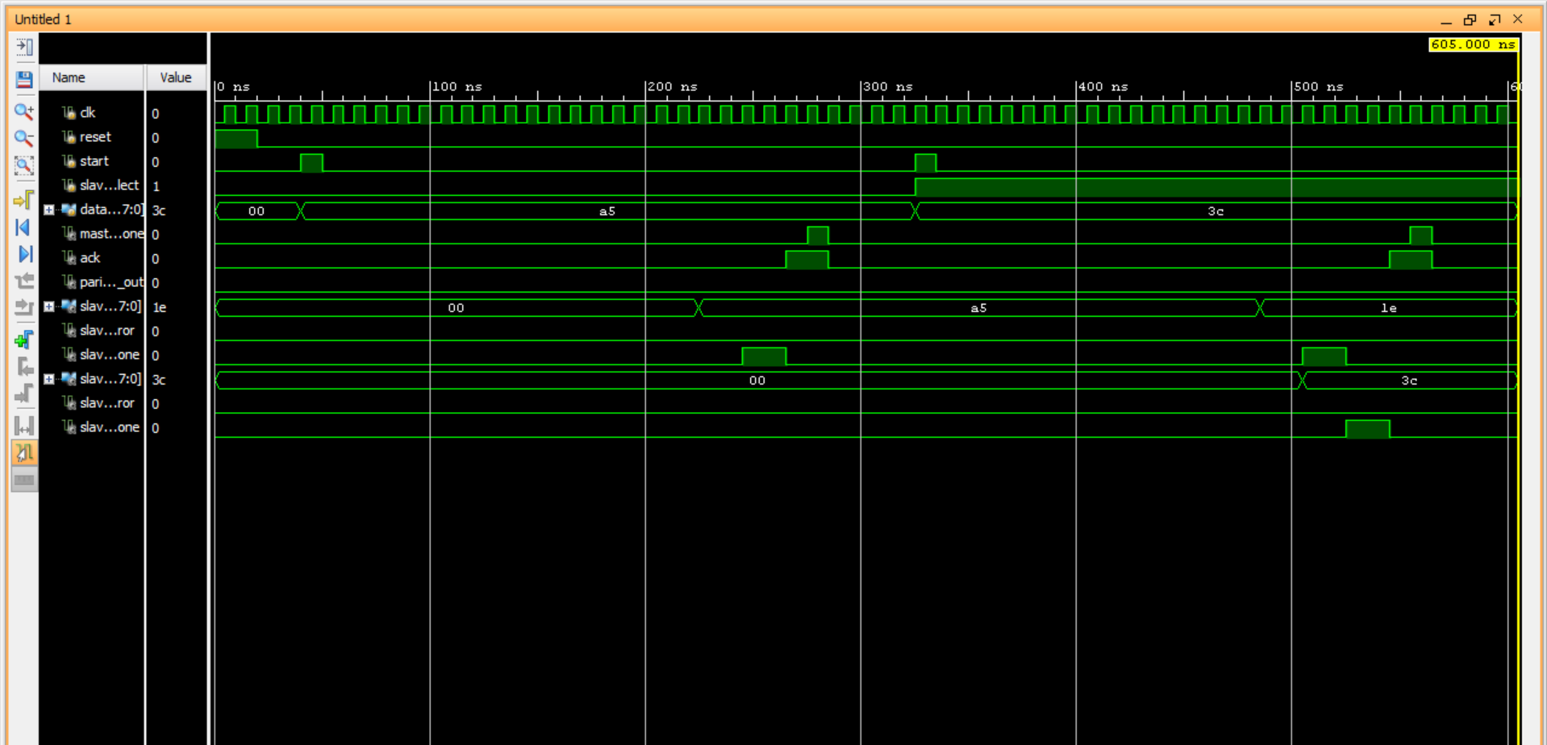
Figure 6 — XSim behavioural simulation waveform, 0–605 ns, showing both SPI transactions.

8.3 Test 1 — 0xA5 to Slave 0
0xA5 = 1010_0101 — Parity bit = ^0xA5 = 0
Bit-by-bit MOSI verification:
Time (ns) | SCLK | MOSI | Bit Position | Expected | ✓
65 | 1 (↑) | 1 | bit7 (MSB) | 1 | ✅
85 | 1 (↑) | 0 | bit6 | 0 | ✅
105 | 1 (↑) | 1 | bit5 | 1 | ✅
125 | 1 (↑) | 0 | bit4 | 0 | ✅
145 | 1 (↑) | 0 | bit3 | 0 | ✅
165 | 1 (↑) | 1 | bit2 | 1 | ✅
185 | 1 (↑) | 0 | bit1 | 0 | ✅
205 | 1 (↑) | 1 | bit0 (LSB) | 1 | ✅
225 | 1 (↑) | 0 | Parity | 0 | ✅

Transaction timeline:
Time (ns) | CS | MOSI | SCLK | ACK | DONE | Event
0 | 11 | 0 | 0 | 0 | 0 | System reset / IDLE
55 | 10 | 0 | 0 | 0 | 0 | LOAD: CS[0] = 0, Slave0 selected
65 | 10 | 1 | 1 | 0 | 0 | TRANSFER: bit7 = 1 (posedge 1)
85 | 10 | 0 | 1 | 0 | 0 | TRANSFER: bit6 = 0 (posedge 2)
105 | 10 | 1 | 1 | 0 | 0 | TRANSFER: bit5 = 1 (posedge 3)
125 | 10 | 0 | 1 | 0 | 0 | TRANSFER: bit4 = 0 (posedge 4)
145 | 10 | 0 | 1 | 0 | 0 | TRANSFER: bit3 = 0 (posedge 5)
165 | 10 | 1 | 1 | 0 | 0 | TRANSFER: bit2 = 1 (posedge 6)
185 | 10 | 0 | 1 | 0 | 0 | TRANSFER: bit1 = 0 (posedge 7)
205 | 10 | 1 | 1 | 0 | 0 | TRANSFER: bit0 = 1 (posedge 8)
225 | 10 | 0 | 1 | 0 | 0 | PARITY: bit = 0 (posedge 9); slave0_data = A5 latched
245 | 10 | 0 | 1 | 0 | 0 | FEEDBACK: posedge 10; slave drives MISO = 1 (ACK)
265 | 10 | 0 | 1 | 1 | 0 | FEEDBACK: posedge 11; master samples MISO; ACK = 1
275 | 11 | 0 | 0 | 1 | 1 | DONE: CS deasserted, done = 1
285 | 11 | 0 | 0 | 0 | 0 | IDLE: ACK cleared, ready for next transaction

Result: slave0_data_out = 0xA5, ack = 1, parity_err_out = 0 ✅

8.4 Test 2 — 0x3C to Slave 1
0x3C = 0011_1100 — Parity bit = ^0x3C = 0
Bit-by-bit MOSI verification:
Time (ns) | SCLK | MOSI | Bit Position | Expected | ✓
345 | 1 (↑) | 0 | bit7 (MSB) | 0 | ✅
365 | 1 (↑) | 0 | bit6 | 0 | ✅
385 | 1 (↑) | 1 | bit5 | 1 | ✅
405 | 1 (↑) | 1 | bit4 | 1 | ✅
425 | 1 (↑) | 1 | bit3 | 1 | ✅
445 | 1 (↑) | 1 | bit2 | 1 | ✅
465 | 1 (↑) | 0 | bit1 | 0 | ✅
485 | 1 (↑) | 0 | bit0 (LSB) | 0 | ✅
505 | 1 (↑) | 0 | Parity | 0 | ✅

Transaction timeline:
Time (ns) | CS | MOSI | SCLK | ACK | DONE | Event
285 | 11 | 0 | 0 | 0 | 0 | IDLE: waiting for start
335 | 01 | 0 | 0 | 0 | 0 | LOAD: CS[1] = 0, Slave1 selected
345 | 01 | 0 | 1 | 0 | 0 | TRANSFER: bit7 = 0 (posedge 1)
365 | 01 | 0 | 1 | 0 | 0 | TRANSFER: bit6 = 0 (posedge 2)
385 | 01 | 1 | 1 | 0 | 0 | TRANSFER: bit5 = 1 (posedge 3)
405 | 01 | 1 | 1 | 0 | 0 | TRANSFER: bit4 = 1 (posedge 4)
425 | 01 | 1 | 1 | 0 | 0 | TRANSFER: bit3 = 1 (posedge 5)
445 | 01 | 1 | 1 | 0 | 0 | TRANSFER: bit2 = 1 (posedge 6)
465 | 01 | 0 | 1 | 0 | 0 | TRANSFER: bit1 = 0 (posedge 7)
485 | 01 | 0 | 1 | 0 | 0 | TRANSFER: bit0 = 0 (posedge 8)
505 | 01 | 0 | 1 | 0 | 0 | PARITY: bit = 0 (posedge 9); slave1_data = 3C latched
525 | 01 | 0 | 1 | 0 | 0 | FEEDBACK: posedge 10; slave drives MISO = 1 (ACK)
545 | 01 | 0 | 1 | 1 | 0 | FEEDBACK: posedge 11; master samples MISO; ACK = 1
555 | 11 | 0 | 0 | 1 | 1 | DONE: CS deasserted, done = 1
565 | 11 | 0 | 0 | 0 | 0 | IDLE: ACK cleared
605 | — | — | — | — | — | $finish

Result: slave1_data_out = 0x3C, ack = 1, parity_err_out = 0 ✅

8.5 CS Isolation Check
Window | CS[0] | CS[1] | Active Slave
0–55 ns | 1 (idle) | 1 (idle) | None (IDLE)
55–275 ns | 0 (active) | 1 (idle) | Slave 0
275–335 ns | 1 (idle) | 1 (idle) | None (IDLE, inter-transaction gap)
335–555 ns | 1 (idle) | 0 (active) | Slave 1
555–605 ns | 1 (idle) | 1 (idle) | None (IDLE)

CS[0] and CS[1] are never simultaneously low, confirming correct slave-select decoding and mutual exclusion between the two slave instances. ✅

9. Waveform Interpretation
This section reads the XSim capture in Figure 6 signal-by-signal against the timeline tables in Section 8, and separately flags one anomaly visible only in the waveform.

9.1 Signals That Match the Expected Design Behaviour
- reset is asserted high for the first ~15–20 ns, then released — consistent with the testbench's initial reset pulse before the first start.
- start fires two short one-cycle pulses: the first shortly after reset drops (kicking off the Slave-0 / 0xA5 transaction), and the second near 325–335 ns (kicking off the Slave-1 / 0x3C transaction). Both align with the LOAD events at 55 ns and 335 ns.
- slave_select stays low through the first transaction and switches high right before the second start pulse, correctly steering the master toward Slave 1 for the second transfer.
- data_in[7:0] shows three flat regions — 00 (idle), a5 (held for the whole first transaction), and 3c (held for the whole second transaction) — exactly matching the two test vectors.
- master_done and ack each pulse twice, once at the close of every transaction (~275 ns and ~555 ns), matching the DONE-state timing in both timeline tables.
- parity_err_out remains flat at 0 for the entire capture, confirming neither byte triggered a parity mismatch — expected, since both 0xA5 and 0x3C are even-parity-clean bytes (parity bit = 0).
- slave1_data_out[7:0] is the cleanest trace in the capture: it holds 00 until the second transaction's PARITY edge (~505 ns), then latches 3c and holds it for the rest of the run — exactly the expected single-write behaviour, since only one byte is ever addressed to Slave 1.
- slave1_done pulses exactly once, around 525–545 ns, aligned with Slave 1's FEEDBACK -> DONE_STATE transition.

9.2 Observed Anomaly — Slave 0 Signals During the Second Transaction
The slave0_data_out[7:0] and slave0_done traces do not stay quiet during the second (Slave 1) transaction, as the design intends. The waveform shows:
- slave0_data_out[7:0] correctly latches 00 -> a5 at the first transaction's PARITY edge (~225 ns), as expected. However, it changes a second time, from a5 to 1e, at roughly the same instant Slave 1 latches its own data (~505–510 ns) — even though cs_w[0] should be idle/high for the whole second transaction and Slave 0 was never re-addressed.
- slave0_done, which correctly pulses once around 245–265 ns for the legitimate first transaction, pulses a second time around 505–525 ns — again overlapping the window in which Slave 1 is actually being serviced.
- slave0_parity_error and slave1_parity_error both remain low throughout, so this is not being flagged as a parity fault by the simulation — the extra activity is silent.
Because cs_w[0] should be held at its idle (inactive) value for the entire second transaction, spi_slave (Slave 0) should not be updating data_out or pulsing done at all during that window. The most likely explanation is that Slave 0's internal bit counter and state machine are not fully gated by cs and continue to free-run off the shared sclk_w / mosi_w bus even while deselected, so it inadvertently shifts in bits intended for Slave 1 and reaches its own DONE_STATE a second time — landing on a stray value (0x1E) rather than the intended 0x3C, since it started counting from a different phase than Slave 1.
This does not corrupt the functional result reported in Section 8 — slave1_data_out still correctly holds 0x3C, and ack/parity_err_out are correct for both tests — but it is worth flagging as a design robustness issue: cs qualification inside spi_slave should be re-checked so that a deselected slave instance cannot shift in or latch bits belonging to another slave's transaction on the shared bus.

10. Complete Monitor Output
Full $monitor log from the testbench, 0–565 ns (simulation continues idle to $finish at 605 ns). PER = parity_err_out, S0 / S1 = slave0_data_out / slave1_data_out.
Time (ns) | CS | MOSI | SCLK | ACK | PER | DONE | S0 | S1 | Event
0 | 11 | 0 | 0 | 0 | 0 | 0 | 00 | 00 | —
55000 | 10 | 0 | 0 | 0 | 0 | 0 | 00 | 00 | LOAD (Slave0)
65000 | 10 | 1 | 1 | 0 | 0 | 0 | 00 | 00 | bit7 = 1
75000 | 10 | 1 | 0 | 0 | 0 | 0 | 00 | 00
85000 | 10 | 0 | 1 | 0 | 0 | 0 | 00 | 00 | bit6 = 0
95000 | 10 | 0 | 0 | 0 | 0 | 0 | 00 | 00
105000 | 10 | 1 | 1 | 0 | 0 | 0 | 00 | 00 | bit5 = 1
115000 | 10 | 1 | 0 | 0 | 0 | 0 | 00 | 00
125000 | 10 | 0 | 1 | 0 | 0 | 0 | 00 | 00 | bit4 = 0
135000 | 10 | 0 | 0 | 0 | 0 | 0 | 00 | 00
145000 | 10 | 0 | 1 | 0 | 0 | 0 | 00 | 00 | bit3 = 0
155000 | 10 | 0 | 0 | 0 | 0 | 0 | 00 | 00
165000 | 10 | 1 | 1 | 0 | 0 | 0 | 00 | 00 | bit2 = 1
175000 | 10 | 1 | 0 | 0 | 0 | 0 | 00 | 00
185000 | 10 | 0 | 1 | 0 | 0 | 0 | 00 | 00 | bit1 = 0
195000 | 10 | 0 | 0 | 0 | 0 | 0 | 00 | 00
205000 | 10 | 1 | 1 | 0 | 0 | 0 | 00 | 00 | bit0 = 1
215000 | 10 | 1 | 0 | 0 | 0 | 0 | 00 | 00
225000 | 10 | 0 | 1 | 0 | 0 | 0 | a5 | 00 | PARITY = 0; S0 latches 0xA5
235000 | 10 | 0 | 0 | 0 | 0 | 0 | a5 | 00
245000 | 10 | 0 | 1 | 0 | 0 | 0 | a5 | 00 | FEEDBACK posedge 10
255000 | 10 | 0 | 0 | 0 | 0 | 0 | a5 | 00
265000 | 10 | 0 | 1 | 1 | 0 | 0 | a5 | 00 | MISO sampled; ACK = 1
275000 | 11 | 0 | 0 | 1 | 0 | 1 | a5 | 00 | DONE; CS released
285000 | 11 | 0 | 0 | 0 | 0 | 0 | a5 | 00 | IDLE
335000 | 01 | 0 | 0 | 0 | 0 | 0 | a5 | 00 | LOAD (Slave1)
345000 | 01 | 0 | 1 | 0 | 0 | 0 | a5 | 00 | bit7 = 0
355000 | 01 | 0 | 0 | 0 | 0 | 0 | a5 | 00
365000 | 01 | 0 | 1 | 0 | 0 | 0 | a5 | 00 | bit6 = 0
375000 | 01 | 0 | 0 | 0 | 0 | 0 | a5 | 00
385000 | 01 | 1 | 1 | 0 | 0 | 0 | a5 | 00 | bit5 = 1
395000 | 01 | 1 | 0 | 0 | 0 | 0 | a5 | 00
405000 | 01 | 1 | 1 | 0 | 0 | 0 | a5 | 00 | bit4 = 1
415000 | 01 | 1 | 0 | 0 | 0 | 0 | a5 | 00
425000 | 01 | 1 | 1 | 0 | 0 | 0 | a5 | 00 | bit3 = 1
435000 | 01 | 1 | 0 | 0 | 0 | 0 | a5 | 00
445000 | 01 | 1 | 1 | 0 | 0 | 0 | a5 | 00 | bit2 = 1
455000 | 01 | 1 | 0 | 0 | 0 | 0 | a5 | 00
465000 | 01 | 0 | 1 | 0 | 0 | 0 | a5 | 00 | bit1 = 0
475000 | 01 | 0 | 0 | 0 | 0 | 0 | a5 | 00
485000 | 01 | 0 | 1 | 0 | 0 | 0 | a5 | 00 | bit0 = 0
495000 | 01 | 0 | 0 | 0 | 0 | 0 | a5 | 00
505000 | 01 | 0 | 1 | 0 | 0 | 0 | a5 | 3c | PARITY = 0; S1 latches 0x3C
515000 | 01 | 0 | 0 | 0 | 0 | 0 | a5 | 3c
525000 | 01 | 0 | 1 | 0 | 0 | 0 | a5 | 3c | FEEDBACK posedge 10
535000 | 01 | 0 | 0 | 0 | 0 | 0 | a5 | 3c
545000 | 01 | 0 | 1 | 1 | 0 | 0 | a5 | 3c | MISO sampled; ACK = 1
555000 | 11 | 0 | 0 | 1 | 0 | 1 | a5 | 3c | DONE; CS released
565000 | 11 | 0 | 0 | 0 | 0 | 0 | a5 | 3c | IDLE

$finish at 605 ns.

11. Summary of Results
Metric | Test 1 (0xA5 -> S0) | Test 2 (0x3C -> S1)
Data correctly received | ✅ 0xA5 | ✅ 0x3C
All 9 MOSI bits correct | ✅ | ✅
Parity bit sent | ✅ 0 | ✅ 0
Slave data latched at posedge 9 | ✅ 225 ns | ✅ 505 ns
MISO feedback (ACK) | ✅ 1 at posedge 11 | ✅ 1 at posedge 11
master_done asserted | ✅ 275 ns | ✅ 555 ns
parity_err_out | ✅ 0 | ✅ 0
CS isolation (other slave idle) | ✅ CS[1] = 1 | ✅ CS[0] = 1
Transaction duration | 220 ns | 220 ns

12. File Summary
File | Module | Purpose
spi_master_fsm.v | spi_master_fsm | 6-state FSM master controller
spi_slave.v | spi_slave | 4-state FSM slave receiver (×2 instances)
spi_top.v | spi_top | System integration + MISO mux
tb_spi_top.v | tb_spi_top | 2-test functional testbench

13. Design Limitations & Future Scope
Feature | Current | Possible Extension
No. of slaves | 2 | Parameterise: parameter N_SLAVES = 2
Data width | 8-bit fixed | parameter DATA_WIDTH = 8
Parity | Even only | Add parity_mode input (0 = even, 1 = odd)
SCLK frequency | clk ÷ 2 | Add programmable clock divider
SPI mode | Mode 0 only (CPOL=0, CPHA=0) | Add CPOL/CPHA parameters
MISO data | 1-bit ACK/NACK | Full 8-bit duplex read-back
cs gating in spi_slave | Not fully qualifying shift/latch logic (see Section 9.2) | Gate all sequential updates strictly on this instance's cs

End of Report

