Hotel Room Booking & Front Office Management (Work flow)

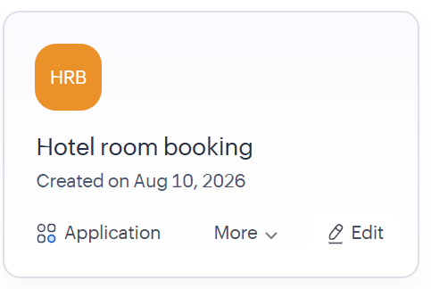

Accessing the application…
Fig. 1: Configuration of On_Booking_Submit_Workflow in Zoho Creator to automate booking confirmation after successful form submission.
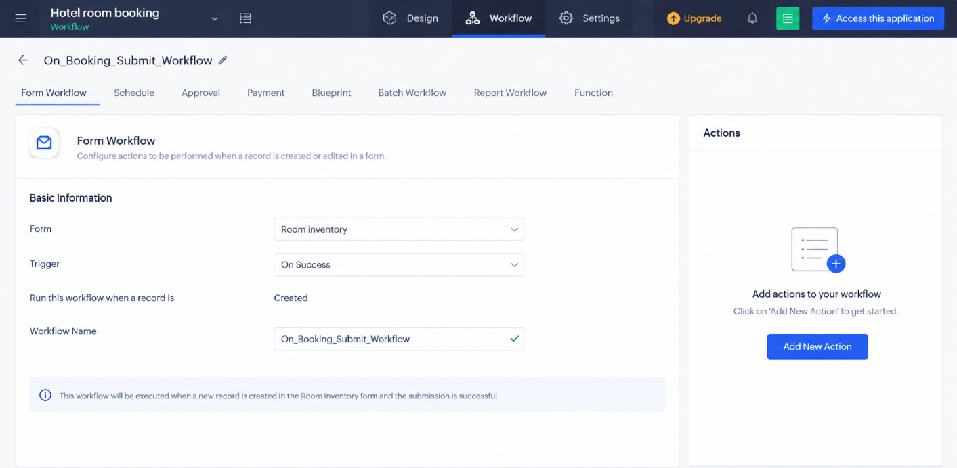
Fig. 2: Configuration of the Daily Check-in Reminder Schedule in Zoho Creator to automate reminders for guests checking in the following day.
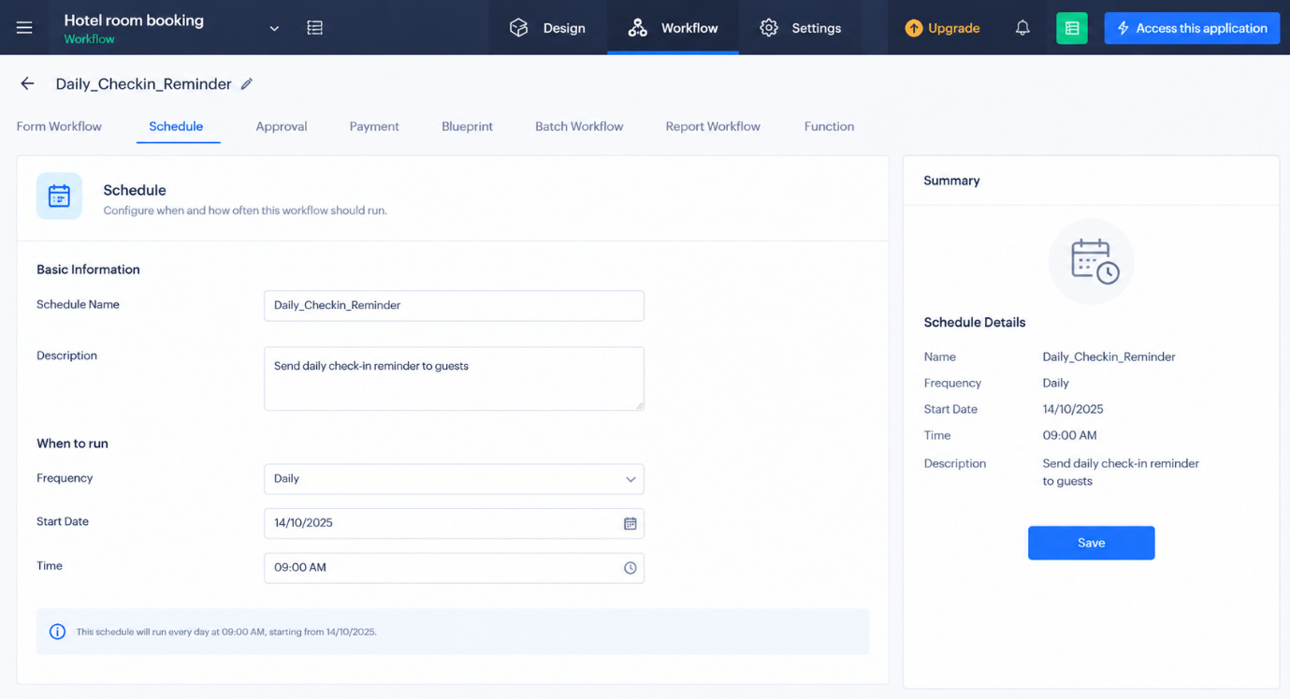
Fig. 3: Approval workflow configuration for room upgrades and discount requests in Zoho Creator.
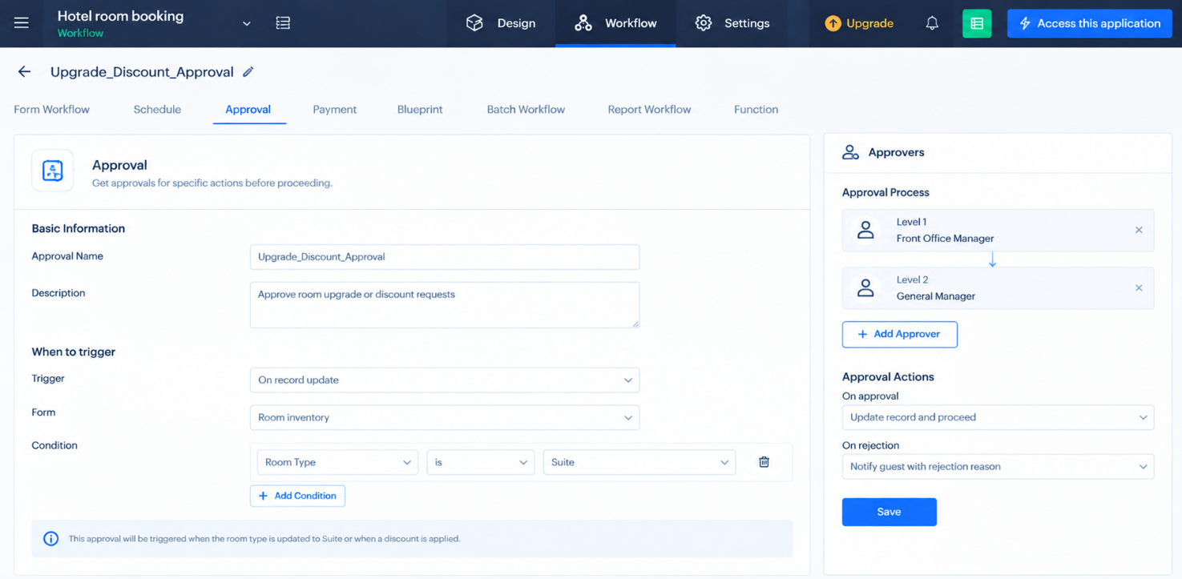
Fig. 4: Configuration of the Advance Payment Workflow in Zoho Creator for collecting booking advance payments and sending payment links to guests.
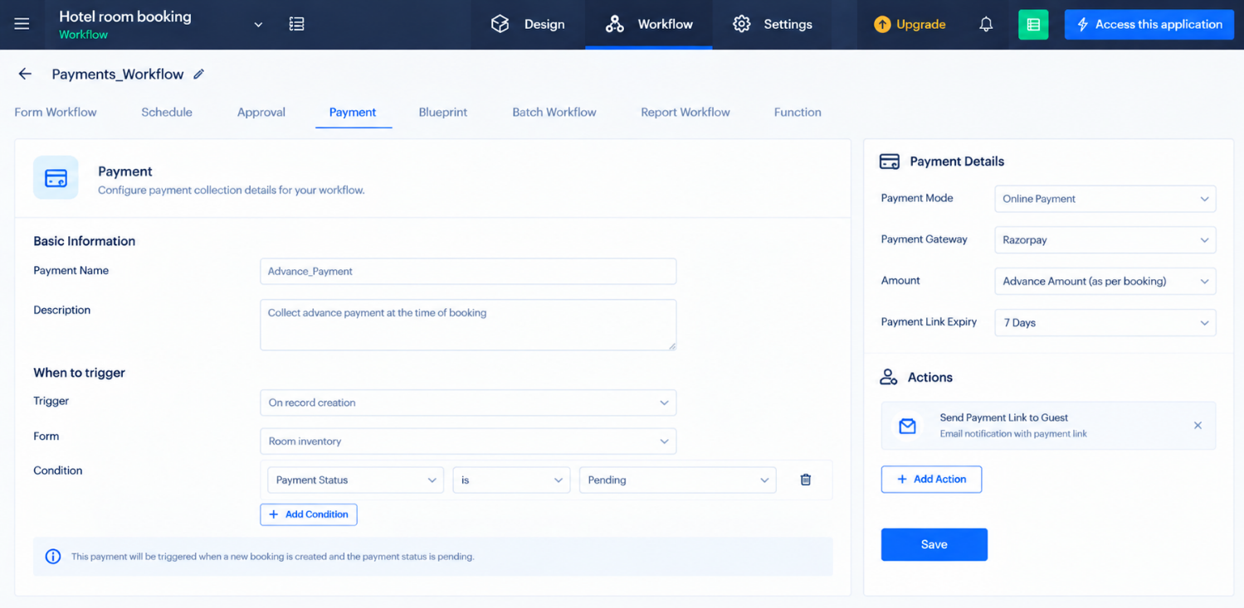

Fig. 5: Configuration of the Report Workflow in Zoho Creator to generate and email daily booking reports to the hotel manager.
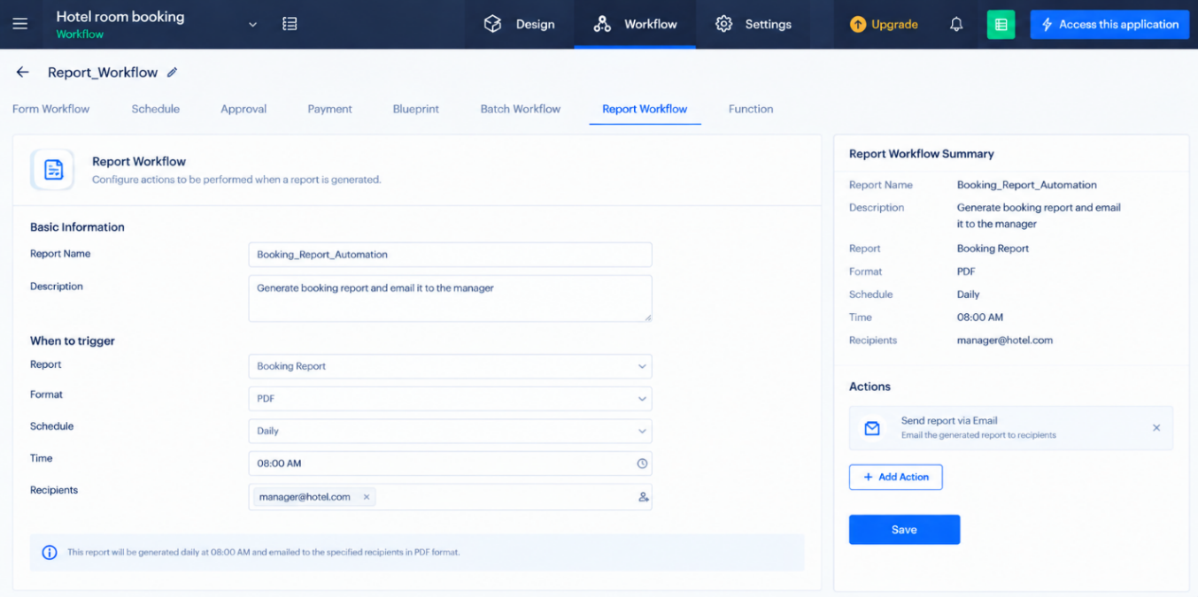
Fig. 6: Batch Workflow – Feedback Request Setup: Shows the configuration of a batch workflow to automatically send feedback request emails to guests after checkout, with daily execution, booking status and check-out date conditions, and workflow summary details.
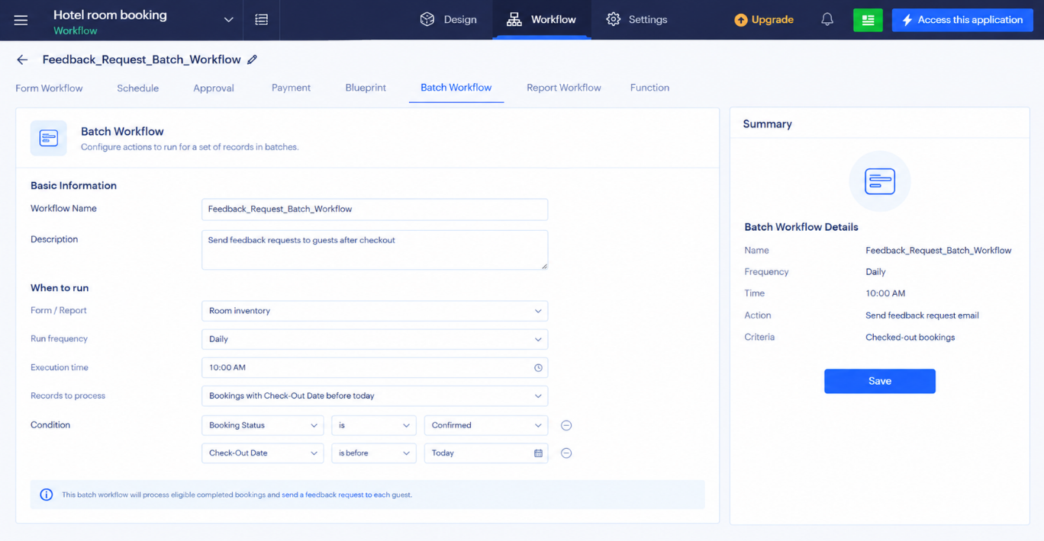
Fig. 7: Blueprint Configuration – Booking Lifecycle Management: Shows the booking process in Zoho Creator, including manager approval, payment collection, check-in, and transitions to confirmed, payment received, checked-in, or cancelled states.
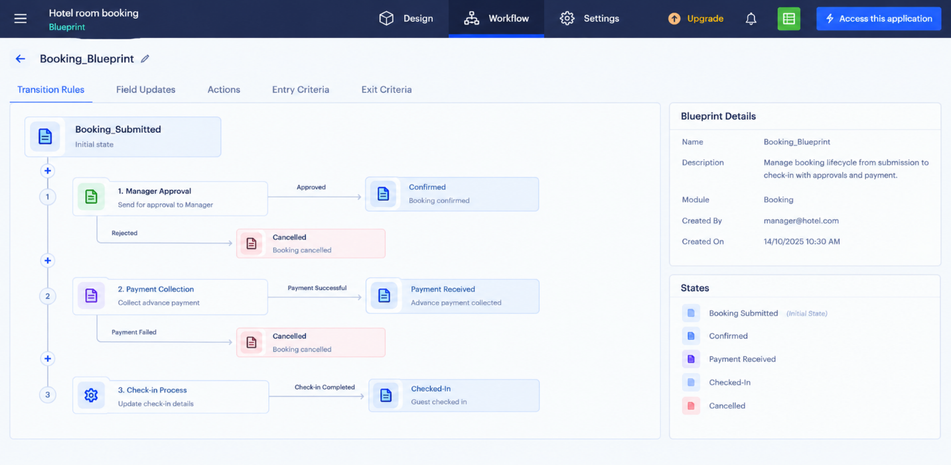
Fig. 8: Generate_Invoice_Function – reusable Deluge function in Zoho Creator that validates the guest details, calculates roomcharges, taxes and add-ons, and emails the final stay invoice PDF to the guest.
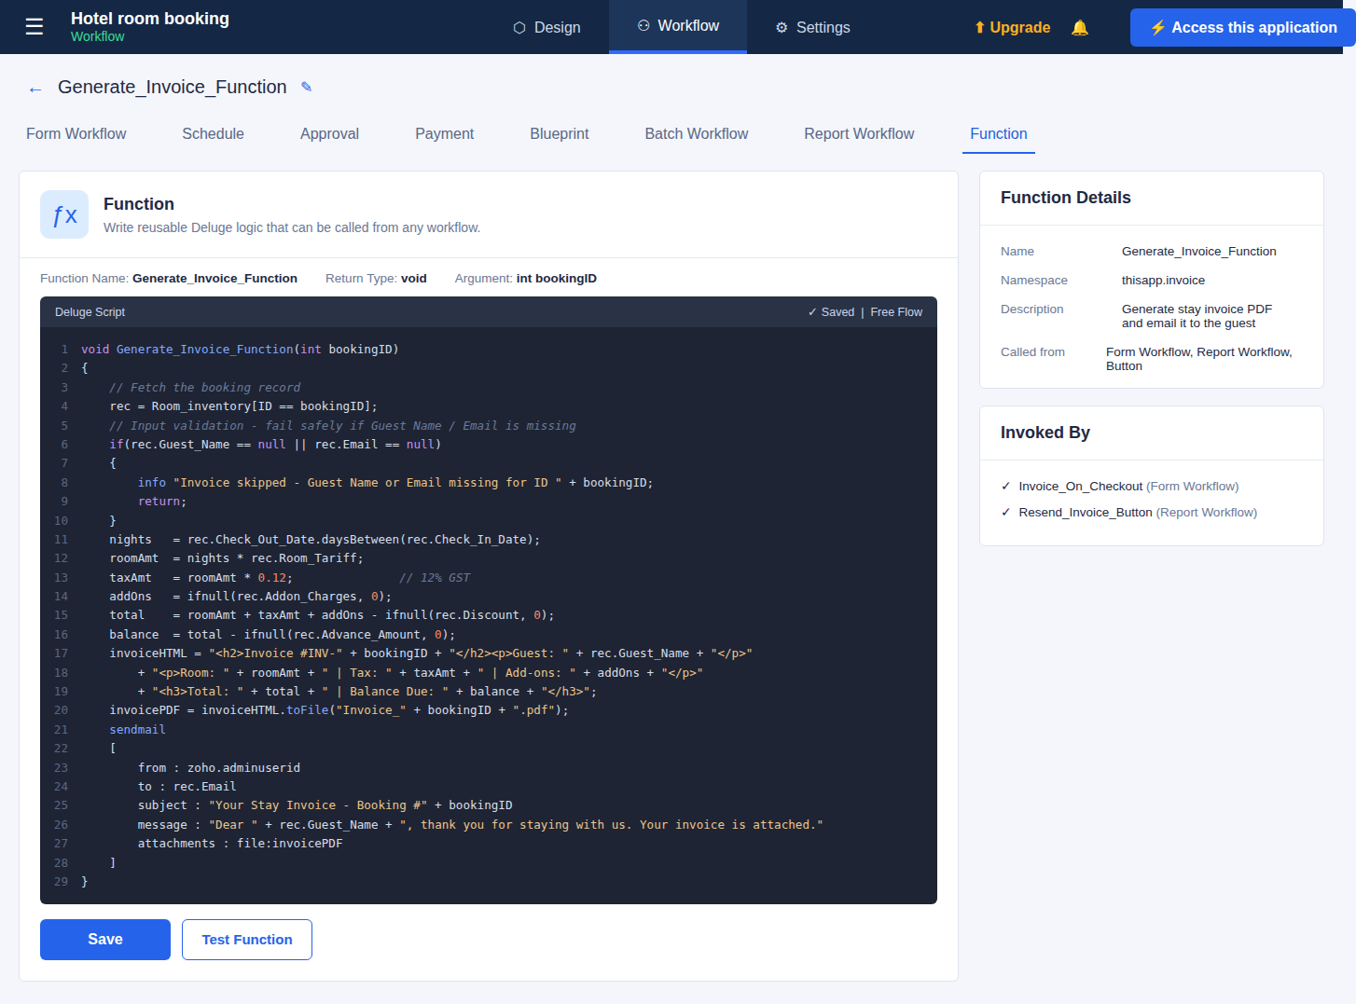
Fig. 9: Sample booking confirmation email received by the guest after form submission, triggered by On_Booking_Submit_Workflow, showing the Booking ID and stay details.
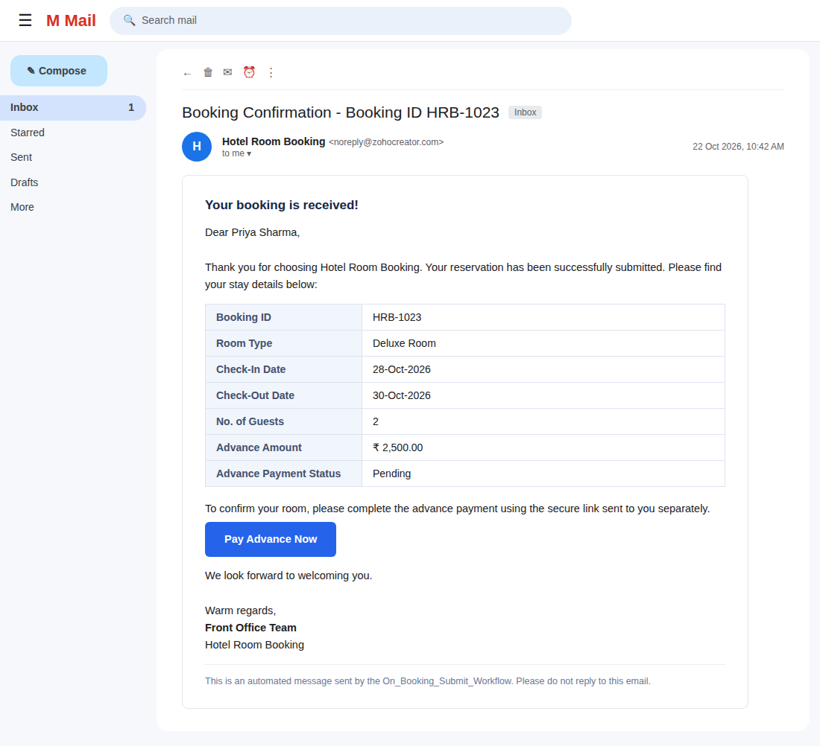
Fig. 10: Advance payment link generated by the Payments workflow and opened by the guest on the Razorpay payment gateway page for the advance amount.
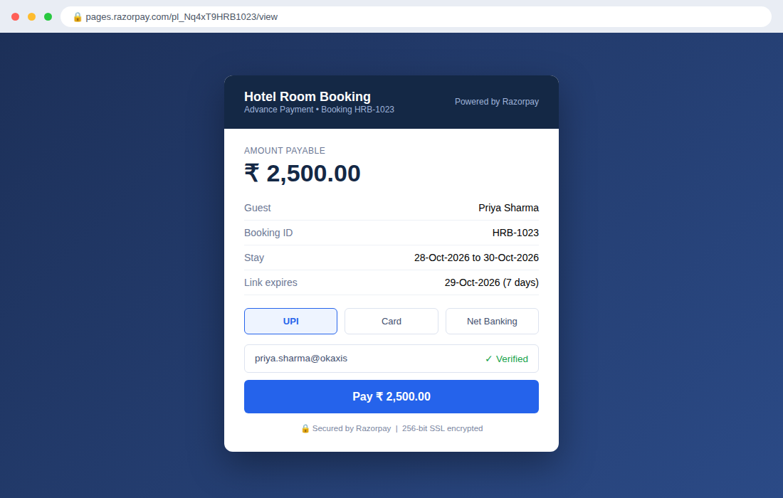
Fig. 11: Evidence of Generate_Invoice_Function being invoked from two different workflow types – a Form Workflow (automatically on Checked-Out) and a Report Workflow custom button (manual Resend Invoice) – along with the execution log.
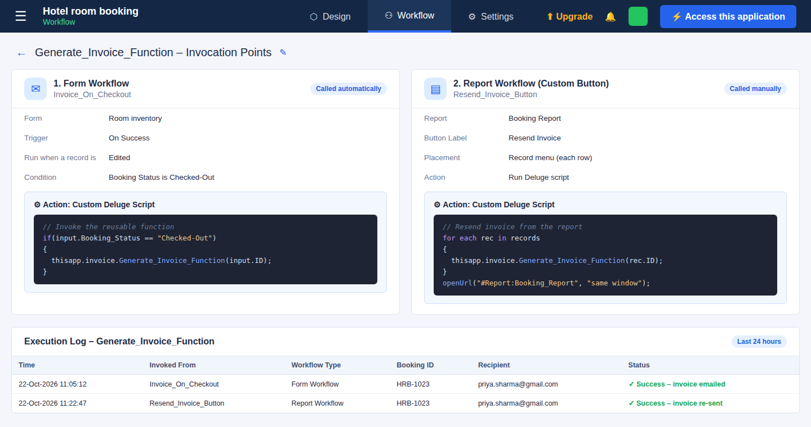
Summary
The Hotel Room Booking and Front Office Management system in Zoho Creator automates the hotel booking process using different workflow options. The Form Workflow sends booking confirmations, while the Schedule sends check-in reminders. The Approval Workflow manages upgrade and discount requests, and the Payments Workflow collects advance payments. The Blueprint controls booking stages, and the Batch Workflow sends feedback requests after checkout. The Report Workflow automates booking reports for the hotel manager. The Generate_Invoice_Function, written in Deluge, calculates room charges, taxes, and add-ons, generates a PDF invoice, and emails it to the guest. Overall, the system reduces manual work, improves accuracy, ensures timely communication, and makes hotel management more efficient.

