**SYNOPSIS  
MINOR PROJECT REPORT**

ON **C++ Tutorials**

**Submitted in partial fulfillment of requirements for the Award of   
Degree of Bachelor of Engineering in Computer Science & Engineering**

**Submitted To  
  
  
  
  
RAJIV GANDHI PRODHYOGIKI VISHWAVIDHYALAYA   
BHOPAL (M.P)  
  
  
Submitted By:  
Bharti Mewada (0161CS181006)**  
**Under the Guidance of**  
**Prof. Deepak Mishra**  
  
  
Department of Computer Science & Engineering  
**VNS GROUP OF INSTITUTIONS BHOPAL**

**INTRODUCTION**

Summary:

**C++ tutorials is an original piece of work done by me and has not been published or submitted elsewhere. it is an online platform. The aim of c++ tutorials is to help the people or customer who are wandering here and there for learning programming language.**

Role:

**We are happy to tell you that our project will help you to learning c++ programming language in your mobile or PC. and you can also easily find the content related to language. This platform is free of cost so you can easily learn and master in c++.**

Technology:

**FrontEnd- HTML5,CSS3,JAVASCRIPT,JQUERY,BOOTSTRAP**

**BackEnd-PHP,MYSQL**

**Editor-Notepad++**

Feature:

**We all know that time is money and it is very important for all and it is going fast ,so we thought that why we are not save your precious time and also we thought about you ,that’s why we provide comfortzone for you by the help of c++ tutorials.**

**First of all , we will connect all the learners at one place called admin. When a user or customer will go to our website or project and search for video tutorials,. A solution for every problem related to the c++ programming will be found here.**

**PROBLEM STATEMENT**

**While searching the learning content we are face many problems like.**

**If we want to buy books from shop during exam time or any time, how much time are we wasted while searching a shop.even after that we are unable to find the right shop and we don’t even know about content that we need and we don’t even know how much the price of this particular learning content is, what is the timing of this shop from where we are buying learning content.**

**SOLUTION OF PROBLEM**

**Customer or user easily will be able to search all video tutorials related to c++ programming language ,,,,**

**The Best material or content will be provided by the c++ tutorials and it is absolutely free for all users.**

**Provide the searching facilities based on various factors**

**This side is extremely very useful for you and you can trust it with your eyes closed. in this way online learning have become common.**

**LITERATURE SURVEY**

**IN TODAY’S ENVIRONMENT , THIS PROJECT IS MOST NEEDED**

* **The goal of c++ tutorials are to protect stored items from loss, damage, theft, or wastage and to manage the reliable movement of supplies from source to user in the most economical and expeditious way. Effective management of information is the key to achieving these goal.**
* **For those of us who lead busy lifestyle and simply do not have the time in the day to know about coaching center these are extremely helpful .The same goes for people who might live a long way from their nearest coaching center or perhaps the elderly or infirm that are no longer able to travel independently .**
* **Can you remember the last time that you had the choice of a dozen retail shops all offering a similar product? It doesn’t happen that often in real life but when you buy your books online ,this is exactly the way it works. why not spend a little time and save some money also? Just be careful not to fall for those fake shops that promise you something for next to nothing because nothing is usually what you end up with.**

**References**

1. **Easylearning (for idea )**
2. **Codewithharry**
3. **apnacollege**
4. **Freeprojectz**
5. **Medium (for software process model)**

**PLANNING OF WORK**

**Software process model:**

**To develop this project , one of the most popular Software Development life cycle (SDLC) “WATERFALL MODEL” is used which consist of following steps:**

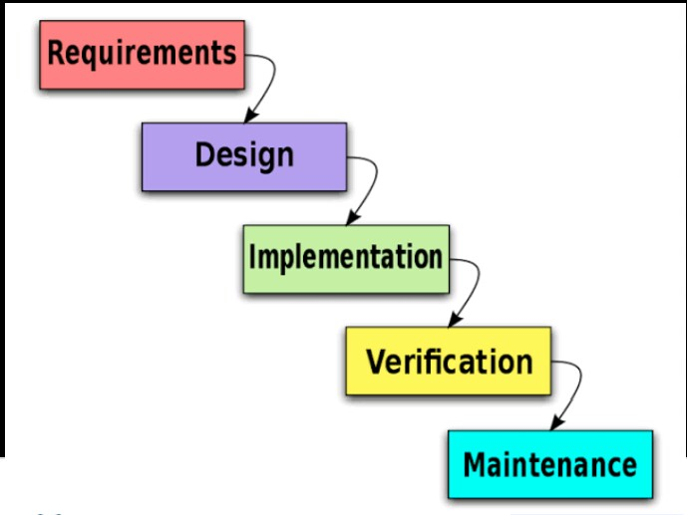

1. **Requirements : In this stage we are gather comprehensive information about what this project requires.**
2. **Design : Using the established requirements our team designs the system.**
3. **Implementation : With inputs from the system design , the system is first developed in small programs called units.**
4. **Verification : The project is tested to check whether it meets the requirements of the customer.**
5. **Maintenance : It includes making changes to improve a system’s performance , correct problems , enhance security , or address user requirements.**

**ANALYSIS**

**CONTEXT LEVEL DIAGRAM OF C++Tutorials**

**A system context diagram is a diagram that defines the boundary between the system , or part of a system, and its environment , showing the entities that interact with it. This diagram is a high level view of system.**

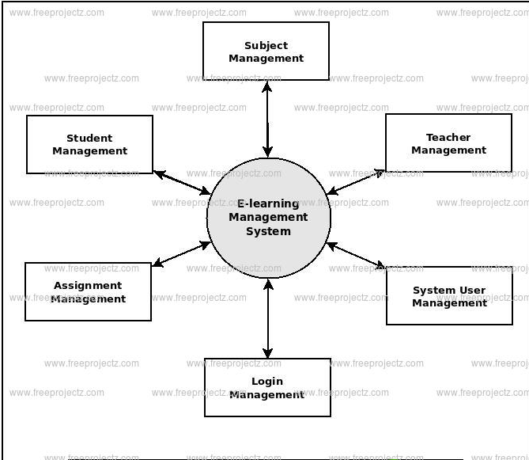

**E-R DIAGRAM OF C++Tutorials**

**An Entity Relationship Diagram is a visual representation of different**

**entities within a system and how they relate to each other.**

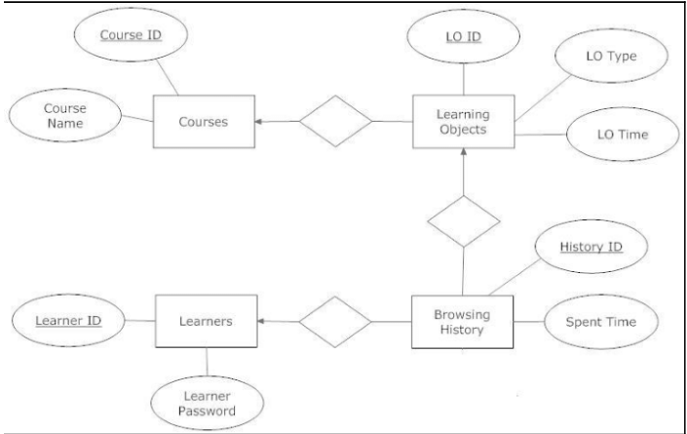

**USE CASE DIAGRAM OF C++Tutorials**

**Use case disgrams is a dynamic or behavior diagram in UML.use case diagrams model the functionality of a system using actors and use cases. Use cases are set of actions, services, and functions that the system needs to perform.**

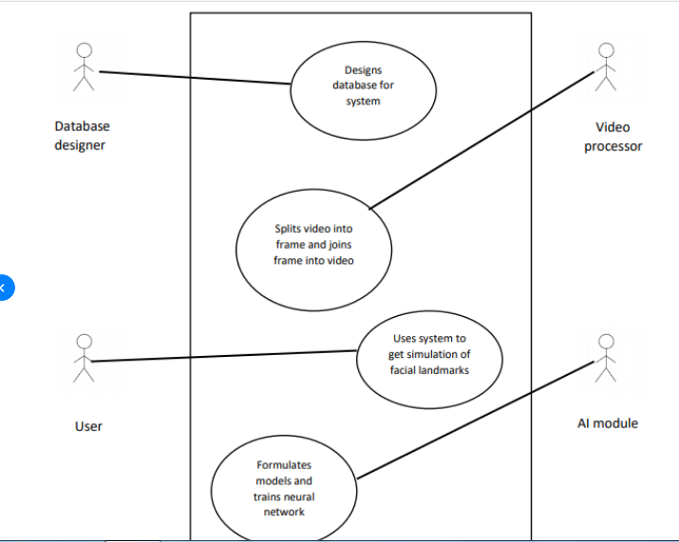

**Snapshot of Project**

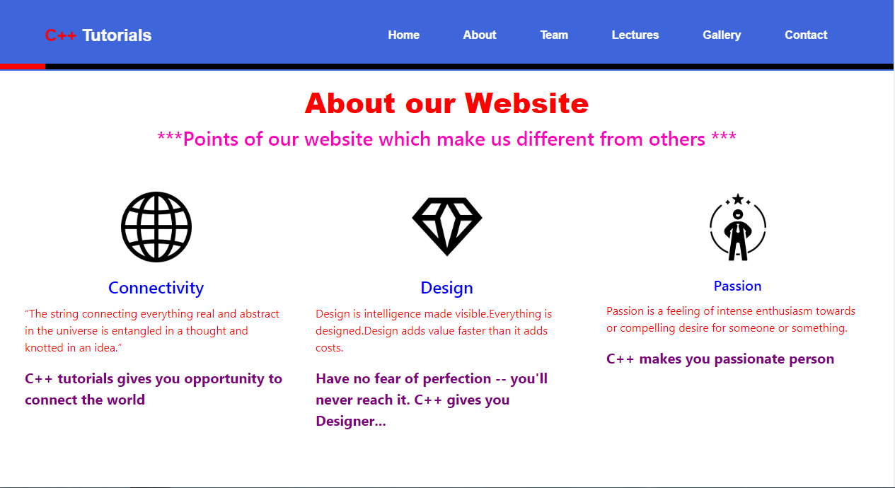

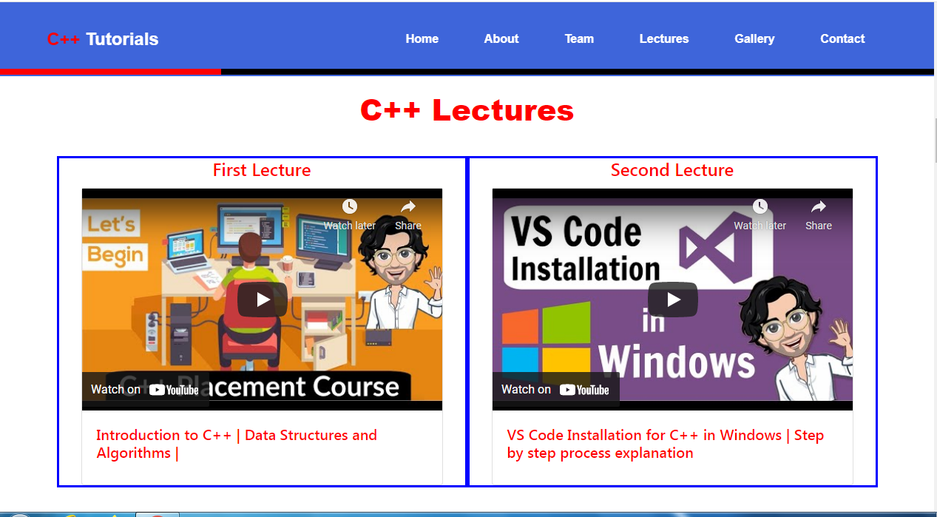

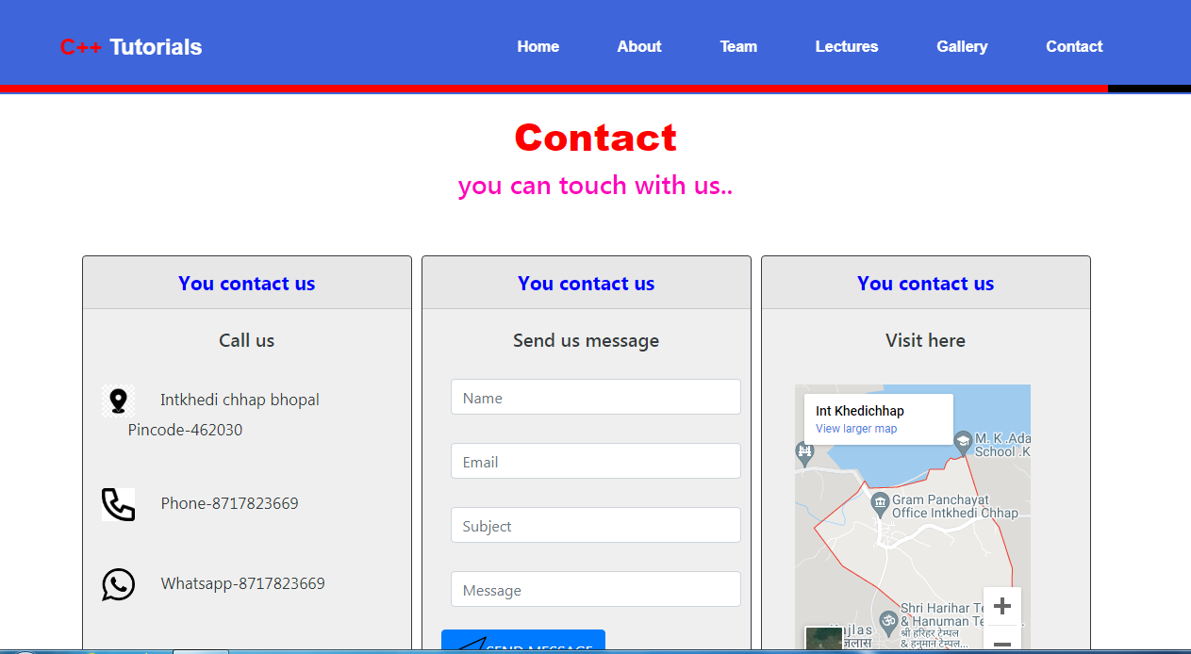

**TESTING**

**This project has been tested by “BLACK_BOX” testing method as it is a method of software testing that examines the functionality of an application without peering into its internal structure or workings. This method of test can be applied virtually to every level of software testing : unit , integration, system and acceptance.**

**PROJECT TIME LINE**

|  |  |  |  |
| --- | --- | --- | --- |
| **ANALYSiS** | **DESiGNiNG** | **iMPLEMENTATiON** | **TESTiNG** |
| **0-5days** | **0-7days** | **25-30days** | **0-7days** |

**THANKYOU**