

**Social Media Post Analyzer And User Insights**

**Presented By :**   
Varsha Bai -2312389

Vishaka Shankar Golani-2312390

## Section : 4G

## Department : Computer Science

**Course :** Database Management System

## ACKNOWLEDGMENT

##### We are really grateful because we managed to complete our project within the time given by our teacher [Abid Ali and Usama Khalid]. This assignment cannot be completed without the effort and co-operation from our group members, Group

members [Vishaka and Varsha].

##### We also sincerely thank our teacher [Abid Ali and Usama Khalid] for the guidance and encouragement in finishing this project and also for teaching us in this course.

##### Last but not the least, we would like to express our gratitude to our friends and respondents for the support and willingness directly or indirectly to spend some times with us to fill in the questionnaires.

## CONTENT

Introduction 4

Objectives of the project 5

Topic of Our Project 6

Hardware/ Software Requirements 7

WORK ANALYSIS 8

# Introduction

###### The Social Media and Post Analyzer is a web-based tool designed to study and understand social media content. It helps users analyze different parts of social media posts such as authors, likes, comments, shares, hashtags, reactions, and user activity. The tool uses an API to collect data and shows it in an organized way. Users can view and explore data in different categories like posts, post hashtags, post reactions, and more. It is built using HTML, CSS, Bootstrap, and JavaScript, making it easy to use and accessible on any device. This project aims to give a better understanding of how content is created, shared, and interacted with on social media platforms

# Objectives of the project

###### The main goal of the Social Media and Post Analyzer project is to show social media data in a simple and clear way. It helps users see details about posts, such as who posted them, how many likes, comments, shares, hashtags, and reactions they got. It also shows user activity and how people interact with the posts. The project uses an API to collect this data and display it in different views. It is made to be easy to use, so anyone can understand and explore social media data easily. It also helps users save time by giving a quick overview of post performance. This project can be useful for students, researchers, and anyone interested in social media analysis.

# Topic of Our Project

##### Our project “ Social Media and Post Analyzer” is a simple tool that helps to check and understand social media posts. It looks at how posts are shared, liked, or passed on by others. The tool uses basic programming to study the posts and how people interact with them. Users can give input and choose some settings to see the results. This project helps to learn how posts spread on social media.

# Hardware/ Software Requirements

# The Social Media and Post Analyzer project is made using HTML for page structure, CSS for styling, and Bootstrap to make the design responsive. JavaScript is used to add functions and make the tool work properly. Since it is API-based, it connects to an online API to get and analyze social media posts. To run the project, a web browser like Chrome is needed. A code editor like Visual Studio Code is used to write and edit the code.

# This tool helps users understand how posts are shared or passed on social media. It is easy to use and can be opened on any device with internet access.

# WORK ANALYSIS

|  |  |  |
| --- | --- | --- |
| **Task** | **Varsha** | **Vishaka** |
| Analysis |  |  |
| Design |  |  |
| Coding |  |  |
| Testing |  |  |
| Documentation |  |  |

**ER Diagram:**

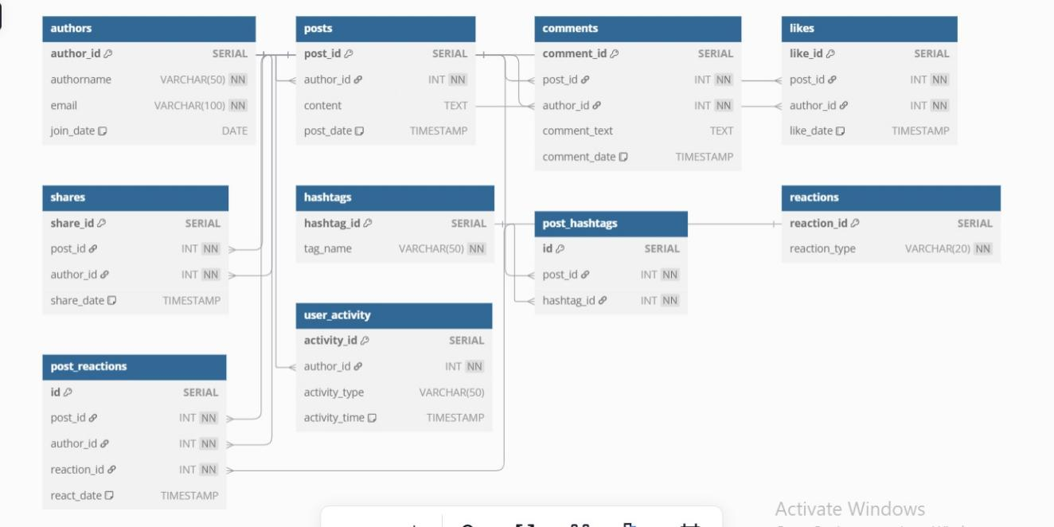

### **Code Snippets:**

#### **Data Base Connection:**

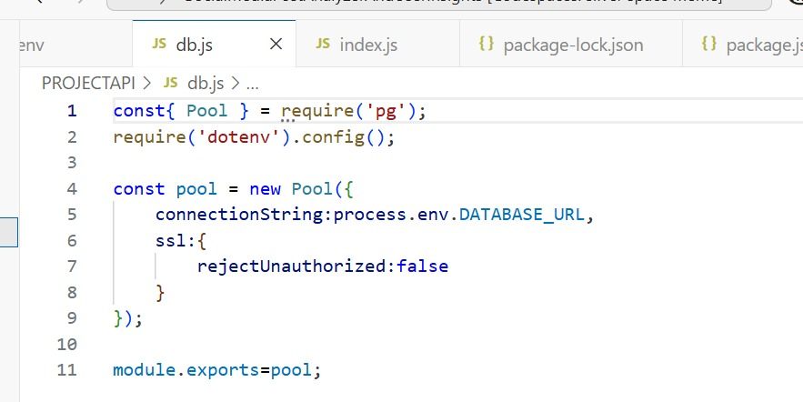

This code connects your Node.js application to a PostgreSQL database using environment variables for security.

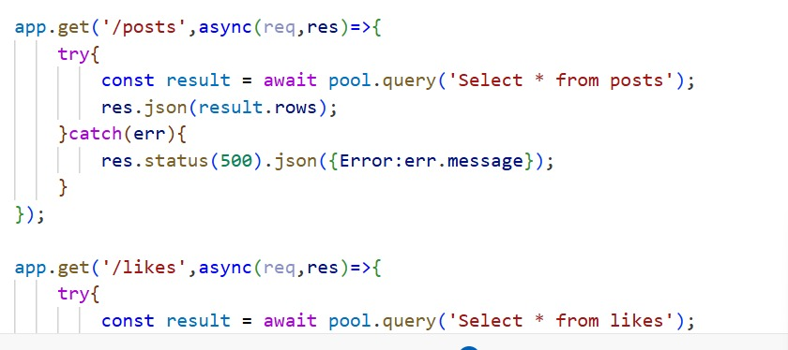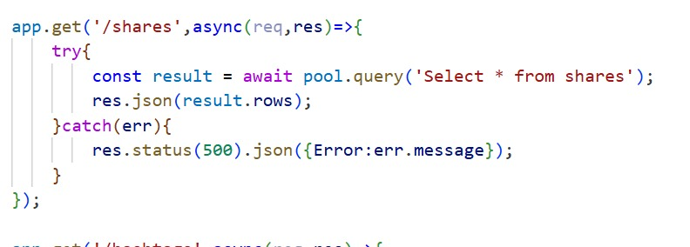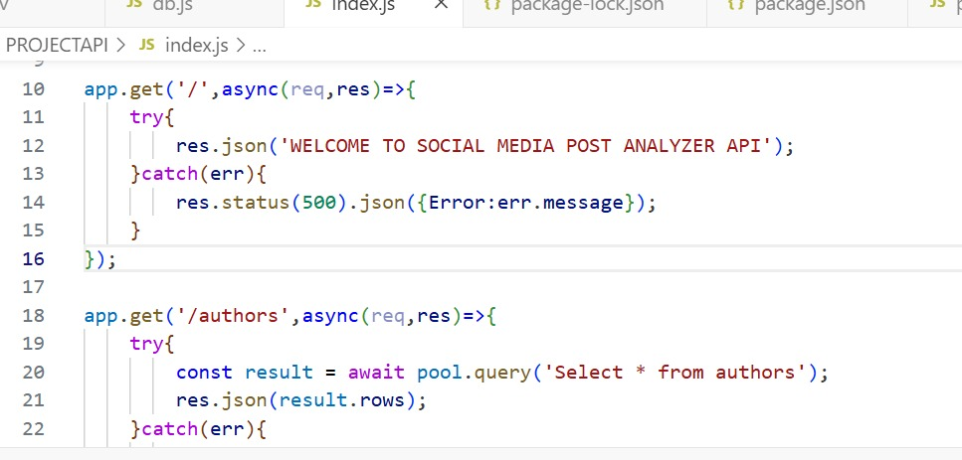

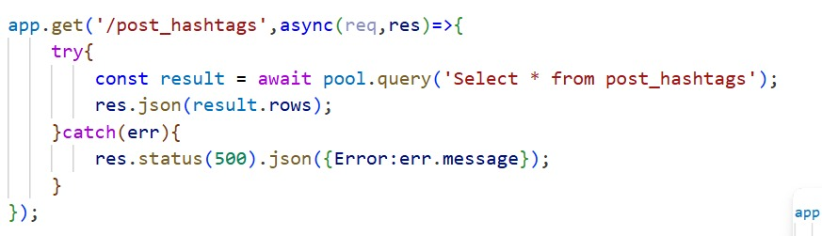

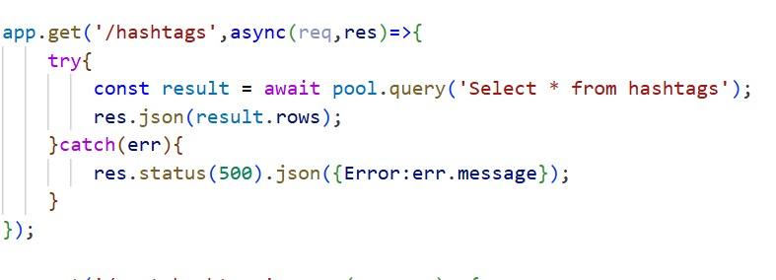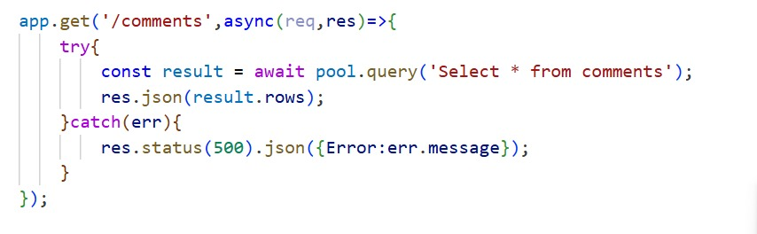

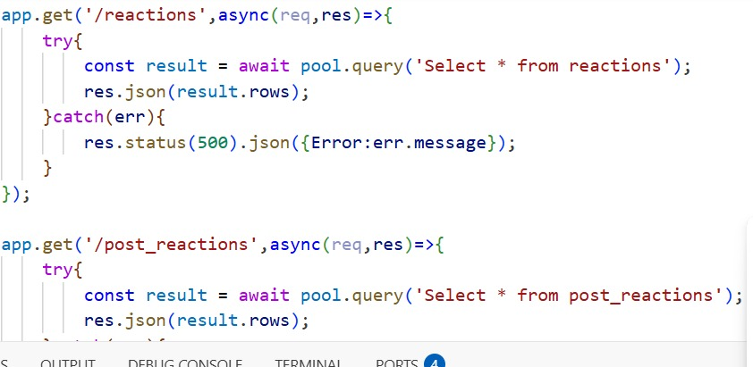

These code snippets include all the data views Tables.

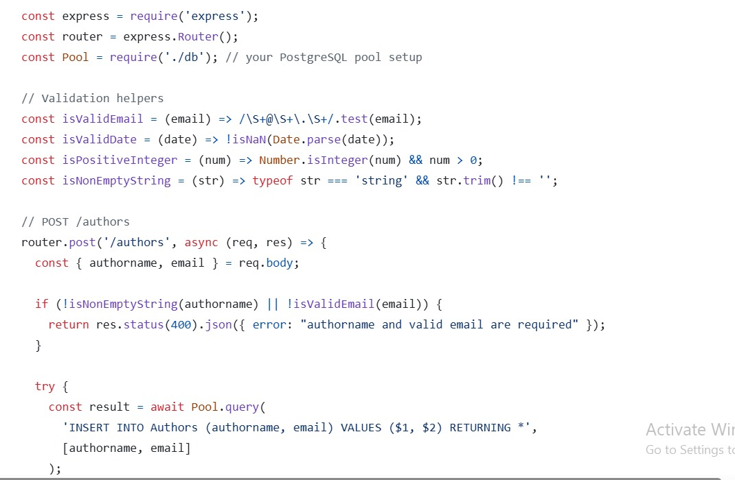

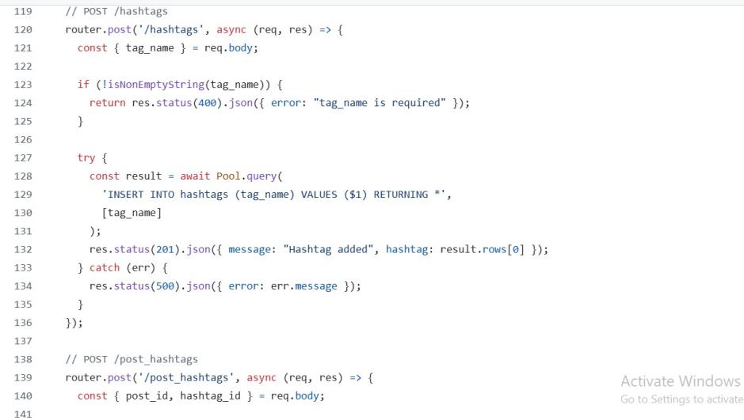

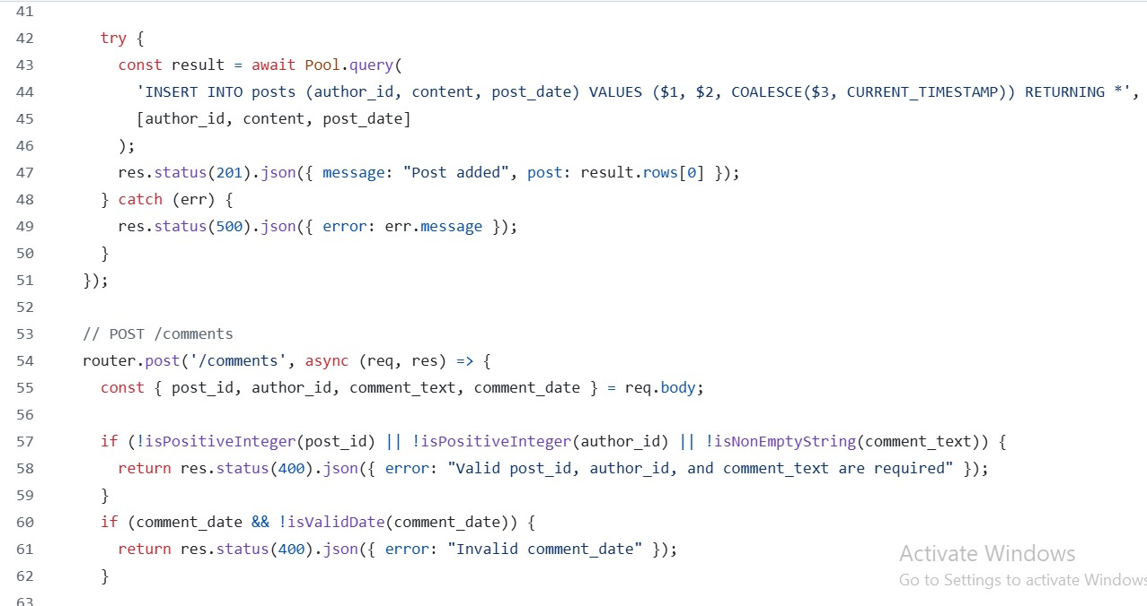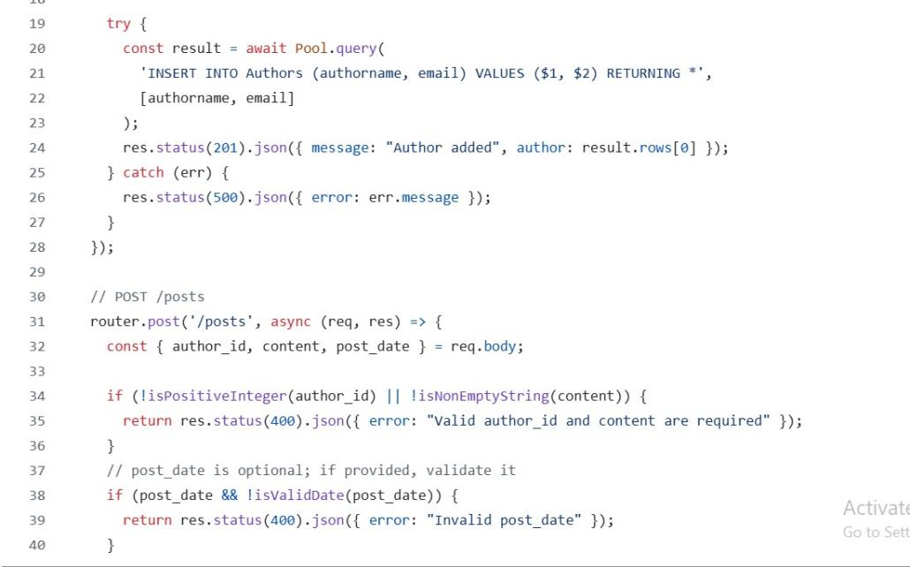

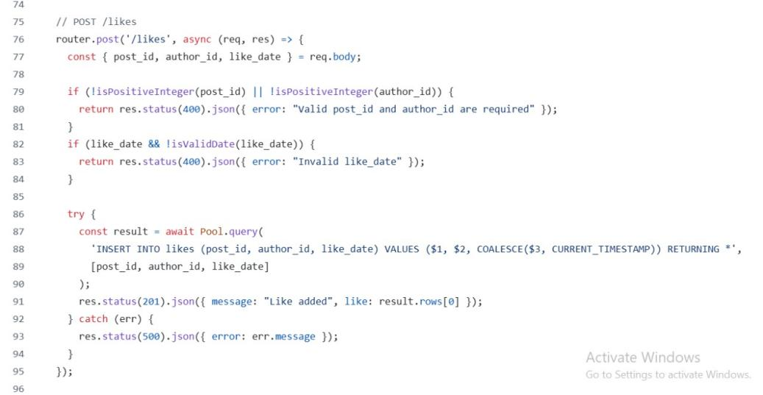

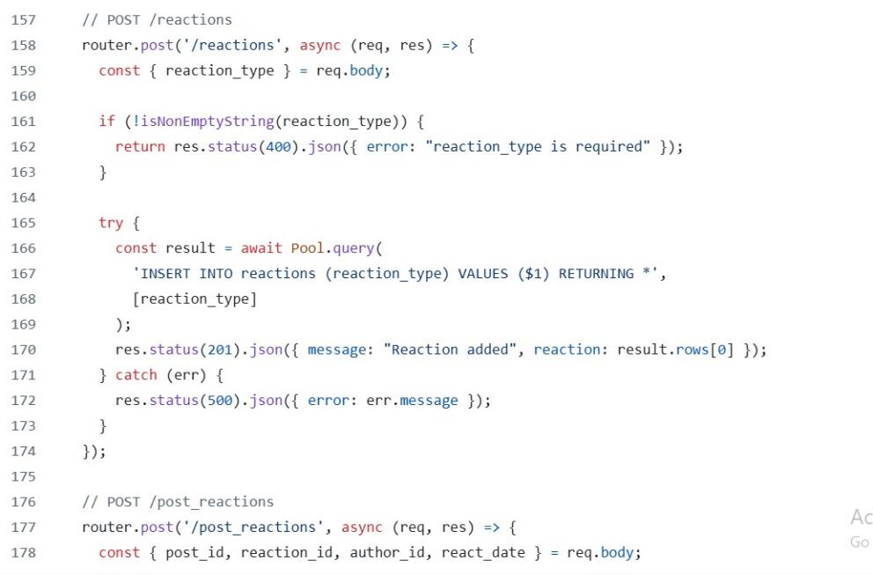

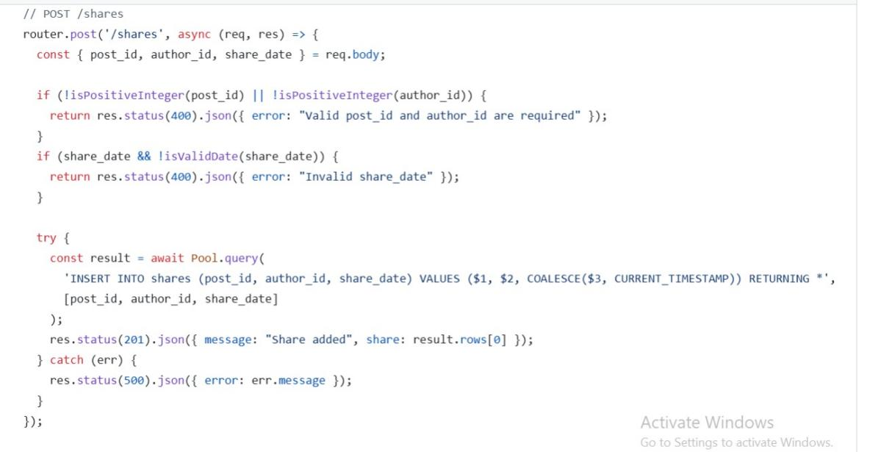

These code snippets includes data view tables data .

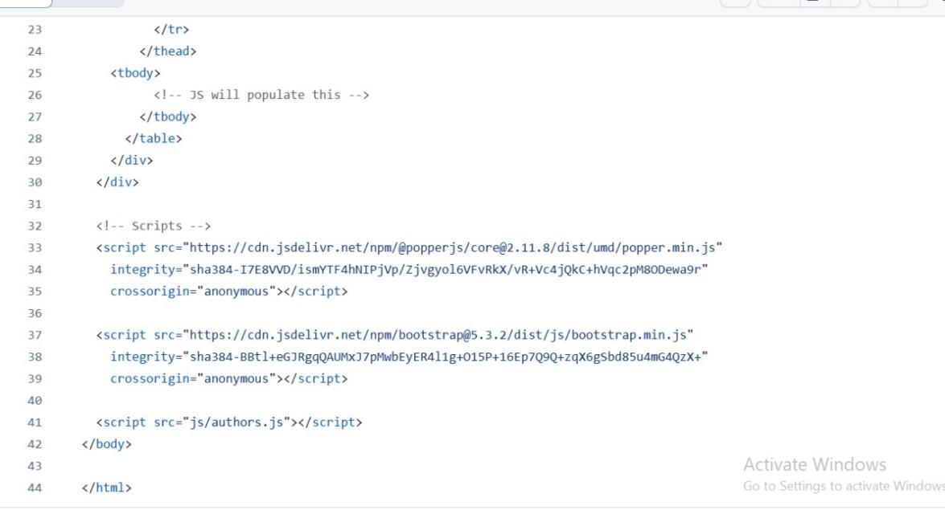

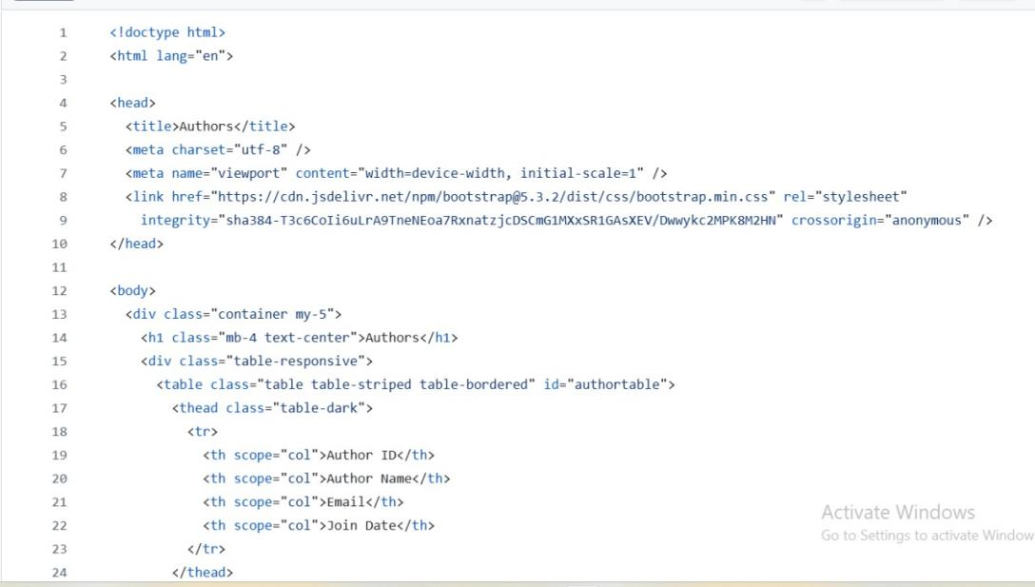

These code snipptets include author table data.

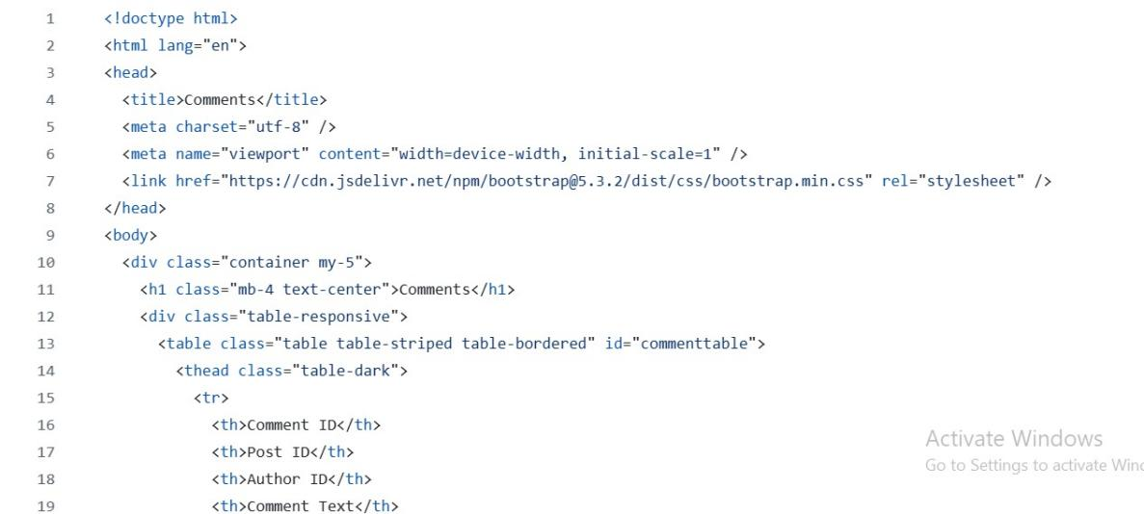

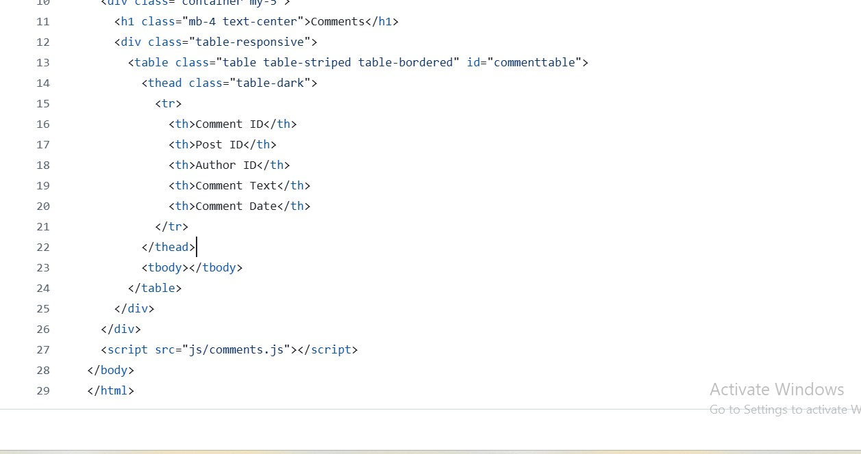

These code snippets include comments table data

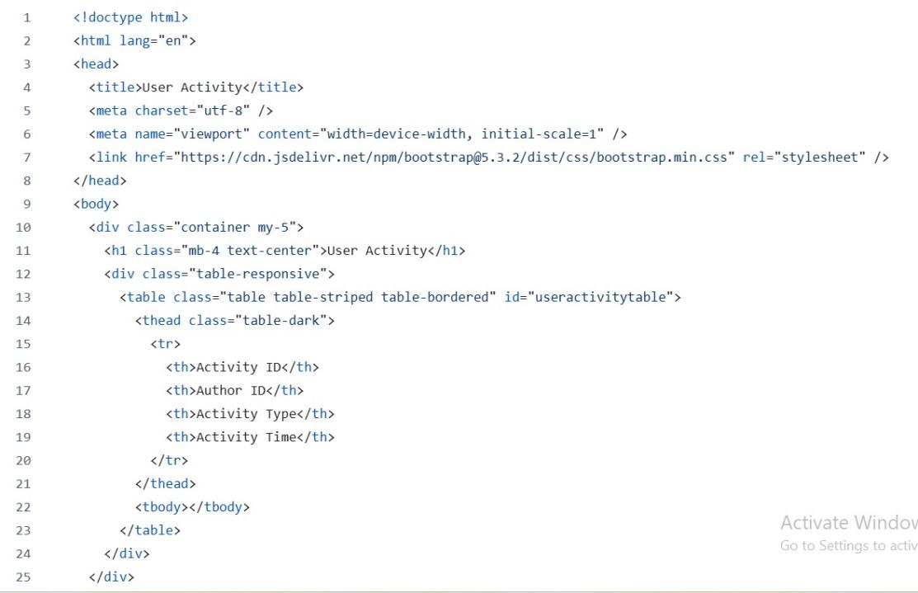

This snippet include user Activity table data.

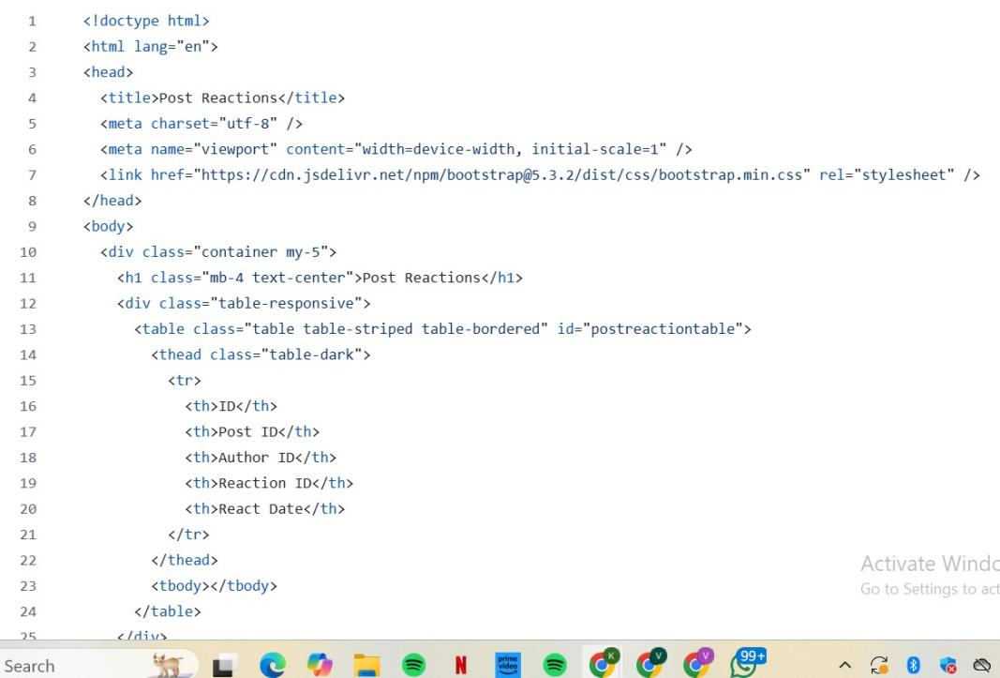

This snippet include post reactions data

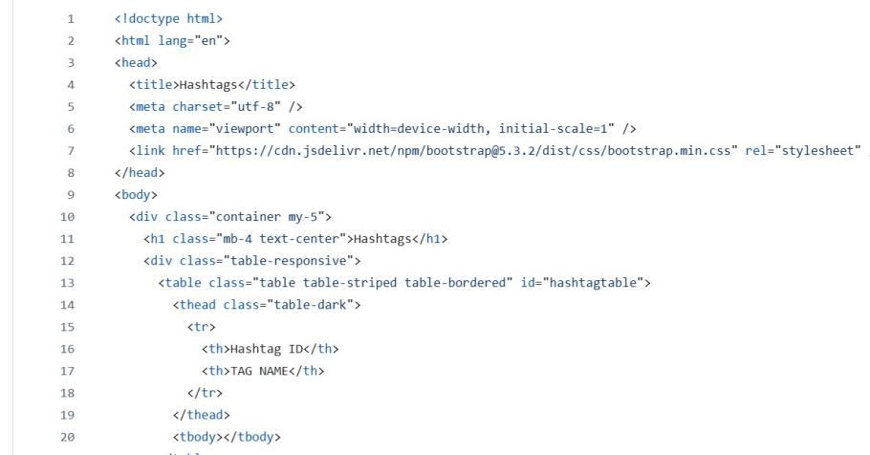

This snipet include hashtag data

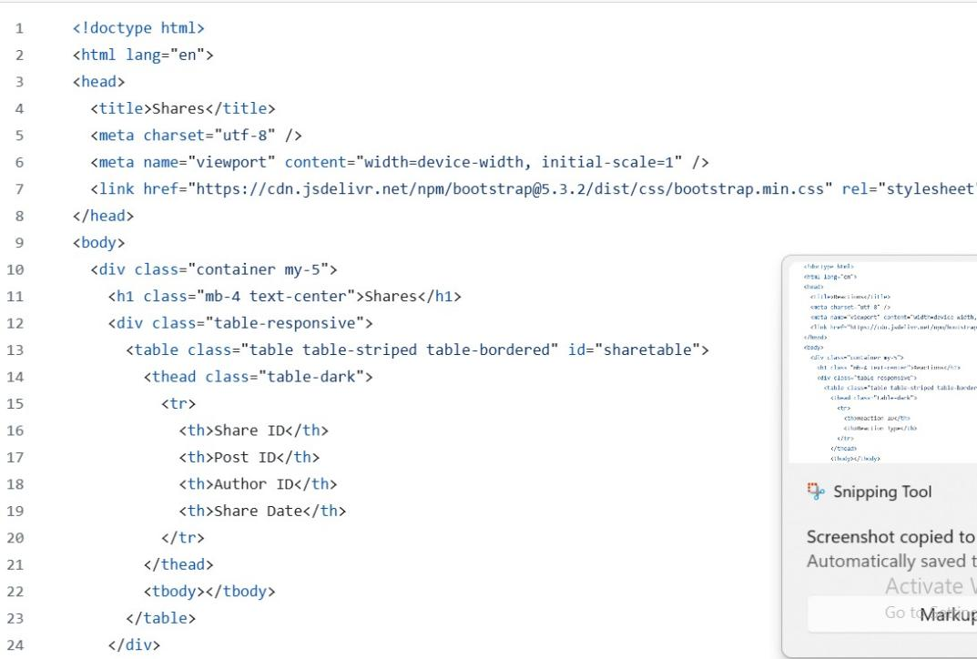

This snippet includes shares table data.

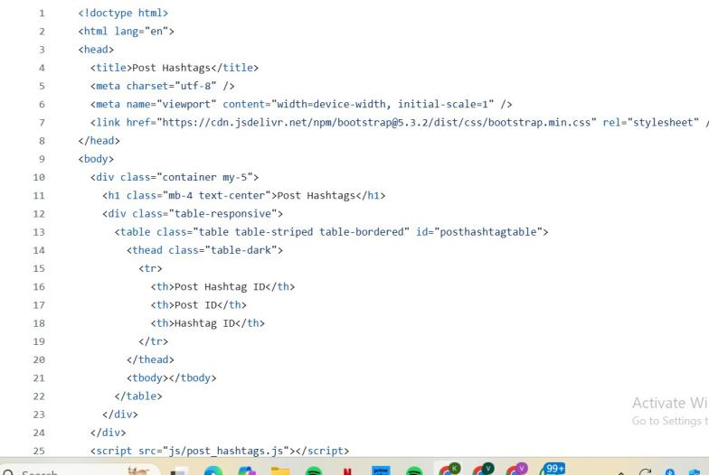

This snippet includes post hashtags

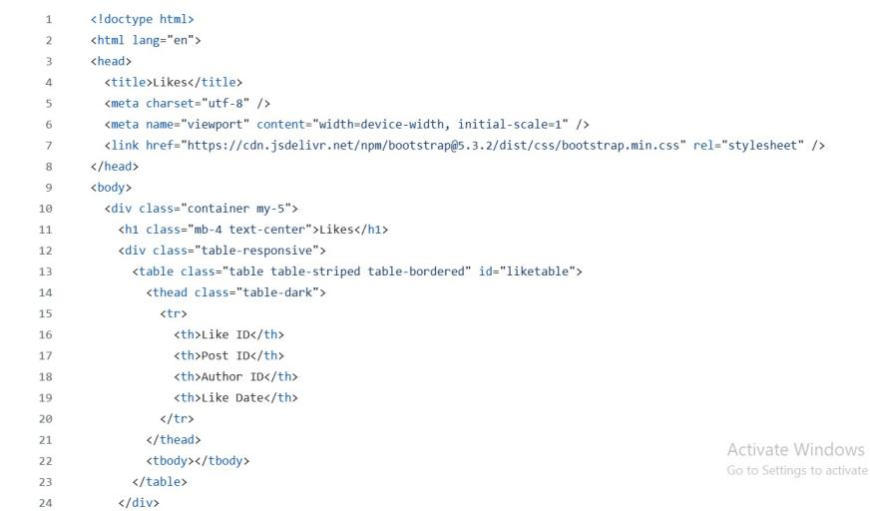

This snippet includes likes table data.

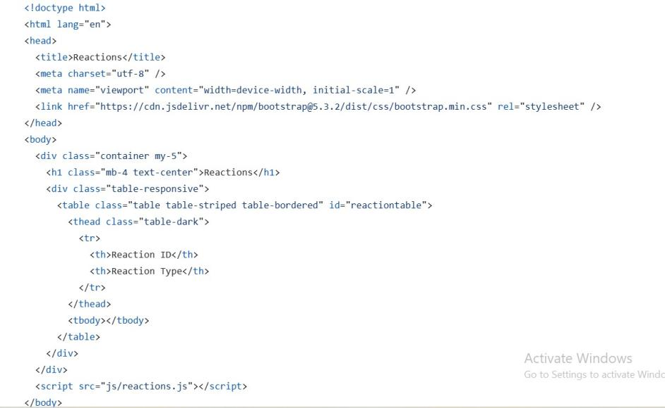

This snippet includes reactions table data.



This includes comments table data.

**Conclusion:**

The Social Media and Post Analyzer project effectively captures and analyzes key engagement metrics such as posts, likes, comments, reactions, and shares. By processing this data, the system provides valuable insights into user interaction, content performance, and audience preferences. This analysis helps users and organizations make informed decisions to improve their social media strategies and enhance overall engagements.

THANK YOU