HealthScope: An Intelligent Public Health Analytics and Risk Assessment Platform
Harshini S. R.  Department of Computer Science  and Engineering  Koneru Lakshmaiah Education Foundation  Hyderabad, India  2420030113 | Varsha  Department of Computer Science  and Engineering  Koneru Lakshmaiah Education Foundation  Hyderabad, India  2420030331 | Dr. N. Sunanda  Project Guide  Department of Computer Science  and Engineering  Koneru Lakshmaiah Education Foundation  Hyderabad, India
Project Guide: Dr. N. Sunanda

Abstract—HealthScope is proposed as an integrated public health analytics and risk-assessment platform that transforms structured health datasets into interpretable population-level insights. The workflow combines data collection, preprocessing, exploratory data analysis, statistical and correlation analysis, machine-learning-based assessment where supported by the dataset, and interactive visualization. The platform is intended to help users examine health trends, compare demographic or geographic groups, and explore associations among health indicators through a unified dashboard. Unlike a paper that proposes a single prediction algorithm, this project emphasizes integration of the analytical workflow and clear presentation of outputs. The final model, target variable, and dataset will be selected according to data availability and the research question. Since implementation and quantitative evaluation results have not been provided for this draft, no accuracy or performance claims are made. Preliminary exploratory outputs from a working dataset are included to illustrate the analyses the platform produces and the interpretive cautions that accompany them.
Keywords—HealthScope, public health analytics, population health, data preprocessing, exploratory data analysis, machine learning, risk assessment, data visualization.

I. INTRODUCTION
The growing availability of digital health and population datasets creates opportunities to study health trends, compare population groups, and support preventive planning. However, the information contained in raw datasets is not always easy for non-technical users to interpret. Data may require cleaning, statistical examination, and visualization before useful patterns can be identified. Predictive models can provide an additional analytical perspective when the data contain an appropriate target variable and sufficient observations.
Population-health questions rarely involve a single variable. Life expectancy, disease prevalence, vaccination coverage, air quality, access to clean water, and economic conditions are measured by different agencies, at different resolutions, and are shaped by overlapping social, environmental, and behavioral factors. Analysts who wish to study these indicators together must therefore move between several tools: spreadsheets for inspection, scripts for cleaning, statistical packages for hypothesis testing, notebooks for modeling, and separate business-intelligence software for presentation. Each hand-off is an opportunity for undocumented decisions, version drift, and results that a colleague or reviewer cannot reproduce.
This fragmentation is particularly consequential for students, early-career researchers, and small public-health teams that may lack the engineering support needed to build a reproducible pipeline. The problem addressed in this work is therefore not the invention of a new prediction algorithm but the design of a coherent, documented workflow that carries structured health data from acquisition to interpretable presentation, while making the assumptions, limitations, and uncertainty of each step visible to the end user.
HealthScope is proposed as an end-to-end public health analytics platform that brings together data preparation, exploratory analysis, statistical investigation, machine-learning-based assessment, and dashboard presentation. Its intended users may include students, researchers, and public-health stakeholders exploring population-level data. The system is designed to communicate observed patterns and model outputs clearly, while distinguishing association from causation and population-level estimates from individual medical advice.
The primary objectives are to: (1) collect and prepare suitable public health datasets; (2) summarize distributions and trends; (3) examine relationships among health indicators; (4) develop and evaluate an appropriate analytical or machine-learning model when the selected data support one; and (5) present the resulting insights through an interactive dashboard.
The contributions of this paper are fourfold. First, it specifies a staged analytical pipeline and a layered system architecture for HealthScope. Second, it sets out design principles intended to prevent common misinterpretations, such as treating correlation as causation or treating population-level estimates as individual predictions. Third, it presents preliminary exploratory outputs from a working dataset to illustrate the analyses the platform produces and the cautions that accompany them. Fourth, it defines an evaluation plan that separates data-processing correctness, model validity, and dashboard usability.
The remainder of the paper is organized as follows. Section II reviews related work and identifies the research gap. Section III describes the proposed methodology. Section IV presents the system workflow and implementation stack. Section V reports preliminary exploratory outputs. Section VI sets out expected outcomes and evaluation criteria. Section VII discusses limitations and responsible-use considerations, and Sections VIII and IX conclude the paper and outline future work.

II. LITERATURE REVIEW
Morgenstern et al. reviewed the use of machine learning for population-health prediction and examined data sources, outcomes, model development, and reporting practices. Their scoping review included 231 studies and highlighted that important aspects of model development and validation were not consistently reported [1]. This motivates explicit documentation of preprocessing, feature selection, validation, and evaluation in HealthScope. Related work has also evaluated machine-learning models for disease-specific risk prediction [5].
Public-health data platforms also demonstrate the value of accessible population-level information. The U.S. Centers for Disease Control and Prevention's PLACES program provides local health estimates and tools for exploring health indicators across geographic areas [2]. Its methodology includes small-area estimation approaches, including multilevel regression and poststratification [3]. These resources show that geographic comparisons and interactive health-data exploration already exist; therefore, HealthScope does not claim to be the first platform to offer them. The PLACES program has also been described in the public-health literature as a resource for local-level health planning [6].
HealthScope differs in its proposed project scope: it aims to bring data cleaning, EDA, correlation analysis, optional model development and evaluation, and visualization into one student-developed workflow. Its contribution should be assessed through the actual implementation, the quality of its selected dataset, model validation where applicable, and the usability and correctness of its dashboard.

A. Reporting, Reproducibility, and Interpretability
A recurring theme in the prediction literature is that technical performance alone is not sufficient; models must also be reported in a way that allows readers to judge their validity. The TRIPOD statement set out a checklist for the transparent reporting of multivariable prediction models, covering the source of data, participants, predictors, outcome definition, handling of missing data, model building, validation, and presentation of results [16]. Although HealthScope is not restricted to clinical prediction, these items map naturally onto the documentation that its workflow should generate automatically, such as a record of the dataset, variables, transformations, and validation design.
Reproducibility also depends on how data are described and shared. The FAIR guiding principles state that data should be findable, accessible, interoperable, and reusable, and they emphasize rich metadata and clear usage licenses [17]. For a dashboard that draws on public datasets, this implies keeping a machine-readable description of each source, including its provenance, version, definitions, and licensing terms, and exposing that description to users instead of hiding it behind the interface.
Systematic reviews of disease risk prediction have also examined how machine-learning techniques have been integrated into statistical methods [4]. This supports HealthScope's decision to treat conventional statistical analysis and machine-learning models as complementary components of one workflow, not as competing alternatives. Reviews of machine learning applied to real-world data for disease prediction and management [13], and guidelines for the development, testing, and implementation of machine-learning applications in population and public health [14], are directly relevant to the validation and documentation plan described in Section III.

B. Open-Source Analytical Software
HealthScope is intended to be built on widely used open-source scientific software, which lowers cost and improves transparency. The Python scientific ecosystem provides array computing through NumPy [18], numerical and statistical routines through SciPy [19], tabular data structures and manipulation through pandas [20], plotting through Matplotlib [21], and consistent interfaces for machine-learning models, preprocessing, and validation through scikit-learn [22]. Because these libraries are documented and widely examined, analyses built on them can be inspected and re-run by others, which supports the reproducibility goals described above.
Among learning algorithms, random forests are attractive for tabular indicator data because they combine many decision trees trained on resampled data and random subsets of predictors, which reduces variance relative to a single tree and provides a built-in measure of variable importance [23]. As discussed below, such importance measures must be interpreted carefully.

C. Statistical Pitfalls in Population-Level Analysis
Three pitfalls are especially relevant to aggregated health indicators. The first is collinearity: when predictors are strongly correlated, coefficient estimates and importance rankings can become unstable, and it becomes difficult to separate the contribution of one indicator from another [24]. The second concerns variable-importance measures in random forests, which can be misleading when predictors are correlated with one another [25]. The third is the ecological fallacy: associations observed between group-level averages do not necessarily describe relationships among individuals within those groups [26]. HealthScope's design responds to each pitfall by reporting correlation structure alongside any model, by recommending importance estimates that are checked on held-out data, and by labeling all outputs as population-level.

D. Surveillance, Fairness, and Responsible Use
Beyond prediction, public-health practice increasingly draws on novel data sources and analytic methods. An overview of innovations in public health surveillance describes how new data and analytic approaches are being applied to support surveillance [10], and a review of internet-based surveillance systems has examined their use for predicting infectious diseases [15]. These developments increase the volume and variety of data available to analysts, which strengthens the case for tools that help users inspect and interpret such data in a structured, documented way.
Fairness is a second concern. A scoping review of fair machine-learning techniques for real-world data [11] and a survey of methods for addressing AI fairness and bias in biomedicine [12] describe approaches to identifying and reducing bias across population groups. Although the initial scope of HealthScope is descriptive and population-level, these works motivate the fairness assessment listed under future work and the cautious labeling of group-level results discussed in Section VII.

E. Research Gap
The literature does not support a broad claim that existing public-health systems lack analytics or visualization. A narrower project opportunity is to implement and document a reproducible workflow in which data preparation, exploratory and statistical analysis, appropriately validated model outputs, and interactive presentation are connected. HealthScope will address this opportunity by integrating these stages and making the analytical process and limitations visible to users. The practical value of this integration must be assessed after implementation.

III. PROPOSED METHODOLOGY
The proposed methodology follows a staged pipeline from raw health data to an interactive dashboard. The stages are data collection, preprocessing, exploratory data analysis, statistical and correlation analysis, feature and target definition, model development and evaluation where appropriate, and visualization.
Four design principles guide the pipeline. Modularity: each stage has defined inputs and outputs so that it can be tested or replaced independently. Transparency: every transformation, assumption, and parameter is recorded and visible to the user. Separation of evidence types: observed values, derived statistics, and model-generated estimates are labeled differently in every output. Restraint: when the data do not support a claim, such as an individual-level prediction or a causal conclusion, the platform presents descriptive output instead of over-reaching.

A. Data Collection
Publicly available health datasets will be selected from documented and reliable sources. Selection criteria will include relevance to the research question, variable definitions, data quality, time period, geographic coverage, and permission for reuse. Potential variables may include demographic attributes, lifestyle indicators, environmental measures, geographic identifiers, and health outcomes, depending on the chosen dataset. If multiple datasets are combined, their units, time periods, identifiers, and definitions will be checked for compatibility. The final paper should name the exact dataset and version used. The WHO Global Health Observatory is one potential source for documented international health indicators, subject to dataset suitability and availability [9].
Each accepted dataset will be accompanied by a data dictionary listing every variable, its unit, definition, source, and permitted range, following the metadata emphasis of the FAIR principles [17]. Where indicators are published at different spatial or temporal resolutions, a common unit of analysis, such as region-year, will be defined, and any aggregation or interpolation required to reach it will be documented. Licensing terms will be recorded so that redistribution of derived tables and charts remains consistent with the conditions of the source.

B. Data Preprocessing
The collected data will be inspected for missing values, duplicates, inconsistent formats, invalid entries, and data-type problems. Suitable cleaning operations will be applied and documented. Categorical encoding and numerical scaling will be used only where required by the chosen analysis or algorithm. Missing-value handling will be selected according to the data characteristics rather than applied uniformly. Any transformation that learns parameters from data will be fitted on training data only when predictive modeling is performed, reducing the risk of data leakage.
Missing values will first be characterized by their extent and pattern, for example by variable, region, and year, before any treatment is chosen. Depending on the pattern, options include removing records or variables with excessive missingness, imputing numerical values using the median or a group-specific statistic, or carrying out a sensitivity analysis that compares results under alternative treatments. Outliers will be identified with simple rules such as the interquartile-range criterion and checked against domain knowledge; values that are implausible, such as percentages outside the range of 0 to 100, will be flagged as errors, whereas extreme but plausible values will be retained and noted. Standardization will be applied for distance-based or linear methods but is unnecessary for tree-based models. To ensure that these steps are applied identically to training and test data, preprocessing and model fitting will be wrapped in a single pipeline object, as supported by scikit-learn [22].

C. Exploratory Data Analysis
Descriptive statistics and visualizations will be used to understand the dataset's structure and distributions. Depending on the variables, analysis may include counts, proportions, summary statistics, histograms, bar charts, box plots, line charts, and geographic comparisons. EDA will help identify unusual values, data-quality concerns, temporal patterns, and differences between available population groups. Observations from this stage will guide later analysis, but will not by themselves establish causation.
The exploratory stage follows Tukey's emphasis on looking at the data before formal modeling [27]. It proceeds from univariate summaries, such as the distribution of each indicator, to bivariate views, such as scatter plots and correlation matrices, and then to grouped and temporal views, such as regional trend lines. A data-quality summary reporting the share of missing values, the number of duplicates removed, and the number of values corrected or flagged will be produced automatically and displayed alongside the charts, so that users can judge how much confidence to place in them.

D. Statistical and Correlation Analysis
Relationships between selected health indicators will be examined using statistical methods appropriate to the variable types and data distributions. Pearson correlation may be used for suitable continuous variables with approximately linear relationships, while Spearman correlation may be considered for ranked data or monotonic relationships. Results will be interpreted as associations, with attention to confounding factors, sample size, missingness, and other dataset limitations. Statistical significance, if tested, will be reported alongside effect size and context rather than treated as proof of practical importance.
For two continuous indicators x and y observed on n units, the Pearson correlation coefficient is the sample covariance of the two indicators divided by the product of their sample standard deviations:
r = cov(x, y) / (s_{x} s_{y}) (1)
where cov(x, y) is the sample covariance and s_{x} and s_{y} are the sample standard deviations. The coefficient ranges from −1 to +1 and measures the strength of linear association only; it is sensitive to outliers and says nothing about the direction of causation. When several indicators are strongly intercorrelated, the platform will report the full correlation matrix and variance inflation factors so that users can see where collinearity may compromise interpretation [24]. When many pairwise tests are performed, the risk of spurious findings increases, so adjusted p-values or an explicit statement that comparisons are exploratory will accompany the results. Finally, because the units of analysis are aggregates, findings will be reported at the aggregate level to avoid the ecological fallacy [26].

E. Feature and Target Definition
Before supervised machine learning is undertaken, the research question and target variable must be explicitly defined. Feature selection will consider domain relevance, data quality, redundancy, and the risk of information leakage. If the dataset contains only aggregated regional statistics, the analysis will remain at that population level; it will not be presented as an individual-level medical prediction. If no defensible target label exists, HealthScope may focus on descriptive analytics and association analysis instead of supervised prediction.
Two types of target are anticipated. A continuous target, such as life expectancy, supports regression. A categorical target, such as a low, moderate, or high risk group for a prevalence indicator, supports classification. When risk groups are created by splitting the distribution of an indicator into equal-sized bins, they describe relative standing within the dataset and not clinical risk, and the dashboard must label them accordingly. Predictors that are mathematically or conceptually derived from the target will be excluded to avoid leakage; for instance, a risk category defined from diabetes prevalence cannot use diabetes prevalence as a predictor.

F. Machine-Learning-Based Assessment
Where the selected dataset supports a predictive task, candidate models will be chosen according to the target and data characteristics. For classification, candidate baselines may include Logistic Regression, Decision Tree, and Random Forest; for continuous targets, regression methods may be more suitable. The data will be split into training and testing subsets, or evaluated with an appropriate cross-validation design. Model selection and tuning will use training data only, and the held-out test set will be reserved for final evaluation. General reviews of machine learning in medicine emphasize the importance of matching methods to the clinical or public-health task and evaluating their limitations [7], [8].
Random forests [23] are proposed as a primary non-linear model for tabular indicators because they handle mixed relationships with limited tuning, and they will be compared with simpler baselines. For a regression target the baselines include a predictor that always returns the training-set mean and a linear regression model; for classification they include a majority-class predictor and logistic regression. Reported improvement is meaningful only relative to such baselines. Hyperparameters such as the number of trees, the maximum depth, and the minimum samples per leaf will be tuned by cross-validation within the training data.
Because indicator data are often repeated observations of the same regions over several years, a random split of rows can place near-duplicate observations in both the training and test sets, producing optimistic estimates. HealthScope will therefore prefer grouped cross-validation, in which all observations from one region are held out together, and time-aware splits, in which later years are used for testing, whenever the research question concerns generalization to new regions or future periods.
Classification metrics may include precision, recall, F1-score, a confusion matrix, and ROC-AUC when appropriate. Regression metrics may include mean absolute error, root mean squared error, and the coefficient of determination. For a risk-estimation task, calibration and the meaning of the predicted output should also be considered. Metrics will be chosen to fit the task; no numerical performance is reported in this proposal because completed experimental results were not supplied.
For regression, the principal metrics are the mean absolute error, the root mean squared error, and the coefficient of determination:
MAE = (1/n) Σ |y_{i} − ŷ_{i}| (2)
RMSE = √[(1/n) Σ (y_{i} − ŷ_{i})²] (3)
R² = 1 − Σ (y_{i} − ŷ_{i})² / Σ (y_{i} − ȳ)² (4)
where y_{i} is the observed value, ŷ_{i} the prediction, ȳ the mean of the observations, and n the number of test observations. For classification, precision P and recall R are combined in the F1-score:
F₁ = 2PR / (P + R) (5)
Metrics are always reported together with the validation design that produced them. For risk-estimation tasks, calibration plots will be used to check whether predicted probabilities correspond to observed frequencies.

G. Interactive Dashboard
The dashboard will combine descriptive summaries, charts, group comparisons, associations, and model outputs where available. Streamlit is a suitable candidate for implementing the interface, while Pandas, NumPy, Plotly or Matplotlib, and Scikit-learn can support data handling, visualization, and modeling. These are proposed tools and may be updated to match the actual implementation. Filters and labels will make it clear which values are observed data and which are model-generated estimates.
The interface will be organized into a small number of pages: an overview page with headline indicators and data-quality notes; a trends page for time-series comparison; an associations page showing correlation matrices and scatter plots; a risk-groups page for category-based comparisons; and a model page presenting the model definition, validation design, and feature importance. Global filters for region, year range, and indicator will apply consistently across pages. Each chart will carry a short plain-language caption, a statement of the data source, and a marker distinguishing observed from modeled values. Colour palettes will be chosen to remain distinguishable for users with common forms of colour-vision deficiency, and the tables underlying each chart will be downloadable so that results can be checked independently.

H. System Evaluation
Evaluation will cover data-processing correctness, model performance where a model is implemented, and dashboard functionality. Tests will check whether the application loads the intended dataset, applies the documented transformations, displays consistent summaries, responds correctly to filters, and communicates model outputs without misleading interpretation. If feasible, model results will be compared with a simple baseline. The final report should state the dataset size, target variable, experimental setup, model parameters, validation strategy, and measured results.
Evaluation proceeds at three levels. At the data level, automated checks will compare row counts, value ranges, and summary statistics before and after each transformation. At the model level, results will be compared with baselines under the validation design described above, and stability will be examined by repeating the procedure with different random seeds. At the interface level, functional tests will confirm that filters, charts, and exports behave as specified, and a short task-based usability session with a small group of target users will be used to identify confusing labels or misleading displays.

IV. SYSTEM WORKFLOW AND IMPLEMENTATION
The proposed workflow is: Public Health Data Sources → Data Collection → Data Preprocessing → Exploratory Data Analysis → Statistical and Correlation Analysis → Feature/Target Definition → Model Development and Evaluation (if appropriate) → Interactive Dashboard → Population-Level Insights. This workflow links data engineering and analysis with a user-facing presentation layer.
A possible implementation stack includes Python for programming; Pandas and NumPy for data manipulation; SciPy or Statsmodels for statistical analysis; Scikit-learn for conventional machine-learning models; and Streamlit with Plotly or Matplotlib for dashboard development. The final paper must retain only the tools actually used. Dataset provenance, preprocessing decisions, and software versions should be recorded to improve reproducibility.

A. Layered Architecture
HealthScope is organized into three layers, shown in Fig. 1. The data layer is responsible for acquiring source files, recording provenance, and performing cleaning and validation; its output is a versioned, documented, analysis-ready table together with a data-quality report. The analytics layer consumes that table and produces exploratory summaries, statistical results, and, where appropriate, trained models with their validation results. The presentation layer reads only the outputs of the analytics layer and renders them as interactive charts and tables. Keeping the layers separate means that a change to a model does not require changes to data acquisition, and that the dashboard never recomputes quantities in ways that could disagree with the documented analysis.
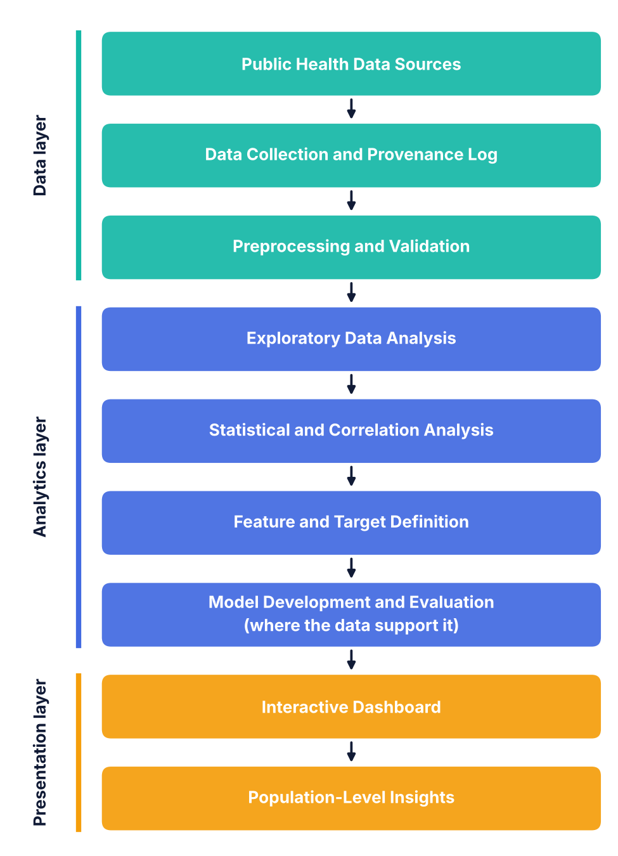
Fig. 1. Layered workflow of the proposed HealthScope pipeline.

B. Implementation Stack
Table I summarizes the proposed implementation stack. These are candidate tools, and the final paper should retain only those actually used.
TABLE I
Proposed implementation stack
Layer | Tool | Role
Data handling | pandas [20], NumPy [18] | Loading, cleaning, reshaping, and array computation
Statistics | SciPy [19], Statsmodels | Correlation, hypothesis tests, and diagnostics
Modeling | scikit-learn [22] | Pipelines, models, cross-validation, and metrics
Visualization | Matplotlib [21], Plotly | Static and interactive charts
Interface | Streamlit | Dashboard pages, filters, and downloads

C. Reproducibility and Version Control
To make analyses repeatable, all parameters will be stored in a configuration file instead of being hard-coded, random seeds will be fixed and logged, and software versions will be pinned in an environment specification. Source code will be kept under version control, and each exported figure or table will carry the identifiers of the dataset version and code revision that produced it. Intermediate tables will be saved in open formats so that individual stages can be re-run independently. These practices are intended to allow an independent reader to regenerate every reported result from the raw inputs.

V. PRELIMINARY EXPLORATORY ANALYSIS
This section presents exploratory outputs produced from a working dataset of regional health and socioeconomic indicators. Their purpose is to illustrate the analyses that HealthScope generates and to show how the cautions described in Section III apply in practice. The outputs are descriptive; no predictive accuracy has been evaluated, and the observations below should not be read as validated findings or causal claims.

A. Dataset and Indicators
The working dataset describes six world regions (East Asia, Europe, Latin America, North America, South Asia, and Sub-Saharan Africa) over the years 2015 to 2023. It contains seven indicators, listed in Table II. The risk-stratification output in Fig. 5 is based on 648 observations. Before a final study is reported, the exact source, version, and license of the dataset must be documented as described in Section III-A.
TABLE II
Indicators in the working dataset
Indicator | Description | Unit
gdp_per_capita_usd | Gross domestic product per person | USD
pm25_ug_m3 | Fine particulate matter (PM2.5) concentration | µg/m³
clean_water_access_pct | Population with access to clean water | %
vaccination_coverage_pct | Vaccination coverage | %
mean_bmi | Mean body-mass index | kg/m²
diabetes_prevalence_pct | Diabetes prevalence | %
life_expectancy_years | Life expectancy | years

B. Regional Life Expectancy Trends
Fig. 2 shows mean life expectancy by region from 2015 to 2023. Two clusters are visible. North America and Europe remain between roughly 78.5 and 80.5 years throughout the period and converge near 78.7 years in 2022. East Asia lies in between at about 76 to 77 years. Latin America rises gradually from about 71.5 to about 72.8 years, while South Asia and Sub-Saharan Africa begin at about 66.4 years and end at roughly 68.7 and 67.2 years, respectively. The gap between the highest and lowest regional means ranges from about 10.5 years, in 2022, to about 13 years, in several earlier years.
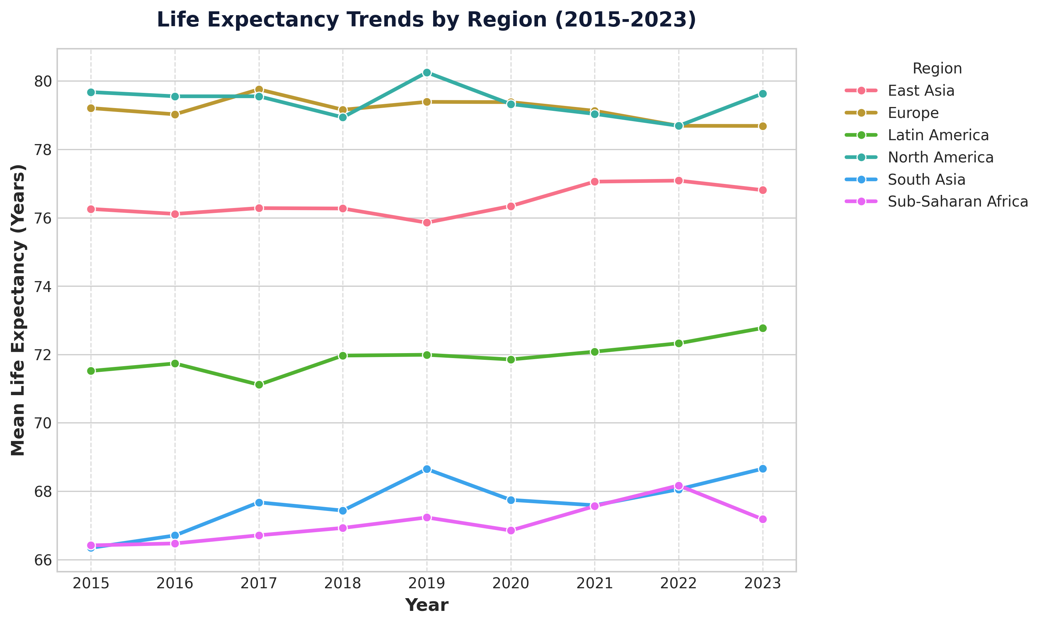
Fig. 2. Mean life expectancy by region, 2015–2023.
Several regions show year-to-year movements, including a drop for South Asia between 2019 and 2020 and a fall for Sub-Saharan Africa after 2022. The figure alone cannot explain these movements, and any attribution to specific events would require supporting documentation. HealthScope therefore presents trends descriptively and leaves attribution to the analyst.

C. Correlation Structure
Fig. 3 displays the Pearson correlation matrix. All indicators except PM2.5 are positively correlated with one another, and PM2.5 is negatively correlated with all of them. Life expectancy is most strongly associated with PM2.5 (r = −0.96) and clean-water access (r = 0.93), followed by GDP per capita and vaccination coverage (both r = 0.86), mean BMI (r = 0.82), and diabetes prevalence (r = 0.76). The strongest pair overall is mean BMI and diabetes prevalence (r = 0.97), and 18 of the 21 indicator pairs exceed 0.85 in magnitude.
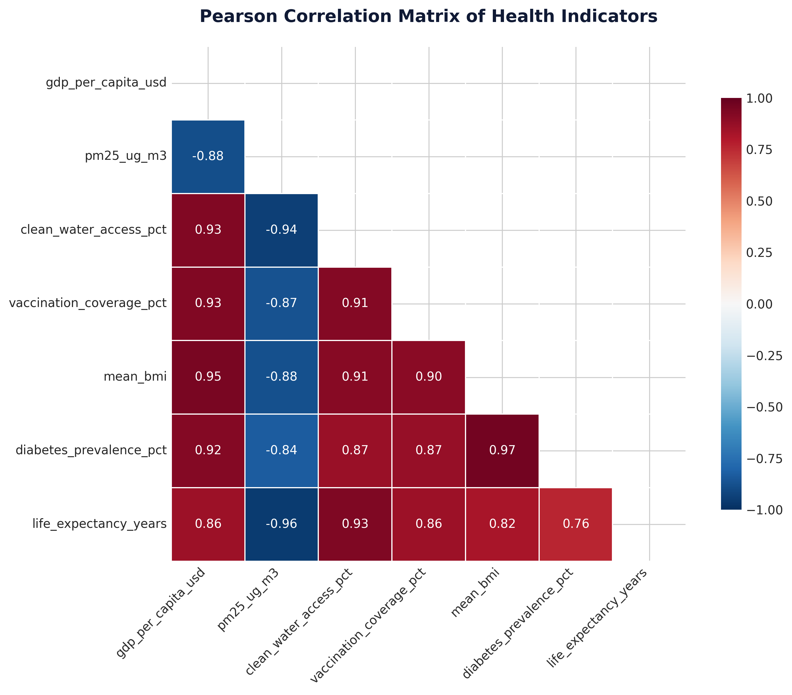
Fig. 3. Pearson correlation matrix of health indicators.
These values illustrate why correlations must be interpreted with care. The positive correlations of mean BMI and diabetes prevalence with life expectancy should not be read as evidence that higher BMI or diabetes prolongs life. A plausible reading, which the data alone cannot confirm, is that all of these indicators vary with the overall level of economic and health-system development across regions, so that the correlations reflect shared underlying drivers and the aggregation of data at regional level [26]. Correlations this high also signal strong collinearity, which complicates the interpretation of any model that uses these indicators together [24].

D. Feature Importance
Fig. 4 shows relative importance scores from a Random Forest fitted to predict life expectancy from five of the indicators. PM2.5 accounts for about 0.63 of the total importance, followed by GDP per capita (about 0.19) and clean-water access (about 0.16), whereas mean BMI and vaccination coverage each contribute less than 0.02.
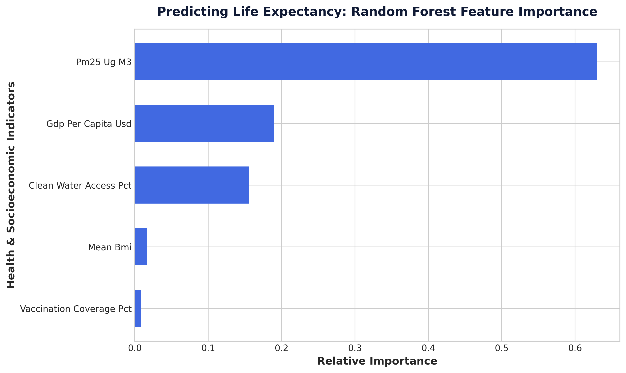
Fig. 4. Random Forest feature importance for predicting life expectancy.
These scores describe how much each indicator contributed to the model's splits on this dataset; they are not effect sizes and do not indicate causal influence. Vaccination coverage correlates strongly with life expectancy (r = 0.86) yet receives the lowest importance, which is consistent with redundancy: once PM2.5, GDP, and water access are available, vaccination coverage may add little further information. Importance scores can be misleading when predictors are correlated [25], and the ranking could change under a different random seed or data split. HealthScope will therefore accompany importance charts with held-out permutation importance, repeated runs, and a link to the correlation matrix, and will not present importance as evidence of a causal mechanism. The figure reports no predictive accuracy; model performance remains to be evaluated under the validation design in Section III-F.

E. Risk Stratification
Fig. 5 shows the number of observations assigned to low, moderate, and high risk groups for diabetes prevalence. Each group contains exactly 216 of the 648 observations. Equal counts are what an equal-frequency (tertile) split would produce, which suggests that the categories express relative standing within this dataset and not clinical thresholds. This is an acceptable way to compare regions or periods, but the dashboard must label such groups as relative and avoid terms that imply clinical risk. If absolute cut-offs from a clinical or public-health guideline are adopted instead, their source must be cited and the group sizes will no longer be equal.
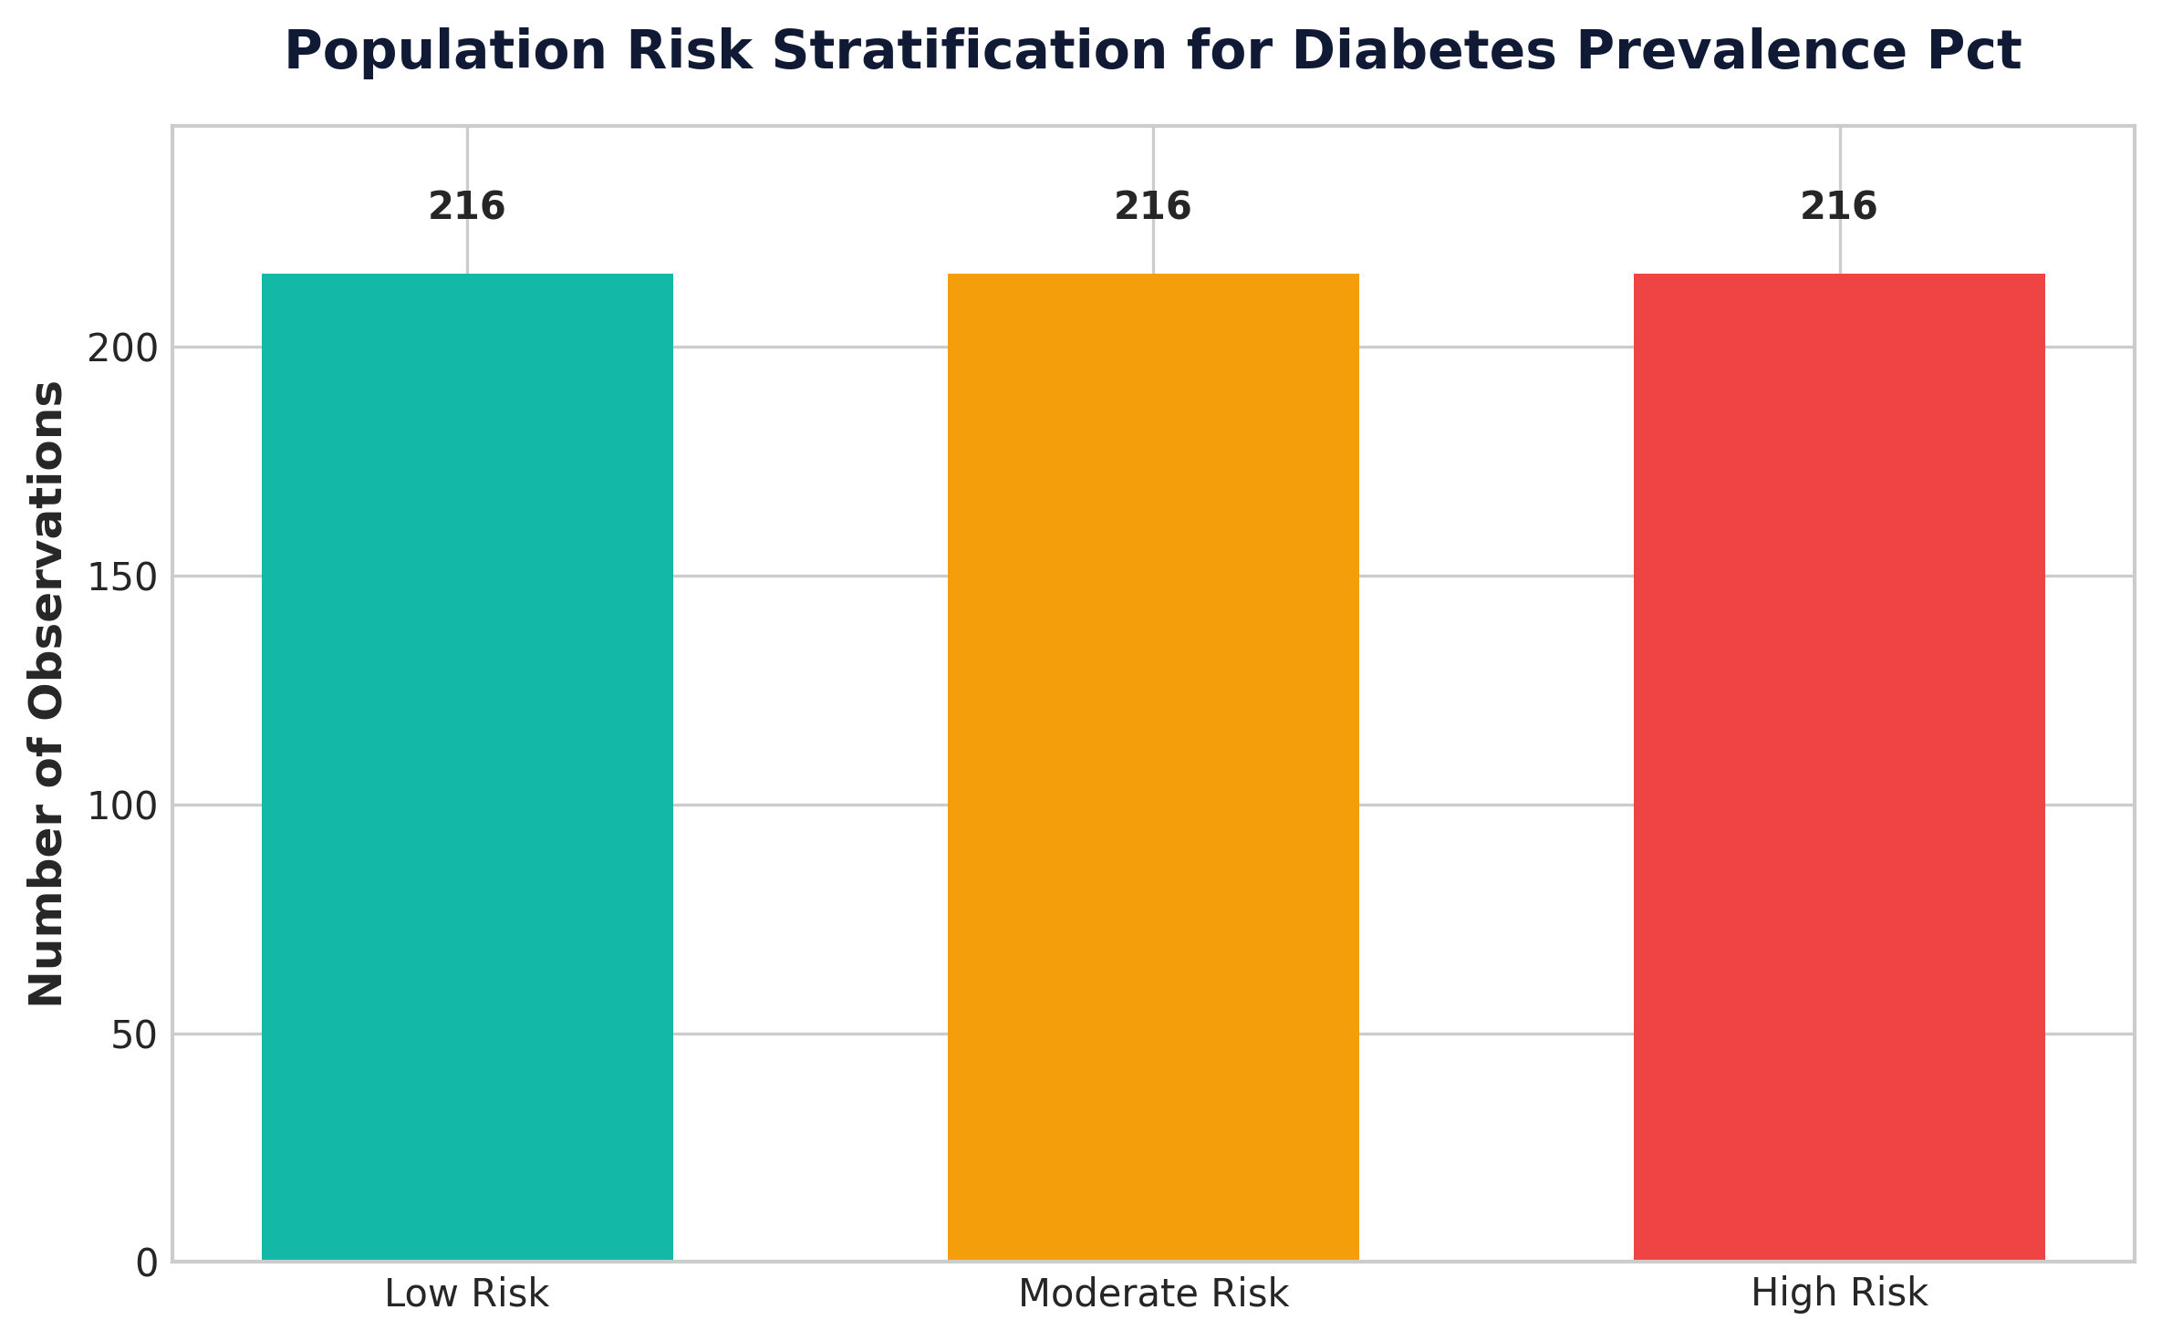
Fig. 5. Population risk stratification for diabetes prevalence.

F. Implications for Platform Design
Taken together, the exploratory outputs lead to four design requirements. First, the interface should place a correlation matrix next to any model-based chart so that users can see collinearity. Second, importance scores should be accompanied by an explicit caution and by a stability check. Third, derived groups should state how they were constructed. Fourth, trend charts should provide access to the underlying values and data-quality notes so that unusual movements can be checked.

VI. EXPECTED OUTCOMES AND EVALUATION
The expected deliverables are a cleaned and documented dataset, exploratory visualizations, statistical summaries and association analyses, an evaluated model if the dataset supports prediction, and an interactive dashboard. The dashboard is intended to help users inspect health patterns and compare available population groups in a single interface.
These statements describe intended outcomes, not measured results. The exploratory outputs in Section V are descriptive. No predictive accuracy values, user-study findings, or performance comparisons have been produced for this draft, and such results must be added after implementation. If the system is evaluated, the paper should report the observed results and explain their limitations instead of relying on assumed performance values.

A. Evaluation Criteria
Table III lists the criteria by which the completed system will be judged. Each criterion is paired with a method so that the evaluation can be repeated by others.
TABLE III
Evaluation criteria and methods
Component | Criterion | Method
Data processing | Row counts, ranges, and summaries are consistent before and after each step | Automated validation checks
Statistical analysis | Correlations and tests can be reproduced from raw data | Re-run from versioned configuration
Predictive model | Performance exceeds baselines under grouped or time-aware validation | Cross-validation and held-out test set
Model reporting | Metrics, validation design, and limitations are stated | Checklist based on TRIPOD [16]
Dashboard | Filters, charts, and exports behave as specified | Functional test cases
Usability | Target users complete tasks without misreading outputs | Task-based session with a small group

Success will not be defined by a single score. A model that marginally outperforms a baseline but cannot be explained, or a dashboard that is accurate but easily misread, would not meet the aims of the project. The evaluation therefore treats correctness, validity, and communicability as jointly necessary.

VII. DISCUSSION AND LIMITATIONS
HealthScope's intended strength is the integration of several analytical stages into one workflow. However, the usefulness of the results will depend on dataset quality, representativeness, definitions of health indicators, and the suitability of analytical methods. Public datasets may be aggregated, incomplete, delayed, or geographically uneven. Correlation analysis cannot establish causality, and a model trained on one population or period may not generalize to another.
A further limitation is that the final dataset, prediction target, and algorithms have not yet been specified in the supplied project description. Consequently, the current paper presents a proposed methodology rather than a validated predictive system. Any risk categories must be defined transparently and must not be represented as clinical diagnoses. HealthScope is intended for exploratory and population-level decision support, not as a substitute for professional medical judgment.

A. Interpretation of Preliminary Outputs
The preliminary outputs support the central motivation of the project. An integrated view allows an analyst to move from trend to association to model within one interface and to see where the cautions of each step apply. For example, the strong correlations in Fig. 3 help explain why the importance ranking in Fig. 4 should be treated with caution, a connection that is easy to miss when the analyses are produced in separate tools. At the same time, the outputs underscore that high correlation and apparent importance are not substitutes for validation.

B. Data and Methodological Limitations
The working dataset is aggregated at regional level and covers only nine years, so it cannot support conclusions about individual health or about differences within regions. Regional means can mask large internal variation. Indicators may be measured differently across sources, and reporting delays may mean that the most recent values are provisional. A model trained on these data may not transfer to other regions, periods, or levels of granularity. Finally, the work has not yet been subject to external validation or user testing.

C. Ethical and Responsible-Use Considerations
Although aggregated public data carry lower privacy risk than individual records, ethical issues remain. Group labels such as “high risk” can stigmatize regions or communities if presented without context, and indicators of unequal health outcomes may be misread as inherent properties of the groups concerned. HealthScope will therefore describe risk groups as relative, avoid language that implies blame, show the data source and uncertainty beside each result, and state explicitly that the platform does not provide medical advice or diagnosis. If finer-grained or individual-level data are used in future, privacy protection, ethical approval, and fairness assessment across population subgroups [11], [12] will be required before any model output is displayed.

D. Threats to Validity
Internal validity is threatened by data leakage, repeated measurements, and collinearity, which the validation design and diagnostics are intended to address. External validity is limited by the choice of dataset and period. Construct validity depends on whether each indicator measures the concept it is named for. Conclusion validity depends on the statistical methods used and on avoiding multiple-comparison artifacts. Documenting these threats alongside the results allows readers to weigh the findings appropriately.

VIII. CONCLUSION
HealthScope proposes an integrated platform for public health data preparation, exploratory and statistical analysis, optional machine-learning-based assessment, and interactive visualization. By connecting these stages, the project aims to make population-level health patterns easier to explore and communicate. The project contribution will depend on the quality of the selected data, the transparency of the methodology, appropriate validation of any predictive model, and the correctness and usability of the dashboard. Future work should implement the workflow, evaluate it using a documented dataset, and report measured findings.
The preliminary exploratory outputs presented in this paper illustrate both the potential and the hazards of an integrated approach. The platform can quickly surface regional gaps, strong associations, and candidate model drivers, but the same outputs reveal strong collinearity and aggregation effects that demand cautious interpretation. HealthScope is designed so that these cautions travel with the results.

IX. FUTURE SCOPE
Future extensions may include additional health datasets, time-series analysis, geographic mapping, explainable machine-learning methods, model calibration, fairness assessment across population groups, and automated data refresh where reliable sources permit it. The platform may also include comparisons across time periods and geographic areas. These extensions should be introduced only when the data support them and should be evaluated for reliability, interpretability, and responsible use.
In the near term, the priority is to replace the working dataset with a documented public source, complete the preprocessing and validation procedures described in Section III, and report baseline-referenced model performance. Subsequent work may add explainability methods based on Shapley values to complement permutation importance, forecasting of indicator trends with uncertainty intervals, interactive maps at finer geographic resolution, and fairness assessment across population groups [11], [12]. A controlled usability study with public-health students and practitioners would provide evidence on whether the dashboard improves correct interpretation of results. Finally, deployment as a hosted service with automated data refresh would require attention to data licensing, monitoring for changes in the sources, and clear versioning so that earlier results can still be reproduced.

REFERENCES
[1] J. D. Morgenstern, E. Buajitti, M. O’Neill, T. Piggott, V. Goel, D. Fridman, K. Kornas, and L. C. Rosella, “Predicting population health with machine learning: a scoping review,” BMJ Open, vol. 10, no. 10, e037860, 2020, doi: 10.1136/bmjopen-2020-037860.
[2] Centers for Disease Control and Prevention, “About PLACES: Local Data for Better Health.” Available: https://www.cdc.gov/places/about/. Accessed: Oct. 13, 2026.
[3] Centers for Disease Control and Prevention, “Methodology—PLACES: Local Data for Better Health.” Available: https://www.cdc.gov/places/methodology/index.html. Accessed: Oct. 13, 2026.
[4] M. Zhang, Y. Zheng, X. Maidaiti, B. Liang, Y. Wei, and F. Sun, “Integrating Machine Learning into Statistical Methods in Disease Risk Prediction Modeling: A Systematic Review,” Health Data Science, 2024, doi: 10.34133/hds.0165.
[5] Z. Xie, O. Nikolayeva, J. Luo, and D. Li, “Building Risk Prediction Models for Type 2 Diabetes Using Machine Learning Techniques,” Preventing Chronic Disease, vol. 16, art. 190109, 2019, doi: 10.5888/pcd16.190109.
[6] K. J. Greenlund, H. Lu, Y. Wang, K. A. Matthews, J. M. LeClercq, B. Lee, and S. A. Carlson, “PLACES: Local Data for Better Health,” Preventing Chronic Disease, vol. 19, art. 210459, 2022, doi: 10.5888/pcd19.210459.
[7] A. Rajkomar, J. Dean, and I. Kohane, “Machine Learning in Medicine,” New England Journal of Medicine, vol. 380, pp. 1347–1358, 2019, doi: 10.1056/NEJMra1814259.
[8] E. W. H. Beam and I. S. Kohane, “Big Data and Machine Learning in Health Care,” JAMA, vol. 319, no. 13, pp. 1317–1318, 2018, doi: 10.1001/jama.2017.18391.
[9] World Health Organization, “Global Health Observatory.” Available: https://www.who.int/data/gho. Accessed: Oct. 13, 2026.
[10] H. Rilkoff, S. Struck, C. Ziegler, L. Faye, D. Paquette, and D. Buckeridge, “Innovations in public health surveillance: An overview of novel use of data and analytic methods,” Canada Communicable Disease Report, vol. 50, no. 3–4, pp. 93–101, 2024, doi: 10.14745/ccdr.v50i34a02.
[11] Y. Huang, J. Guo, W.-H. Chen, H.-Y. Lin, H. Tang, F. Wang, H. Xu, and J. Bian, “A scoping review of fair machine learning techniques when using real-world data,” Journal of Biomedical Informatics, vol. 151, Art. no. 104622, 2024, doi: 10.1016/j.jbi.2024.104622.
[12] Y. Yang, M. Lin, H. Zhao, Y. Peng, F. Huang, and Z. Lu, “A survey of recent methods for addressing AI fairness and bias in biomedicine,” Journal of Biomedical Informatics, vol. 154, Art. no. 104646, 2024, doi: 10.1016/j.jbi.2024.104646.
[13] N. H. Alhumaidi, D. Dermawan, H. F. Kamaruzaman, and N. Alotaiq, “The use of machine learning for analyzing real-world data in disease prediction and management: Systematic review,” JMIR Medical Informatics, vol. 13, Art. no. e68898, 2025, doi: 10.2196/68898.
[14] A. D. Pinto et al., “Machine learning applications in population and public health: Guidelines for development, testing, and implementation,” JMIR Public Health and Surveillance, vol. 11, Art. no. e68952, 2025, doi: 10.2196/68952.
[15] H. McClymont et al., “Internet-based surveillance systems and infectious diseases prediction: An updated review of the last 10 years and lessons from the COVID-19 pandemic,” Journal of Epidemiology and Global Health, vol. 14, pp. 645–657, 2024, doi: 10.1007/s44197-024-00272-y.
[16] G. S. Collins, J. B. Reitsma, D. G. Altman, and K. G. M. Moons, “Transparent reporting of a multivariable prediction model for individual prognosis or diagnosis (TRIPOD): The TRIPOD statement,” Annals of Internal Medicine, vol. 162, no. 1, pp. 55–63, 2015, doi: 10.7326/M14-0697.
[17] M. D. Wilkinson et al., “The FAIR Guiding Principles for scientific data management and stewardship,” Scientific Data, vol. 3, art. 160018, 2016, doi: 10.1038/sdata.2016.18.
[18] C. R. Harris et al., “Array programming with NumPy,” Nature, vol. 585, pp. 357–362, 2020, doi: 10.1038/s41586-020-2649-2.
[19] P. Virtanen et al., “SciPy 1.0: Fundamental algorithms for scientific computing in Python,” Nature Methods, vol. 17, pp. 261–272, 2020, doi: 10.1038/s41592-019-0686-2.
[20] W. McKinney, “Data structures for statistical computing in Python,” in Proc. 9th Python in Science Conf., 2010, pp. 56–61.

