**CS7611-COMPILER LABORATORY**

**NEWS CLASSIFICATION**

Submitted by:

A.Varsha -2017103606

S.Subashini -2017103600

**Problem statement:**

Classifying the news based on the headlines.

**Languages used:**

Lex , python.

**Github link:**

https://github.com/VarshaAnandavel/Varsha

**Implementation details:**

We have implemented in both python and lex. In lex implementation, the input is read from a file and the output will be the news and the category to which it belongs to. Ie, if the news is related to politics , ‘**political’** will be displayed. We have also displayed the total number of news in each category. Using python, we have displayed the number of news in each category provided with a dataset. The precision and accuracy will also be displayed.

**Output:**

Output of lex code: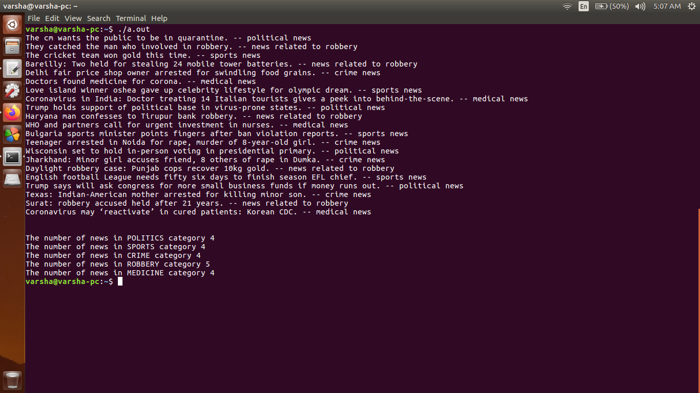

Output of python code:

