ID: bvarshsp
Name: Varsha SP
Day 21 – 24th July 2025

Task 01:
class Animal {
void sound() {
sout(" sounds of different animals");
}
}
class Cat extends Animal{
@Override
void sound() {
sout(" Meow is the sound of cat");
}
}
class Main{
psvm(String[] args) {
Animal obj = new Cat();
obj.sound(); //Meow is the sound of cat
}
}

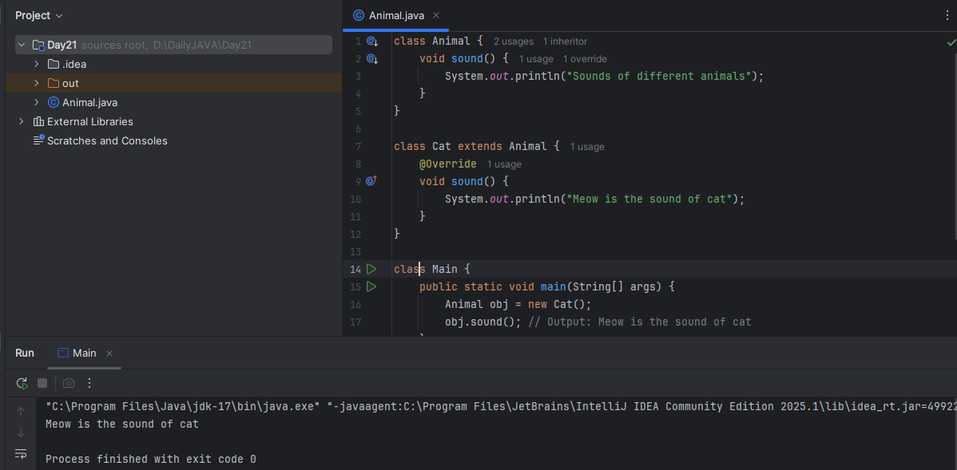

Task 02:
they are useful whern the code does not depends on the actual type parmeter

void printList(List<?> list) {
for(Object element: list) {
sout (element);
}
}

List<Cat> clist = new ArrayList<>();
clist.add(new Cat());
printList(clist); //

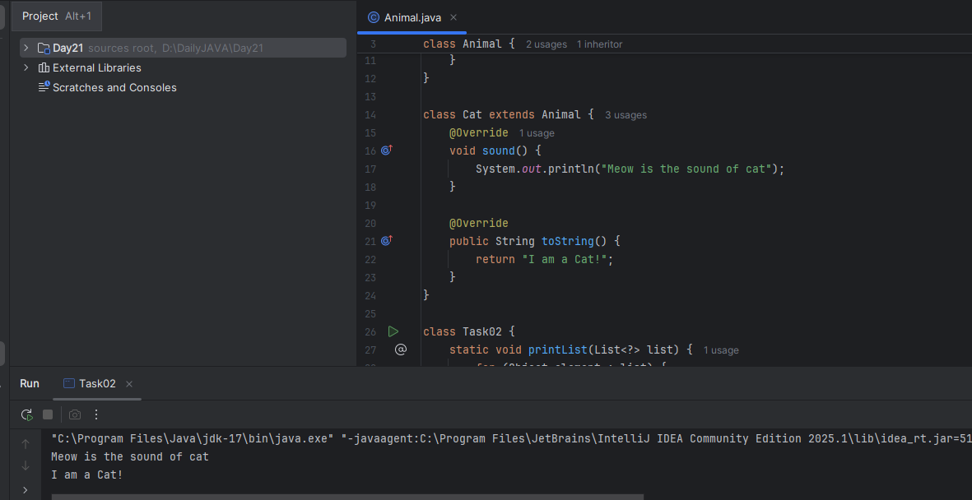

Task 03:

Upper Bounded Wildcards

void animalSound(List<? extends Animal> animalList) {
for(Animal elements : animalList
elements.sound();
}
}
List<Cat> cats = new ArrayList<>();
cats.add(new Cat());
animalSound(cats); //meow

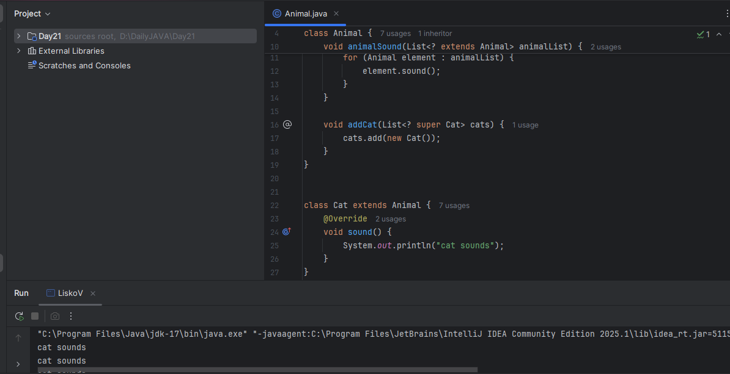

Task 04:

lower Bounded Wildcards

void addAcat(List<? super Cat> cats) {
cats.add(new Cat());
}
List<Animal> animals = new ArrayList<>();
addAcat(animals); //


Task 05:

// tight coupling

class Student {
public int roll_no = 10;
//private int roll_no = 10; // this code breaks...
public int getRoll() {
sout("getRoll method");
return roll_no;
}
public void setRoll(int roll) {
if(!(roll > 100)
roll_no = roll;
}
}
class Tight_coupling {
psvm(String....) {
Student sobj = new Student();
sobj.roll_no = 10; // we are not following the rule of Student class roll no > 100..
//sobj.roll_no = 110;
sout("the roll no of student is "+ sobj.roll_no); // 110 // private - error //10
}
}

Task 06:

// loose coupling

class Student {
private int roll_no = 0;
public int getRoll() {
sout("getRoll method");
return roll_no;
}
public void setRoll(int roll) {
if(!(roll > 100)
roll_no = roll;
}
}
class Loose_coupling {
psvm(String....) {
Student sobj = new Student();// Person pobj = new Student(); // person got a bonus
sobj.setRoll(10);
sout("the roll no of student is "+ sobj.getroll();
}
}

/*

Module 1 Module 2 Module 3
independent .. they do communicate

// we should do coupling -- importance

good maintainability
testability
Error propagation
high coupling - errors and it will propagate throught the project.. not at all recommandable..
reusability:

No coupling :

the modules wont interact with eachother.. -- completely independent..

*/

Task 07:

//DIP violating

class LightBulb {
void turnOn() {
sout("light turned on");
}
void turnOff() {
sout("light is off");
}
}
class Switch { // switch class directly depends on the lightbulb class ---- DIP violating
LightBulb lbulbobj;
Switch(LightBulb lbulbobj) {
this.lbulbobj = lbulbobj;
}
void operates(){
lbulbobj.turnOn();
}
psvm(....){
LightBulb lbulbobj = new lightBulb();
Switch Switchobj = new Switch(lbulbobj);
Switchobj.operate();
}
}

Task 08:

DIP implementation:

interface SwitchOnOff {
void turnOn();
void turnOff(); // void remoteControl();// void alexaVoiceControl();
}
class LightBulb {
void turnOn() {
sout("light turned on");
}
void turnOff() {
sout("light is off");
}
} // or class fan, class inverter, class washing machine...(in future remote for washing machine
// i can extend without modification..
class Switch { // switch is depending on switchonoff class not on light bulb..
SwitchOnOff device;
void Switch(SwitchOnOff device) {
this.device = device;
}
void operates() {
device.turnOn();
}
}
class DIP {
psvm(....){
SwitchOnOff lbulbobj = new LightBulb();
Switch lightswitch = new Switch(lbulbobj);
lightswitch.operate();
}
}

Explain the different types of relationships in UML (association, aggregation, composition, inheritance):

Association:
Association represents a general connection or link between two classes. It signifies that instances of one class can be related to instances of another class.
A general relationship between two independent classes. One class "knows about" the other class or "uses" the other class. But neither of the class owns the other.
Ex: A Student is associated with a Teacher. The student knows their teacher, but they can exist independently.

Aggregation:
Aggregation is a "part-of" relationship where one class (the whole or aggregate) contains or is composed of other classes (the parts).
It is like one class is a container, but parts can exist independently that is one class is a part of another class that can exist independently. It represents a "has-a" or "part-of" relationship.
Ex: A Department has many Professors. If the department closes, professors still exist (they can transfer).

Composition:
Composition is a stronger "part-of" relationship where the parts are entirely dependent on the whole for their existence.
It represents a strong whole-part relationship. The part cannot exist without the whole. If the whole is destroyed, the parts are too.
Ex: A House contains Rooms. If the house is demolished, rooms don’t exist separately.

Inheritance:
Inheritance is a relationship where a class (the subclass or derived class) inherits properties and behaviors from another class (the superclass or base class).
It represents a hierarchical relationship. One class (subclass) inherits behavior/attributes from another class (superclass).
Ex: A Dog is an Animal. Dog inherits common traits from Animal.

Task 09:

Why should we choose Composition over Inheritance?

- Loose coupling
- Flexibility
- Better encapsulation

