ID: bvarshsp
Name: Varsha SP
Day 33 – 4th September 2025

Task1:

What do you understand by DynamoDb Architecture. explain using a diagram.

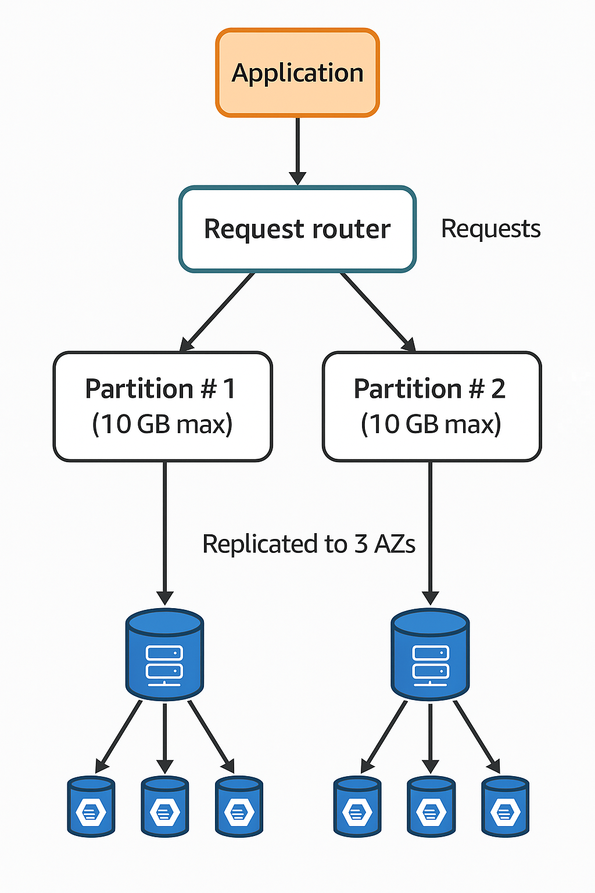
DynamoDB Architecture – Explanation
1. Application Layer
- Applications (mobile apps, web apps, microservices) interact with DynamoDB using:
  - AWS SDKs (Java, Python, Node.js, etc.)
  - AWS CLI
  - REST API
- These calls are made to the DynamoDB service endpoint.
2. Request Router (Front-End Layer)
- The request router is the “gatekeeper”.
- Responsibilities:
  - Authenticate requests (IAM policies).
  - Parse API calls (GetItem, PutItem, Query, Scan).
  - Route requests to the correct partition using the partition key hash function.
- Ensures low-latency and efficient routing.
3. Partitions
- Core building blocks of DynamoDB’s storage.
- Each partition:
  - Can store up to 10GB of data.
  - Can handle 3000 RCUs (Read Capacity Units) and 1000 WCUs (Write Capacity Units).
- The Partition Key (HASH key) determines which partition an item is stored in.
- If the table grows, DynamoDB automatically splits partitions (horizontal scaling).
4. Sort Key (Optional)
- If defined, it organizes items within a partition.
- Allows range queries (e.g., between, begins_with).
- Example: EmployeeID as partition key, JoiningDate as sort key.
5. Replication Across Availability Zones
- Each partition is replicated across 3 different Availability Zones (AZs) in a region.
- Ensures:
  - High Availability (if one AZ goes down, others serve requests).
  - Durability (data is not lost even in failures).
- Writes are synchronously replicated to all copies.
6. Consistency Model
- DynamoDB provides:
  - Eventually Consistent Reads (default, faster, cheaper).
  - Strongly Consistent Reads (optional, slightly slower, higher cost).
7. Additional Components
- DynamoDB Streams: Capture real-time changes (for auditing, replication, Lambda triggers).
- Global Tables: Multi-region replication for global apps.
- DAX (DynamoDB Accelerator): In-memory caching for microsecond latency.
- Backup & Restore: On-demand snapshots and PITR (Point-In-Time Recovery).
Summary
- Application → Request Router → Partitions → Replicas
- Data is automatically distributed, partitioned, and replicated.
- DynamoDB ensures scalability, availability, and durability by design.
- Supports millions of requests per second with near-constant performance.

Task2:
What are multivalue sorts or filters..? Explain briefly..
Answer:
Example:
- Table: Orders
- Partition Key = CustomerID
- Sort Key = OrderDate

Multi-Value Sorting (Range Queries):
You can filter items within a range of Sort Key values.
- BETWEEN → fetch items between two values.
- begins_with → fetch items starting with a prefix.
- >, <, >=, <= → fetch items greater or less than a value.
Example:
Get orders for CustomerID = CUST#123 placed in 2025:
OrderDate BETWEEN "2025-01-01" AND "2025-12-31"
Filtering = additional conditions on non-key attributes.
Filtering on Non-Key Attributes:
- Queries only use keys (Partition & Sort Key).
- To filter on other attributes, use FilterExpression.
Example:
Get all orders where Amount > 1000:
FilterExpression: "Amount > :amt"
Multi-Attribute Filtering:
You can combine conditions with AND / OR.
Example:
Get all orders where:
- Amount > 1000
- AND Status = "Shipped"
FilterExpression: "Amount > :amt AND OrderStatus = :status"

Task 03:
How do you lower the cost of DynomaDB.explain ways to do so…
Answer:
Lowering the Cost of DynamoDB:
1. Choose the Right Capacity Mode
- On-Demand Mode
  - Pay per request (good for unpredictable traffic).
  - No need to guess RCUs/WCUs.
- Provisioned Mode
  - Fixed Read/Write Capacity Units.
  - Add Auto Scaling to adjust to traffic.
Always choose based on workload patterns.
2. Optimize Read/Write Patterns
- Use Query (efficient) instead of Scan (expensive).
- Use ProjectionExpression → fetch only needed attributes.
3. Design Keys & Indexes Carefully
- Avoid hot keys (all traffic hitting one partition).
- Use good partition key distribution → spreads load evenly.
- Create Global Secondary Indexes (GSIs) only when really needed (they double write cost).
4. Use Caching
- Use DAX (DynamoDB Accelerator) or external cache (Redis, Memcached).
- Offload repeated read requests → huge RCU savings.
5. Control Storage Costs
- Remove unused attributes (every KB stored costs money).
- Delete old/unused data with TTL (Time To Live) → DynamoDB auto-deletes expired items.
6. Backup & Restore Smartly
- Use Point-in-Time Recovery (PITR) only if needed.
- Delete old backups to save storage costs.
7. Monitor & Tune Usage
- Right-size throughput → don’t over-provision.
- Use auto-scaling thresholds to match real demand.

