ID: bvarshsp
Name: Varsha SP
Day 17 – 10th July 2025

Task 1:

Write Algo for AVL tree

Answer:

Insert like a normal Binary Search Tree (BST).
- Go left if the value is smaller.
- Go right if the value is larger.
Update the height of each node while returning back from recursion.
- Height = 1 + max(height of left and right child)
Calculate the Balance Factor.
- Balance = height(left child) - height(right child)
Check if the node is unbalanced.
- If balance is greater than 1 or less than -1, the tree is unbalanced.
Fix the unbalanced node using rotations:
- Left-Left (LL): Do Right Rotation.
- Right-Right (RR): Do Left Rotation.
- Left-Right (LR): First do Left Rotation on left child, then Right Rotation.
- Right-Left (RL): First do Right Rotation on right child, then Left Rotation.
Repeat this check while going back up the tree until the root is balanced.

Task 2:

Write code for AVL tree

Hint: try to insert nodes
While inserting get the balance of the tree
Create 2 methods for left rotate and right rotate
Try to insert
Finally display

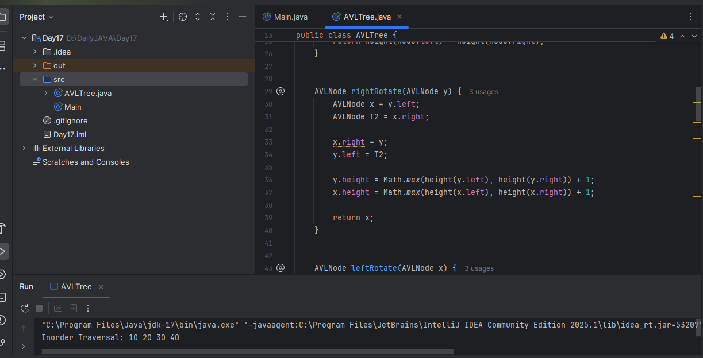

Task 3:

Write algo for Read Black tree insertion

Answer:

RBT Insertion Algorithm
1. Check if the tree is empty
- If tree is empty, insert the new node as root.
- Color of root node = Black (Red-Black Tree rule).
2. If the tree is not empty
- Insert the new node as a leaf node using Binary Search Tree logic.
- Color the new node = Red
3. Check for violation of Red-Black rules
After inserting:
- If parent is Black, nothing to do (tree is still valid).
- If parent is Red, it violates the Red-Black rule (no two consecutive Reds).
4. Check uncle (parent's sibling)

Case 1: Uncle is Red
- Flip colors:
  - Set parent = Black
  - Set uncle = Black
  - Set grandparent = Red
- Move pointer to grandparent, check again.
5. Case 2: Uncle is Black or NULL

Check rotation patterns:

Case 2a: Left-Left (LL)
- Node is left child of its parent, and parent is left child of grandparent.
- Right Rotate the grandparent.
- Flip color of parent and grandparent.

Case 2b: Right-Right (RR)
- Node is right child of parent, and parent is right child of grandparent.
- Left Rotate the grandparent.
- Flip color of parent and grandparent.

Case 2c: Left-Right (LR)
- Node is right child of parent, but parent is left child of grandparent.
- Left Rotate the parent → Now it becomes LL
- Apply Right Rotate on grandparent
- Flip color of new parent and grandparent

Case 2d: Right-Left (RL)
- Node is left child of parent, and parent is right child of grandparent.
- Right Rotate the parent → Now it becomes RR
- Apply Left Rotate on grandparent
- Flip color of new parent and grandparent
6. After all fixes
- Ensure the root is always Black

Task 4:

Wap to insert an element in red black tree

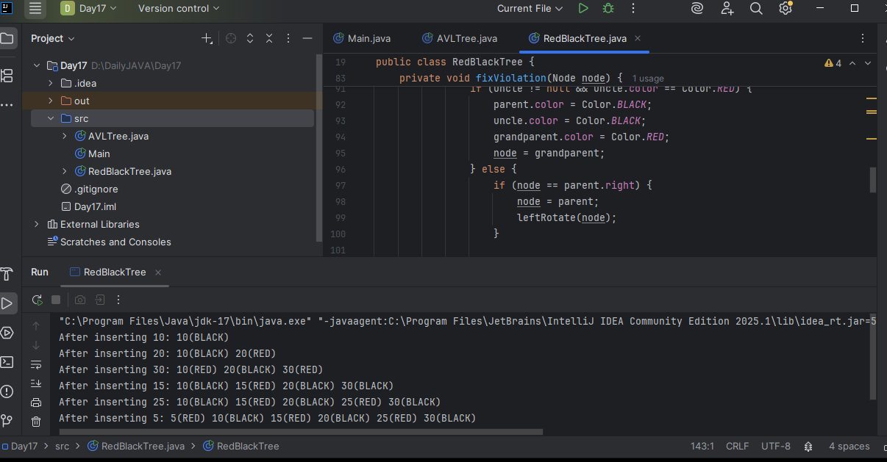

AVL qn:

Why are AVL trees considered balanced, and how does this impact performance?

- They rearrange nodes to ensure maximum depth for fast access.
- They allow unbalanced growth in left subtrees for quick insertion.
- They maintain a balance factor (height difference) of at most 1 between subtrees to ensure O(log n) operations.
- They replicate nodes for redundancy, enabling constant-time deletion.

What is the maximum height of an AVL tree with p nodes?
a) p
b) log(p)
c) log(p)/2
d) p⁄2

What maximum difference in heights between the leafs of a AVL tree is possible?
a) log(n) where n is the number of nodes
b) n where n is the number of nodes
c) 0 or 1
d) atmost 1 (as avl is self balanced)
Why to prefer red-black trees over AVL trees?
a) Because red-black is more rigidly balanced
b) AVL tree store balance factor in every node which costs space
c) AVL tree fails at scale
d) Red black is more efficient

