ID: bvarshsp
Name: Varsha SP
Day 34 – 10th September 2025

Task 01:

Create a java program to retrieve dynamodb table records and display.
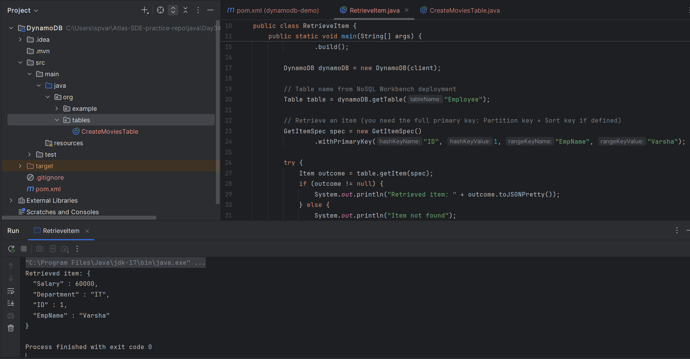

TASK 02:
Create a java program to create a table and insert 2 items .. the NOSQl workbench we should be able to see the table updated.
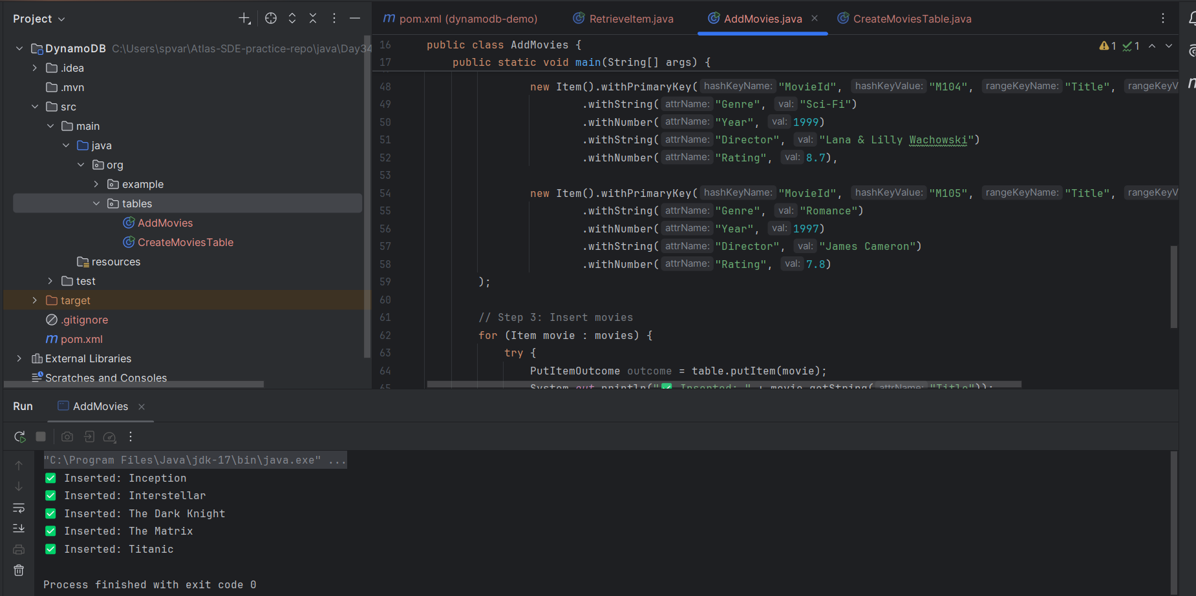
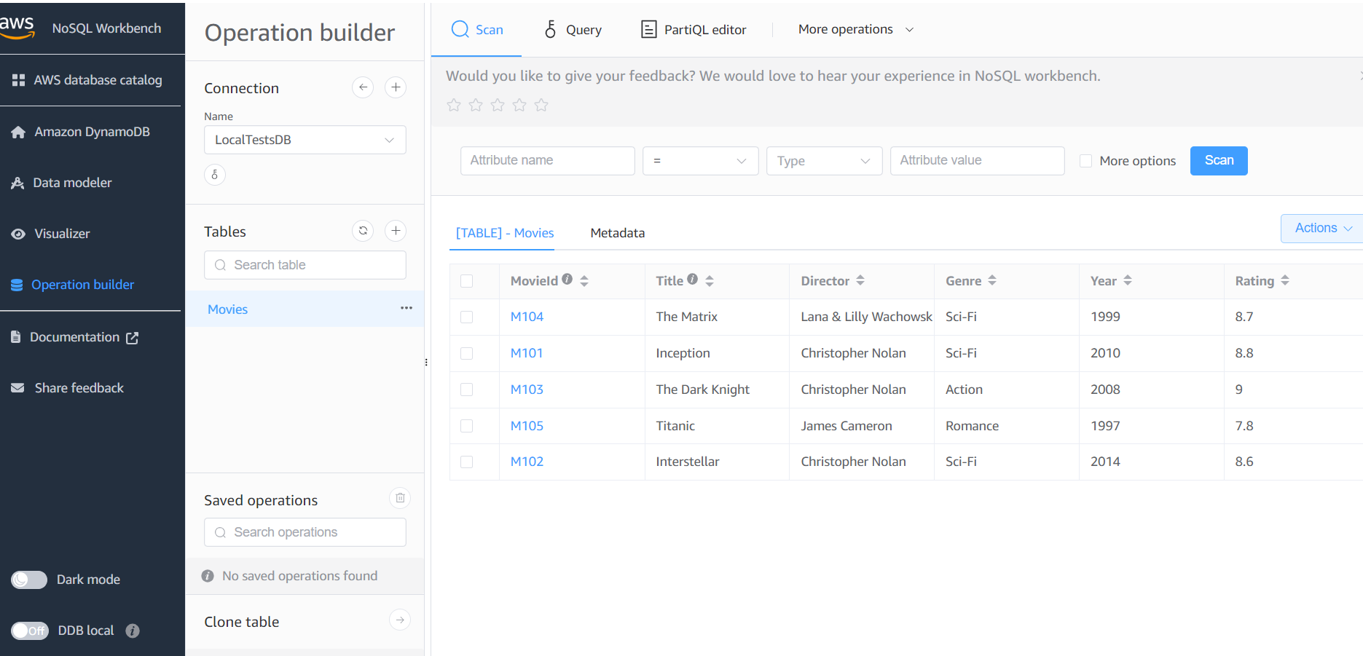

Task 03:
What key features of DynamoDB?
1. Managed NoSQL Database
- Fully managed by AWS → no need to install, patch, or maintain servers.
- AWS handles scaling, backups, replication, and security.

2. Schema-less / Flexible Data Model
- You must define primary key (Partition Key, or Partition + Sort Key).
- Other attributes are flexible → you can add/remove attributes per item (no fixed schema like SQL).

3. High Performance
- Single-digit millisecond latency for reads and writes.
- Supports millions of requests per second with auto scaling.

4. Scalable Storage
- Stores virtually unlimited data across distributed partitions.
- Scales horizontally automatically when your dataset grows.

5. Throughput Modes
- Provisioned capacity → you choose Read/Write Capacity Units (RCU/WCU).
- On-demand mode → pay-per-request, scales automatically.

6. Multi-Region Replication
- With Global Tables, you can replicate data across multiple AWS regions → useful for global apps with low latency.

7. High Availability & Durability
- Data is replicated across multiple Availability Zones (AZs) in a region.
- No single point of failure.

8. Query and Scan
- Query → fetch items quickly using keys + indexes.
- Scan → read the whole table (slower and costly, but useful for debugging).

9. Indexes
- Global Secondary Index (GSI) → query on non-primary key attributes.
- Local Secondary Index (LSI) → alternate sort key per partition.

10. Transactions
- Supports ACID transactions for coordinated, all-or-nothing updates (like SQL).

11. Security
- Integrated with AWS IAM for fine-grained access control.
- Supports encryption at rest (KMS) and in transit (TLS).

12. Streams
- DynamoDB Streams → capture item-level changes in real time → used for event-driven apps (like syncing data, triggers, real-time analytics).

13. Backup & Restore
- On-demand backups.
- Point-in-time recovery (PITR) to restore to any second in the last 35 days.

14. Integration with AWS Ecosystem
- Works smoothly with Lambda, S3, API Gateway, Kinesis, Redshift, Athena, CloudWatch, etc.
- Foundation for serverless applications.

Task 04:
What are the advantages and disadvantages of DynamoDB?
Advantages of DynamoDB
1. Fully Managed (Serverless)
- No need to manage servers, replication, scaling, or patching — AWS does it for you.
2. High Performance
- Consistent single-digit millisecond latency.
- Can handle millions of requests per second.
3. Scalability
- Scales horizontally and automatically with demand.
- On-demand capacity mode removes guesswork about provisioning.
4. Highly Available & Durable
- Data is replicated across multiple Availability Zones within a region.
- With Global Tables, you get multi-region replication for global apps.
5. Flexible Schema
- Only primary key must be defined.
- Other attributes can vary across items (good for dynamic/JSON-like data).
6. Integration with AWS Ecosystem
- Works seamlessly with Lambda, API Gateway, S3, Kinesis, etc. → perfect for serverless apps.
7. Backup & Recovery
- Point-in-time recovery (PITR) up to 35 days.
- On-demand backups.
8. Event-Driven via Streams
- DynamoDB Streams allow real-time event processing and replication triggers.
9. Security
- Built-in IAM-based access control, KMS encryption, and TLS for secure operations.

Disadvantages of DynamoDB
1. Complex Query Limitations
- Optimized for key-value lookups.
- No support for joins or complex queries like SQL databases.
- For advanced querying, you must design indexes (GSI/LSI) or restructure data (single-table design).
2. Cost Management
- Can become expensive at high throughput (especially with on-demand mode).
- Need careful partition key design to avoid “hot partitions” that waste capacity.
3. Learning Curve
- Requires understanding of NoSQL modeling, partitioning, and single-table design patterns.
- Developers used to relational DBs may struggle initially.
4. Limited Transaction Support
- Transactions exist (ACID), but they are more limited in scale and costlier compared to RDBMS.
5. Size Limits
- Item size limit: 400 KB max per item.
- Query/Scan results are paginated (1 MB per request).
6. Vendor Lock-in
- Proprietary AWS service.
- Migrating away to another NoSQL database (like MongoDB, Cassandra) can be difficult.

Task 05:
Where do we use DynamoDB (use cases of DynamoDB)
Common Use Cases of DynamoDB
1. E-Commerce Applications
- Product catalogs (flexible schema for different products)
- Shopping carts (real-time session storage)
- Inventory management (fast lookups of stock availability)

2. Gaming Applications
- Player profiles (partition key = PlayerId)
- Game state/session data
- Leaderboards with high-speed writes & queries

3. IoT (Internet of Things)
- Store sensor/device data streams
- High write throughput for millions of devices
- Works well with time-series data

4. Mobile & Web Applications
- User profiles and authentication data
- Session management (fast key-value lookups)
- Preferences, settings, and activity logs

5. Ad Tech & Recommendation Engines
- Real-time bidding (RTB)
- Personalized recommendations
- Store user click-stream and behavior data

6. Financial & Banking Apps
- Transaction records (with ACID transactions support)
- Fraud detection using DynamoDB Streams + Lambda
- Wallet or ledger systems

7. Content Management Systems (CMS)
- Blogs, articles, and metadata
- Video and image metadata for streaming platforms
- Catalog of media assets (like Netflix, Prime Video)

8. Serverless Applications
- DynamoDB pairs perfectly with AWS Lambda and API Gateway
- Used as a serverless backend for microservices
- Enables scalable, event-driven architectures

9. Real-Time Analytics
- Using DynamoDB Streams → capture changes in tables → push into Kinesis / Redshift / Elasticsearch
- Power dashboards & monitoring apps

10. Global Applications
- With Global Tables, keep data close to users in multiple regions
- Great for apps like social media platforms or ride-sharing apps that need low-latency reads/writes worldwide

Task 06:
What is DynamoDBMapper?
- DynamoDBMapper is a high-level object persistence API provided in the AWS SDK for Java.
- It lets us map our Java classes to DynamoDB tables using annotations.
- Instead of writing low-level code (createItem, updateItem, etc.), you can work with plain Java objects (POJOs).
How it Works
- Define a Java POJO class and annotate it with @DynamoDBTable, @DynamoDBHashKey, @DynamoDBRangeKey, and @DynamoDBAttribute.
- Use a DynamoDBMapper object to perform CRUD operations directly on Java objects.
- The mapper automatically translates between your object and the DynamoDB table.

Task 07:
What are DynamoDb Projections?
- In an Index (GSI/LSI), projections define which attributes are copied from the main table into the index.
- Types:
  - KEYS_ONLY → Only primary + index keys.
  - INCLUDE → Keys + some selected attributes.
  - ALL → Keys + all attributes.
Helps optimize query performance and reduce storage costs.

Task 08:
How can you say that DYnamoDB prevents data loss?
- Data is replicated automatically across multiple Availability Zones (AZs) in a region.
- Supports Point-in-Time Recovery (PITR) and on-demand backups.
- Even if one server/zone fails, your data is safe.

Task 09:
What is in-place atomic updates means ? does dynamoaDB supports?
- In-place atomic update → update a single attribute without replacing the whole item.
- Example: Increment a counter or update just one field.
- DynamoDB supports it using UpdateItem with operators like ADD, SET, etc.
- This ensures changes are atomic (no conflicts/loss even under concurrent updates).

Task 10:
What are Streams in DynamoDB?
- DynamoDB Streams capture real-time changes (insert, update, delete) in a table.
- Can be used with AWS Lambda to trigger actions → e.g., sync data, analytics, notifications.
- Enables event-driven architectures.

Task 11:
What are DynamoDb Pricing Tiers?
Two main modes:
- Provisioned Capacity → you set Read/Write Capacity Units (RCU/WCU).
  - Good for predictable workloads.
- On-Demand Capacity → pay-per-request, scales automatically.
  - Good for unpredictable workloads.
Extra costs: storage, backups, Streams, Global Tables, DAX.

Task 12:
Do you have any max limit for Item Size in DynamoDb? If so what is it?
- 400 KB per item (including all attributes + names + values).
- Larger data must go to S3, store only metadata/keys in DynamoDB.

Task 13:
At a max of how many GSI’s Global Secondary Indexes can you create in a table?
- Up to 20 GSIs per table (soft limit, can be increased via AWS support).
- Up to 5 Local Secondary Indexes (LSIs) per table.

Task 14:
What is DynamoDb Accelarator?
- In-memory caching service for DynamoDB.
- Reduces read latency from milliseconds → microseconds.
- Fully managed, highly available, compatible with DynamoDB API.
- Best for read-heavy workloads (like gaming leaderboards, recommendation engines).

Task 15:
What are DynamoDB Global tables?
- Global Tables = A fully managed, multi-region replication feature in DynamoDB.
- They automatically replicate your tables across multiple AWS regions.
- Any write in one region is propagated to all other regions.
- Benefits:
  - Low-latency access for users worldwide.
  - Disaster recovery (if one region fails, others still serve data).
- Example: A shopping app used in India, US, Europe can read/write in the nearest region with consistent data across all.

Task 16:
What are indexes and Secondary indexes in DynamoDB?
Indexes in DynamoDB
- Allow you to query data on attributes other than the primary key.
- Without indexes, you can only query by the Partition Key (and Sort Key if present).
- Indexes = optimized lookup tables.

Types of Secondary Indexes
- Local Secondary Index (LSI)
  - Defined at table creation (cannot add later).
  - Uses the same Partition Key as the base table.
  - But allows a different Sort Key.
  - Up to 5 LSIs per table.

- Global Secondary Index (GSI)
  - Can be created anytime (at or after table creation).
  - Can use different Partition Key and Sort Key from the base table.
  - More flexible than LSI.
  - Up to 20 GSIs per table.

Task 17:
What are Hot Keys and Hot Partitions?
Hot Keys & Hot Partitions
1. Hot Key
- A partition key that gets disproportionately high traffic (lots of reads/writes to the same key).
- Example: In a Songs table, if everyone streams "SongId=123" at once, that partition key becomes “hot”.
- Problem: DynamoDB distributes data across partitions → if one key gets all requests, it overloads that partition → leads to throttling and latency.

2. Hot Partition
- When a whole partition (collection of keys) gets too much traffic compared to others.
- Partitions in DynamoDB are supposed to get traffic evenly distributed.
- Hot partitions happen due to bad partition key design (e.g., all users use the same key or keys not spread out enough).

Task 18:
What are Table level operations and Item level operations in DynamoDB?
Table-level and Item-level Operations
1. Table-Level Operations
- Operations that act on the whole table.
- Examples:
  - CreateTable → create a new table
  - DeleteTable → drop a table
  - UpdateTable → change provisioned throughput, add GSI, etc.
  - DescribeTable → get metadata about a table
  - ListTables → list all tables
They affect the entire table’s structure/configuration.

2. Item-Level Operations
- Operations that act on individual items (rows).
- Examples:
  - PutItem → insert/replace one item
  - GetItem → retrieve one item by primary key
  - UpdateItem → modify attributes of an item
  - DeleteItem → remove one item
  - BatchWriteItem → insert/delete multiple items
  - Query / Scan → read multiple items
They deal with data manipulation, not table structure.

