ID: bvarshsp
Name: Varsha SP
Day 18 – 16th July 2025

Task 01

What kind of collision resolution strategy is implemented in the below Hash Table ?
import java.util.*;

class Task01 {

LinkedList<Entry>[] data = new LinkedList[10];

public void put(String keyval, int value) {
int index = Math.abs(keyval.hashCode() % data.length);

if (data[index] == null) {
data[index] = new LinkedList<>();
}
for (Entry e : data[index]) {
if (e.keyval.equals(keyval)) {
e.value = value;
return;
}
}

data[index].add(new Entry(keyval, value));
}

static class Entry {
String keyval;
int value;

Entry(String k, int v) {
keyval = k;
value = v;
}
}
}

is it using

to fill collisions is it linear probing with backtracking

or
Opening address by placing values at next available bucket

or
at each index chaining using a linked list

or
on each collision resizing hash table

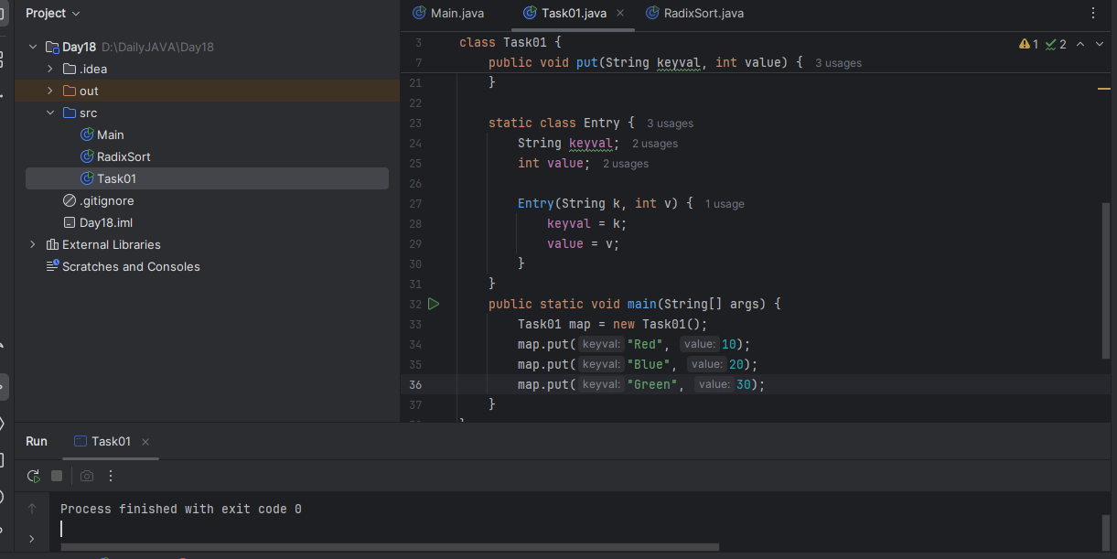

Task 02:
Wap to take input from the user a 5 digit no and display digit by digit in the output

Hint:
If input is 456897
Output:
units digit is 7
Ones digit is 9
Hundreds digit is 8
Thousands digit is 6
10 thousands digit is 5
Lakhs digit is 4
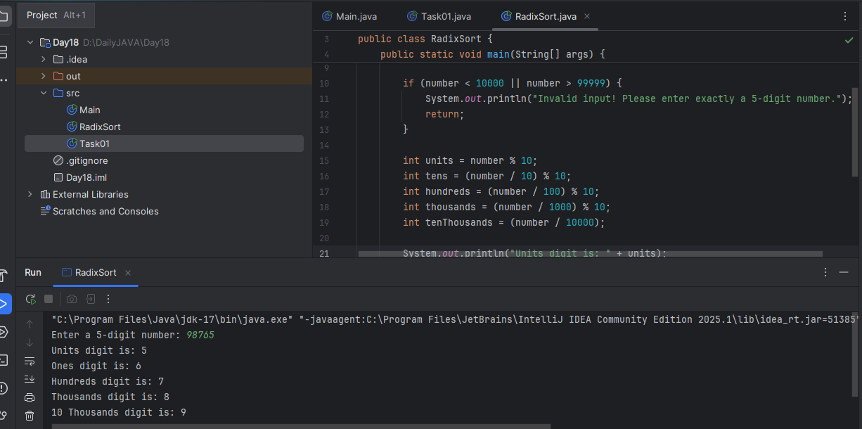

Task 03:
Wap to take number from the user and display the no of digit it has

HInt:
If input is:
10,000
Output:
Its a 5 digit number

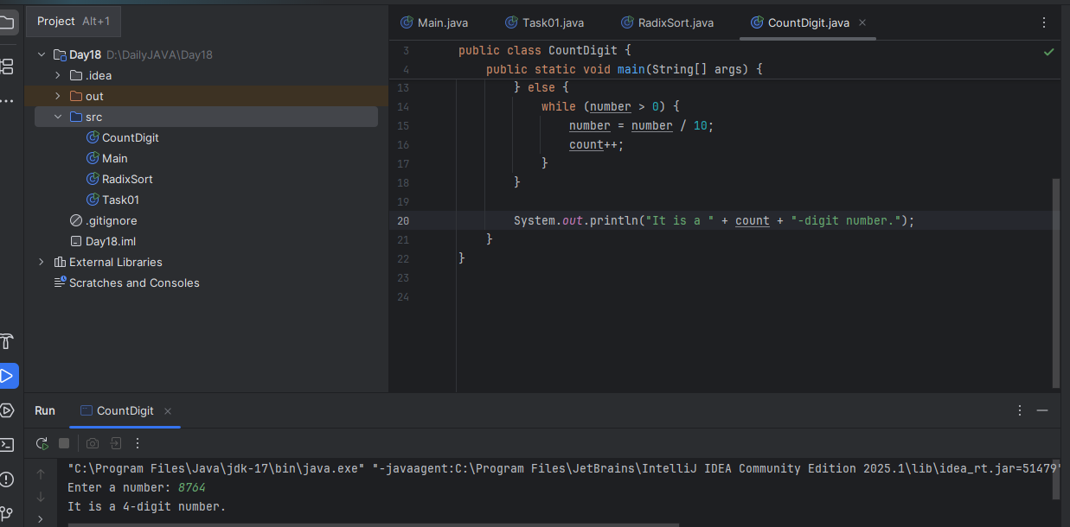

Task 04:

Wap to display the groups of digits depending upon the unit digits

Hint:
If input is 45,81, 85,100,20. 95,60,10,21
Output:
Array 1 has : 100,20,60,10

Array 2 has : 81, 21

Array 3 has : 45 , 85 ,95

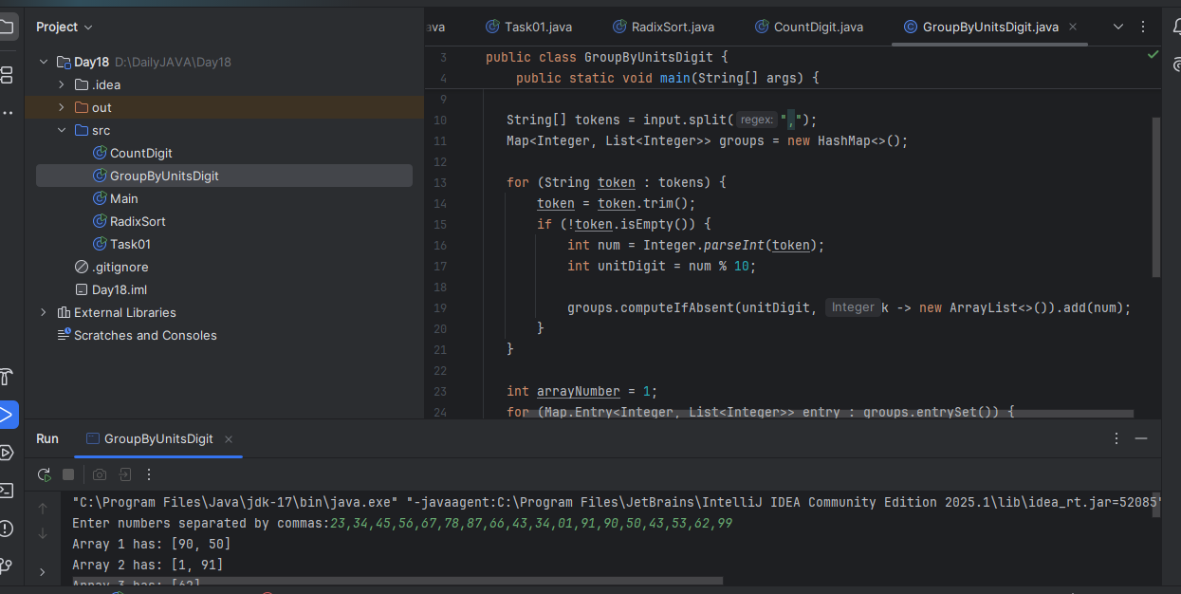

Task 05:
Algorithm for Radix sort:
Answer:
Find the maximum number in the array to find out the number of digits to be processed.
Start from the least significant digit (units place).
For each digit position (units, tens, hundreds and so on), use a stable sorting algorithm (like Counting Sort) to sort the numbers based on that digit.
Repeat this process for the next digit place, until the most significant digit is processed.
After all digit places are sorted, the array will be fully sorted.
Task 06:
Pseudocode for Radix Sort:
Answer:
RADIX_SORT(arr):
1. Find the maximum number in arr → max
2. Set exp = 1 // represents digit place: 1s, 10s, 100s, ...
3. While (max / exp > 0):
a. call COUNTING_SORT_BY_DIGIT(arr, exp)
b. exp = exp * 10
COUNTING_SORT_BY_DIGIT(arr, exp):
1. Initialize count[10] = {0} // For digits 0 to 9
2. Initialize output[] same size as arr
3. For each number in arr:
index = (number / exp) % 10
count[index]++
4. Modify count[] to store positions:
for i = 1 to 9:
count[i] = count[i] + count[i - 1]
5. For each number in arr (right to left):
index = (number / exp) % 10
output[count[index] - 1] = number
count[index]—
6. Copy output[] back to arr

Task 07:
Code for Radix Sort:

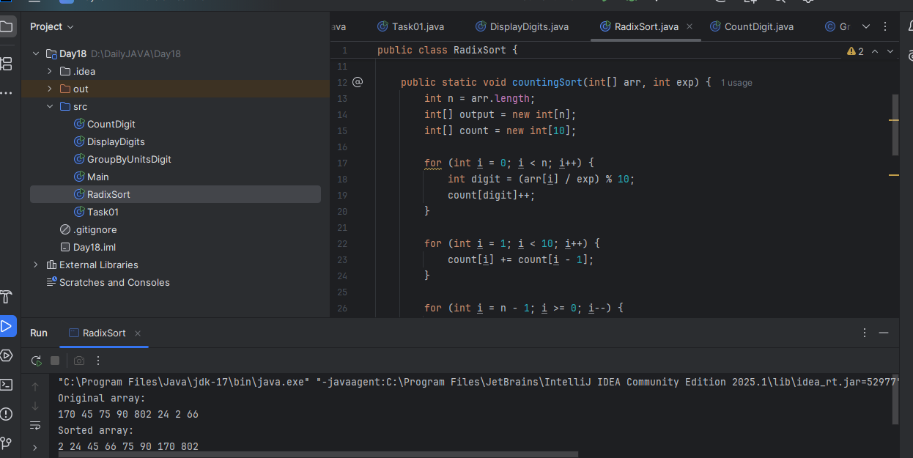

Task 08:

Do you find any significance change between the breadthFirstSearchRecursive() approach compared to the standard BFS?

Answer:
Will it the need for queues entirely by using a stack-based recursion?

Will it simplifies implementation by using queues implicitly within recursive function calls?

will it achieve same result but emphasizes on recursive style using the same level-order logic with explicit queue management?

or
will it processes nodes in post-order sequence to avoid memory allocation?

Task 09:

What is memoization?
Write in ur own words with examples.

Answer:
Memoization is a technique where we store the results of function calls so that the next time we need the same result, we can reuse it instantly instead of recalculating it. It is used mainly with recursive functions that solve the same subproblems multiple times.

Task 10:

What do you understand by Dynamic Programming?
Write in your own words with examples.

Answer:
Dynamic Programming is a method used to solve complex problems by breaking them into smaller subproblems, solving each subproblem only once, and saving their results to avoid repeated work.

Task 11:

Can you write fibonacci series using dynamic programming?

Answer:
Top-Down Approach (with Memoization):
import java.util.HashMap;
import java.util.Map;
public class FibonacciMemo {
static Map<Integer, Integer> memo = new HashMap<>();
static int fib(int n) {
if (n <= 1) return n;
if (memo.containsKey(n)) {
return memo.get(n);
}
int result = fib(n - 1) + fib(n - 2);
memo.put(n, result);
return result;
}
public static void main(String[] args) {
int n = 10;

System.out.println("Fibonacci series up to " + n + " terms:");
for (int i = 0; i < n; i++) {
System.out.print(fib(i) + " ");
}
}
}

Bottom-Up Approach (with Tabulation):
public class FibonacciTabulation {
static void printFibonacci(int n) {
if (n <= 0) return;
int[] dp = new int[n];
dp[0] = 0;
if (n > 1) dp[1] = 1;
for (int i = 2; i < n; i++) {
dp[i] = dp[i - 1] + dp[i - 2];
}
System.out.println("Fibonacci series up to " + n + " terms:");
for (int i = 0; i < n; i++) {
System.out.print(dp[i] + " ");
}
}
public static void main(String[] args) {
int n = 10;
printFibonacci(n);
}
}
Task 12:

How does heap sort work? explain the technique … oral

Task 13:

how can you say recursive functions maintain the state of each call during execution?

1. Each recursive call creates a new thread, and context switching maintains state.

2. Recursive functions store state in global variables accessible across calls.

3. The system call stack tracks local variables and return addresses for each recursive invocation.

4. Recursive functions replicate the heap structure to keep values between calls.

Task 14:

Iterative implementations use less memory as they do not require stack frames for each call. True

with regard to the difference in memory usage between recursive and iterative implementations of the same algorithm?
the above statement is true or false

True
Task 15:

Recursion that lacks a proper base case or makes too many nested calls, exhausting the call stack. – true

with regard to stack overflow error in recursive functions. do you think above statement is true

True

Task 16:

what happens when inserting keys with the same hash in this custom hash map

public class HashCollision {

static class Entry {
String key;
int value;

Entry(String key, int value) {
this.key = key;
this.value = value;
}
}

List<Entry>[] table = new AL[10];

public void put(String key, int val) {
int index = Math.abs(key.hashCode() % table.length);

if (table[index] == null) {
table[index] = new AL<>();
}

table[index].add(new Entry(key, val));
}
}

1. Insertion will fail due to duplicate key exception

2. Values are distributed across different buckets using linear probing

3. Only one key-value pair will be stored due to overwriting

4. Multiple values are stored in same bucket via chaining

Task 17:

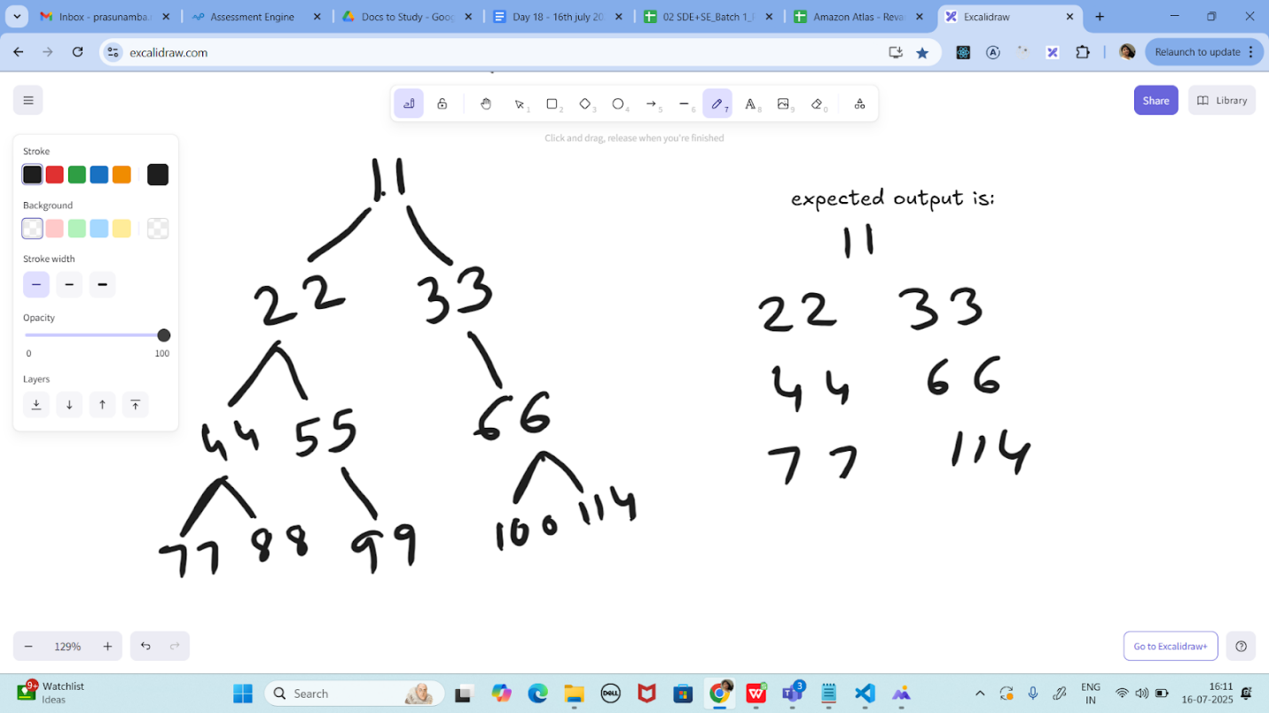

Write a code for binary search tree for expected output

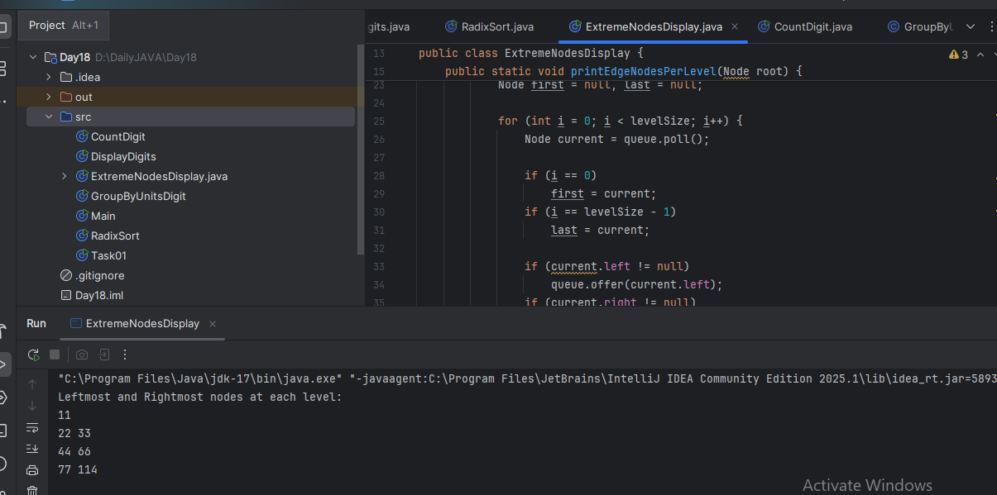

Task 18:

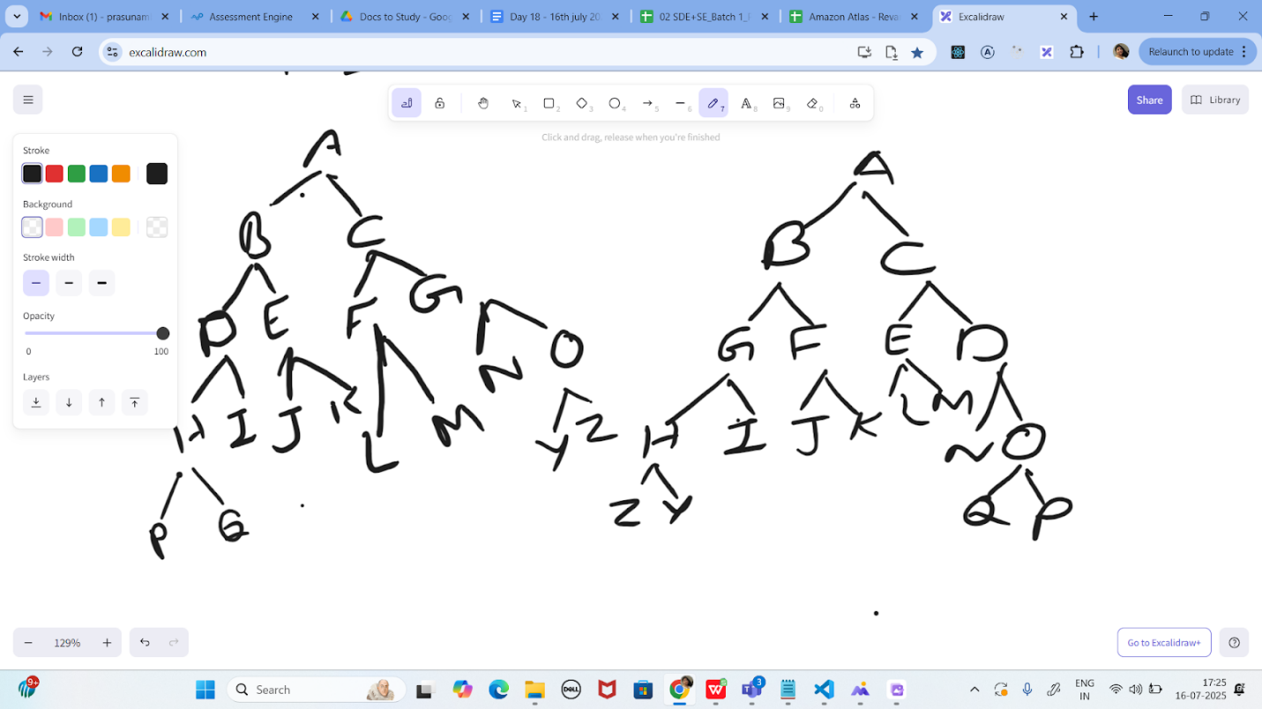

Print reverse order for alternative levels.

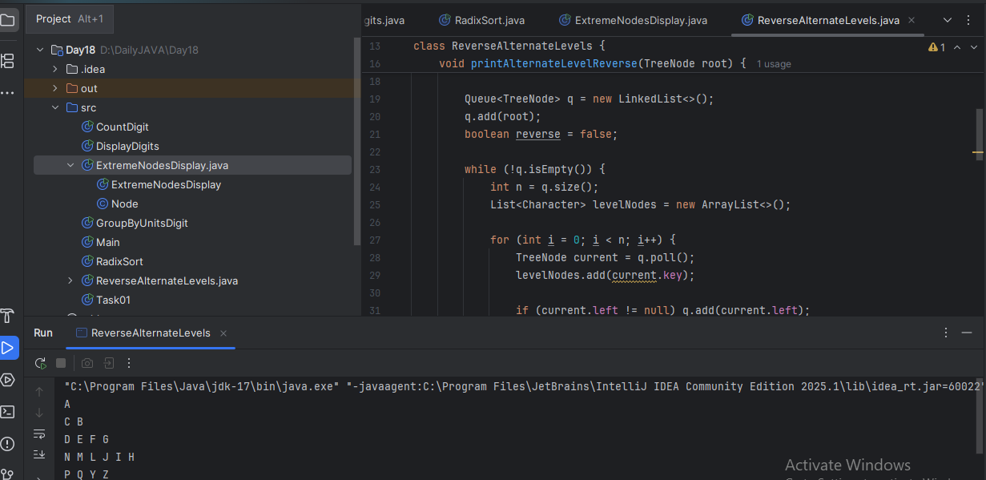

Task 19:

https://leetcode.com/problems/binary-tree-right-side-view/description/

Plz solve this Problem statement

