ID: bvarshsp
Name: Varsha SP
Day 24 – 06th August 2025

Task 01:

On the basis of above SS try to create a factory Method Design Pattern program

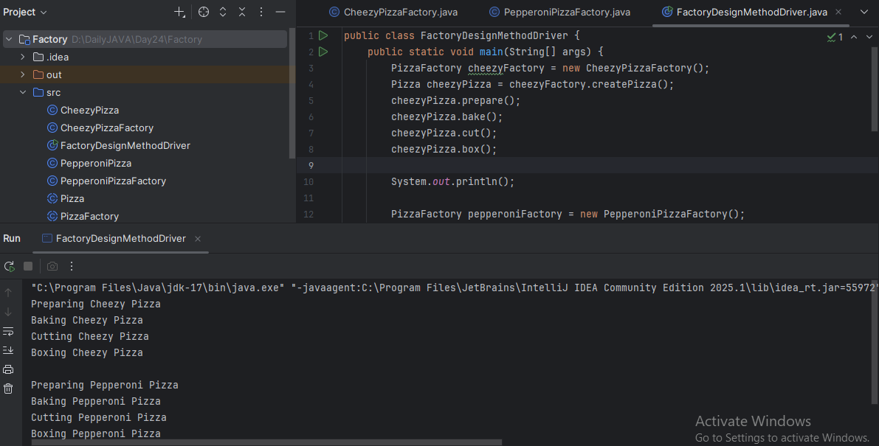

Task 02:

Singleton Design pattern

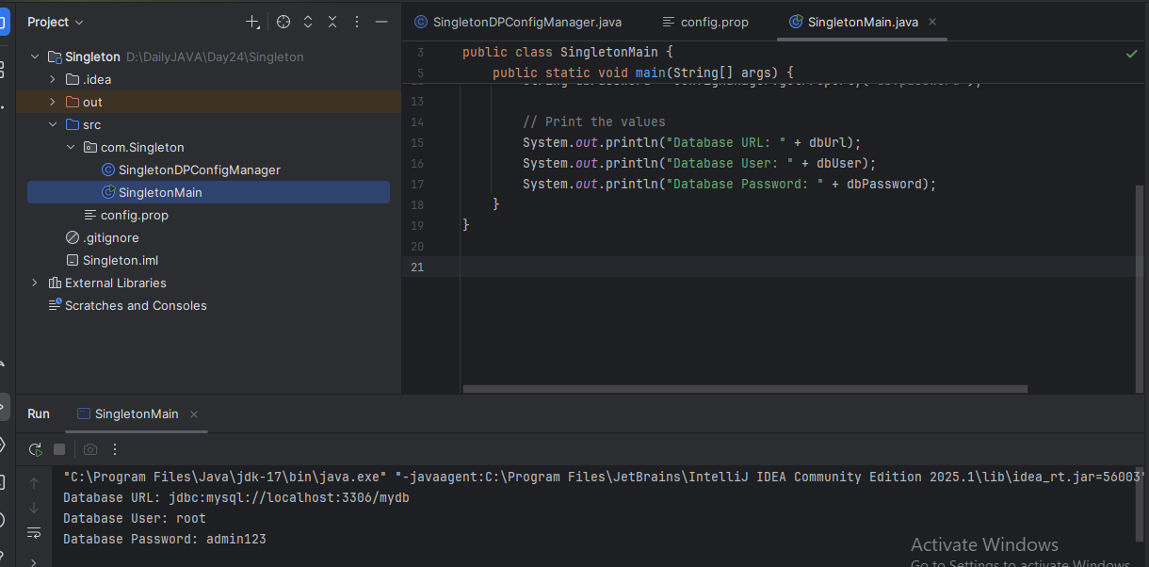

Task 03:

Abstract Factory Design Pattern
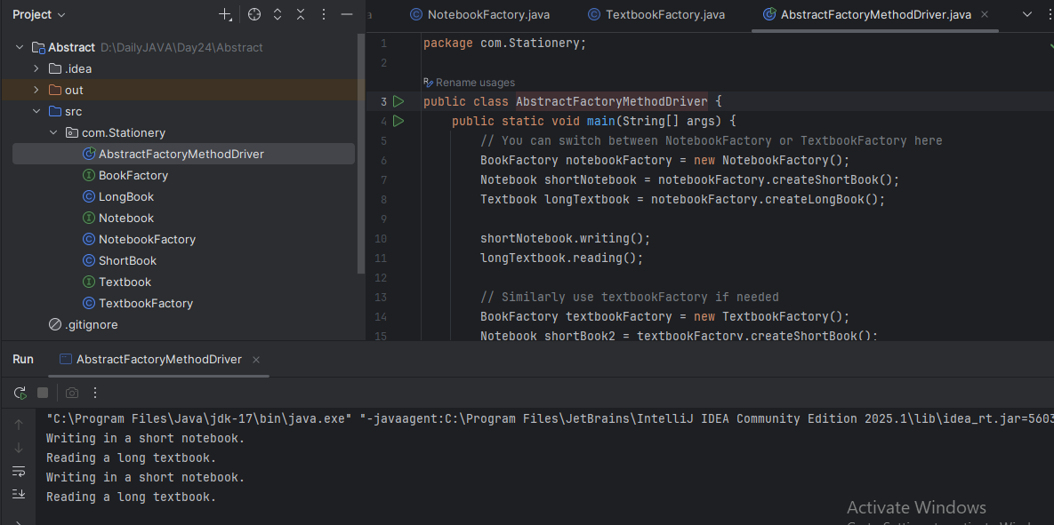

Task 04:

Prototype Design Pattern
