ID: bvarshsp
Name: Varsha SP
Day 20 – 23rd July 2025

Task 1:

Wap to create a class Student.. With 3 methods
registrationDetails(), marksCalc(), feesCalc().

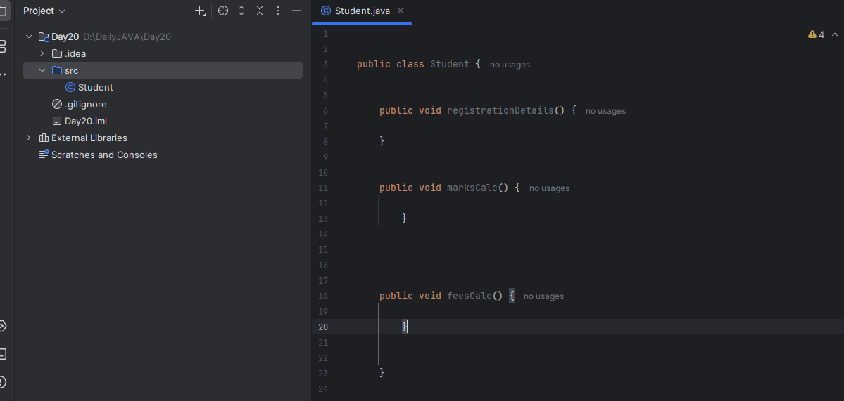
Task 02:

class Employee {
private String name;
private String email;
private double salary;

// Methods related to employee data

// Method to generate PDF report
public void generatePdfReport() {
// Code to generate PDF report
}

// Method to send email
public void sendEmail() {
// Code to send email
}
}
In the above example code, the Employee class violates the SRP because it has multiple responsibilities: managing employee data, generating PDF reports, and sending emails. These responsibilities are not cohesive and may change for different reasons.
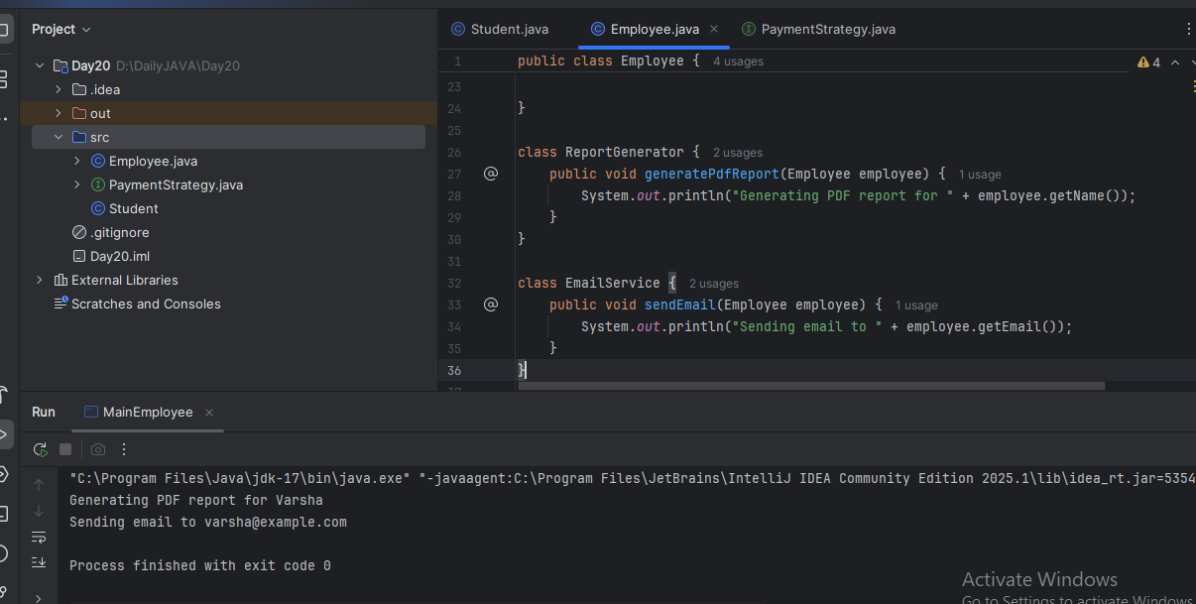
Task 03:

In the below example, the `PaymentProcessor` class violates the OCP because every time a new payment type needs to be supported, the `processPayment` method needs to be modified, which is against the principle of being closed for modification.

class PaymentProcessor {
public void processPayment(String paymentType, double amount) {
if (paymentType.equals("credit card")) {
// Process credit card payment
} else if (paymentType.equals("paypal")) {
// Process PayPal payment
} else if (paymentType.equals("bitcoin")) {
// Process Bitcoin payment
}
// ... more payment types
}
}
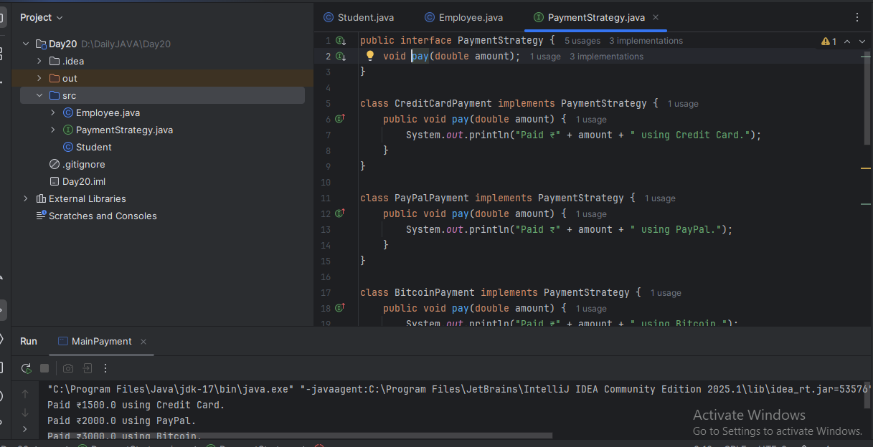
Task04:

Sequence diagram:

@startuml
Prasunamba -> Atlas_Batch1: Congratulations all
Atlas_Batch1 --> Prasunamba: Thank you Meher

Prasunamba -> Atlas_Batch1: Good luck for your Module 3
Atlas_Batch1 --> Prasunamba: Thank you Meher in advance
or
Prasunamba < -- Atlas_Batch1: Thank you Meher in advance
@enduml
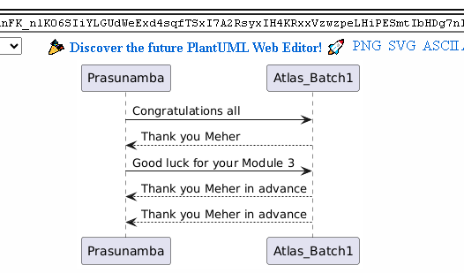
Task 5:

@startuml
pax "A" as A
pax "B" as B

A --> B: Message/action
A ..> B: reply
@enduml
