ID: bvarshsp
Name: Varsha SP
Day 25 – 07th August 2025

Task 01:

Builder

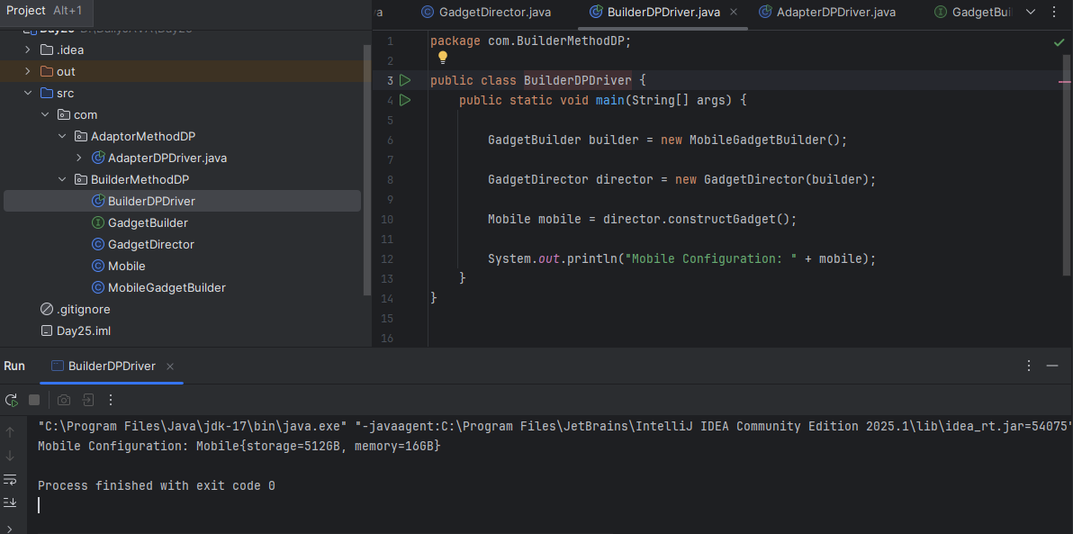

Task 02:

Adaptor

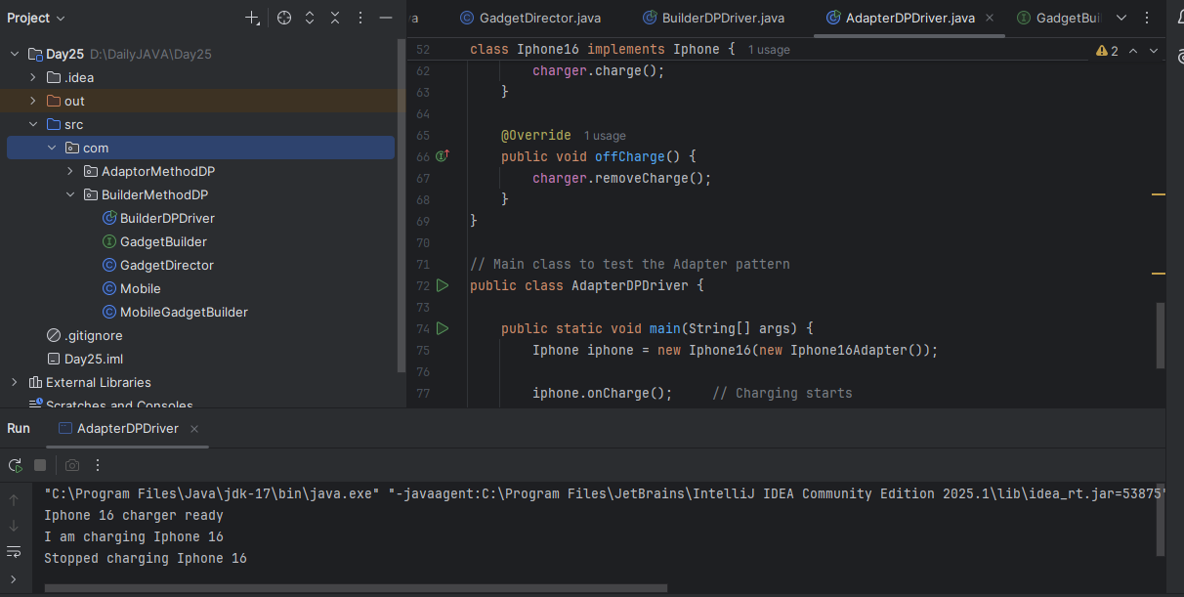

Task03:

Create a class diagram in uml.

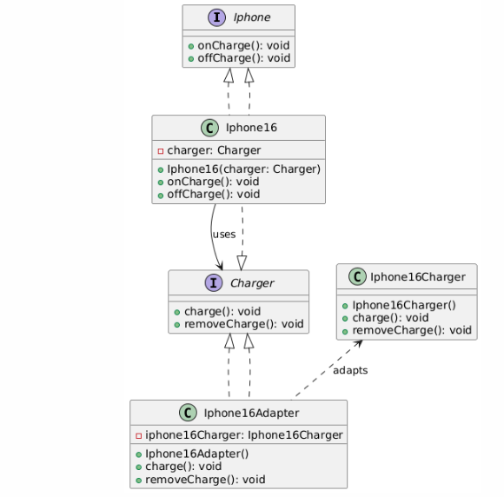

Task 04:

What are the commonly used visibility Notations in class diagrams?

Eg: =,-, ~, #,

Answer:
+ | Public | Accessible from anywhere (outside or inside the class).

- | Private | Accessible only within the class itself.

# | Protected | Accessible within the class and its subclasses.

~ | Package (default) | Accessible to classes in the same package (i.e., package-private).

Task 05:

What do you know about Parameter Directionality?
List them

Answer:

Parameter Directionality in UML refers to the flow of data in and out of an operation (or method). It specifies how parameters are passed to or from an operation and what their purpose is.

in → Input parameter (data flows into the operation). This is the default.

out ← Output parameter (data is set by the operation and passed back to the caller).

inout ↔ Input and output parameter (data is passed in, modified, and returned).

return ← The return value of the operation. Not typically marked with direction in UML diagrams, just placed after the colon (:).

Task 06:

Association:
Association represents a general connection or link between two classes. It signifies that instances of one class can be related to instances of another class.
A general relationship between two independent classes. One class "knows about" the other class or "uses" the other class. But neither of the class owns the other.
Ex: A Student is associated with a Teacher. The student knows their teacher, but they can exist independently.

Aggregation:
Aggregation is a "part-of" relationship where one class (the whole or aggregate) contains or is composed of other classes (the parts).
It is like one class is a container, but parts can exist independently that is one class is a part of another class that can exist independently. It represents a "has-a" or "part-of" relationship.
Ex: A Department has many Professors. If the department closes, professors still exist (they can transfer).

Composition:
Composition is a stronger "part-of" relationship where the parts are entirely dependent on the whole for their existence.
It represents a strong whole-part relationship. The part cannot exist without the whole. If the whole is destroyed, the parts are too.
Ex: A House contains Rooms. If the house is demolished, rooms don’t exist separately.

Inheritance:
Inheritance is a relationship where a class (the subclass or derived class) inherits properties and behaviors from another class (the superclass or base class).
It represents a hierarchical relationship. One class (subclass) inherits behavior/attributes from another class (superclass).
Ex: A Dog is an Animal. Dog inherits common traits from Animal.

Task 07:

Package notation

Answer:

Package Notation is used in UML (Unified Modeling Language) to group related classes, interfaces, diagrams, or other UML elements under a common namespace. It's a way to organize large systems into manageable parts.

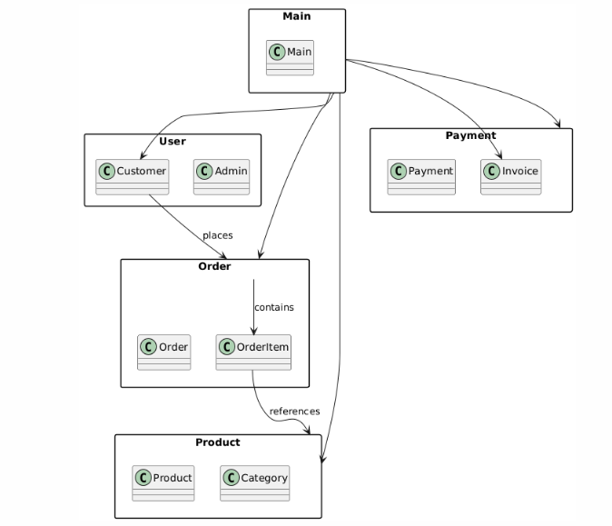

Task 08:

what is state notation .. initial and final ?
Answer:
State notation is part of the UML State Machine Diagrams (or State Diagrams) that represent the states of an object and how it transitions between those states due to events.
Initial State ●: (solid black filled circle) - Represents the starting point of the state machine.
Final State◎: (black filled circle with outer ring) - Represents the end of the object's state transitions.

