ID: bvarshsp
Name: Varsha SP
Day 36 – 17th September 2025

Task 1:
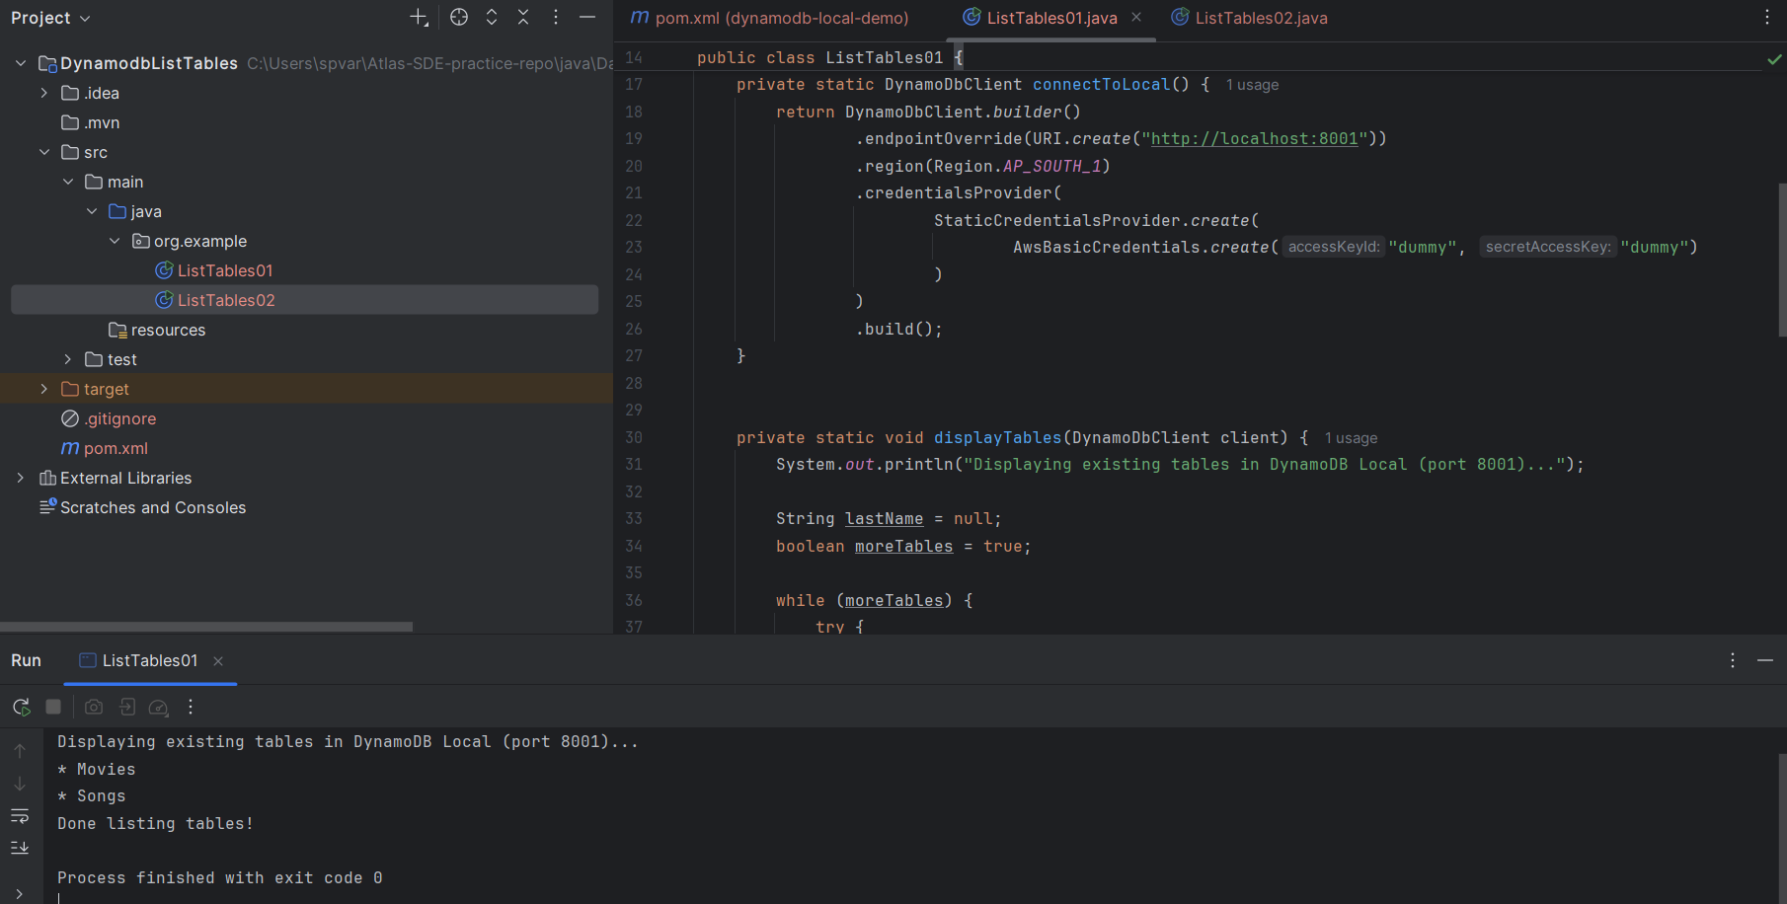

Task 2:
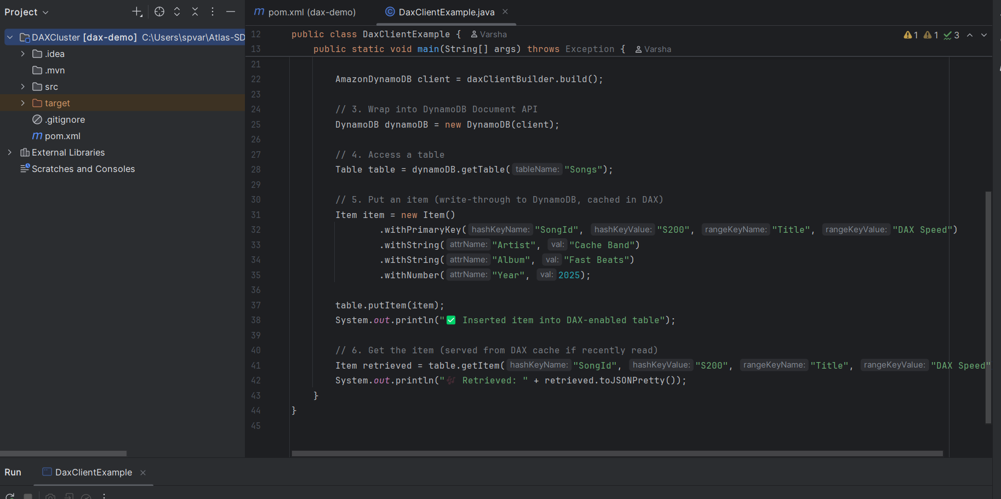

Task 3:
What is JUNIT?
Answer:
JUnit is a unit testing framework for Java. It’s one of the most widely used frameworks to write and run automated tests for Java applications.
Breakdown:
- JUnit is a Java library that helps developers test small pieces of code (usually methods or classes) to make sure they behave as expected.
- It supports test-driven development (TDD) and automated testing.
- It provides annotations, assertions, and test runners to simplify testing.
Why use JUnit?
- Automation – Instead of manually checking outputs, you write tests once and re-run them anytime.
- Regression safety – When you change code, you can rerun old tests to ensure nothing breaks.
- Faster development – Bugs are caught early, reducing debugging time.
- Integration with build tools – Works well with Maven, Gradle, and CI/CD pipelines.

Task 4:
What is the latest version of Junit
Answer:
The latest stable (GA) version of JUnit 5 is JUnit 5.13.4.

Task 5:
Write a test case to check if 2 strings or equal?
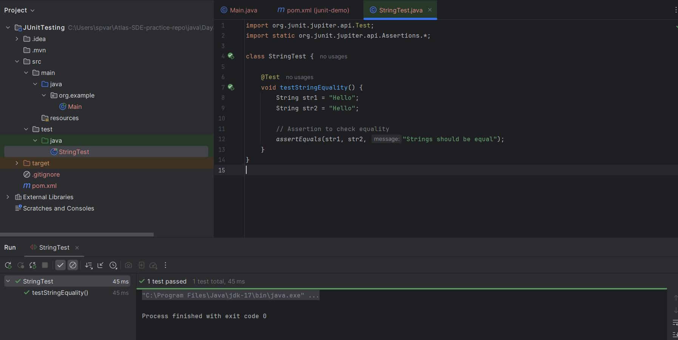

Task 6:
Write the list of tags in Junit5.
Answer:
JUnit 5 Key Annotations:
1. Basic Test Annotations
- @Test → Marks a test method.
- @ParameterizedTest → Runs the same test with different inputs.
- @RepeatedTest → Runs a test multiple times.
- @TestFactory → Marks a method that generates dynamic tests.
- @TestTemplate → Defines a template for multiple invocations.
- @Disabled → Disables (skips) a test or class.
2. Lifecycle Annotations
- @BeforeEach → Runs before each @Test method.
- @AfterEach → Runs after each @Test method.
- @BeforeAll → Runs once before all tests in a class (must be static unless using @TestInstance(Lifecycle.PER_CLASS)).
- @AfterAll → Runs once after all tests in a class.
3. Tagging & Filtering
- @Tag("name") → Assigns a category/tag to tests (e.g., @Tag("smoke"), @Tag("slow")).
- @Tags({@Tag("smoke"), @Tag("fast")}) → Multiple tags.
4. Assertions & Assumptions
(not annotations, but important tools in test code)
- Assertions → assertEquals, assertTrue, assertThrows, etc.
- Assumptions → assumeTrue, assumeFalse, etc. (skip test if assumption fails).
5. Parameter Injection / Advanced
- @DisplayName("custom test name") → Human-readable test names.
- @Nested → Inner test classes for better grouping.
- @Order → Defines execution order (with @TestMethodOrder).
- @Timeout → Fails test if it exceeds time limit.
- @ExtendWith → Register extensions (e.g., Mockito, Spring).
- @TempDir → Injects a temporary directory/file.
- @EnabledOnOs, @DisabledOnOs → Enable/disable tests by OS.
- @EnabledOnJre, @DisabledOnJre → Enable/disable tests by Java version.
- @EnabledIf, @DisabledIf → Conditional execution.

Task 7:
What are meta-annotations and composed annotations. Can you describe with an example code
Answer:
1. Meta-Annotations
A meta-annotation is an annotation that is used on another annotation.
JUnit 5 annotations like @Test, @BeforeEach, @Disabled, etc., are meta-annotated with @Target, @Retention, and sometimes other JUnit-specific annotations.
Example:
import org.junit.jupiter.api.Test;
import java.lang.annotation.*;

@Retention(RetentionPolicy.RUNTIME) // meta-annotation
@Target(ElementType.METHOD) // meta-annotation
@Test // JUnit test meta-annotation
public @interface MyCustomTest {
}
Here:
- @Retention and @Target are meta-annotations that define where and how your annotation works.
- @Test itself is also a meta-annotation, because now we’re building on top of it.
2. Composed Annotations
A composed annotation is when you combine multiple annotations into one custom annotation.
This makes test code cleaner and reusable.
Example: Instead of writing @Test, @Tag("smoke"), and @DisplayName everywhere, we can compose them into one:
import org.junit.jupiter.api.Tag;
import org.junit.jupiter.api.Test;
import org.junit.jupiter.api.DisplayName;
import java.lang.annotation.*;

@Retention(RetentionPolicy.RUNTIME)
@Target(ElementType.METHOD)
@Test // test method
@Tag("smoke") // tag applied
@DisplayName("Smoke Test") // custom name
public @interface SmokeTest {
}
Now, we can just use @SmokeTest in our test class:
class MyTests {

@SmokeTest
void quickCheck() {
System.out.println("Running smoke test");
}
}
This is a composed annotation, because it “composes” multiple meta-annotations into one reusable one.

Task 8:
What are Assertions?
Answer:
Assertions are methods that check whether the actual output matches the expected output.
If the condition is not met, the test fails.
Common Assertions in JUnit 5:
Assertion | Purpose | Example
assertEquals(expected, actual) | Check equality | assertEquals(5, calculator.add(2,3));
assertNotEquals(unexpected, actual) | Check inequality | assertNotEquals(4, calculator.add(2,3));
assertTrue(condition) | Check if condition is true | assertTrue(num > 0);
assertFalse(condition) | Check if condition is false | assertFalse(list.isEmpty());
assertNull(obj) | Check if object is null | assertNull(value);
assertNotNull(obj) | Check if object is not null | assertNotNull(user);
assertThrows(Exception.class, executable) | Verify exception is thrown | assertThrows(IllegalArgumentException.class, () -> new User(null));
assertAll() | Group multiple assertions | assertAll(() -> assertEquals("John", user.getName()), () -> assertEquals(25, user.getAge()));

Task 9:
What are Assumptions?
Answer:
Assumptions in JUnit
Assumptions are conditions that must be true for a test to run.
- If an assumption fails, the test is skipped (not failed).
- They’re useful when a test should only run under certain conditions (e.g., OS, environment, config).
Common Assumptions in JUnit 5:
Assumption | Purpose | Example
assumeTrue(condition) | Run test only if condition is true | assumeTrue("DEV".equals(env));
assumeFalse(condition) | Run test only if condition is false | assumeFalse(System.getProperty("os.name").contains("Windows"));
assumingThat(condition, executable) | Run specific code block if condition true | assumingThat(env.equals("CI"), () -> assertEquals(2, calc.add(1,1)));
Task 10:
What is Disabling Test cases? When will we use them?
Answer:
Disabling a test means marking a test so that it is skipped and not executed.
We use the @Disabled annotation in JUnit 5.
When to Use @Disabled
- Test is not stable yet (flaky test).
- Feature not implemented yet but test case is written.
- Temporarily skipping a failing test (e.g., during a release).

Task 11:
Give the names of Conditional Test Executions.
Answer:
JUnit 5 provides annotations to enable/disable tests conditionally, based on OS, JRE, environment, etc.
List of Conditional Annotations:
- @EnabledOnOs(OS.WINDOWS) / @DisabledOnOs(OS.LINUX)
- @EnabledOnJre(JRE.JAVA_11) / @DisabledOnJre(JRE.JAVA_17)
- @EnabledIfEnvironmentVariable(named="ENV", matches="DEV")
- @DisabledIfEnvironmentVariable(named="ENV", matches="PROD")
- @EnabledIfSystemProperty(named="os.arch", matches=".*64.*")
- @DisabledIfSystemProperty(named="os.arch", matches=".*32.*")
- @EnabledIf / @DisabledIf (custom conditions, usually with extensions)
These allow fine-grained control over test execution depending on runtime conditions.

Task 12:
What is Automated Testing?
Answer:
Automated testing is the process of executing tests automatically using tools/frameworks (instead of manual testing).
Benefits:
- Saves time & effort (tests run with one command).
- Repeatable & consistent (no human error).
- Early bug detection (continuous testing in CI/CD).
- Can run thousands of tests quickly (e.g., regression suites).

Task 13:
List down some automated testing tools and frameworks.
Answer:
Unit Testing Frameworks
- JUnit (Java)
- TestNG (Java)
- NUnit (.NET)
- PyTest (Python)
- Mocha/Jest (JavaScript)
UI / Functional Testing Tools
- Selenium → Web UI automation.
- Cypress → Modern JS-based UI testing.
- Playwright → Cross-browser automation.
API Testing Tools
- Postman → Manual + automated API testing.
- RestAssured (Java).
- Karate DSL.
Continuous Integration (CI) Automation
- Jenkins
- GitHub Actions
- GitLab CI/CD
Test Management & Reporting
- Allure Reports
- Extent Reports
- JUnit XML Reports

Task 14:
What is the life cycle of Test automation?
Answer:
Phases step by step:
1. Decision to Automate
- Identify if automation is needed.
- Not all tests should be automated (e.g., one-time tests are better done manually).
- Decide based on ROI, test repeatability, stability, and complexity.
2. Tool Selection
- Choose the right automation framework/tool depending on:
  - Technology stack (e.g., JUnit/TestNG for Java, Selenium for UI, RestAssured for APIs).
  - Team skill set.
  - CI/CD integration needs.
  - Cost (open-source vs commercial).
3. Test Planning & Design
- Define the scope (which tests to automate).
- Write test automation plan (objectives, risks, deliverables, schedule).
- Identify reusable test data and test environment setup.
- Decide framework type (data-driven, keyword-driven, hybrid, BDD, etc.).
4. Test Development
- Write the automation scripts using the selected tool/framework.
- Follow coding best practices (modularity, reusability, naming conventions).
- Implement assertions, logging, reporting.
5. Test Execution
- Run automated tests (locally, on CI/CD pipelines, in cloud grids).
- Execute on multiple environments/browsers/OS if required.
- Collect logs & reports.
6. Result Analysis & Reporting
- Analyze failures (are they real defects or test script issues?).
- Generate reports (JUnit XML, Allure, Extent Reports, etc.).
- Share results with stakeholders (developers, QA, managers).
7. Test Maintenance
- Update scripts when:
  - Application UI changes.
  - Business logic changes.
  - New features are added.
- Ensure the suite remains stable, reliable, and up to date.
Summary Diagram:
Decision to Automate
↓
Tool Selection
↓
Test Planning & Design
↓
Test Development (scripts)
↓
Test Execution
↓
Result Analysis & Reporting
↓
Test Maintenance

Task 15:
Write a JUNIT5 code to use @suite tag
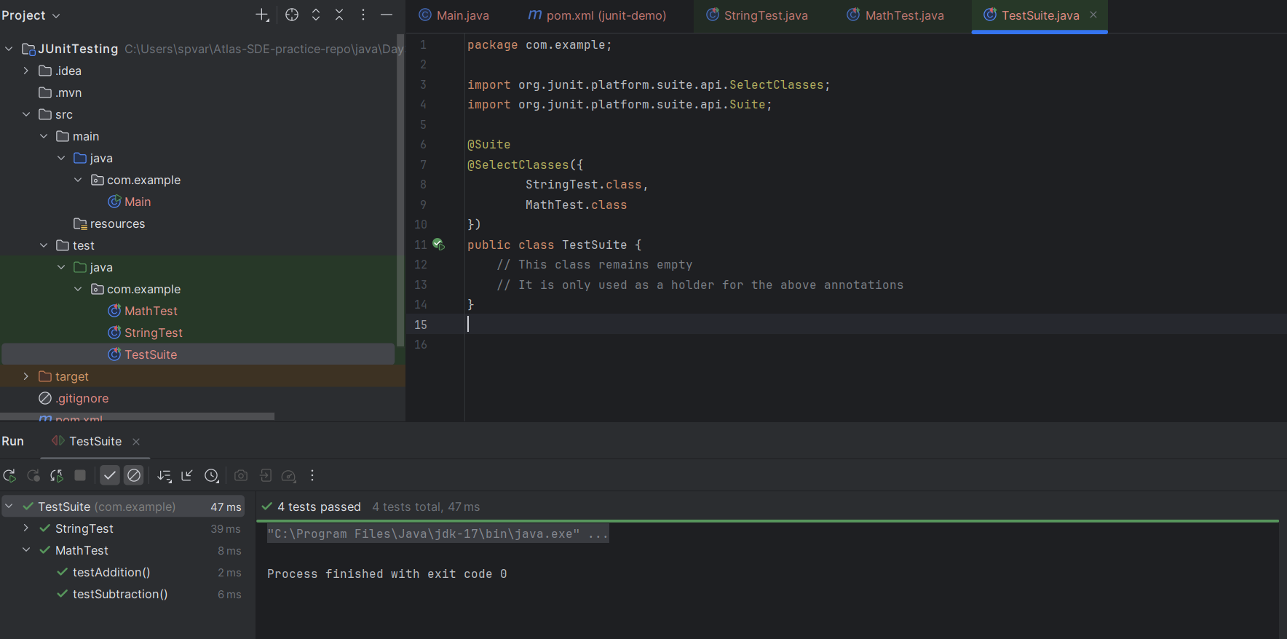

Task 16:
Write JUNIT5 code to use @fast and @slow tag.
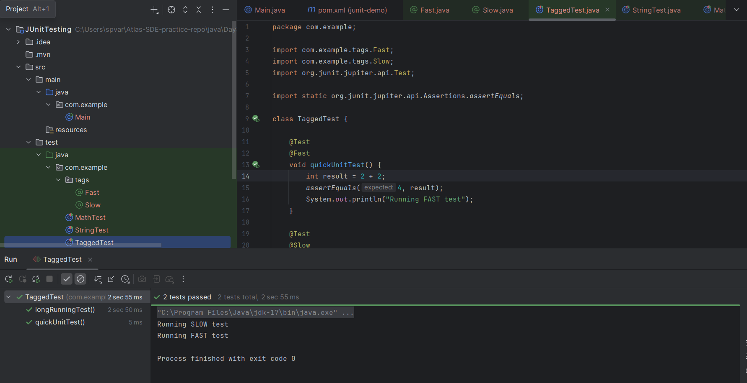

Task 17:
How many types of primary keys does DynamoDB use?
- 5
- 4
- 3
- 2

Task 18:
____ indexes enable you to query table data using a different key?
- Composite
- Secondary
- Primary

Task 19:
DynamoDB uses how many types of secondary indexes?

- 5
- 4
- 2
- 3

Task 20:
Eventually Consistent readings always return current data?
True
False

Task 21:
Which of the following data-reading action in DynamoDB receives a primary key and returns the corresponding item's attributes?
GetItem
BatchGetItem
Scan
Query

Task 22:
DynamoDB often ensures consistency across all copies in less than a second.
True
False

Task 23:
All local secondary indexes retain partition and sort keys from parent tables by default?

True
False

