ID: bvarshsp
Name: Varsha SP
Day 22 – 30th July 2025
Task 1:

What is good code vs Bad code.

Answer:
Good Code – Characteristics
Readable | Easy to understand by other developers (or future you)
Clean | Follows naming conventions, indentation, and formatting
Modular | Broken into small, reusable functions or classes
Reusable | Avoids duplication (follows DRY: Don't Repeat Yourself)
Efficient | Uses appropriate data structures and algorithms
Testable | Easy to write and run unit tests
Maintainable | Easy to fix bugs or add new features
Follows best practices | Uses SOLID principles, design patterns, error handling, etc.

Bad Code – Characteristics
Unclear names | Uses vague variable/method names like x, temp, data
Monolithic | Huge methods/classes doing too many things
Duplicated logic | Same code copy-pasted in multiple places (violates DRY)
Hard to read | No proper indentation or comments
Bug-prone | Poor error handling, hidden logic
Untestable | Tightly coupled logic that's hard to isolate or test
Unmaintainable | Any small change might break multiple parts of the code

Task 2:

BAD CODE vs GOOD CODE - ORAL

Task 3:

What do you understand by databinding?

Answer:
Data Binding is a technique that connects UI elements (like text fields or labels) with data sources (like objects or variables) — so that changes in one automatically reflect in the other.
Data Binding = Link between our application’s data and UI.
When the data changes, the UI updates automatically, and in two-way binding, when the user changes the UI, the data also updates.

Task 4:

What do you know about continuous development?

Answer:
Continuous Development (CD) is a software engineering practice where code is built, tested, integrated, and delivered frequently and automatically. It ensures that software is always in a deployable state.
It’s part of a broader DevOps or Agile workflow, aimed at faster and safer delivery of applications.

Task 5:

What are the conditions for polymorphism?

Answer:
Polymorphism means “many forms” — in Java, it allows a single action to behave differently depending on the object that invokes it.
To use polymorphism, certain conditions or requirements must be met.

Conditions for Compile-Time Polymorphism (Method Overloading)
- Method name must be the same
- Parameter list must differ (in number, type, or order)
- Can occur in the same class
- Return type may or may not differ (but alone it’s not enough)

Conditions for Runtime Polymorphism (Method Overriding)
- Inheritance is required (class must extend another)
- Method in subclass must have same name and signature as in parent class
- Access modifier must be the same or more visible
- Cannot override final or static methods
- Use dynamic method dispatch (parent reference → child object)

Task 07:

import org.junit.jupiter.api.Test;
import org.junit.jupiter.api.Tags;
import org.junit.jupiter.api.Assertions.assertEquals;
class TestCase02 {
@Test
@Tags("firstPriority")
void testMethod01() {

}

@Test
@Tag("firstPriority")
void runTestcase02() {

}
@Tags("fastTag")
void testMethod03() {

}

@Test
@Tag("slowTag")
void runTestcase04() {

}
}
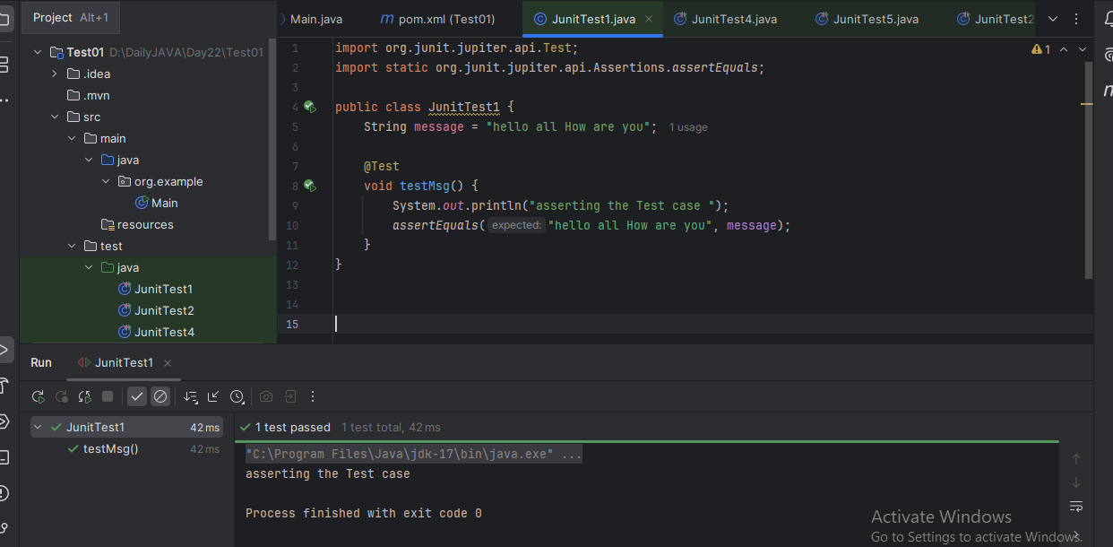
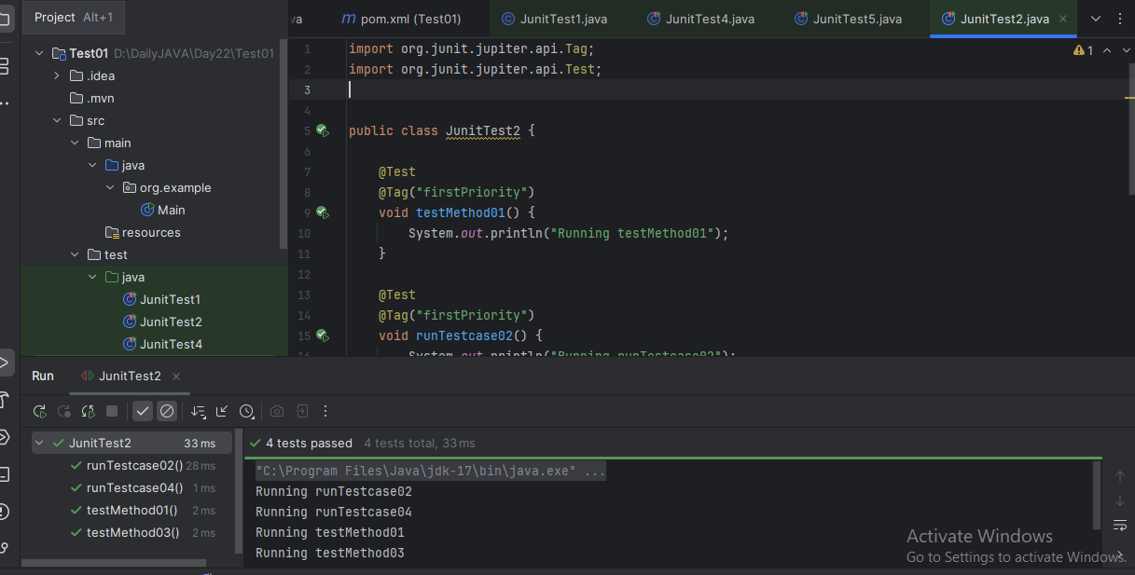

Task 08:

Write a test case for the below java file

public class Junit4Test {
public int compare(int n1, int n2) {
if (n1 > n2) return 1;
return -1;
}
}
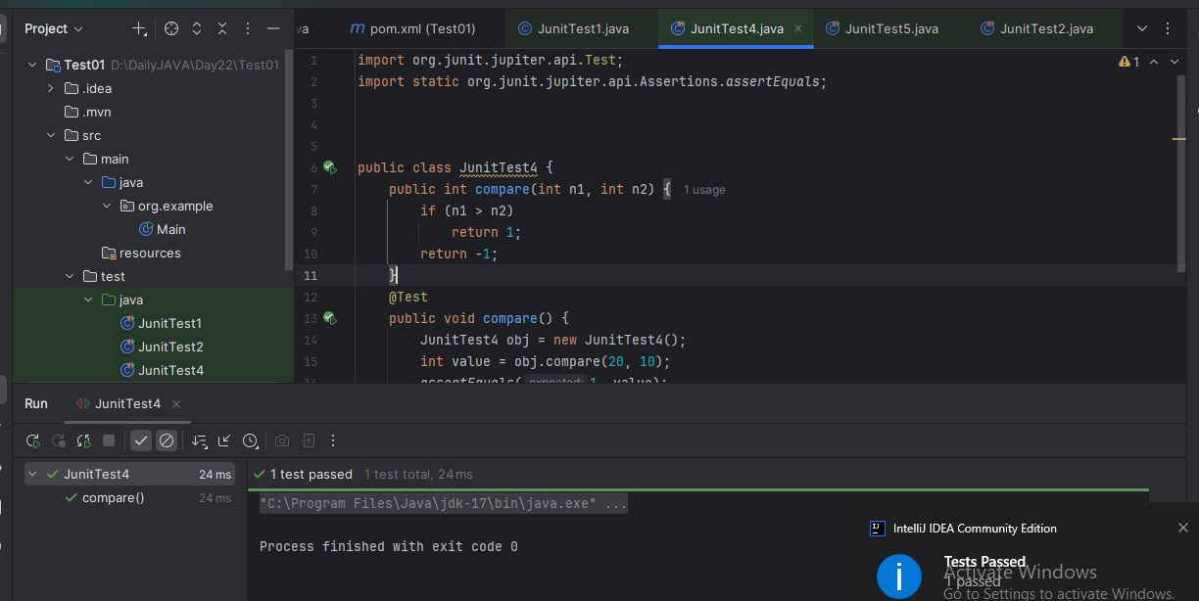
Task 09:
Write test case for below code

public int compare(int n1, int n2) {
if (n1 > n2) return 1;
else if (n1 < n2) return -1;
return 0;
}

