ID: bvarshsp
Name: Varsha SP
Day 16 – 9th July 2025

Task 1:
Write an algorithm / step for selection sort.

Answer:

1. Start from the first element (index i = 0).
2. Assume the current index i holds the minimum element.
3. Compare it with the rest of the array to find the actual minimum element.
4. Swap the found minimum with the element at index i.
5. Repeat steps 2–4 for the next position (i = i + 1) until the array is sorted.

Task 2:

Write a pseudo code for the selection sort
Answer:
Given: arr = [64, 25, 12, 22, 11, 90, 45, 33]
for i from 0 to n-2:
minIndex = i
for j from i+1 to n-1:
if arr[j] < arr[minIndex]:
minIndex = j
if minIndex ≠ i:
swap arr[i] and arr[minIndex]

Task 3:

Wap to make sure your list is sorted using selection sort.
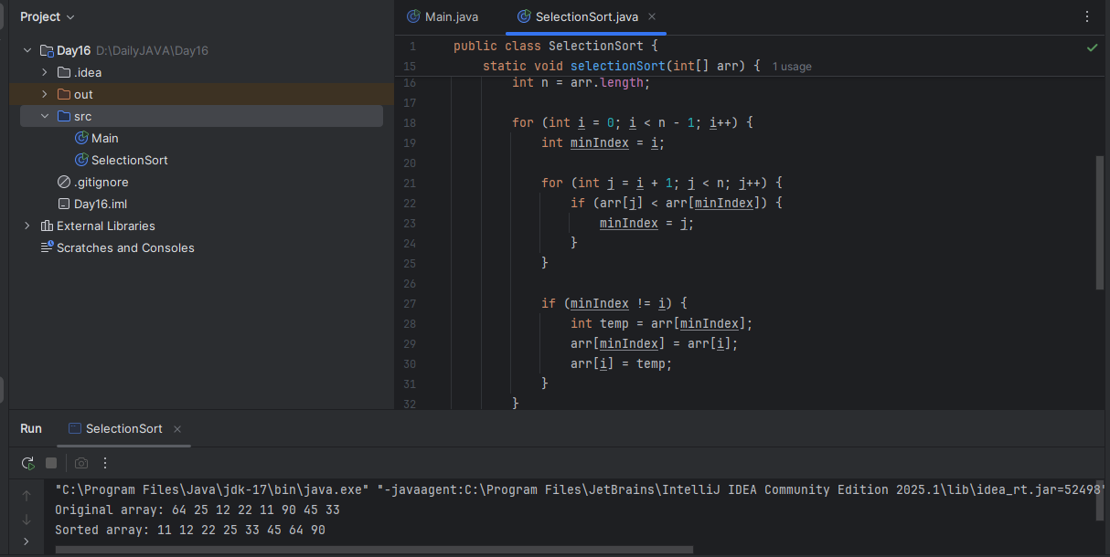
Task 4:

Write algorithm for the Bubble sort.

Input: An array A of n elements
Output: The array sorted in ascending order
Start
Let A be the array of n elements
Repeat for i = 0 to n - 1
Repeat for j = 0 to n - i - 2
If A[j] > A[j + 1] then
Swap A[j] and A[j + 1]
End Repeat
explanation:
The outer loop runs n-1 times to move through all passes.
The inner loop compares adjacent elements and swaps them if needed.
With every pass, the largest unsorted element "bubbles up" to its correct position.

Task 5:

Write [psedo code for the bubble sort

BubbleSort(A, n)
for i from 0 to n - 1 do
for j from 0 to n - i - 2 do
if A[j] > A[j + 1] then
// Swap A[j] and A[j + 1]
temp ← A[j]
A[j] ← A[j + 1]
A[j + 1] ← temp

Task 6:

Wap to make sure your list is sorted using Bubble sort.

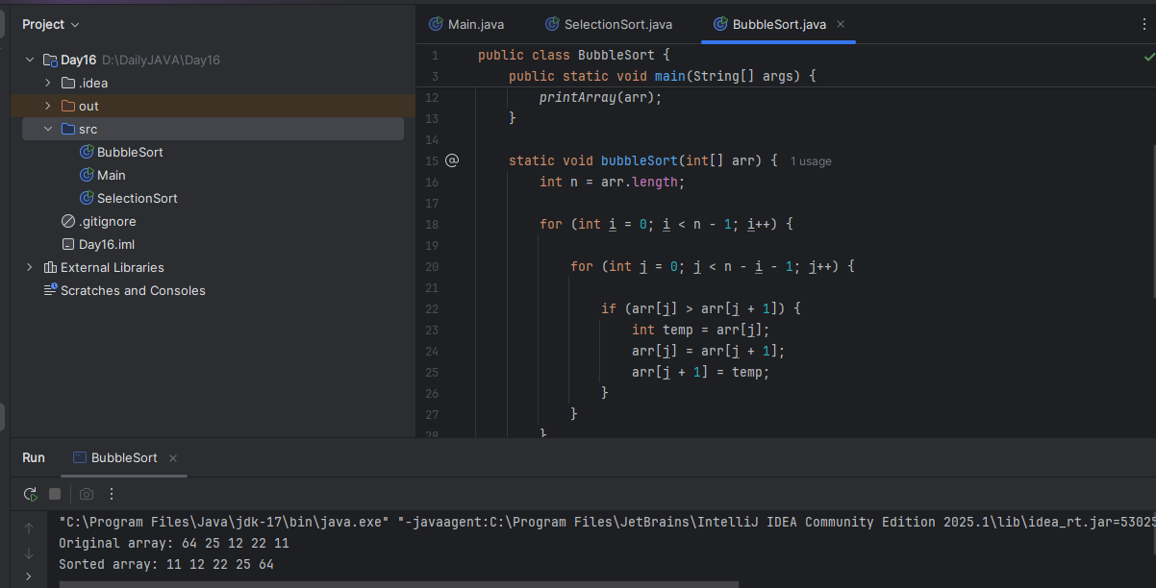

Task 7:

Write algorithm for the Insertion sort.

Answer:
Given: An array A of n elements
Goal: Sort the array in ascending order
1. Repeat for i = 1 to n - 1:
a. Set key = A[i]
b. Set j = i - 1
2. While j >= 0 and A[j] > key:
a. Move A[j] one position forward (A[j + 1] = A[j])
b. Decrement j (j = j - 1)
3. Place key at A[j + 1]
4. Repeat steps 1 to 3 until array is sorted
Task 8:

Write psedo code for the Insertion sort

Answer:

InsertionSort(A)
for i ← 1 to A.length - 1 do
key ← A[i]
j ← i - 1
while j ≥ 0 and A[j] > key do
A[j + 1] ← A[j]
j ← j - 1
A[j + 1] ← key

Task 9:
Wap to make sure your list is sorted using Insertion sort.

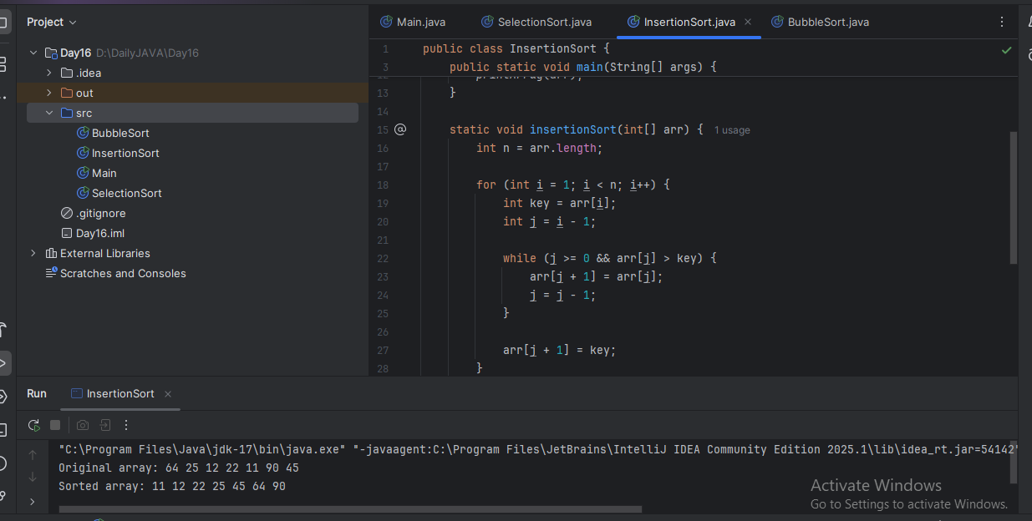

Task 10:

What are the advantages and disadvantages of Bubble sort Algo?
List them
Answer:
Advantages of Bubble Sort:
-Simple to understand and implement – Great for beginners.
-No extra memory needed – Works in-place, requires only constant space.
-Good for small datasets – Performs reasonably well with tiny inputs.
-Stable sort – Preserves the relative order of equal elements.
Disadvantages of Bubble Sort:
-Very inefficient for large datasets – Time complexity is O(n²).
-Unnecessary comparisons – Even if the array is sorted early.
-Slower than other algorithms – Like Insertion, Merge, or Quick Sort.
-Not suitable for real-world large data – Too many swaps degrade performance.
Task11:
Write algorithm for the Merge sort.
Answer:
Step 1: Divide
If the array has 1 or 0 elements, it's already sorted.
-return.
Otherwise:
-Find the middle index.
-Split the array into two halves: left and right.
Step 2: Conquer (Recursively Sort)
Recursively apply merge sort on the left half.
Recursively apply merge sort on the right half.
Step 3: Combine (Merge)
Merge the two sorted halves into one sorted array.

Task12:
Write psedo code for the Merge sort

MERGE_SORT(arr, start, end):
if start < end:
mid = (start + end) / 2
MERGE_SORT(arr, start, mid) // Sort left half
MERGE_SORT(arr, mid + 1, end) // Sort right half
MERGE(arr, start, mid, end) // Merge sorted halves

MERGE(arr, start, mid, end):
Create temporary arrays: left[] and right[]
Copy data to left[] and right[] from arr[start..mid] and arr[mid+1..end]
Merge left[] and right[] back into arr[start..end] in sorted order
Task13:
Wap to make sure your list is sorted using Merge sort.

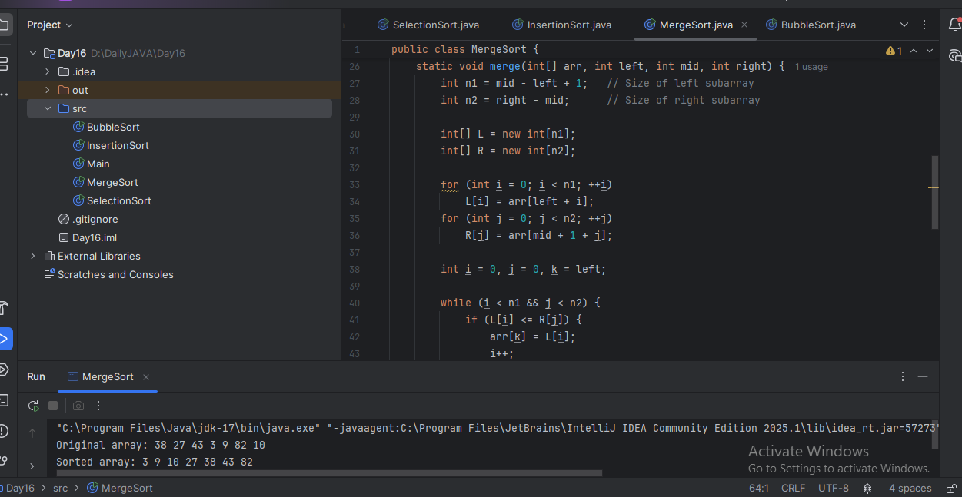
Task 14:

Algo fro quick sort

Answer:

Step 1: Start

Step 2: Choose a pivot element from the array (typically the last element)

Step 3: Partition the array around the pivot
- Move all elements smaller than pivot to its left
- Move all elements greater than pivot to its right

Step 4: Recursively apply Quick Sort to the left sub-array

Step 5: Recursively apply Quick Sort to the right sub-array

Step 6: Done (when sub-arrays have size 0 or 1)

Task 15:

Pseudo code for quick sort

QUICK_SORT(array, low, high)
if low < high then
pivotIndex ← PARTITION(array, low, high)
QUICK_SORT(array, low, pivotIndex - 1)
QUICK_SORT(array, pivotIndex + 1, high)

PARTITION(array, low, high)
pivot ← array[high] // choose the last element as pivot
i ← low - 1 // index of smaller element

for j ← low to high - 1 do
if array[j] < pivot then
i ← i + 1
SWAP(array[i], array[j])

SWAP(array[i + 1], array[high]) // place pivot in correct position
return i + 1

Task 16:

Code for Quick sort

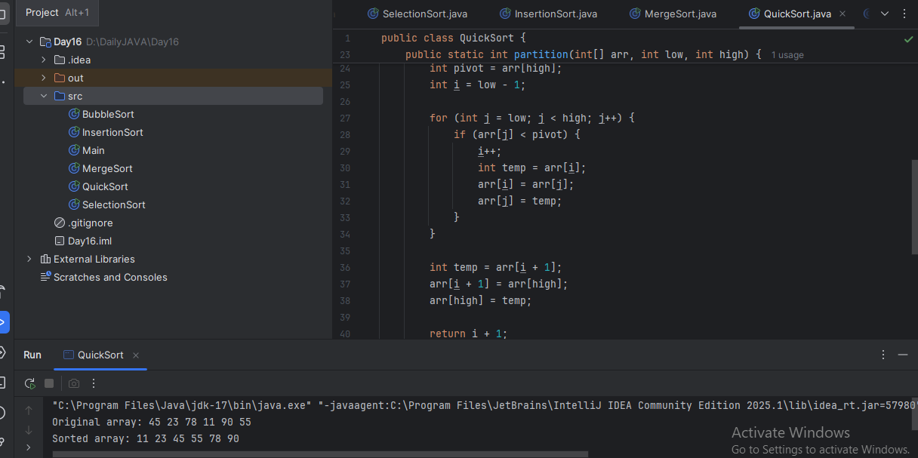

Task 17:

Which one is better merge or bubble in terms of time complexity?

Note: industrial applications like huge data bases … prefer merge sort.

Note:
Merge: O (n log n)
Bubble: O (n square)

Answer: Merge Sort is clearly better than Bubble Sort in terms of time complexity, especially for large or unsorted data.

Task 18:
Leet code qn:

Find the time complexity of the given merge operation between two sorted arrays.

Answer:

Time complexity: sum of 2 array sizes.
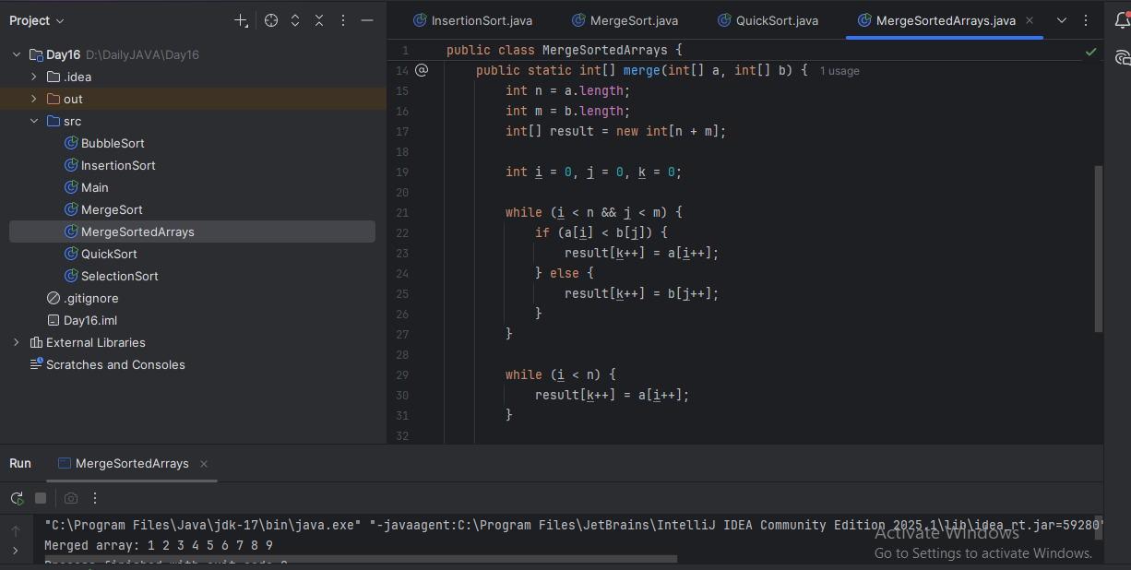

Task 19:

This code is going overflow of stack.. Can you plz help me fix it guys.. ☹️

public class RecLoop {

public int calc(int n) {
if (n == 0) return 0;
return n + calc(n);
}

psvm(String[] args) {
System.out.println(new RecLoop().calc(10));
}
}

Answer:
The issue lies in this line inside the calc() method. We are not reducing the input n in the recursive call. So instead of getting closer to the base case (n == 0), we're calling calc(n) with the same value again and again. This causes StackOverflowError because infinite recursive calls means no base case reached and hence call stack overflows. We should decrement n in each recursive call: return n + calc(n - 1); Now n gets smaller each time, eventually reaching 0, and the recursion stops.
Task 20:

public class BinarySearchNew {
public int search(int[] arr, int toFind) {
int left = 0, right = arr.len - 1;

while (left <= right) {
int mid = left + (right - left) / 2;

if (arr[mid] == toFind) {
return mid;
} else if (arr[mid] < toFind) {
left = mid + 1;
} else {
right = mid - 1;
}
}
return -1;
}
}

binary search function can we use in unsorted list?
Will it give you correct index no?
Answer:
No, we cannot use Binary Search on an unsorted list. Binary Search only works on sorted arrays/lists (ascending or descending). It relies on the middle element comparison and halving the search space based on sorted order.

