ID: bvarshsp
Name: Varsha SP
Day 32 – 3rd September 2025

Task1:

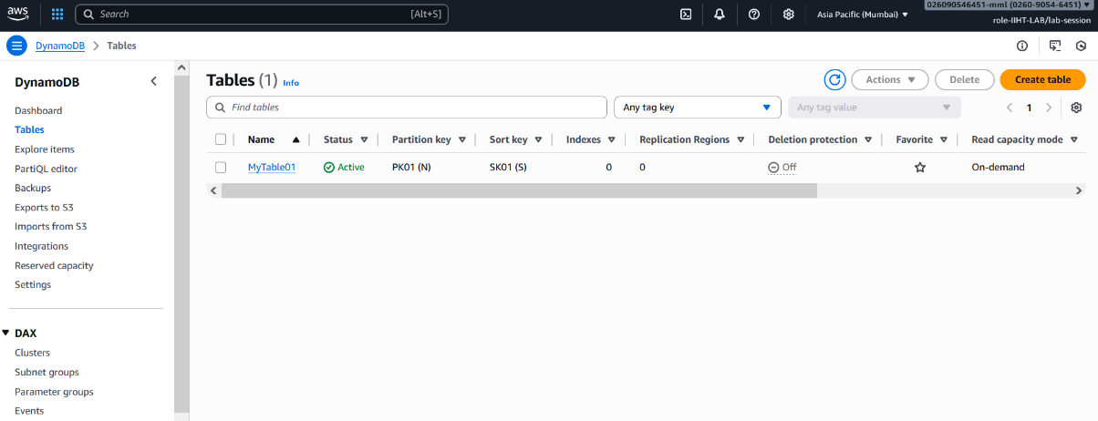

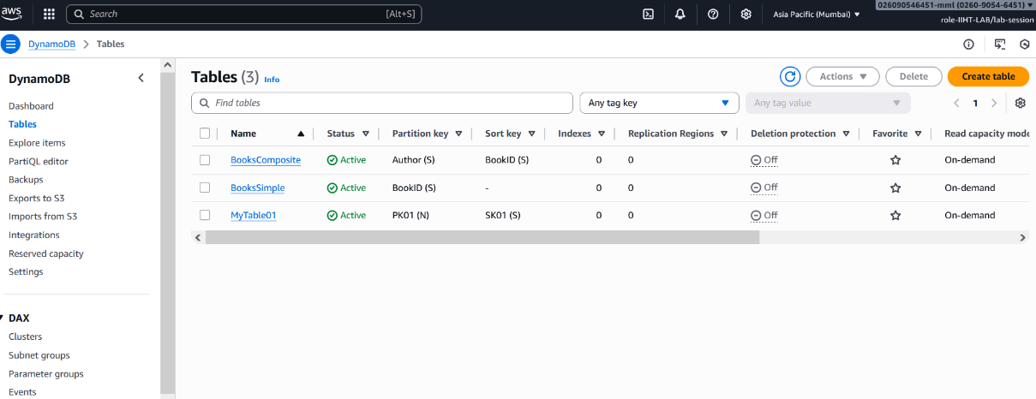
-----------------------------------------------------------------------------------------------------------------------------
Task2:

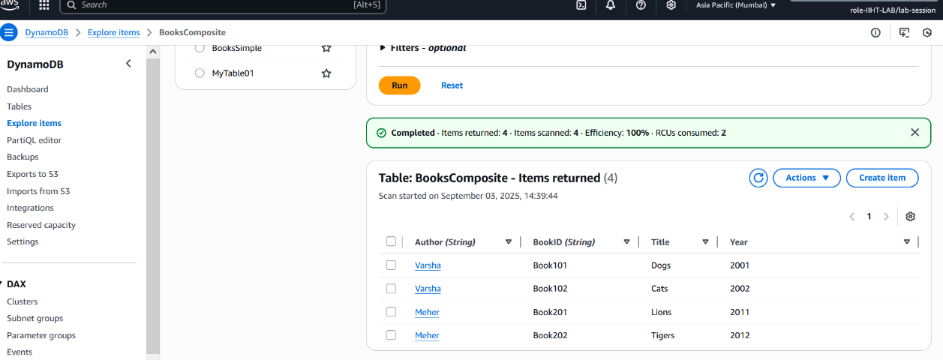
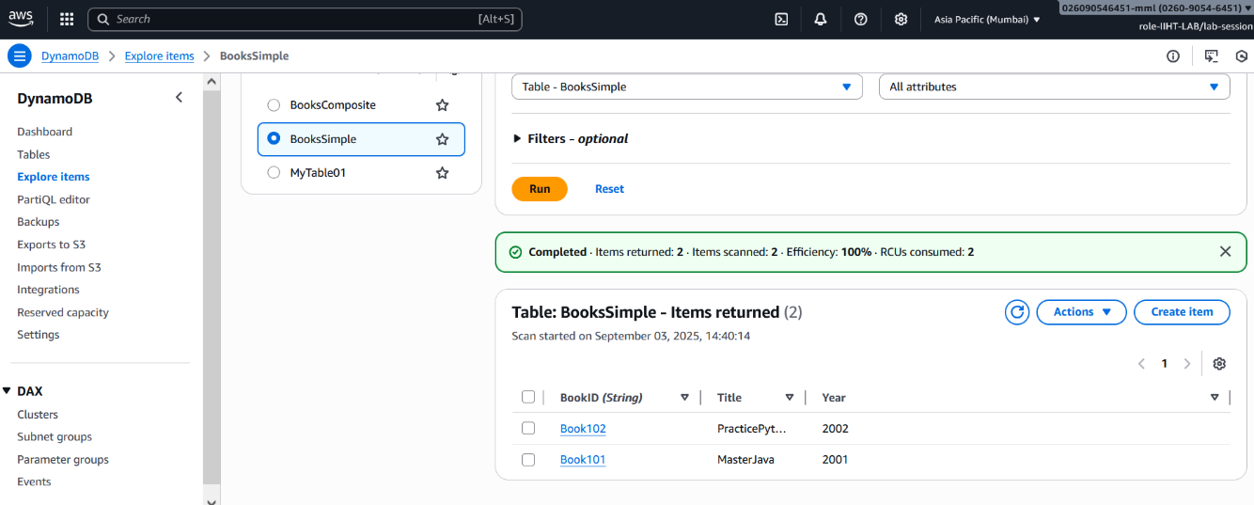

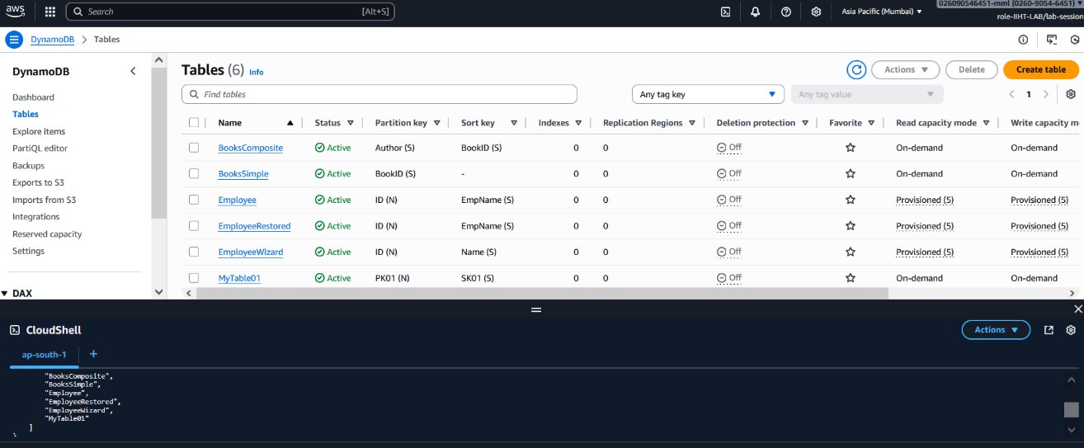

===============================================================================
CREATE Table:
aws dynamodb create-table \
--table-name Employee \
--attribute-definitions \
AttributeName=ID,AttributeType=N \
AttributeName=EmpName,AttributeType=S \
--key-schema \
AttributeName=ID,KeyType=HASH \
AttributeName=EmpName,KeyType=RANGE \
--provisioned-throughput ReadCapacityUnits=5,WriteCapacityUnits=5
Explanation:
--table-name Employee → table name
--attribute-definitions → defines key attributes and their types
- ID = Number (N)
- EmpName = String (S)
--key-schema → defines the primary key
- ID = Partition Key (HASH)
- EmpName = Sort Key (RANGE)
--provisioned-throughput → sets capacity (RCU/WCU)
- ReadCapacityUnits=5
- WriteCapacityUnits=5

CRUD operations/commands for Employee table (In CLI):
Partition Key = ID (Number)
Sort Key = EmpName (String)

1. CREATE(insert item):
aws dynamodb put-item \
--table-name Employee \
--item '{
"ID": {"N": "1"},
"EmpName": {"S": "Varsha"},
"Department": {"S": "IT"},
"Salary": {"N": "50000"}
}'
Adds an employee (ID=1, EmpName=Varsha).

2. READ
(a) Get one item by primary key
aws dynamodb get-item \
--table-name Employee \
--key '{
"ID": {"N": "1"},
"EmpName": {"S": "Varsha"}
}'
Fetches only Varsha’s record.
(b) Scan all items (like SELECT *)
aws dynamodb scan --table-name Employee
Returns all employees in the table.

3. UPDATE
Example: Update Varsha’s salary from 50000 → 60000:
aws dynamodb update-item \
--table-name Employee \
--key '{
"ID": {"N": "1"},
"EmpName": {"S": "Varsha"}
}' \
--update-expression "SET Salary = :s" \
--expression-attribute-values '{":s": {"N": "60000"}}' \
--return-values ALL_NEW
Updates the Salary field and returns the new record.

4. DELETE
Delete Varsha’s record:
aws dynamodb delete-item \
--table-name Employee \
--key '{
"ID": {"N": "1"},
"EmpName": {"S": "Varsha"}
}'
Removes that employee completely.
Scan all items (like SELECT * FROM Employee)
aws dynamodb scan --table-name Employee

Query all employees with a given ID
Example: Find all employees where ID = 1
aws dynamodb query \
--table-name Employee \
--key-condition-expression "ID = :id" \
--expression-attribute-values '{":id":{"N":"1"}}'
If ID=1 has multiple employees (e.g., Varsha, Meher), you’ll get all of them.
Note: We can scan/query only for specific attributes too.

